EVALUATION AND ENHANCEMENT OF THE NATIONAL NETWORK OF LIBRARIES OF MEDICINE (NN/LM) HEALTH LITERACY WEB BASED RESOURCE

Diana Almader-Douglas, NLM Associate Fellow
Spring, 2013

Project Sponsors
Angela Ruffin, PhD, National Network Office
Lisa Boyd, MA, MLS, National Network Office

Table of Contents
Abstract page 3
Background page 4
Methods page 5
Results page 9
Discussion page 13
Recommendations page 13
Acknowledgments page 15
References page 16
Appendix I: Project Proposal page 19
Appendix II: Google Analytics page 21
Appendix III: SurveyMonkey Questions for the Consumer Health Coordinators page 29
Appendix IV: Survey Results page 30
Appendix V: Social Media Promotion Message page 35
Appendix VI: Consumer Health Coordinator Telemeeting March 12, 2013 page 38
Appendix VII: Jing Video page 41

ABSTRACT

Objective
The purpose of this project is to develop and design a new health literacy resource for the National Network of Libraries of Medicine (NN/LM) Web site or redesign the existing NN/LM Health Literacy Web page (http://nnlm.gov/outreach/consumer/hlthlit.html). The goal is to provide health sciences, consumer health, outreach and public librarians with a useful, appropriate and easily accessible health literacy resource.

Methods
I conducted an environmental scan and a literature review related to health literacy issues. I led discussions, historical interviews and issued a questionnaire to the Consumer Health Coordinators and other key stakeholders. I evaluated Google Analytics metrics, added new content, and promoted the changes to the Web page via social media.

Results
Pageviews increased on the days of heavy social media promotion. Pageviews decreased on the July 4 holiday. Pageviews were lower between June and July, but this is a typical trend for the summer months. Google Analytics data from the previous year revealed that summer months had lower percentages of Pageviews. This information supports evidence that the addition of content did not compromise the integrity of the page.

Conclusions
By enhancing the NN/LM Health Literacy Web page with content about health literacy in a cultural context, Consumer Health librarians will be able improve the health information services of vulnerable and diverse population groups they are serving.

BACKGROUND
Health literacy is the ability to obtain, process, and understand basic health information and services needed to make appropriate health decisions (Ratzan and Parker, 2000, p.vi). Health literacy is important because it influences how people search for health information, their ability to apply healthy behaviors, and respond to public health issues (http://www.health.gov/communication/literacy/). Low health literacy is associated with poorer health outcomes and higher health care costs (Berkman, et al., 2004). According to the 2003 National Assessment of Adult Health Literacy (NAAL), only twelve percent of U.S. adults had proficient health literacy. Proficient level “indicates skills necessary to perform more complex and challenging literacy activities” (Osborne, 2013, p. 116).

Administered by the National Library of Medicine, the mission of the National Network of Libraries of Medicine (NN/LM®) is to advance the progress of medicine and improve the public health by providing U.S. health professionals equal access to biomedical information and by improving the public's access to information to enable them in making informed health-related decisions (http://www.nlm.nih.gov/nno/). The NN/LM Health Literacy Web page supports the consumer health outreach efforts of the National Library of Medicine and the National Network of the Libraries of Medicine. The Web based resource provides the library community and ultimately the people they serve with crucial, accessible, quality, and up to date health literacy information. The Health Literacy resource is currently a Web page within the nnlm.gov Consumer Health Outreach Resources (http://nnlm.gov/outreach/consumer/). The NN/LM Health Literacy Web page supports the consumer health outreach efforts of the National Library of Medicine and the National Network of the Libraries of Medicine. The Web based resource provides the library community and ultimately the people they serve with crucial, accessible, quality, and up to date health literacy information.

The purpose for adding information about the context of culture in health literacy to the Health Literacy Web page is twofold. First, in line with the American Library Association Policy Manual section B.3.2, “care must be taken to acquire and provide materials that meet the educational, informational and recreational needs of diverse communities.” Despite its positive qualities, the Health Literacy Web page did not address the construct of culture or identify the importance of how different cultural backgrounds affect health literacy.

This project recognizes the diversity within the US population. According to the US Census (2011 http://quickfacts.census.gov/qfd/states/00000.html), nearly 37% of the population in 2010 were considered to be from ethnic groups other than ‘White’. According to Doak and Doak, “literacy skills of ethnic groups are lower than that of the US population as a whole” (1995, p. 192). “On a percentage basis, more minorities and immigrants do have reading difficulties” (Doak and Doak, 1995, p. 6). Collections and resources should reflect the people they serve. In adding information about culture to health literacy resources, we are acting on the National Action Plan to Improve Health Literacy’s goal of “developing and disseminating health and safety information that is accurate, accessible, and actionable” (2010). In addition, the goals and objectives of the project were developed and revised to reflect that the NN/LM health Literacy Web page is a free resource accessible to everyone, including the public.

METHODS
To find more about health literacy and to carry forth the goals of the project, I conducted an environmental scan and a literature review. I analyzed Google Analytics data, led discussions and interviews with stakeholders, and facilitated a questionnaire. I added additional content to the Web page and promoted the changes through a social media campaign. In addition, I cross-referenced the NN/LM Health Literacy Web resource to the NLM’s PubMed Special Queries Health Literacy Web page.

Environmental Scan
The environmental scan for this project consisted of searching for agencies who acknowledge health literacy and culture. During this process, I tried to identify trends, events, facets and components of health literacy; I searched for information supporting that culture was an element important enough to add to the Health Literacy Web page. I reviewed the Medical Library Association (MLA), NLM PubMed Special Queries, American Speech-Language-Hearing Association, U.S. Department of Health & Human Services, Office of Minority Health (OMH), and the Health Literacy Consulting organization.

I reviewed Medical Library Association (MLA) courses listed in the MLA Educational Clearinghouse (http://www.mlanet.org/resources/healthlit/ to gain a better understanding of how culture and health literacy may be intersecting. The NN/LM Regional Medical Libraries (RMLs) staff facilitated half of the courses. In addition, I reviewed the Health Literacy resources listed on the MLA Web site. The Medical Library Association Guide to Health Literacy (Kars, Baker, and Wilson, 2008) devotes an entire chapter to Health Literacy issues in Special Populations and includes a chapter on cultural competence and health literacy. The chapter addresses the relationship between culture and health, barriers to cultural competence and explains the importance of culture in understanding health literacy.

Since the page was 6-7 years old, I wanted to make sure that the Web site was accessible to people with disabilities and depending on my investigation, I would either make sure the Web site was compliant with Section 508 of the Rehabilitation Act or make recommendations and changes to the Health Literacy Web page consistent with Section 508.
Other health literacy Web resources relate to health literacy were reviewed. Government, commercial and academic institutions acknowledge that cultural influences healthcare. For example, the American Speech-Language-Hearing Association (Hasselkus and Moxley, 2009) addresses how cultural differences can affect communication, and can have an impact on clinical encounters and influence decisions about treatment.
The U.S. Department of Health & Human Services ‘Think Cultural Health’, sponsored by the Office of Minority Health (OMH), addresses cultural and linguistic competency in health care with the goal of advancing health equity at every point of contact and stresses the importance of providing appropriate services to diverse communities. According to the OMH, “ultimately, incorporating cultural competency into your daily activities will allow you to better offer services to the increasingly diverse population of the US” (Cultural Competency Curriculum for Disaster Preparedness and Crisis Response, n.d.).
Helen Osborne, president of the Health Literacy Consulting organization (2013), refers to culture as a factor in communication and in health literacy and provides realistic tips for providing culturally and linguistic appropriate services.

Literature Review
I read, reviewed and analyzed literature and web-based information pertaining to culture in the context of health literacy to confirm that culture is an important aspect of health literacy, and substantiate a need for health literacy in a cultural context.
Acknowledging culture in the context of health literacy is essential in understanding health literacy. Culture is an abstract concept that includes anything from values, beliefs, tradition, and experiences to religion, customs, and attitudes. All of these different ways of thinking and feeling can influence a person’s view of health and illness. “Cultural, social and family influences shape attitudes and beliefs and therefore influence health literacy” (Health Literacy- A Prescription to End Confusion, 2004, p. 109). Helen Osborne, President of Health Literacy Consulting, goes further by asserting that culture influences how individuals comprehend and interpret health-related information (Osborne, 2013, p. 97). The concepts of culture and health literacy are related (Medical Library Association Guide to Health Literacy, 2004, p. 81) and when librarians become aware of this, they more effectively meet the needs and teach others about the issue of health literacy (Medical Library Association Guide to Health Literacy, 2004, p. 81).
Culture affects health literacy. Health literacy levels are influenced by many factors, including education, and individuals’ cultural and linguistic backgrounds (Medical Library Association Guide to Health Literacy, 2004, p. 81). Because culture forms thinking, conduct, attitudes, beliefs, and even knowledge acquired by living through illness (Medical Library Association Guide to Health Literacy, 2004), it is being acknowledged as an element of health status and health outcomes. (p. 74, 80). “As society has become more diverse, learning about and developing an awareness of cultural and ethnic differences is becoming more and more important (MLA Guide p. 79).
Limited health literacy contributes to health disparities. Cultural differences influence interactions and communication between patients and practitioners, which contributes to health inequalities such as higher rates of disease and lower rates of treatment in ethnic minorities (Medical Library Association Guide to Health Literacy, 2004, p. 75). Bennett, et al., state that health literacy and poor health-related outcomes are related (2009).
Members of diverse ethnic and racial groups deserve equitable resources and culturally appropriate and relevant information. Given that there are known health disparities among ethnic minorities, it is important for information professions providing health information to be respectful, appropriate, and responsive to an individual’s language, culture, health beliefs and practices” (Medical Library Association Guide to Health Literacy, 2004, p. 75). Because librarians develop and provide information to others whose languages, customs, values, lifestyles, beliefs and behaviors may differ from their own, it is necessary to understand culture’s role in meeting the needs of their patrons. (Medical Library Association, 2004, p. 79). Librarians are responsible for promoting culturally effective healthcare and health literacy (Medical Library Association, 2004, p. 73), and helping increase awareness is the first step toward inclusive library programs, resources and services.

Google Analytics Data
With the support of staff at the NN/LM Web Services Technology Operations Center (“Web-STOC”), I analyzed user behavior through metrics in Google Analytics and made inferences based on Pageviews, visitors, navigation, and traffic of the Web page combined with other known information to understand how the resource is being used. Google Analytics data helped clarify the use and reach of the NN/LM Health Literacy Web page during three different periods.
According to Ledford, Teixeira, and Tyler (2010), Google Analytics provides data about use of a Web site and its users. Google Analytics use metrics for three different times were analyzed during this project. Web-STOC provided annual data from Google Analytics. Use data were captured from March 12, 2012 through April 11, 2013. Data about Pageviews, unique Pageviews, new and returning visitors, and average time on page were captured for a 30-day period, from March 12, 2013 through April 11, 2013. Data was captured from June 9, 2013 through July 9, 2013 to assess whether the addition of the new content affected the page, and to monitor impact of the social media promotion. For this project, I analyzed Pageviews, the time spent on a page and traffic of the Health Literacy Web page.

Discussions & Questionnaire
To learn more about the resource, and about the users of the Web page, I facilitated individual and group discussions with key stakeholders of the NN/LM Health Literacy Web page via conference calls, meetings, emails, and telephone conversations. I consulted with key stakeholders, including Regional Medical Library (RML) staff, Consumer Health Coordinators, former Consumer Health Coordinators, the Technology Coordinator, NN/LM OERC staff, NN/LM Web Services Technology Operations Center (“Web-STOC”), and the author of the NN/LM Health Literacy Web page (see Appendix VI). The discussions helped shape the goals and objectives of the project.
On May 16, 2013, I pushed out a SurveyMonkey® 5-question questionnaire to eleven consumer health coordinators (See Appendix III, IV). I learned that webinars and in-person courses are the most common teaching formats and that the largest groups attending RML courses are public librarians and community agencies. Members of the public are most frequently referred to the resource and all of the responders said they were extremely likely or likely to use information addressing how cultural differences affect health literacy.

Social Media Promotion
I implemented a plan to promote the addition of the content on social media sites. The purpose of promoting the addition of new content was to find out if using social media is an effective way to promote outreach efforts within the National Network. I referred to the Substance Abuse and Mental Health Services Administration (SAMHSA) promotional materials page http://www.samhsa.gov/preventionweek/materials.aspx for ideas on how to announce the new content to the NN/LM Health Literacy Web page.
I created a Word document containing pre-written posts, blogs and containing federal government resources addressing the importance of culture on health literacy. I then emailed the Word document to the Consumer Health Coordinators, listservs, and NN/LM and NLM staff, colleagues, and other institutions. I posted, tweeted, and blogged about the new content on the Health Literacy Web page, while keeping a journal to serve as tracking record to compare to the last set of Google Analytics metrics.

RESULTS
I added a new section titled “Health Literacy in a Cultural Context” that would be positioned under the definition of Health Literacy. I added a link to HHS’ Quick Guide to Health Literacy to highlight how culture plays a role in communication and helps people better understand health literacy.
Next, I added information and included a link to the 2010 Surgeon General’s Perspective, in which Dr. Regina Benjamin communicated relationships between cultural and linguistic differences, health literacy and health disparities. I chose to add this resource because it relayed the magnitude of low health literacy as a national public health issue, while addressing the impact of cultural and linguistic differences on health literacy.
Last, I included information and a link to HHS’s Health Resources and Services Administration (HRSA). I selected this resource because it openly acknowledges how cultural differences and low English proficiency affect the way people navigate their healthcare.
During the process of adding new content to the Health Literacy Web page, I made a concentrated effort to adhere to the voice of the original creator of the resource, while keeping the word count low; the page was already lengthy. I attempted to adhere to the same style of the original creator of the resource and to retain the same quality of writing. Before going live, the changes received approval from my supervisor, my project leaders and Penny Glassman. The new content was added to the Health Literacy Web page and went live on June 10, 2013.Analyzing metrics was a crucial step in determining the use and trends of the Health Literacy Web page before and after the implementation of new content. Google Analytics data allowed me to make inferences about the use and trends of this page. “Google Analytics is a tool to help us understand how visitors behave when they visit the Web site” (Ledford and Teixeira, 2010, p. 17). There is no guarantee that inferences are correct, but combined with other known information about the Web page, the inferences should have a good degree of accuracy.
Pageviews
Pageviews represent use of the Web site. Pageviews indicate how many times users looked at the Web page. Unique Pageviews are “aggregate Pageviews that are generated by the same user during the same session; it represents the number sessions during which that page was viewed one or more times” (Google Analytics, 2013). Unique Pageviews are described as the number of visitors that come to your Web site.
Table 1: Google Analytics: Pageviews and visitors of the NNLM Health Literacy Web page

Average time on page
Average time spent on a page indicates the “amount of interest your site generates for that visitor” (Ledford, Teixeira, and Tyler, 2010, p.86).
Traffic
Traffic is what brings people to the web page and how they find the Web site. Knowing how people enter a Web page can tell Web site owners about users.
- Search: entry from a search engine
- Direct: entry from a typed URL into a browser, or a direct link from a favorites list
- Referral: entry from link on other sites, banners or from another site or page (Ledford, Teixeira, and Tyler, 2010, p. 296-299).
Table 2: Google Analytics: Average time on NNLM Health Literacy Web page
Average Time on Page
The average time spent on the Health Literacy Web page varied between 3:38 minutes through 5:16 minutes, depending on the way individuals entered the Web site to view the page, and changed slightly during the different periods evaluated during this project. Throughout the year, the average time spent on the Page was lower than after the period in which new content was added. A good inference could be that the new content caused the user to read more text, which resulted in more time spent on the page. This inference is likely in that Search traffic during the final period only increased by about 6 seconds, while those who were referred or directed to the page (possibly through social media promotion) may have been made aware that new content had been added.
Pageviews during Jun-July were lower than March-April, which is a typical trend during the summer months. Google Analytics data from the previous year revealed that summer months tend to have lower percentages of Pageviews. This information supported evidence that the addition of content did not compromise the integrity of the page.
I confirmed that the Health Literacy Web site was compliant with Section 508 of the Rehabilitation Act. In May 2013, Mr. Boer confirmed that there were no errors in WebAIM’s Web Accessibility Evaluation Tool (WAVE) Toolbar. Launched in 2001, WAVE is a free Web-based tool used to evaluate web accessibility (WebAIM, n.d.)
Based on information that external events affect Pageviews (Boer M, 2013), I implemented a social media promotional plan to ‘advertise’ the addition of new content to the Health Literacy Web page. The purpose was to determine whether social media could increase virtual users and readership, particularly in the consumer health community.
Figure 1: Google Analytics: Pageviews reflecting peaks and flows from Jun 9-Jul 9 2013
Jun 19
Social Media Promotion Jun 9-Jul 9 2013
Jul 1-3
Holiday Jul 4
The social media campaign consisted of posting, blogging and tweeting on randomly selected days during between June 19, 2013 and July 9, 2013. On June 19, 2013, the addition of new content was promoted heavily on social media sites and there was a distinct peak in Pageviews. The new content was also promoted on July 1-3, 2013. July 4th indicates a decrease in Pageviews, and this could be because it was a holiday; holidays typically reflect lower Pageviews than other days. On July 5, 2013, the new content was again heavily promoted on social media sites and shows an increase in Pageviews compared to the previous day. Pageviews increased when there were social media posts or activities.
Another significant finding was that there was a decrease in Pageviews during the summer months (July-August) compared to other months during the year.
During this period, there was a significantly higher rate of direct traffic than search traffic. This may indicate that users already know, use or recognize the resource.
Pageviews were lower during period. It was expected that the summer months would experience a decrease in 2013 just as they did during the March 2012-April 2013 period.
There were three constants in the data – most users the Health Literacy Web page are entering from a search engine, such as Google. In addition, the Health Literacy Web page has more Pageviews than any other NN/LM Web page, and is usually the first resource listed in the Google Search Engine.
A final step was to cross-link the NN/LM Health Literacy Web page to the NLM PubMed Special Queries Health Literacy Web page. The purpose of linking the resources was to provide even exchanges between the resources. Cross-linking the Web pages increases the chances of having readers of one Web page visit the other. Although both Web pages address the same topic of health literacy, the NLM PubMed Special Queries Health Literacy page contains a bulleted list of links related to health literacy and is nearly free of text, other than the concise description above the links. In comparison, the NN/LM Health Literacy Web page contains much more text and is organized in sections. Another difference between the resources is that the NN/LM resource covers general literacy. Further, it provides information directed at Consumer Health Librarians.

DISCUSSION
By addressing culture and how culture impacts health literacy, the Health Literacy Web page has the potential to increase awareness about how cultural and linguistic differences affect health literacy, especially in vulnerable and special populations, and highlights the connection to health disparities and health literacy. In addition, the content related to culture and diversity provides the users of the resource with a better opportunity to disseminate the information to a wider population base.
By enhancing the existing NN/LM Health Literacy Web page, I brought attention to how culture is one of the most important aspects of health literacy; a fact that consumer health librarians, public librarians, and other users of the page need to meet the health information needs of diverse populations and wider audiences.
The most significant challenge was that I was evaluating a highly utilized and well-known resource that I had not been using. There was no reason to believe that the Web page needed improvement or had any areas needing improvement. However, it was important to remember that we are in a constantly changing environment where user needs alter, new research becomes published, and new trends emerge. For librarians, evaluating good resources can help us figure out why a resource is good, and may give us ideas on extending these qualities to other services or programs.
Another challenge was that there were many revisions of the project goals. The proposed design change was not accepted initially- there was concern about compromising the rest of the resource, which shared a uniform design. In addition, site re-design and re-organization might be wasted effort, as the host site will be merging to Drupal in the near future.
The revisions of goals resulted in communication gaps about the purpose of the project, its span and the desire for collaboration.
Social media promotion is a time consuming process that involves active attention to several different social network services. This requires daily commitment to Social Media promotion, and requires consistent presence in order to respond to posts or tweets on a timely basis.

RECOMMENDATIONS
An evaluation of the Consumer Health Outreach Resources Web page http://nnlm.gov/outreach/consumer/ for efficacy and use may be a worthwhile effort to undertake. The Consumer Health Outreach resources page was last updated on July 10, 2012 but its page views are significantly lower than the Health Literacy Web page. Analysis of use metrics, as well as the resource’s purpose should be assessed. This can determine whether there are areas in need of improvement, whether the resource can be revised, redesigned or perhaps even removed from the Web site.
In the future, the implementation social media promotions should be more formally planned, monitored and evaluated. Social media may be a very useful tool for promoting online resources and may aid in outreach efforts, but it requires time, staffing and maintenance.
Anytime changes are made to the resource, it may be advantageous to collect use metrics as a measure of gauging whether the changes affect readership as evidenced by Pageviews.

ACKNOWLEDGEMENTS
I would like to thank the National Network of Libraries of Medicine and my project sponsors- Angela Ruffin and Lisa Boyd for their support, their time, and for their endless encouragement throughout the course of the project. I enjoyed learning from two such dedicated and talented individuals.
I would like to thank everyone who provided assistance including Myrna Morales, Susan Barnes, Cindy Olney, and Penny Glassman. I would also like to thank NN/LM Web-STOC and Michael Boer, who provided the necessary metrics twice during the project and provided me with instruction about the Google Analytics service, which was central to the outcome of this project.
A very special thanks to the Consumer Health Coordinators; Dana Abbey, Lydia Collins, Michelle Eberle, Kelli Ham, Samanthi Hewakapuge, Gail Kouame, Terri Ottosen, Nancy Patterson, Monica Rogers, Lori Togawa, and Karen Vargas.
I would like to thank everyone at the National Library of Medicine including Dr. Lindberg, Betsy Humphreys, Joyce Backus, Marcia Zorn, Lisa Sedlar, and Lou Knecht.
Thanks to Kathel Dunn and the Associate Fellows, especially Kevin Read, who assisted with the social media promotion portion of this project.
Last, I cannot express how grateful I am to have had Dianne Babski as my preceptor this year. Dianne provided me with everything I needed to ensure that this year was a successful one.

REFERENCES
American Library Association Council. ALA Policy Manual. B.3 Diversity. [Updated 2013 Jan 27, cited 2013 Jul 1]. Available from: http://www.ala.org/aboutala/governance/policymanual/updatedpolicymanual/section2/diversity
Andrulis DP, Brach C. Integrating literacy, culture and language to improve health care quality for diverse populations. Am J. Health Behav. 2007;31(Suppl 1):S122-133.
Benjamin RM. Improving health by improving health literacy. Public Health Rep. 2010 Nov-Dec;125(6):784-785.
Bennett IM, Chen J, Sorou JS, White S. The contribution of health literacy to disparities in self-rated health status and preventive health behaviors in older adults. Ann Fam Med. 2009 May/Jun;7(3):204-11.
Berkman ND, DeWalt DA, Pignone MP, Sheridan S L, Lohr KN, Lux L, et al. Literacy and Health Outcomes (AHRQ Publication No. 04-E007-2). Rockville, MD: Agency for Healthcare Research and Quality. 2004;[cited 2013 Aug 9]. Available from: http://www.ncbi.nlm.nih.gov/books/NBK11854/
Doak CC, Doak LG, Root JH. Teaching patients with low literacy skills. 2nd ed. Philadelphia: JB Lippincott Co; 1995, 224 p.
Google Analytics. The difference between clicks, visits, visitors, entrances, pageviews, and unique pageviews. [Internet]. Mountain View (CA);[cited 2013 May 30]; [about 2 screens]. Available from: https://support.google.com/analytics/answer/1257084?hl=en
Hasselkus A, Moxley A. Health literacy at the intersection of cultures. The ASHA Leader [Internet]. 2009 Mar 24 [cited 2013 Jul 29]. Available from: http://www.asha.org/Publications/leader/2009/090324/090324e/
Institute of Medicine of the National Academies. Health Literacy: a prescription to end confusion. Nielsen-Bohlman L, Panzer AM, Kindig DA, editors. Washington: National Academies Press; 2004, 345 p.
Kars M, Baker LM, Wilson FL. The Medical Library Association guide to health literacy. New York: Neal-Schuman Publishers, Inc.; 2008. 314 p. Available from: http://www.ncbi.nlm.nih.gov/pmc/articles/PMC2670218/
Keller SG. The secret power of community connections. Reference Librarian. 2010 Oct 22; 25(54):29-44.
Ledford J, Teixeira, J, Tyler ME. Google analytics. 3rd ed. Indianapolis (IN): Wiley; 2010. 404 p.
Osborne H. Health literacy from A to Z. 2nd ed. Burlington, MA: Jones & Bartlett Learning; 2013. 256 p.
Ratzan SC, Parker, RM. National Library of Medicine Current Bibliographies in Medicine: Health Literacy. NLM Pub. No. CMB 2000-1. National Institutes of Health. [cited 2013 Aug 12]. Available from: http://www.nlm.nih.gov/archive//20061214/pubs/cbm/hliteracy.pdf
Section 508 Standards Summary. Section508.gov. US General Services Administration [Internet]. [Cited 2013 Jul 26]. Available from: https://www.section508.gov/index.cfm?fuseAction=AboutUs
United States Department of Education, Institute of Education Sciences. Results from the 2003 National assessment of adult literacy (NAAL) [Internet]. National Center for Education Statistics. [2003; cited 2013 Jul 29]. Available from: http://nces.ed.gov/naal/health.asp
United States Department of Health and Human Services. Health Resources and Services Administration (HSRA). Culture, Language and Health Literacy. Available from: http://www.hrsa.gov/culturalcompetence/index.html
United States Department of Health and Human Services. Health communication, health literacy, & e-health. 2013 Aug 10; [cited 2013 Aug 10]. Available from: http://www.health.gov/communication/literacy/#four
United States Department of Health and Human Services, Office of Disease Prevention and Health Promotion. National Action Plan to Improve Health Literacy. [Internet] 2010. Washington (DC). 2010 May. [Cited 2013 Jul 1]. Available from: http://www.health.gov/communication/hlactionplan/pdf/Health_Literacy_Action_Plan.pdf
United States Department of Health and Human Services, Office of Minority Health. Cultural competency curriculum for disaster preparedness and crisis response [Internet]. [Cited 2013 Jul 29]. Available from: https://cccdpcr.thinkculturalhealth.hhs.gov/)
United States Department of Health and Human Services, Office of Minority Health. Think cultural health [Internet]. [Cited 2013 Jul 29]. Available from: https://www.thinkculturalhealth.hhs.gov/Content/ContinuingEd.asp#disaster_prepare
United States Department of Health and Human Services. Quick Guide to Health Literacy Fact Sheet: Health Literacy Basics [Internet]. Washington (DC): Office of Disease Prevention and Health Promotion; [cited 2013 May 21]. Available from: http://www.health.gov/communication/literacy/quickguide/factsbasic.htm
United States National Library of Medicine. National Institutes of Health. Fact Sheet: National Network of Libraries of Medicine. [Internet]. [Updated 2012 Jun 29; cited 2013 Jul 1]. Available from: http://www.nlm.nih.gov/pubs/factsheets/nnlm.html
WebAIM. WAVE-Web accessibility evaluation tool [Internet]. [Cited 2013 Aug 12]. Available from: http://wave.webaim.org/about.
Zarcadoolas C, Pleasant A, Greer DS. Understanding health literacy: an expanding model. Health Promot Int. 2005 Mar 23;20(2):195-203.

APPENDIX I: PROJECT PROPOSAL
Project Title: Creating a Health Literacy Information Resource for Librarians
Submitted By: NNO
Brief Description:
Health Literacy is not simply the ability to read. It is the degree to which individuals have the capacity to obtain, process, and understand basic health information and services needed to make informed health care decisions. The library community can support the health literacy needs of consumers by providing quality, current, accurate and above all understandable, easy-to-read health information. In order, however, for librarians to accomplish the aforementioned objective they themselves must be knowledgeable in the multifaceted issues and challenges of health literacy.
The proposed project is to develop and design a new health literacy resource for the national NN/LM Web site or redesign the existing NN/LM Health Literacy Web-based resource (http://nnlm.gov/outreach/consumer/hlthlit.html). The goal of the project is to provide health sciences, consumer health, outreach and public librarians with a useful, appropriate and easily accessible health literacy resource. In addition, the project includes developing strategies for marketing and promoting the new or enhanced NN/LM resource and developing evaluation methods to be used in the future for determining the usefulness of the Web-based resource.
The Web-based Health Literacy resource, whether a newly designed tool or redesign of the existing tool, will be incorporated into the NN/LM Consumer Health Outreach Resources - http://nnlm.gov/outreach/consumer/
Total Duration / Elapsed Time [in weeks]: 12 – 16 weeks
External Schedules / Deadlines [if any]: None
Primary Learning Objectives for Associate:
Develop an understanding of the NLM and NN/LM consumer health outreach mission.
Gain insights into the outreach partnership between NLM and the NN/LM to achieve their shared consumer health outreach mission.
Become familiar with the complex and multi-faceted issues of health literacy
Develop skills in evaluation methods
Develop skills in marketing and promotion
Assess and gain knowledge in what works well and what is problematic in the NN/LM’s strategies for outreach in health literacy
Collaborate with NLM and NN/LM staffs and other health sciences library and information professionals
Expected Project Experiences:
Data analysis
Identification of and negotiation for needed project resources
Identification of others’ technical expertise
Identification and evaluation of alternatives
Development and presentation of recommendations
Responsibility and accountability for a discrete product
Participation in group dynamics
Expected Outputs / Products:
Development of a national Web-based NN/LM health literacy resource
Development of evaluation methods and techniques
Development of marketing and promotional strategies
Suggested Methodologies:
Associate will develop the methodologies in conjunction with the project leader
Literature Review
Websites Review
Environmental Scan
Interviews
Data analysis
Web site creation
Other: Collaborative work with the NN/LM
Benefits to NLM:
A national health literacy resource will support the crucial consumer health outreach mission of NLM and the NN/LM. The Web-based informational and educational tool will provide the library community with current, quality and important health literacy information. It will also assist librarian with their important task of making good health and wellness information, not only accessible, but understandable to the consumer. The evaluation methods and techniques may be applied in the future by NLM and the NN/LM staffs to determine the usefulness and usage of the resource.
Offering a national health literacy resource will further strengthen NLM and the NN/LM’s relationship with the library community, their important outreach partners and constituency.
Project Leaders(s):
Lisa M. Boyd, Consumer Health Librarian
Angela Ruffin, Head, NNO
Other Resource People:
NN/LM Consumer Health Coordinators
The Outreach Evaluation Resource Center (OERC)
The Web Services Technology Operations Center (Web-STOC)
Software/server access required:

APPENDIX II: GOOGLE ANALYTICS

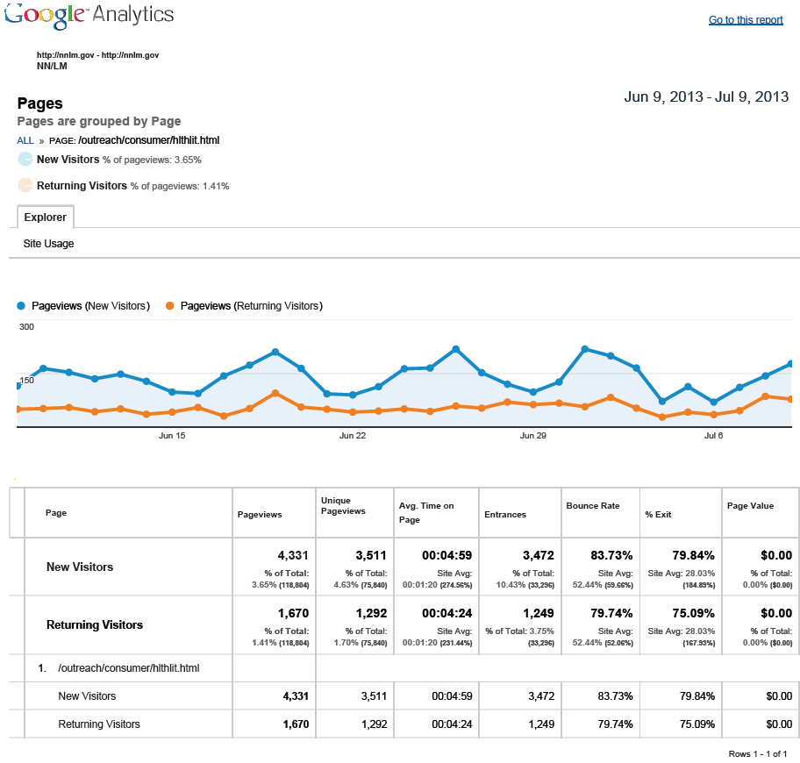

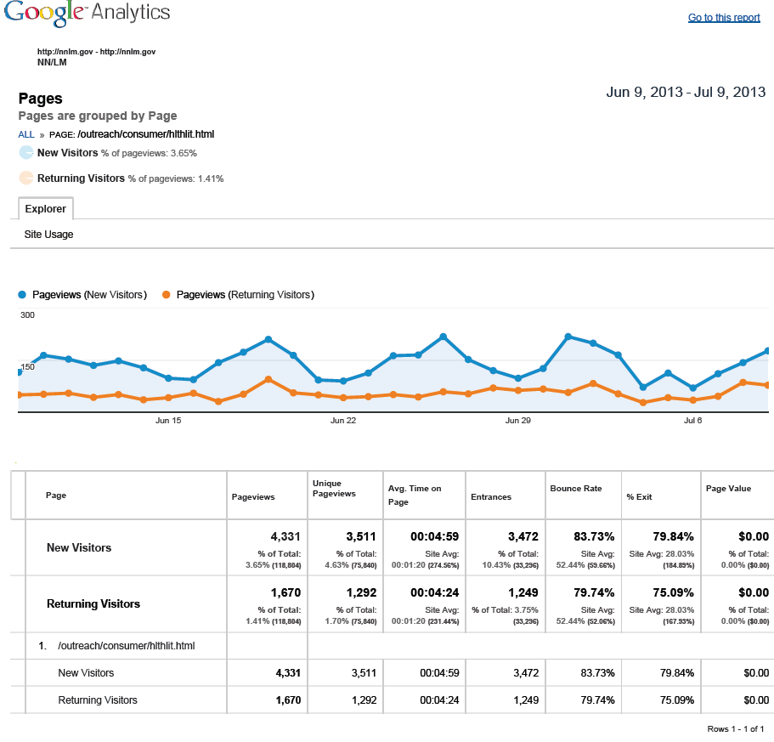

APPENDIX III: SURVEYMONKEY QUESTIONS FOR THE CONSUMER HEALTH COORDINATORS
- Please provide the name(s) of the course(s) you have taught or led during the past 12 months.

- Please provide the teaching formats you have used during the past 12 months. Please check all that apply.
☐In person
☐Webinar
☒Self-paced tutorial
☐Blended format (e.g. self-paced tutorial with face to face component)
☐Other- please specify

- During the past 12 months, what user groups have attended your courses? Please check all that apply.
☐Public librarians
☐Public health workers
☐Nurses
☐Paraprofessionals
☐Health ministers
☐Community agencies
☐General public
☐Other- please specify

- If you have referred specific users to the Health Literacy Web page during the past 12 months, please specify the user type.
☐Healthcare Provider
☐Consumer or members of the general public
☐Community Agency
☐Other- please specify
☐Not applicable

- How likely are you to use information that addresses how cultural differences impact health literacy?
☐Extremely likely
☐Likely
☐Neutral
☐Unlikely
☐Extremely unlikely

APPENDIX IV: SURVEYMONKEY QUESTIONNAIRE RESULTS

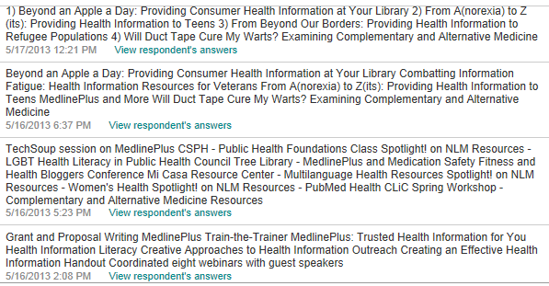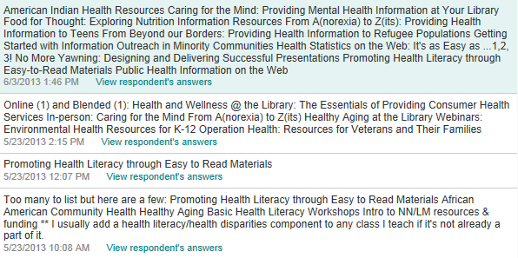
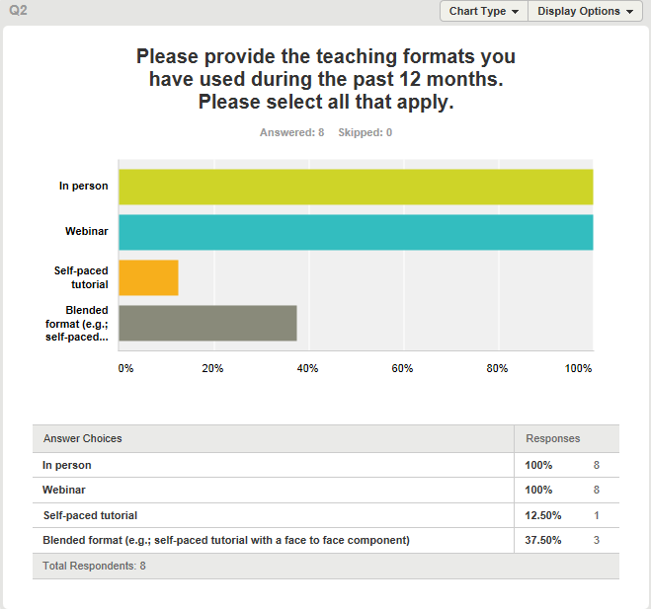
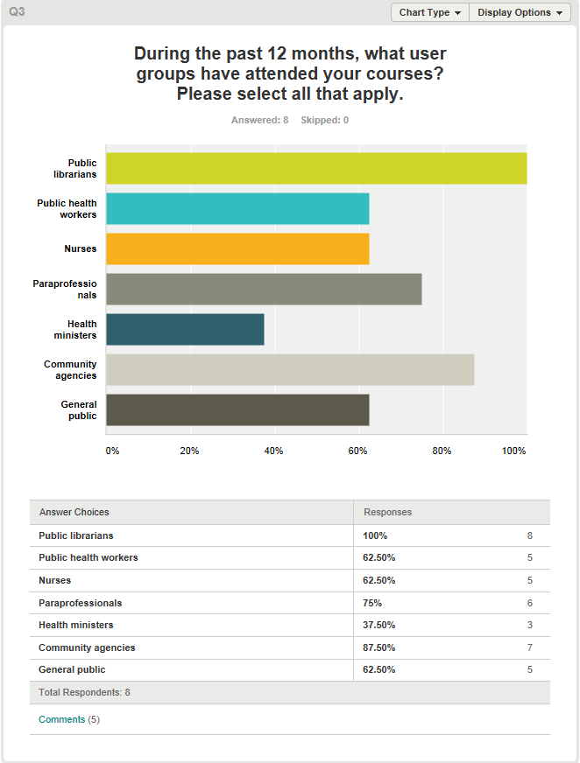
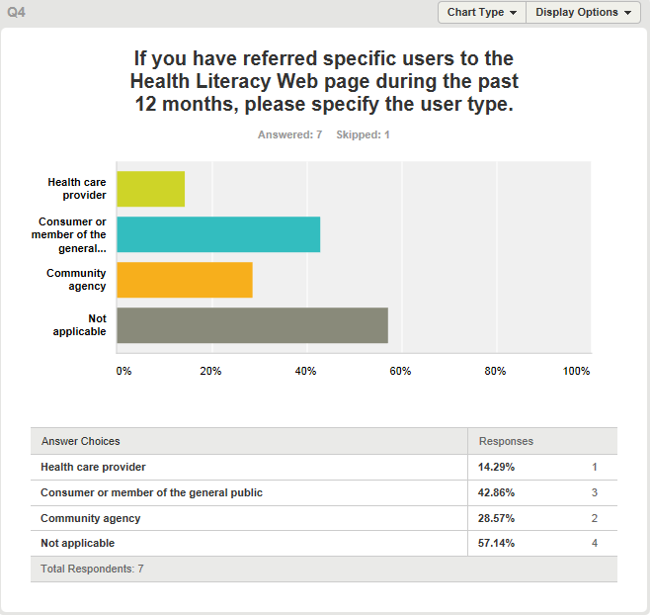
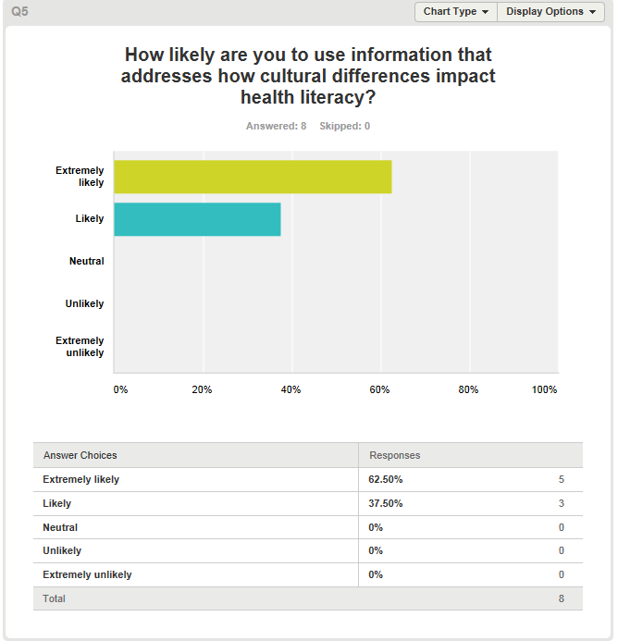

APPENDIX V: SOCIAL MEDIA PROMOTION MESSAGE
Hello All!
The National Network of Libraries of Medicine (NN/LM) is pleased to announce that through a National Library of Medicine (NLM) Associate Fellow project, it has added information about culture in the context of health literacy to its Health Literacy Web resource (http://nnlm.gov/outreach/consumer/hlthlit.html). Please join us in spreading the word to raise awareness about culture and health literacy by posting the following on your social media sites.
Post about the new content on your Facebook page! Copy and paste the following message in your status updates.
Learn about how and why culture impacts health literacy. Visit the National Network of Libraries of Medicine Health’s Health Literacy Web page for more information. http://nnlm.gov/outreach/consumer/hlthlit.html
The National Network of Libraries of Medicine adds content about culture and its impact on health literacy to its online resource at http://nnlm.gov/outreach/consumer/hlthlit.html. Learn why culture is an important aspect of health literacy.
Culture is one important aspect of health literacy. Learn how the library community can support the health literacy needs of consumers by providing quality, current, accurate and relevant health information to diverse populations. http://nnlm.gov/outreach/consumer/hlthlit.html
The National Network of Libraries of Medicine enhanced its Health Literacy Web page by adding information about culture in context to health literacy. Visit http://nnlm.gov/outreach/consumer/hlthlit.html to learn more.
Tweet about the new content! Copy and paste the following messages on Twitter.
How does #culture impact #healthliteracy? Find out from the newly enhanced #NNLM Health Literacy resource: http://nnlm.gov/outreach/consumer/hlthlit.html
Learn more about #healthliteracy in a #cultural context from the #NNLM Health Literacy resource: http://nnlm.gov/outreach/consumer/hlthlit.html
#NNLM adds information about #culture and #healthliteracy to its Health Literacy resource. Visit http://nnlm.gov/outreach/consumer/hlthlit.html for more.
Need information about health literacy? Visit http://nnlm.gov/outreach/consumer/hlthlit.html for information about how #culture impacts #healthliteracy.
Copy and paste one of the following blog posts on your blog.
National Library of Medicine Associate Fellow Raises Awareness About the Importance of Culture on Health Literacy.
Through a National Library of Medicine Associate Fellowship Project, 2013-2013 Associate Fellow Diana Almader-Douglas evaluated and enhanced the National Network of Libraries of Medicine’s (NN/LM) Health Literacy resource by adding content and resources related to culture in the context of health literacy.
By providing information about the relationship between culture and health literacy, the highly-utilized resource has the ability to impact a wider audience by encouraging the dissemination of culturally relevant health information by librarians and information professionals.
Through this project, I tried to raise awareness about vulnerable and special populations while highlighting the connection to health disparities and health literacy.
For more information about culture and health literacy, visit
Benjamin RM. Improving Health by Improving Health Literacy. Public Health Rep. 2010, Nov-Dec; 125(6):784-785. Available from: http://www.ncbi.nlm.nih.gov/pmc/articles/PMC2966655/pdf/phr125000784.pdf
United States Department of Health & Human Services. Health Resources and Services Administration (HSRA). Culture, Language and Health Literacy. Available from: http://www.hrsa.gov/culturalcompetence/index.html
United States Department of Health & Human Services. National Library of Medicine Specialized Information Services Outreach Activities & Resources. Multi-cultural Resources for Health Information. Available from: http://sis.nlm.nih.gov/outreach/multicultural.html
The National Network of Libraries of Medicine (NN/LM) adds information about culture to its Health Literacy resource.
The NN/LM has added content to its Health Literacy resource to include information about culture in the context of health literacy. As part of a project of the National Library of Medicine (NLM) Associate Fellowship Program, Diana Almader-Douglas evaluated the existing health literacy Web-based resource at the NN/LM and determined that the resource would benefit from addressing the importance of culture in understanding health literacy.
Culture is one component of health literacy, but it is also a critical element of the complex topic of health literacy. Culture shapes communication, beliefs, and the comprehension of health information. By enhancing the NN/LM Health Literacy Web page with content about health literacy in a cultural context, users of the page, and end users will be able to better meet the health information needs of vulnerable and diverse population groups they are serving.
By adding content related to culture and how culture impacts health, the resource raises increased awareness about vulnerable and special populations, and highlights the connection to health disparities and health literacy.
For more information on culture and health literacy, visit:
Benjamin RM. Improving Health by Improving Health Literacy. Public Health Rep. 2010, Nov-Dec; 125(6):784-785. Available from: http://www.ncbi.nlm.nih.gov/pmc/articles/PMC2966655/pdf/phr125000784.pdf
United States Department of Health & Human Services. Health Resources and Services Administration (HSRA). Culture, Language and Health Literacy. Available from: http://www.hrsa.gov/culturalcompetence/index.html
United States Department of Health & Human Services. National Library of Medicine Specialized Information Services Outreach Activities & Resources. Multi-cultural Resources for Health Information. Available from: http://sis.nlm.nih.gov/outreach/multicultural.html

APPENDIX VI: DISCUSSIONS & QUESTIONNAIRE
Discussion with Marcia Zorn: February 20, 2013 and April 23, 2013
I met with Marcia Zorn in NLM Reference and Web Services Section to discuss the origin of the definition of Health Literacy, and about her role in creating the MEDLINE/PubMed health literacy search Special Query page http://www.nlm.nih.gov/services/queries/health_literacy.html, which provides 25 health literacy resources. Marcia, whose special interest is in health communication, mentioned that the IOM and the Committee on Health Literacy has published report as an excellent resource. In an email following up this conversation, Marcia stressed the need for consumer health librarians to understand the cultures of their patrons. Marcia also acknowledged that culture is one of several critical components of health literacy.
Consumer Health Coordinator Telemeeting: March 12, 2013
- What do you like about the resource? A respondent stated that she liked that the resource is a “one stop shop” and that it appears that it is the first place people go on the Web when looking for health literacy information.

- If you could, what would you change about the resource? Comments included improving the long pages of text and heavy dense working. Other comments included needing examples and ‘how to’ tips for improving communication. Suggestions included adding a question and answer section, and adding a section on consumer/patient engagement.

- Are you reaching all the populations that you want to reach? Respondents indicated that the intended population is not the consumer, and one respondent expressed that addressing other languages, cultural competence, and English as a second language might muddy the resource. Respondents indicated that they believe they are reaching the public, public librarians, public health workers, nurses, paraprofessionals, health ministers, and community agencies.

- What do you know about the people who access the Web page? Someone reported that the resource is “number 22 on the top hit NN/LM Web pages” and someone commented that there is “high access” of the resource every month”.

- What kind of feedback have you received? Respondents stated that feedback received has been positive; no suggestions for improvement or constructive criticism have been received.
Telephone Discussion with Cindy Olney: March 19, 2013
I facilitated a telephone conversation with Cindy Olney, the Evaluation Specialist at the NN/LM Outreach Evaluation Resource Center (OERC). I provided a brief background of the project and provided her with what was already known about the Health Literacy Web page, such as users, and Google Analytics use statistics. I also informed Ms. Olney about the comments and answer to questions that the Consumer Health Coordinators provided during the telemeeting on March 12, 2013. Ms. Olney suggested finding out where the resource is being promoted, and suggested that I approach the project as a redesign of the Web page based on the CHCs’ input, and usability of the resource. Ms. Olney also suggested having health literacy specialists look at the resource for their opinions, and to identify trends that perhaps the resource does not include. She made suggestions for using Libguides as a formatting tool for a visual redesign, if that is the direction of the project. She encouraged me to find out more about the history of the resource, the current use of the resource, and its primary users before taking the next step.
Historical Interview with Michelle Eberle: April 11, 2013
Michelle Eberle, Consumer Health Coordinator in the New England Region (8) was present when the Health Literacy resource was developed in about 2007. Ms. Eberle reported that Penny Glassman, the former Technology Coordinator for the New England Region, was a Masters level student at the time that Karen Vargas was tasked with developing an online consumer health manual. At the time, health literacy was a hot topic and Ms. Glassman had written a paper that contained up to date information. With her permission, the content of her paper was uploaded as the health literacy ‘chapter’ of the Consumer Health Manual. Since its creation, the Web page has undergone updates, and link checks to keep it current up to date. Ms. Eberle stated that the resource was not intended to be a resource for the public, but rather was created for Consumer Health librarians. Ms. Eberle stated that she would like to know it is so highly utilized to create other resources that receive the same high use. I asked if she was aware of any emerging trends in health literacy; Ms. Eberle stated that Pew conducted a study that revealed emerging trends of health tracking, e-records, and the e-patient. She mentioned that communication is a current trend. She suggested that a change in design would allow for ‘better’ flow of the content in the resource.
Telephone Discussion with Michael Boer (WebSTOC): April 12, 2013
I arranged for a telephone discussion with Michael Boer from WebSTOC, to find out how to gauge user behavior on the Health Literacy Web page. Mr. Boer educated showed me how to read Google Analytic metrics to make inferences about the resource. He provided information on the significance of new versus returning Web page visitors, the difference between bounce rate and exit rate. Mr. Boer indicated that there is much meaningful data in the report; he stated that the fact that the Web page is first place in the Google Search engine, without paid ads or promotion tells us that the Web page is highly used. He stated that the fact that the length of stay on the page averages over five minutes, is also meaningful in that length of stay on Web pages is generally very short. Mr. Boer forwarded the reports so that I could have visual data to support the statistics. Mr. Boer stated that the Web page tends to be viewed more immediately after an external event such as a mention in an article, blog post, or tweet.
Historical Interview with Penny Glassman: April 18, 2013
I called the creator of the Health Literacy Web page, Ms. Glassman. Ms. Glassman is no longer with the Regional Medical Library (RML), but gave her permission for me to add text on ‘culture’ and its relationship to health literacy.

APPENDIX VII: JING VIDEO
http://www.screencast.com/users/dalmader/folders/Default/media/e782071b-184f-4e24-9296-28d0e08d2cf3

