A Community Engagement Toolkit for NLM and NNLM
Allison Cruise, Associate Fellow 2020-2022
July 2021
Project Sponsors: George Franklin, Blair Anton, Martha Meacham

Contents
Abstract 3
Objective 3
Methods 3
Results 3
Conclusions 3
Introduction 4
Background 4
Objective 4
Procedures 4
Defining Community Engagement 4
Development of Principles 5
Interviews 5
Creation of Toolkit 6
Outcomes 6
Interviews 6
A Community Engagement Toolkit for NLM and NNLM 7
Discussion 7
Personal Impact 8
Recommendations 9
Acknowledgements 9
Works Cited 10
Appendix A: Final Principles Document 11
Appendix B: Interview Questions 19
Appendix C: Final Toolkit 20
Introduction 21
Purpose 21
What is Community Engagement? 21
How to Use this Toolkit 22
Principles and Strategies for Community Engagement 23
Trust 23
Strategies for Trust 23
Flexibility 24
Strategies for Flexibility 24
Respect 25
Strategy for Respect 25
Intentionality 26
Strategies for Intentionality 26
Empowerment 26
What to Do Next/Where to Learn More/Other Things to Consider 27
Acknowledgements 27

Abstract

Objective
The goal of this project was to provide a resource to help NLM and NNLM stakeholders with their community engagement activities. The ultimate result of this project was the creation of a toolkit which aimed to define community and community engagement within the context of the project itself and establish a set of principles of community engagement. These principles were paired with strategies to form an actionable resource for community engagement practice at any level.

Methods
The project began with defining community and community engagement through collaboration in a shared document. Principles of community engagement were then researched, discussed, and refined through several stages. A set of interview questions was created, and stakeholders from NIH ICs, NLM, and NNLM were interviewed. Feedback on the principles was also solicited from these stakeholders. Through these data collection methods, a toolkit was established which paired the principles, refined through collaboration and feedback, with actionable strategies for community engagement practitioners to employ.

Results
The final product of this project is an organized toolkit document featuring five principles of community engagement. Four of these principles are paired with strategies to help toolkit users plan and prepare intentional engagement activities in line with the vision of community engagement defined within the toolkit. Additional resources are provided for users who wish to learn more about community engagement.

Conclusions
This project represents a collaborative process informed by stakeholders across NIH, NLM and NNLM. Through collectively defining community and community engagement, the project was able to establish a set of informed, interrelated principles which can help guide community engagement in a variety of settings. The inclusion of strategies, paired with these principles, provides an introductory foundation to community engagement.

Introduction

Background
The second goal of NLM’s Strategic Plan is “Reach more people in more ways through enhanced dissemination and engagement” (“A Platform”). One of NLM’s Office of Engagement and Training’s major goals is Community Engagement (“NLM Office”). OET also coordinates the Network of the National Library of Medicine (NNLM), which works to “advance the progress of medicine and improve public health by providing U.S. health professionals with equal access to biomedical information and improving individuals' access to information to enable them to make informed decisions about their health” (“About”). To that end, NNLM funds many outreach and engagement projects, provides training opportunities for librarians, educators and health professionals, offers free health information resources and conducts engagement projects like All of Us.

Objective
With these goals and commitments in mind, OET developed a project proposal which was submitted for possible selection by the NLM Associate Fellows. The original project proposal stated the need for an exploration of what NLM and NNLM stakeholders believe successful community engagement to be, in preparation for an expansion of the role of NLM and NNLM exhibitors to include engaging with community at each exhibit. The goal of the project was a resource of some kind to assist NLM and NNLM stakeholders with community engagement.
After an initial meeting about the project goals, the project sponsors and Associate Fellow Allison Cruise developed a phase approach for meeting the goals of the project, which were determined to be: defining community engagement and exploring current engagement practices at NIH and beyond, developing principles of community engagement based on that exploration, interviewing stakeholders at NIH, NLM, and NNLM, presenting principles for feedback, and utilizing all information collected to develop a community engagement toolkit.

Procedures

Defining Community Engagement
The process of defining community engagement for the purposes of this project was a collaborative one. George Franklin, Blair Anton and Allison Cruise worked together in a shared document, providing ideas, resources, and commenting on one another’s findings. The final document, a freeform place to share thoughts and notes, was 16 pages long and included definitions for community and community engagement, engagement strategies and resources, background information about engagement at NLM and NLM engagement and outreach goals, and a list of NLM divisions and NIH Institutes and Centers with outreach or engagement programs.
The goal of the document was to think critically about how community and community engagement should be defined for NLM and NNLM purposes, and for the purposes of the project. Through the collection of data on defining community and community engagement, which included definitions from multiple outside resources, a list of principles could be developed which would inform the final toolkit for the project. Essentially, as the goal was a toolkit for community engagement, it was necessary to define the meaning of community engagement within the project’s context. The results of the definition can be seen in the toolkit section titled What is Community Engagement? (Appendix C). The research stage also provided many of the resources listed in the toolkit.

Development of Principles
Taking the information pooled in the shared document, the next step of the project was to begin brainstorming a set of principles of community engagement. This was done to organize and consolidate the most important ideas around the topic of community engagement for the project and begin thinking about how the principles could be applied by NLM and NNLM stakeholders for successfully engaging.
The first draft of the identified principles of community engagement was a long document wherein Allison made attempts to summarize all the most important ideas collected in the collaborative document. After feedback on the first draft, a second version was created which was more concise than the previous version. The principles were also labelled for easier understanding.
The third draft demonstrated an important turning point. In this version there were both principles and strategies. This organization of principles with corresponding related strategies to apply to help realize those principles would be carried forward throughout the project and inform the organization of the final toolkit itself.
It was agreed that this third draft could be used moving forward to the interview stage of the project, and it was this draft which was presented to each of the stakeholders, whose comments and feedback led to the final version of the principles document, available in Appendix A. This was used to assist with the creation of the toolkit.
Throughout the revision process, Allison worked alongside OET to make the principles more concise and appropriate. The ongoing conversations among team members through brief meetings and emails helped Allison to discover what principles would be useful and appropriate for this project. These steps were, in many ways, a way to organize a large amount of information on broad topics into a concise, specified, and usable series of principles and strategies.

Interviews
A total of eleven interviews were conducted in support of this project. Interviewees were identified with help from George Franklin and Martha Meacham. These interviewees represented three different divisions within NNLM and three other NIH institutions. Five NNLM members were interviewed as well. The interviewee names and institutions can be found in the Acknowledgements section of this paper.
A standard set of questions was asked in each of these interviews. The questions are available in Appendix B.
The interviews were conducted over a four-week period, and typically lasted one hour. All interviews were conducted online via the Zoom platform due to COVID-19. During these interviews, brief notes were taken on the answers to the standard questions, follow up questions were asked when appropriate, and if time allowed, the principles document was shared so feedback could be collected.
The results of these interviews were summarized, anonymized, and shared with the OET team in a short document. Feedback to the principles was incorporated into the final version of the principles document.

Creation of Toolkit
Following completion of the stakeholder interviews and incorporation of feedback into the principles, the first draft of the toolkit was created. The first shared definitions document and its resources, the interviews, and the overall collaborative process with OET throughout the project culminated in the first draft.
The first draft of the toolkit was submitted to OET for feedback and revised. Few revisions were identified, and the final toolkit was prepared and provided to the project sponsors, as well as all of the interviewees who participated in the project. The final toolkit is available in Appendix C.

Outcomes

Interviews
Conducting interviews for this project provided an opportunity to hear honest feedback from experts working in a broad range of engagement-related activities. This was valuable not only from the perspective of toolkit creation. The interviews helped to broaden the definition of community to include not only the public, the original viewpoint Allison had when beginning this project, but to include the audience for NIH, NLM and NNLM, which includes healthcare workers, educators, scientists, and researchers. This community of people who work with the public more directly is diverse and crucial to the missions of the NIH and NLM.
These interviews also provided important feedback about what community engagement is, its importance to different NIH ICs and NLM divisions, and the many forms engagement and outreach can take. Engaging in these conversations uncovered challenges, questions, and concerns the interviewees had about their own engagement efforts. Some of the major challenges included working in a virtual environment, time constraints, and developing social skills to help when engaging with new audiences. While the toolkit does not address these challenges directly, the principles and strategies therein can be utilized as a starting place to ease these difficulties faced when practicing outreach and engagement.

A Community Engagement Toolkit for NLM and NNLM
The toolkit begins with an introduction to the project and a purpose statement to help make sense of the document. The definition of community engagement, as determined for the purposes of the toolkit, is provided. A brief description of how to use the toolkit is supplied, explaining that the toolkit is split into the six identified principles, with corresponding strategies identified beneath each principle to help with realization of engagement goals.
The principles identified for the toolkit are:
- Trust
- Flexibility
- Respect
- Intentionality
- Empowerment
Each principle is followed by bulleted explanations of what is meant by that principle and why it is important to engagement. All the principles except engagement have at least one strategy attached. Empowerment does not have any strategies, as the toolkit posits it cannot be simply brought about but can come to be on its own if conditions are right.
Each strategy includes its own definition or explanation of what the strategy entails, some questions to consider when implementing the strategy, and a short list of potential tools to use for the strategy. Resources and examples are also provided when appropriate. These resources were discovered through research, provided by interviewees, or recommended by trusted stakeholders.
The toolkit concludes with some resources and thoughts on what to do next to continue the community engagement journey, and acknowledgements.
The Community Engagement Toolkit for NLM and NNLM, brought about by the processes described above, represents a collection of principles to be considered, which are paired with strategies that NLM, NNLM, and other stakeholders can utilize to bring those principles to fruition. While the final document may look different than other available engagement toolkits available, it details some of the most important values to consider as identified by all of the included collaborators. Through the summarization of these values and inclusion of related strategies, the toolkit aims to help those interested in community engagement consider new opportunities and approach them with intention and knowledge.

Discussion
This project was a chance for the Associate Fellow to work collaboratively and engage in conversations with many stakeholders, learning about community engagement across NIH ICs, NLM divisions and NNLM regions. The project also gave Allison the opportunity to work independently, with freedom to develop a resource based on her own research and interpretation of the data collected throughout the project phases.
This project represents an in-depth, critical analysis of the meaning of successful community engagement. While this study of community engagement will need real world application to determine its true efficacy in outreach, the Associate Fellow has gained a deep, meaningful understanding of the values, challenges, successes, and failures, which can all be a part of the engagement experience. As Allison moves forward on her library career she intends to continue to grow her skills in outreach and engagement, and has learned of many resources, organizations, individuals, and ideas, to help with this journey.
Working collaboratively on a shared document in a solely virtual space was an unexpectedly effective method for defining concepts as broad and difficult as community and community engagement. Through this collaboration, and the interviews, finding consensus on the meaning of community, community engagement, and community engagement’s most important principles, was an affirming and practical process.
One of the most difficult aspects of this project was aligning the meaning and process of community engagement work within different spheres. The included NIH ICs, NLM divisions, and NNLM stakeholders, worked with different communities, at different levels, and in different ways. Many of the interviewees worked with communities of researchers, educators, and community partners who then themselves worked with the public community at large. Through the interview process and refinement of the principles, Allison found that the potential disconnect between these levels of community work did not significantly impact the development of the toolkit. In other words, the interviewed stakeholders agreed that the principles and strategies in the toolkit were broad enough to apply to their own work, but specific enough to assist with community engagement work at their own stakeholders’ level.

Personal Impact
The interview experience was also enlightening, and the results of the interviews provided new, inspiring ideas which influenced the toolkit and which will be carried forward by the Associate Fellow in her future work.
The goal of this project was to create a resource to help NLM and NNLM stakeholders get started with engagement projects and give them some helpful resources to use along the way. The development of the principles and strategies was an eye-opening experience of personal growth for the Associate Fellow. The principles of trust, respect, and empowerment have especially been important and have already proven useful for other projects and plans Allison has made.
As outreach and engagement are of particular importance to Allison, this intentional, thoughtful approach to defining community and community engagement has led to ongoing reflection of the values of community engagement, what these mean to the Associate, and how Allison can implement these strategies in her own engagement efforts, as well as share these principles and strategies with others.

Recommendations
As the goal of the toolkit is to help NLM and NNLM stakeholders, it is hoped that the toolkit can be utilized by NLM and NNLM, developed further, or integrated into another resource which will allow it to reach a broad audience.
Because communities and community engagement are always growing and changing, new resources and ideas for best practices may come up frequently. It is hoped that the toolkit can be regularly updated with the most recent and relevant information for its target audience if it is adopted.
Incorporating success stories, cautionary tales, and examples of past or current work from the users of the toolkit could enhance the content for future stakeholders. Adding pictures, videos, posters, and other media could improve the toolkit and increase impact as well.
There is no one-size-fits-all approach to community engagement, and no single toolkit can provide all the information needed to have a successful engagement project. The goal of this project was to give NLM and NNLM stakeholders interested in communities and community engagement a starting place. As they have their own experiences in outreach and engagement, they may feel inspired to make their own toolkits, webpages, webinars, or other resources. This toolkit, and this project as a whole, is an example of just one such project.

Acknowledgements
Thank you to the project sponsors, George Franklin, Blair Anton, and Martha Meacham for their guidance and collaboration throughout the project process.
Thank you to the following contributors for their time, attention, and feedback:
Olivier Bodenreider, Senior Scientist, Acting Director LHNCBC, Acting Chief, Computational Health Research Branch, LHNCBC
Julie Botnick, Technical Information Specialist, Exhibition Program, NLM
Wilson Compton, Deputy Director, NIDA
Yamila El-Khayat, Outreach Services Librarian, University of Arizona Health Sciences Library
Sharon Han, Engagement Specialist, NNLM All of Us Community Engagement Center, University of Iowa, Hardin Library for the Health Sciences
Darlene Kaskie, Community Engagement Coordinator, NNLM, University of Iowa
Margot Malachowski, Education and Outreach Coordinator, NNLM, University of MA Medical School
Rana Morris, Staff Scientist, NCBI
Tony Nguyen, Executive Director, NNLM, University of Maryland, Baltimore, Health Sciences and Human Services Library

Works Cited
“A Platform for Biomedical Discovery and Data-Powered Health.” National Library of Medicine, www.nlm.nih.gov/pubs/plan/lrp17/NLM_StrategicReport2017_2027.pdf.
“About the Network of the National Library of Medicine.” NNLM, National Library of Medicine, nnlm.gov/about/about-nnlm.
“NLM Office of Engagement and Training.” U.S. National Library of Medicine, National Institutes of Health, www.nlm.nih.gov/oet/index.html#Engagement.

Appendix A: Final Principles Document
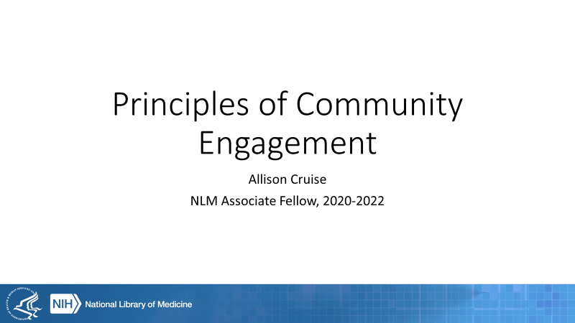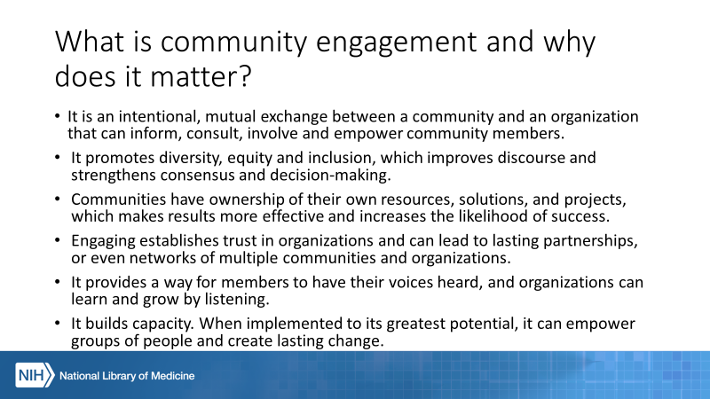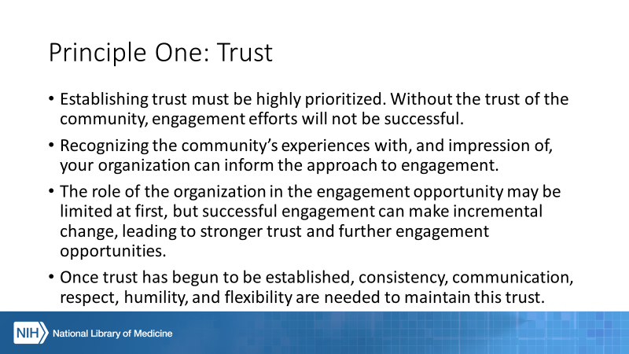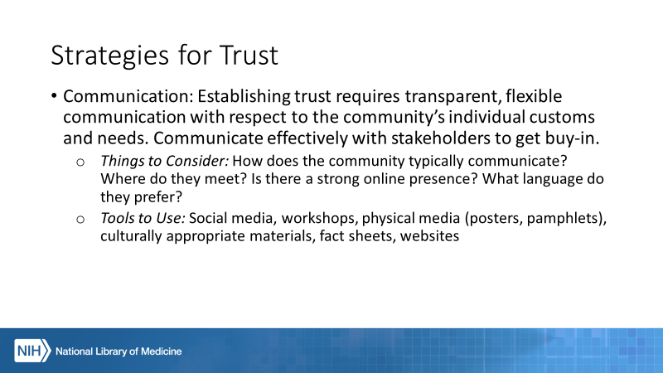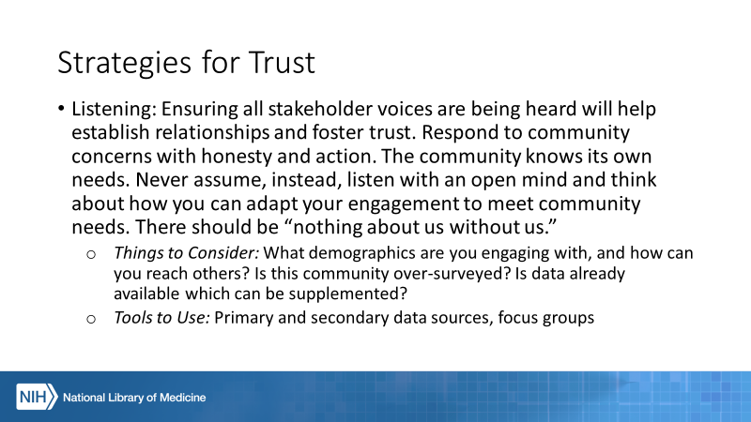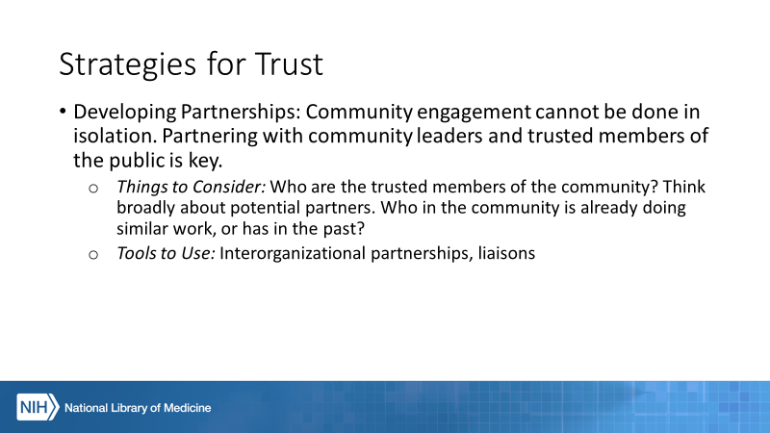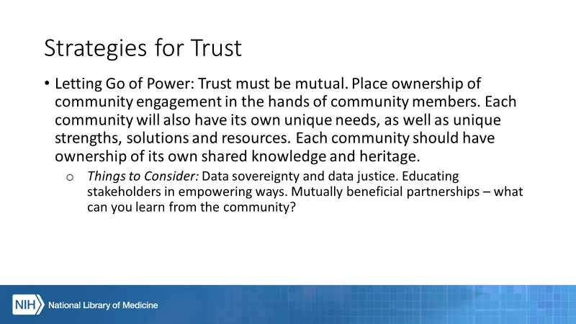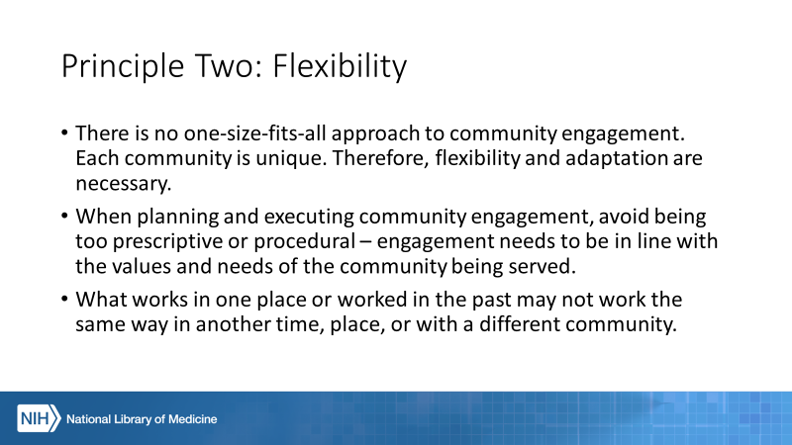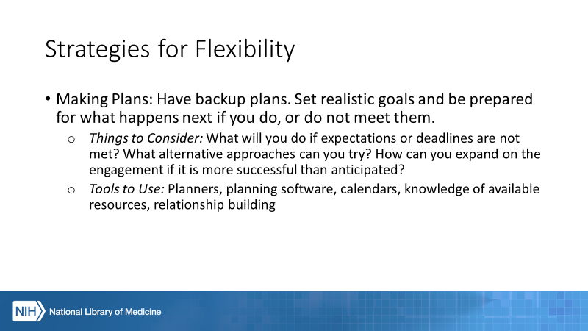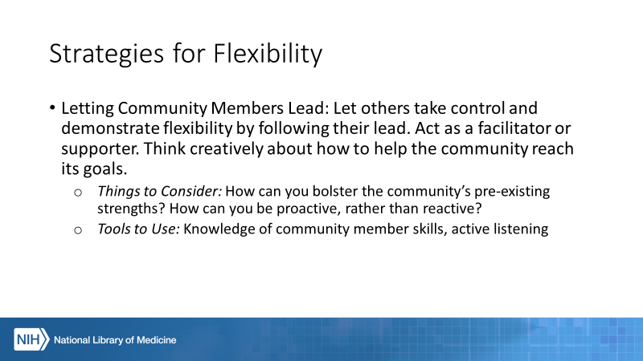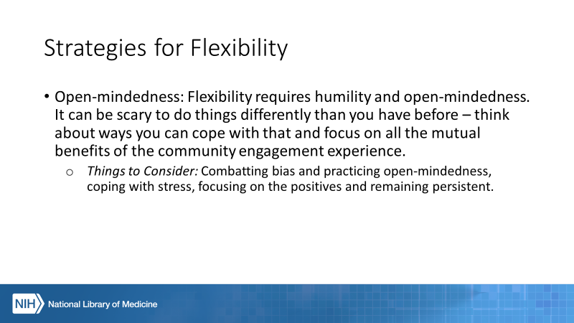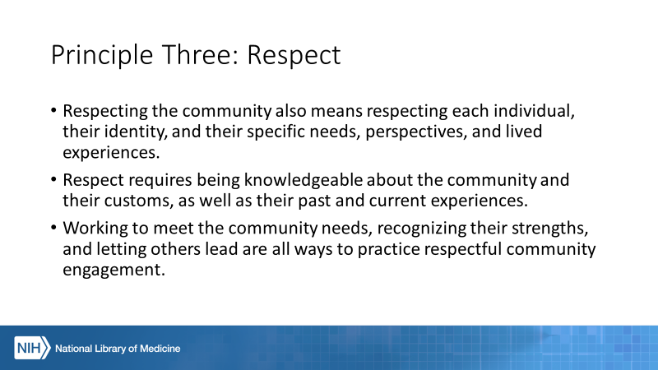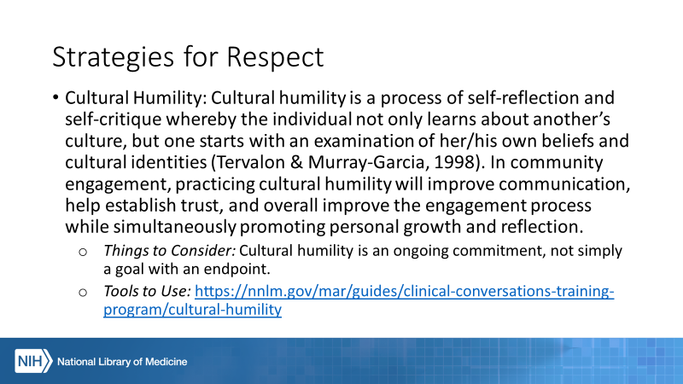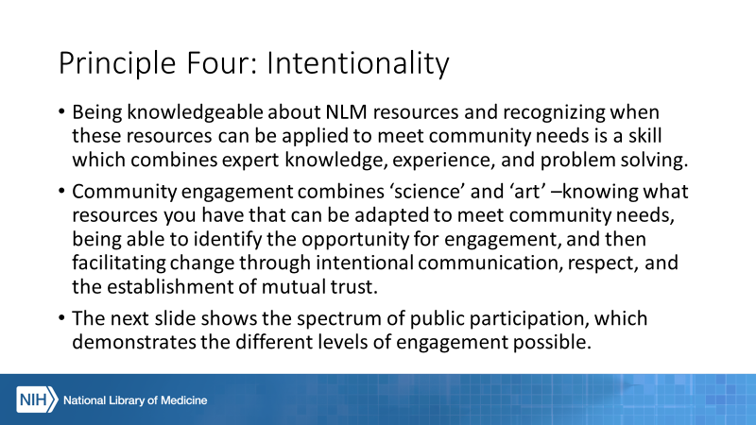To obta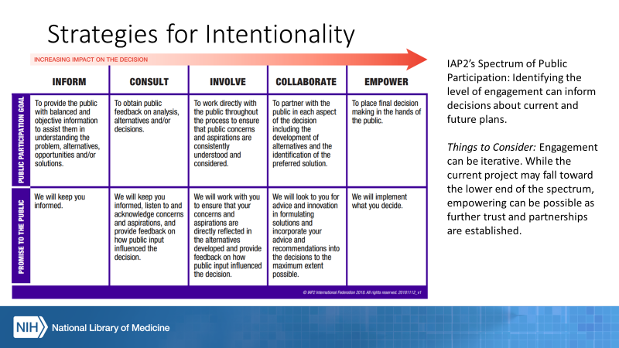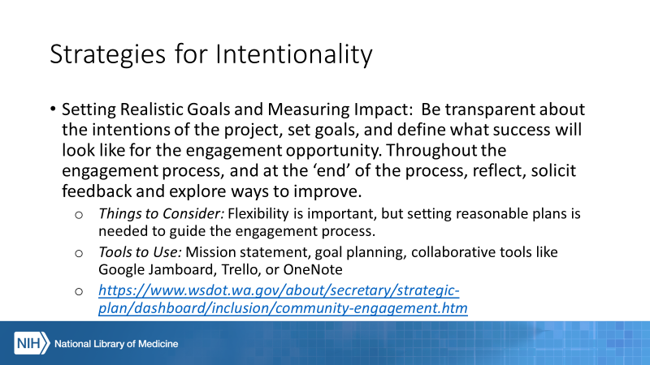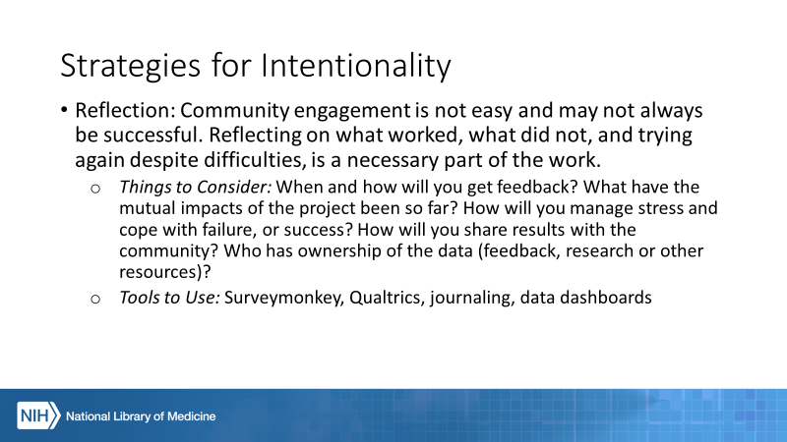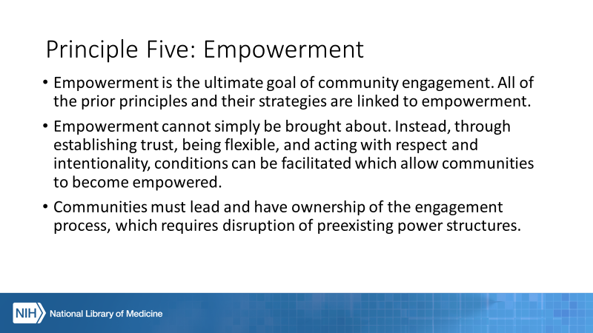

Appendix B: Interview Questions
Q1: What does “community” mean to your organization/division/team?
Q2: What does “community engagement” mean to your organization/division/team?
Q3: What does “successful community engagement” look like for your group? What is your group’s mission when it comes to CE?
Q4: What do you think your group does best when it comes to CE? Where is there room for improvement?
Q5: Do you provide any training for employees involved in CE?
Q6: What does your group look for in CE?
Q7: How does your group encourage diversity, equity, and inclusivity in your engagement activities?
Q8: Is CE limited to the products or materials within your organization?
Q9: What are some of the biggest challenges you face when doing community engagement?
Q10: What feedback do you have for the principles?

Appendix C: Final Toolkit

A Community Engagement Toolkit for NLM and NNLM
Allison Cruise, Associate Fellow 2020-2022
George Franklin, Blair Anton and Martha Meacham
With thanks to interviewees

Contents
Introduction 2
Purpose 2
What is Community Engagement? 2
How to Use this Toolkit 3
Principles and Strategies for Community Engagement 3
Trust 4
Strategies for Trust 4
Flexibility 5
Strategies for Flexibility 5
Respect 6
Strategy for Respect 6
Intentionality 7
Empowerment 7
What to Do Next/Where to Learn More/Other Things to Consider 7
Conclusion/Acknowledgements/References 7

Introduction
This toolkit was designed in response to a project submitted by the Office of Engagement and Training for consideration by the Associate Fellowship Program participants. Allison Cruise, 2020-2022 Associate Fellow, collaborated with OET to create this toolkit.
The original project proposal was to create a resource to facilitate community engagement efforts by NLM and NNLM.

Purpose
Communities are diverse and dynamic. No single resource can inform engagement for all communities across time and space. The purpose of this toolkit is to assist those starting engagement projects with recognizing opportunities where organizational resources and expertise potentially align with community needs and goals, and with beginning the engagement process in an informed, intentional way.
While there is no one-size-fits-all approach to community engagement, we hope this toolkit sparks ideas and inspires confidence for community engagement stakeholders with any level of experience.

What is Community Engagement?
There are many ways to define community and community engagement.
The NIH utilizes the CDC’s definition as follows: “...The process of working collaboratively with and through groups of people affiliated by geographic proximity, special interest, or similar situations to address issues affecting the well-being of those people. It is a powerful vehicle for bringing about environmental and behavioral changes that will improve the health of the community and its members. It often involves partnerships and coalitions that help mobilize resources and influence systems, change relationships among partners, and serve as catalysts for changing policies, programs, and practices (CDC, 1997, p. 9). Community engagement can take many forms, and partners can include organized groups, agencies, institutions, or individuals. Collaborators may be engaged in health promotion, research, or policy making.” Source: https://www.nih.gov/health-information/nih-clinical-research-trials-you/community-engagement
For the purposes of this toolkit, community engagement includes, but is not limited to, the following ideas:
- It is an intentional, mutual exchange between a community and an organization that can inform, consult, involve and empower community members.
- It promotes diversity, equity and inclusion, which improves discourse and strengthens consensus and decision-making.
- It recognizes that communities should have ownership of their own resources, solutions, and projects, which makes results more effective and increases the likelihood of success.
- It recognizes that engaging establishes trust in organizations and can lead to lasting partnerships and networks of multiple communities and organizations.
- It provides a way for members to have their voices heard, and for organizations to learn and grow by listening.
- It builds capacity. When implemented to its greatest potential, it can empower groups of people and create lasting change.
The first step of community engagement is to define the community with which you hope to engage. For NLM and NNLM, this community can include healthcare workers, scientists and researchers, members of the public, teachers, librarians and more. Communities can exist in physical and virtual spaces. They can include people linked by location, interest, beliefs, or common goals. They are not static or passive. Understanding the community you serve, and the communities you could serve, is vital to beginning the engagement process.

How to Use this Toolkit
This toolkit was designed with the goal to be flexible, allowing users to apply the principles and resources to a variety of communities and community needs.
The toolkit is divided into six principles which have been identified with help from OET and NIH, NLM and NNLM stakeholders. Beneath each principle are explanations for why it is important to community engagement, and strategies and resources to help bring the principle into practice. The principles are not hierarchical or independent of one another, instead they are interrelated concepts which overlap and support one another.
Feedback, suggestions, and questions about this toolkit are welcome

Principles and Strategies for Community Engagement

Trust
- Establishing trust must be highly prioritized. Without the trust of the community, engagement efforts will not be successful.
- Recognizing the community’s experiences with, and impression of, your organization can inform the approach to engagement. What level of trust might the community have for your organization now?
- The role of the organization in the engagement opportunity may be limited at first, but successful engagement can make incremental change, leading to stronger trust and further engagement opportunities. A successful introduction between your organization and the community is an example of a successful engagement which can be fostered into a deeper partnership in the future.
- Once trust has begun to be established, consistency, communication, respect, humility, and flexibility are needed to maintain this trust.

Strategies for Trust
- Communication: Establishing trust requires transparent, flexible communication with respect to the community’s individual customs and needs. Communicate effectively with stakeholders to get buy-in.
  - Things to Consider: How does the community typically communicate? Where do they meet? Is there a strong online presence? What language do they prefer?
  - Tools to Use: Social media, workshops and webinars, physical media (posters, pamphlets), culturally appropriate materials, fact sheets, websites
  - Resources for Communication:
    - Accessibility Resource Wiki from the Accessibility Subreddit at Reddit.com
    - Coursera Courses to Improve Communication Skills
    - Implementing Social Marketing from University of Kansas Community Tool Box
  - Examples:
    - Brother, You’re on My Mind
- Listening: Ensuring all stakeholder voices are being heard will help establish relationships and foster trust. Respond to community concerns with honesty and action. The community knows its own needs. Never assume. Instead, listen with an open mind and think about how you can adapt your engagement to meet community needs. There should be “nothing about us without us.”
- Things to Consider: What demographics are you engaging with, and how can you reach others? Is this community over-surveyed? Is data already available which can be supplemented? What resources and expertise do you have which could be helpful to the community? What expertise and skills exist in the community already? What projects have already been done?
- Tools to Use: Primary and secondary data sources, focus groups
- Resources for Listening:
    - Community Guide to Advance Health Information Equity
    - Toolkits from the Asset-Based Community Development Institute

- Developing Partnerships: Community engagement cannot be done in isolation. Partnering with community leaders and trusted members of the public is key.
  - Things to Consider: Who are the trusted members of the community? Think broadly about potential partners. Who in the community is already doing similar work, or has in the past?
  - Tools to Use: Interorganizational partnerships, liaisons
  - Resources for Developing Partnerships: Creating and Maintaining Coalitions and Partnerships from University of Kansas Community Tool Box
  - Examples:
    - Tribal Leaders' Public Health Symposium
- Letting Go of Power: Trust must be mutual. Place ownership of community engagement in the hands of community members. Each community will also have its own unique needs, as well as unique strengths, solutions, and resources. Each community should have ownership of its own shared knowledge and heritage.
  - Things to Consider: Data sovereignty and data justice. Educating stakeholders in empowering ways. Mutually beneficial partnerships – what can you learn from the community?
  - Resources:
    - Coalition of Communities of Color
    - United States Indigenous Data Sovereignty Network
    - Decolonizing Methodologies – Research and Indigenous Peoples by Linda Tuhiwai Smith

Flexibility
- There is no one-size-fits-all approach to community engagement. Each community is unique. Therefore, flexibility and adaptation are necessary.
- When planning and executing community engagement, avoid being too prescriptive or procedural – engagement needs to be in line with the values and needs of the community being served.
- What works in one place or worked in the past may not work the same way in another time, place, or with a different community.

Strategies for Flexibility
- Making Plans: Have backup plans. Set realistic goals and be prepared for what happens next if you do, or do not meet them.
  - Things to Consider: What will you do if expectations or deadlines are not met? What alternative approaches can you try? How can you expand on the engagement if it is more successful than anticipated?
  - Tools to Use: Planners, planning software, calendars, knowledge of available resources, relationship building
  - Resources for Making Plans:
    - Choose Effective Policies and Programs from the CDC Community Health Improvement Navigator
- Letting Community Members Lead: Let others take control and demonstrate flexibility by following their lead. Act as a facilitator or supporter. Think creatively about how to help the community reach its goals.
  - Things to Consider: How can you bolster the community’s pre-existing strengths? How can you be proactive, rather than reactive?
  - Tools to Use: Knowledge of community member skills, active listening
- Open-mindedness: Flexibility requires humility and open-mindedness. It can be scary to do things differently than you have before – think about ways you can cope with that and focus on all the mutual benefits of the community engagement experience.
  - Things to Consider: Combatting bias and practicing open-mindedness, coping with stress, focusing on the positives and remaining persistent.
  - Resources for Open-mindedness:
    - Project Implicit Bias Testing

Respect
- Respecting the community also means respecting each individual, their identity, and their specific needs, perspectives, and lived experiences.
- Respect requires being knowledgeable about the community and their customs, as well as their past and current experiences.
- Working to meet the community needs, recognizing their strengths, and letting others lead are all ways to practice respectful community engagement.

Strategy for Respect
- Cultural Humility: Cultural humility is a process of self-reflection and self-critique whereby the individual not only learns about another’s culture, but one starts with an examination of her/his own beliefs and cultural identities (Tervalon & Murray-Garcia, 1998). In community engagement, practicing cultural humility will improve communication, help establish trust, and overall improve the engagement process while simultaneously promoting personal growth and reflection.
  - Things to Consider: Cultural humility is an ongoing commitment, not simply a goal with an endpoint.
  - Resources for Cultural Humility:
    - Project READY Module 8: Cultural Competence & Cultural Humility
    - Cultural Competency/Humility Courses (Colorado School of Public Health)

Intentionality
- Being knowledgeable about NLM resources and recognizing when these resources can be applied to meet community needs is a skill which combines expert knowledge, experience, and problem solving.
- Community engagement combines ‘science’ and ‘art’ –knowing what resources you have that can be adapted to meet community needs, being able to identify the opportunity for engagement, and then facilitating change through intentional communication, respect, and the establishment of mutual trust.

Strategies for Intentionality
- Setting Realistic Goals and Measuring Impact: Be transparent about the intentions of the project, set goals, and define what success will look like for the engagement opportunity. Throughout the engagement process, and at the ‘end’ of the process, reflect, solicit feedback, and explore ways to improve.
  - Things to Consider: Flexibility is important, but setting reasonable plans is needed to guide the engagement process.
  - Tools to Use: Mission statement, goal planning, collaborative tools like Google Jamboard, Trello, or OneNote
  - Resources for Setting Realistic Goals and Measuring Impact:
    - International Association for Public Participation Spectrum of Public Participation
  - Examples:
    - Washington State Department of Transportation Strategic Plan Dashboard
- Reflection: Community engagement is not easy and may not always be successful. Reflecting on what worked, what did not, and trying again despite difficulties, is a necessary part of the work.
  - Things to Consider: When and how will you get feedback? What have the mutual impacts of the project been so far? How will you manage stress and cope with failure, or success? How will you share results with the community? Who has ownership of the data (feedback, research or other resources)?
  - Tools to Use: Surveymonkey, Qualtrics, journaling, data dashboards

Empowerment
- Empowerment is the ultimate goal of community engagement. All the prior principles and their strategies are linked to empowerment.
- Empowerment cannot simply be brought about. Instead, through establishing trust, being flexible, and acting with respect and intentionality, conditions can be facilitated which allow communities to become empowered.
- Communities must lead and have ownership of the engagement process, which requires disruption of preexisting power structures.
- This principle does not have any attached strategies. Instead, by implementing the included strategies, utilizing your own expertise, and working effectively with the community, empowerment can become possible for all participants.
- Actively sharing these principles or others with your community partners is one way to build capacity, establish trust and demonstrate transparency.
- Act as an advocate and facilitate relationships among community groups and organizations as well as between your own organization and others. Encourage collaboration and further engagement.

What to Do Next/Where to Learn More/Other Things to Consider

Acknowledgements
Thank you to the NIH, NLM and NNLM community for your active support of this project.

