Develop a Suite of Unified Medical Language System (UMLS) Quick Tour Learning Packages
Ada Cornell, 2009-2010 Associate Fellow
Project Leaders: Rachel Kleinsorge, Patrick McLaughlin, MMS/BSD
August 2010

Table of Contents
Table of Contents 2
Structured Abstract 3
Introduction 4
Methods 4
Results 7
MetamorphoSys: Create a Default Subset 7
MetamorphoSys: Create a SNOMED CT Only Subset 7
MetamorphoSys: Search by Code 7
MetamorphoSys: Find a Code From a CUI 7
Discussion 7
Recommendations 8
References 8
Acknowledgements 8
Appendix: Quick Tour Text 9
MetamorphoSys: Create a Default Subset 9
MetamorphoSys: Create a SNOMED CT Only Subset 9
MetamorphoSys: Search by Code 10
MetamorphoSys: Find a code for CUI 11

Structured Abstract
Objective
The purpose of this project was to enhance online education for Unified Medical Language System® (UMLS)® users on how to customize and search the Metathesaurus using MetamorphoSys through the creation of online instructional videos called Quick Tours.
Methods
The topics for the Quick Tours were taken from suggestions on the National Library of Medicine (NLM) Wiki made by MEDLARS Management System (MMS) staff. Four topics were selected, and storyboards for each topic were presented to project leaders. After approval of content, Quick Tours were created in Adobe Captivate and sent to the UMLS team for review. Revisions were made based on UMLS team comments, and sent to the Head of MMS for final review. Further revisions were made, and the Quick Tours were finalized for promotion to the User Education portion of the UMLS Web site.
Results
A total of four Quick Tours were created:
- MetamorphoSys: Create a Default Subset
- MetamorphoSys: Create a SNOMED -CT Only Subset
- MetamorphoSys: Search by Code
- MetamorphoSys: Find a Code From a CUI
Conclusions
These Quick Tours will address user questions and help them learn more about using the UMLS and MetamorphoSys. For more efficient workflow in the future, storyboard content should be reviewed by UMLS team and MMS Head prior to recording of Quick Tours. Adobe Captivate was found to be a user friendly program for creating Quick Tours.

Introduction
The Unified Medical Language System® (UMLS®) was developed by the National Library of Medicine (NLM) to “facilitate the development of computer systems that behave as if they ‘understand’ the meaning of the language of biomedicine and health.” The three UMLS Knowledge Sources, the Metathesaurus, the Semantic Network, and the SPECIALIST Lexicon and Lexical Tools, can be used by developers in information systems that deal with health information and research. MetamorphoSys is the installation and customization program provided by NLM to be used with these Knowledge Sources (1).
Currently, MEDLARS Management Section (MMS) staff provides in-person classes, Webcasts, step-by-step guides, and tutorials to educate users about the UMLS. The Quick Tours created in this project are short online instructional videos that are designed for novice users. The purpose of this project was to further enhance online education for UMLS users on how to customize and search the Metathesaurus using MetamorphoSys. MMS staff had previously posted suggestions on the NLM Wiki of different topics for Quick Tours based on common user questions.

Methods
Various sources were consulted to gain knowledge about the Quick Tour topics including the UMLS® Reference Manual, the UMLS Web site, and partaking in the UMLS Basics classroom training. After reviewing the list of proposed Quick Tours with project leaders, four Quick Tours were selected:
- MetamorphoSys: Create a Default Subset
- MetamorphoSys: Create a SNOMED-CT Only Subset
- MetamorphoSys: Search by Code
- MetamorphoSys: Find a Code From a CUI
There are a number of software programs that are used to create these kinds of tutorials including Captivate, Camtasia, Jing, and Viewlet Builder. Captivate was selected by MMS for this project (Figure 1). This program allows for live motion screenshot recordings and detailed audio and text narration. Project leaders provided training for using Captivate to create Quick Tours. Project leaders also provided training on how to create an effective Quick Tour. For example, it is easier to understand a caption that starts with an action and an explanation of that action instead of embedding the action in the explanation (i.e. sentences should ideally start with “Click” or “Type” or “Select.”) They also advised that Quick Tours should be succinct, with clear wording. One of the project leaders provided Quick Tours she had created as an instructive example.
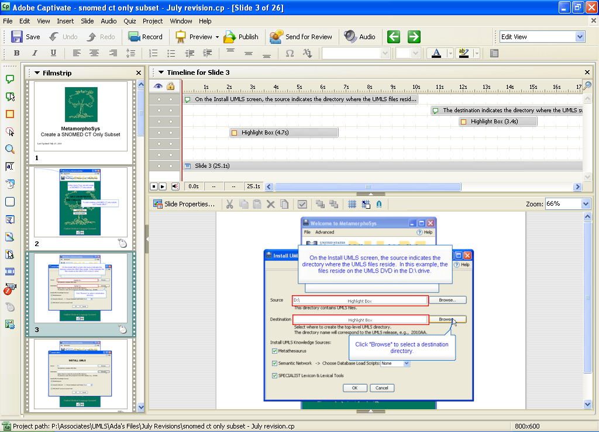
Figure 1. Adobe Captivate interface

Content maps, or storyboards, were developed for each Quick Tour (Figure 2). A storyboard is essentially a draft of the Quick Tour. The purpose of a storyboard is to plan out the content, captioning, and design of the Quick Tour before recording in Captivate. The storyboards were created by taking screen shots and writing accompanying caption text. The screenshots and text were arranged in PowerPoint for review by project leaders. The project leaders reviewed the storyboards for content and style, and suggested revisions. After revisions were implemented, the Quick Tours were recorded based on the storyboard outlines. Project leaders, the UMLS team, and the Head of MMS, Dianne Babski, made suggestions for content, wording, and formatting of the Quick Tours. After implementing these revisions, the Quick Tours were finalized for promotion to the User Education portion of the UMLS Web site.

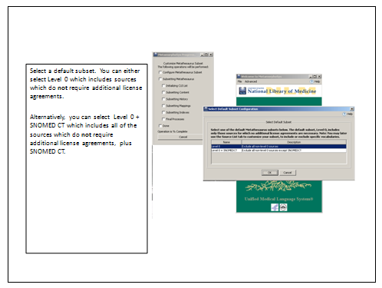
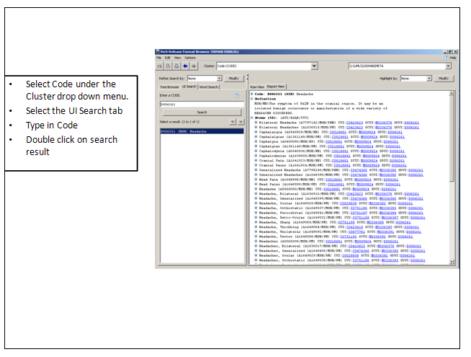
Figure 2. Sample storyboard PowerPoint slides

Results

A total of four Quick Tours were successfully created for this project. They are outlined below. See the Appendix for the full text of the Quick Tours.

MetamorphoSys: Create a Default Subset
This Quick Tour contains instructions on how to create a default subset of Metathesaurus sources. It outlines how to select a destination directory, create a new configuration, alerts users to the License Agreement Notice, and shows the options for creating a default subset with or without SNOMED Clinical Terms (SNOMED CT®).

MetamorphoSys: Create a SNOMED CT Only Subset
This Quick Tour is similar to the “Create a Default Subset” Quick Tour in the first portion, but goes on to instruct users to select “Level 0 + SNOMEDCT” as the default subset, and limit to SNOMED CT in the Source List tab. Users are also shown the option to select related sources.

MetamorphoSys: Search by Code
This Quick Tour shows users how to search by Code using the RRF Browser. First, users are shown how to open and load a saved subset. They are instructed to change the cluster type to “Code” and search for a particular valid Code under the UI Search tab. The Report View and relationships between atom, CUI (concept unique identifier), and Code are briefly explained.

MetamorphoSys: Find a Code From a CUI
This Quick Tour shows users how to find a code from a CUI. It starts by showing users how to open and load a saved subset. It goes on to illustrate how to use the UI Search tab to search by CUI. The Report View and relationships between the CUI, atoms, and Codes are briefly explained. The user is then shown that by clicking on a particular Code, the cluster type changes to Code. The new Report View is briefly explained.

Discussion

The creation of these QuickTours will enhance the User Education portion of the UMLS Web site and increase the online instructional support for MetamorphoSys. They will serve as valuable distance education resources for those who cannot attend classroom trainings.
Captivate was a user friendly program. The process of recording Quick Tours was relatively smooth; however, significant time and effort is necessary to edit the audio and work out the timing of captions and slides. The final touches for audio and caption can take about one hour for a three minute Quick Tour.

Recommendations

The workflow for this project could have been more efficient if the storyboard content was seen by all reviewers prior to creating the Quick Tours. That way, less time could have been spent re-recording Quick Tours that needed changes to style or flow. Also, it would be helpful if standards for Quick Tours were developed and published on the Intranet. There are many elements including wording, level of description, screen size, caption box size, and desktop theme that all staff could conform to if such standards were in place. Another minor limitation to this project was the amount of time it took to procure the Captivate software, and the limited number of licenses available.

References

1. Fact sheet: Unified Medical Language System [Internet]. Bethesda (MD): National Library of Medicine (US); 2006 March 23 [cited 2010 August 3]. Available from: http://www.nlm.nih.gov/pubs/factsheets/umls.html.

Acknowledgements
The author wishes to thank project leaders Patrick McLaughlin and Rachel Kleinsorge as well as Dianne Babski and the UMLS team (Jan Willis, Steve Emrick, Victoria Wilder, Rashmi Puttaswamygowda, and Andrea Demsey). She is also thankful for the support of the other Associate Fellows, Kathel Dunn, and the Associate Fellowship Program, her preceptor, Joyce Backus, and NLM Senior Staff, Dr. Lindberg, Betsy Humphreys, Sheldon Kotzin, and Becky Lyon.

Appendix: Quick Tour Text

MetamorphoSys: Create a Default Subset

- In this Quick Tour, we will create a default subset using MetamorphoSys.
- To start creating default subset, click "Install UMLS."
- On the Install UMLS screen, the source indicates the directory where the UMLS files reside. In this example, the files reside on the UMLS DVD in the D:\ drive.
- The destination indicates the directory where the UMLS subset will be installed.
- Click "Browse..." to select a destination directory.
- Click "Open" when done.
- The UMLS consists of three Knowledge Sources --- the Metathesaurus, the Semantic Network, and the SPECIALIST Lexicon & Lexical Tools. The default settings include all three Knowledge Sources; however, we will only be creating a Metathesaurus subset in this example and do not need to install the other two Knowledge Sources.
- Uncheck the boxes for Semantic Network and SPECIALIST Lexicon & Lexical Tools.
- Now click "OK" to begin configuring your subset.
- You will be prompted to choose a MetamorphoSys configuration. You can either create a new configuration or open a previously saved configuration. Clicking cancel will bring you back to the MetamorphoSys Welcome Screen.
- To create a new default subset, click "New Configuration."
- The License Agreement Notice explains that the Metathesaurus contains source vocabularies produced by many different copyright holders. Some of the vocabularies have additional restrictions on their usage.
- Read the License Agreement Notice, and click “Accept” to continue.
- MetamorphoSys will prompt you to select a default subset. You can either select “Level 0,” which includes sources that have no additional restrictions in the UMLS Metathesaurus License Agreement. Or, you can select “Level 0 + SNOMEDCT,” which includes sources that have no additional restrictions in the UMLS Metathesaurus License Agreement, plus SNOMED CT.
- In this example, we will select "Level 0."
- Click "OK" when done.
- To complete your subset, select "Begin subset" from the "Done" menu
- After your subset completes processing, you will have a data set that includes only the Level 0 source vocabularies, which have no additional restrictions in the UMLS Metathesaurus License Agreement.

MetamorphoSys: Create a SNOMED CT Only Subset

- In this Quick Tour, we will create a SNOMED CT only subset.
- To start creating a SNOMED CT only subset, click "Install UMLS."
- On the Install UMLS screen, the source indicates the directory where the UMLS files reside. In this example, the files reside on the UMLS DVD in the D:\ drive.
- The destination indicates the directory where the UMLS subset will be installed.
- Click "Browse" to select a destination directory.
- Click "Open" when done.
- The UMLS consists of three Knowledge Sources --- the Metathesaurus, the Semantic Network, and the SPECIALIST Lexicon & Lexical Tools. The default settings include all three Knowledge Sources; however, we will only be creating a Metathesaurus subset in this example and do not need to install the other two Knowledge Sources.
- Uncheck the boxes for Semantic Network and SPECIALIST Lexicon & Lexical Tools.
- Now click "OK" to begin configuring your subset.
- You will be prompted to choose a MetamorphoSys Configuration. You can either create a new configuration or open a previously saved configuration. Clicking "Cancel" will bring you back to the MetamorphoSys Welcome screen.
- To create a new SNOMED CT only subset, click "New Configuration."
- The License Agreement Notice explains that the Metathesaurus contains source vocabularies produced by many different copyright holders. Some of the vocabularies have additional restrictions on their usage.
- Read the License Agreement Notice, and click "Accept" to continue.
- MetamorphoSys will prompt you to select a default subset. You can either select "Level 0," which includes sources that have no additional restrictions in the UMLS Metathesaurus License Agreement, or you can select "Level 0 + SNOMED CT," which includes sources that have no additional restrictions in the UMLS Metathesaurus License Agreement, plus SNOMED CT.
- For this example, we will select "Level 0 + SNOMED CT"
- Click "OK" when done.
- Click the "Source List" tab to limit sources to SNOMED CT only.
- Click "Select sources to INCLUDE in subset"
- Scroll down to SNOMED Clinical Terms.
- Some sources have other related sources, such as translations or mappings, which might be useful to include in a subset. These sources are said to be in the same source family.
- You can either select the related sources you want to include and click “OK,” or click “Cancel” if you do not want to include any additional sources.
- For this example, we will choose to also include the Spanish language edition of SNOMED CT.
- Click OK.
- To complete your subset, select "Begin subset" from the "Done" menu
- After your subset completes processing, you will have a data set that includes only the SNOMED CT vocabulary.

MetamorphoSys: Search by Code
- In this Quick Tour, we will search by Code.
- To begin searching, you must first create a subset or open a saved subset. In this example, we will use a saved subset.
- Select "Open Subset" from the "File" menu to open a saved subset.
- To locate your saved subset, click "Browse"
- Click "Open" when done.
- Now click "OK" to load your subset.
- The file path to the subset you are searching is displayed in the upper right corner of the browser.
- Select "Code" under the cluster drop down menu.
- Select the UI search tab.
- Type in a valid Code.
- Click Search.
- In the Report view, the results are clustered by Code. The Code may be associated with one or more atoms. Each atom is associated with a single CUI.
- In this Quick Tour, we learned how to search by Code.

MetamorphoSys: Find a code for CUI

- In this Quick Tour, we will find a Code from a concept unique identifier (CUI).
- To begin searching, you must first create a subset or open a saved subset. In this example, we will use a saved subset.
- Select "Open Subset" from the "File" menu to open a saved subset.
- To locate your saved subset, click "Browse"
- Click "Open" when done.
- Now click "OK" to load your subset.
- The file path to the subset you are searching is displayed in the upper right corner of the browser.
- The default cluster is by Concept.
- Enter your Concept Unique Identifier (CUI) under the UI tab and click Search.
- Under the "Report View," the first line lists the concept unique identifier (CUI).
- Each concept can have multiple atoms associated with it, and each atom has a Code.
- Click on a Code to change the cluster type to Code, instead of Concept.
- The Cluster Type Modification Notice informs you that you are switching from one cluster to another. In this example, we are switching from the Concept cluster type, which groups Metathesaurus data by Concept, to the Code cluster type, which groups Metathesaurus data by code.
- Click “OK” to switch cluster types.
- Now the results are clustered by Code instead of Concept.
- The Code may be associated with one or more atoms. Each atom is associated with a single CUI.
- In this Quick Tour, we searched by CUI, or concept unique identifier, to find a Code.

