Unified Medical Language System (UMLS) Quick Tour Learning Packages
Final Report
August, 2010
MaShana Davis, MIM
NLM Associate Fellow, 2009-2010
Project Leader(s):
Patrick McLaughlin
Rachel Kleinsorge
MEDLARS Management Section
National Library of Medicine
8600 Rockville Pike, Bldg. 38
Bethesda, MD 20894

Table of Contents
Acknowledgements 3
Abstract 4
Introduction 5
Methodology 6
Results 8
Discussion 8
Recommendations 9
Bibliography 11
Appendix 12
Appendix A: Adobe Captivate Interface 12
Appendix B: Suggested Topics List 13
Appendix C: Quick Tour Scripts 15

Acknowledgements
I owe many thanks all those involved in the completion of this endeavor. First, many thanks to my project leaders, Patrick McLaughlin and Rachel Kleinsorge for affording me the opportunity to work on the project, providing guidance and support throughout the project, and granting me creative freedom.
Next, I would like to thank my preceptor, Jenny Heiland-Luedtke, for her insight into the Associate Fellowship Program, selecting projects and 2nd year opportunities. Her mentorship is invaluable and I hope to continue it throughout my career.
Additionally, I would like to extend many thanks to everyone that supports the Associate Fellowship Program, particularly, Jason Broadway, Sally Sinn, and Angela Ruffin for their support, guidance, and encouragement as well as the NLM Administration, Dr. Lindberg, Betsy Humphreys, Sheldon Kotzin, and Becky Lyon for their continued support of the Program.
Lastly, I would like to extend a special thanks to Kathel Dunn, Associate Fellowship Program Coordinator, for supporting me throughout the fellowship year, both professionally and personally. Kathel is an awesome Coordinator and a great mentor.

Abstract
OBJECTIVE: The purpose of this project was to develop a suite of quick tour learning packages for basic and advanced topics of the Unified Medical Language System (UMLS). The quick tours were to be presented in clear, concise, manageable pieces of instruction lasting no more than four minutes that are engaging and instructive to the user.
METHODS: Four topics were selected in consultation with the UMLS team. The UMLS Web site, training materials, and other educational resources were explored to gain an understanding of the topics. Storyboards were developed and approved by the project leaders. Quick tour tutorials were created using Adobe Captivate, a software package that the MEDLARS Management Section (MMS) has used in the past to create brief training tutorials on a variety of topics. Captivate includes full motion demonstration of a task as well as detailed narration.
RESULTS: After several rounds of review and suggestions from my project leaders and the UMLS team, a total of three quick tours were produced on the following topics: (1) Creating an English Only Subset, (2) Creating a Database Load Script, and (3) Limiting a Search by a Source.
DISCUSSION: The UMLS Web site contains a variety of training and educational resources; however, the development of the quick tours further enhances the UMLS training suite. The quick tours provide users with information regarding basic and advanced aspects of the UMLS in an accessible format; and they can be delivered directly to users’ desktops.

Introduction
The Unified Medical Language System (UMLS) is a collection of tools and resources that enable systems to link biomedical information from different sources, and to improve the ability of computer systems to “understand” biomedical meaning and to retrieve and integrate relevant information. In 1986, the National Library of Medicine (NLM) began a long-term research and development project to build the UMLS as an effort to overcome barriers to information access and retrieval, such as multiple ways of expressing the same concepts or distribution of information among many disparate information systems (Lindberg, 1993) (Humphreys, 1998).
The UMLS consists of three Knowledge Sources: the Metathesaurus®, the Semantic Network, and the SPECIALIST Lexicon & Lexical Tools, which are distributed with flexible lexical tools and the MetamorphoSys installation and customization program. The Metathesaurus® is a vocabulary database that contains information about biomedical concepts and terms from a variety of vocabularies and classifications. The Semantic Network defines broad subject categories, to which the Metathesaurus® concepts are assigned and useful relationships that exist between categories. And, the SPECIALIST Lexicon includes commonly occurring English and biomedical words as well as information necessary for natural language processing.
The MEDLARS Management Section (MMS) of the NLM provides a variety of training and educational resources for the UMLS, including classroom and Web-based formats, ranging from basic to advanced topics. With a goal aimed to enhance the UMLS training suite, the MMS proposed to develop a suite of quick tour learning packages for the UMLS. The quick tours were to be presented in clear, concise, and manageable pieces in such a way that is engaging and instructive to the user. Adobe Captivate would be used to develop the quick tours. Captivate is a software package used to develop online instructional content with advanced interactivity, software and scenario simulations, quizzes, and more without requiring programming or multimedia skills. Captivate tutorials include a full motion demonstration of a task as well as detailed narration. MMS has used Captivate in the past to create brief training tutorials on a variety of topics including the UMLS.

Methodology
The project began with a meeting with the project leaders, Rachel Kleinsorge and Patrick McLaughlin, to discuss the project proposal and to identify goals for the project. A list of suggested topics had been compiled by the project leaders based on feedback from UMLS users and MEDLARS Management Section staff. The proposed topics covered three broad areas of the UMLS: the Metathesaurus®, MetamorphoSys subset creation, and MetamorphoSys searching. From the proposed list, four topics were selected for which to develop quick tours; each topic was relevant to a broad area of the UMLS. The topics included creating an English only subset; creating a database load script; completing a UMLS Metathesaurus License Agreement; and limiting a search by a source.
At the outset, the UMLS Web site, training materials and other resources were reviewed to gain more information about the broad areas that the quick tours would address. Subsequently, storyboards were developed using Microsoft® Word to describe what should appear on each screen, including images, actions, and the narration. As the storyboards were developed they were reviewed by the project leaders. After the changes were completed, the quick tours were created in Captivate.
Prior to creating the quick tours, user guides provided by the project leaders as well as information available on the Adobe Web site about Captivate were reviewed to gain an understanding of the application. Once a copy of the software was received, its capabilities were explored. The software’s interface (see Appendix A) was easy to use and navigate. Furthermore, existing UMLS quick tours developed by MMS were reviewed and used as examples for the quick tours. Subsequently, quick tours were developed for each of the selected topics.
The review process:
The review process had several stages: (1) review by my project leaders, (2) review by the UMLS team, which consisted of members of MMS staff, and (3) review by the Head of the MEDLARS Management Section (MMS). Once the drafts were completed, the quick tours went through the first round of review with the project leaders. Revisions were made based on their suggestions and the quick tours were reviewed a second time by the project leaders before they were handed over to the UMLS team.
Before the quick tours were reviewed by the UMLS team, audio was recorded. The UMLS team reviewed the quick tours individually and used SharePoint to post comments. The project leaders compiled the revisions into one document; a meeting was held to discuss the revisions. Revisions were made based on the UMLS team’s suggestions and the quick tours were handed off to the Head of MMS, Dianne Babski.
After receiving the comments from Dianne, the project leaders developed a standards document for the quick tours. The document included details about the computer display theme, the skin of the Captivate tutorial (look and feel), quick tour title page, starting points for the quick tours based on the topic, and text for particular slides in the tutorials. Based on the standards document, a template was developed for the quick tours and the quick tours were re-recorded based on the suggestions from the Dianne and the standards document.
The quick tours were re-recorded without audio and reviewed by my project leader. Once the revisions were made, the audio was recorded and the quick tours were given to the Dianne for a final review. Once the quick tours are approved they will be published and put on the UMLS Web site.

Results
After some discussion with my project leaders, a total of three quick tours were recorded:
- Creating an English Only Subset
- Creating a Database Load Script
- Limiting a Search by a Source
The Creating an English Only Subset quick tour teaches users to create a custom Metathesaurus subset based on a particular language. The Metathesaurus contains over one million concepts and users can create a useful subset by choosing source vocabularies or applying a filter, such as a language filter, in MetamorphoSys. The tutorial is 4 minutes and 33 seconds long. The Creating a Database Load Script quick tour teaches users how to create database load scripts for their subsets. A database load script is an output option for subsets in MetamorphoSys. Database load scripts allow you to load UMLS data into a local database, such as Oracle or MySQL. The tutorial is 2 minutes and 23 seconds long. Lastly, the Limiting a Search by a Source teaches quick tour users how to limit a search by a particular source or set of sources. The Metathesaurus has over 150 source vocabularies for which a subset can contain all of these sources; however, narrowing a search down can be very useful. The tutorial is 3 minutes and 14 seconds long.
The entire license application is being revised; hence the fourth topic⎯How to Complete an UMLS Metathesaurus License Agreement⎯was not completed.
The suite of quick tours can be accessed at any time in the User Education section on the UMLS Web site (http://www.nlm.nih.gov/research/umls/user_education/index.html). Additionally, users can view select portions of each quick tour by adjusting the play bar provided at the bottom of each tutorial screen.

Discussion
The completion of the UMLS quick tours further enhances the UMLS training suite, providing users with information regarding basic and advanced aspects of the UMLS. Additionally, the quick tours serve as distance education for individuals that prefer or need training at their desktop.
Overall, the development of the quick tours was uneventful. Development of the quick tours allowed me to learn more about the UMLS as well as allowed me to acquire a new technical skill and enhance training skills through creating the online tutorials. The time required for learning Adobe Captivate was minimal. And once I felt comfortable with using Adobe Captivate, the process became easier over time.

Recommendations
The overall goal of the project was to create a suite of quick tour learning packages for the UMLS. This goal was satisfied. Based upon my experience in this project, I have provided some recommendations for developing future quick tours to include:
- Standardizing quick tours
During the project, guidelines were provided for the look and feel of the quick tours in Captivate; however, these were provided by word of mouth from my project leaders. No formal documentation was provided. A formal document of these standards should be developed, to include details about the style of the quick tour, text or wording that should be used, and any other pertinent information. Additionally, project templates can be developed in Adobe Captivate. With the standards document and template in place, quick tours developed in the MMS will have the same appearance.

- Assessing the review process in the MEDLARS Management Section (MMS)
The quick tours were reviewed by three distinct groups⎯my project leaders, the UMLS team, and the Head of MMS. The suggestions that were made at each level of review sometimes contradicted the previous group’s suggestions. Each group had its own ideas for the look and feel of the quick tours as well as the process or method by which the topic was covered. The process of review in MMS should be reevaluated to ensure that everyone is on one accord. An example review process could be:

Step 1: Draft content maps
Review by project leaders, UMLS team, and Head of MMS
Revise
Round 2 of review with project leaders, UMLS team, and Head of MMS
Revise, if necessary
Step 2: Develop quick tours sans audio
Review by project leaders, UMLS team, and Head of MMS
Revise
Round 2 of review with project leaders, UMLS team, and Head of MMS
Revise, if necessary
Step 3: Add audio
Review by project leaders, UMLS team, and Head of MMS
Revise
Round 2 of review with project leaders, UMLS team, and Head of MMS
Revise, if necessary
Step 4: Finalize quick tours and publish on Web site

- Evaluation and Feedback
Assessing the Web site hits and use of the quick tours will allow MMS to determine if the quick tours are being utilized. Additionally, soliciting feedback on the quick tours as well as any additional topics that may need to be covered from the UMLS community will help MMS improve their training suite. Additionally, evaluation of the quick tours is important to ensure that they reflect current processes in the UMLS.

Bibliography
Humphreys, B. L. (1998). The Unified Medical Language System: an informatics research collaboration. J Am Med Inform Assoc. , 5 (1), 1-11.
Lindberg, D. H. (1993). The Unified Medical Language. Methods Inf Med. , 32 (4), 281-91.

Appendix

Appendix A: Adobe Captivate Interface
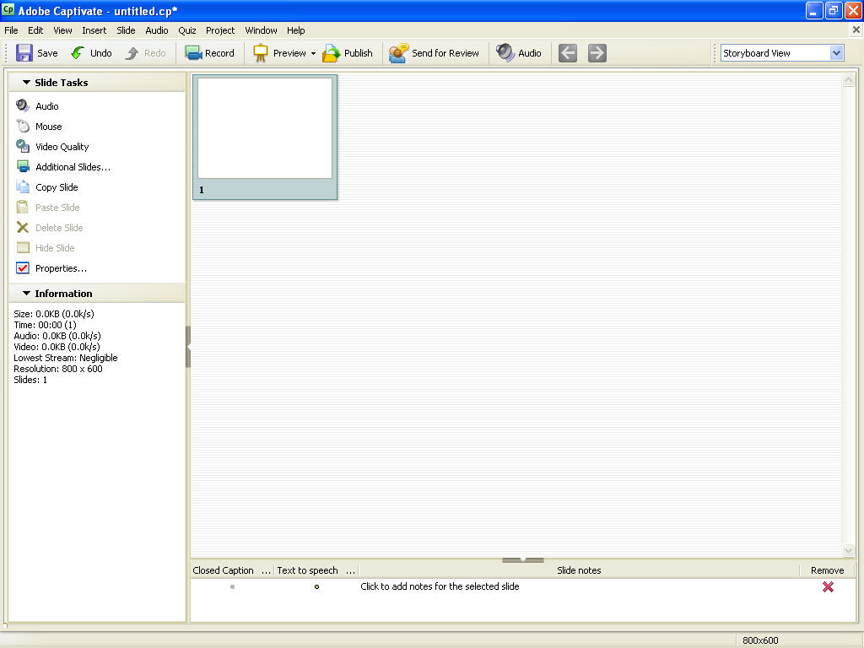

Appendix B: Suggested Topics List
UMLS Quick Tour Topics
Current Topics
MetamorphoSys RRF Browser Restrict Searches and Views Option
(http://www.nlm.nih.gov/research/umls/user_education/quick_tours/restrictor_tutorial.html)
In production
UMLS RRF Browser “Highlight By” Feature
(http://www.teamsite.nlm.nih.gov:81/iw-mount/default/main/nlm/WORKAREA/kleinsr/htdocs/research/umls/user_education/quick_tours/highlight.htm)
UMLS RRF Browser “Refine Search By” Feature
(http://www.teamsite.nlm.nih.gov:81/iw-mount/default/main/nlm/WORKAREA/kleinsr/htdocs/research/umls/user_education/quick_tours/refine_search.htm)
UMLS RRF Browser Cluster Views
(http://www.teamsite.nlm.nih.gov:81/iw-mount/default/main/nlm/WORKAREA/kleinsr/htdocs/research/umls/user_education/quick_tours/cluster_view.html)
Proposed Topics
MMSYS
How to create a default subset
How to create a SNOMED CT subset
How to create an English only subset
How to create a database load script
RRF Browser
Search by code
Restrict Search by Source
Metathesaurus – Beginning
How to complete a UMLS Metathesaurus License Agreement
How to find the code for a CUI
Metathesaurus – Intermediate
A quick look at individual MR files content and structure, starting with MRCONSO, MRREL, MRHIER, and MRSAT
A quick look at metadata files (MRSAB, MRDOC, MRFILESCOLS) and change files
Topics on Hold
UMLSKS
Creating a Log in ID and Password
Logging in
Downloading the UMLS Knowledge Sources
Searching the Metathesaurus
Searching the Semantic Network
Searching the SPECIALIST Lexicon

Appendix C: Quick Tour Scripts
Creating an English Only Subset
(Title slide)
MetamorphoSys: Creating an English Only Subset.
(MetamorphoSys Welcome screen)
In this tutorial, we will create an English only subset using MetamorphoSys.
To start creating an English only subset, click “Install UMLS.”
(Dialog box – Install UMLS)
On the “Install UMLS” screen, the source indicates the directory where the UMLS files resides. In this example, the files reside on the UMLS DVD in the D:\ drive. (Source box highlighted with red rectangle)
The destination directory indicates where the UMLS subset will be installed. (Destination box highlighted with red rectangle)
Click “Browse” to select a destination directory.
(Select and Open a destination directory open in Windows Explorer)
Click “Open” when done.
(Dialog box - Install UMLS)
The UMLS consists of three Knowledge Sources --- the Metathesaurus, the Semantic Network, and the SPECIALIST Lexicon & Lexical Tools. The default settings include all three Knowledge Sources; however, we will only be creating a Metathesaurus subset in this tutorial and do not need to install the other two Knowledge Sources. (Each Knowledge Source is highlighted with a red rectangle as it is mentioned)
Uncheck the boxes for Semantic Network and SPECIALIST Lexicon & Lexical Tools.
Now click “OK” to begin configuring your subset.
(Dialog box – Choose a MetamorphoSys Configuration)
You will be prompted to choose a MetamorphoSys Configuration. You can either create a new configuration or open a previously saved configuration. Clicking “Cancel” will bring you back to the MetamorphoSys Welcome screen.
To create a new English only subset, click “New Configuration.”
(Dialog box – License Agreement Notice)
The License Agreement Notice explains that the Metathesaurus contains source vocabularies produced by many different copyright holders. Some vocabularies have additional restrictions on their usage.
Read the License Agreement Notice, and click “OK” to continue.
MetamorphoSys will prompt you to select a default subset. You can either select “Level 0,” which includes sources that have no additional restrictions in the UMLS Metathesaurus License Agreement. Or, you can select “Level 0 + SNOMED CT,” which includes sources that have no additional restrictions in the UMLS Metathesaurus License Agreement, plus SNOMED CT.
For this example, we will select “Level 0.”
Click “OK” when done.
(Dialog box – UMLS Metathesaurus Configuration 2010AA NLM Data File Format)
To create an English only subset, you must enable the Languages filter.
Select “Enable/Disable Filters” from the “File” menu to enable the Languages filter.
(Dialog box – Enable/Disable Filters)
Check the box for “Languages List” to enable this filter.
Click “OK” when done.
(Dialog box – UMLS Metathesaurus Configuration 2010AA NLM Data File Format)
This Languages List indicates which language(s) will be excluded from your subset. Excluding a language will remove any terms with that language, along with the attributes and relations connected to those terms, from a subset. By default, all of the languages expect English are selected.
To create an English only subset, use the default setting.
Select “Begin subset” from the “Done” menu.
After your subset completes processing, you will have a data set that includes only English language terms for the Level 0 Metathesaurus source vocabularies.
(Closing slide)
For more information about the UMLS go to UMLS New Users Homepage or the UMLS Web site.
Creating a Database Load Script
(Title slide)
MetamorphoSys: Creating a Database Load Script.
(MetamorphoSys Welcome screen)
In this Quick Tour, we will create a database load script using MetamorphoSys. Database load scripts allow you to load UMLS data into a local database, such as Oracle or MySQL.
To start creating a database load script, select “Copy Database Load Script to Hard Drive” from the “Advanced” menu.
(Dialog box - Copy Database Load Script to Hard Drive)
The Metathesaurus is available in two formats --- Original Release Format and Rich Release Format. Users are encouraged to use the Rich Release Format because it offers advantages in source vocabulary transparency and in more convenient representations of concept name, source, and hierarchical context information. Load scripts for the Semantic Network are also available. (Each format is highlighted with a red rectangle as it is mentioned)
In this example, we will use the Rich Release Format.
Select a database format.
There are three options---MS Access 2003, MySQL, and Oracle. In this example, we will use Oracle.
To select a destination directory for your database load scripts, click the “Browse” button.
(Select and Open a destination directory open in Windows Explorer)
Click “Open” when done.
(Dialog box - Copy Database Load Script to Hard Drive)
Click “OK” to copy your load script to your destination directory.
A notice will pop up informing you that the load scripts have been copied to your destination directory.
In this Quick Tour, we created a database load scripts using MetamorphoSys. The database load scripts must be modified for your local installation before being used.
For more information on loading your Metathesaurus subset into a database, please visit the UMLS Load Scripts page at http://www.nlm.nih.gov/research/umls/load_scripts.html.
(Closing slide)
For more information about the UMLS go to UMLS New Users Homepage or the UMLS Web site.
Limiting a Search by a Source
(Title slide)
MetamorphoSys: Limiting a Search by a Source
(Rich Release Format Browser)
In this Quick Tour, we will learn how to limit your search by one or more sources.
To begin searching, you must first create a subset or open a saved subset. In this example, we will use a saved subset.
Select “Open Subset” from the “File” menu to open a saved subset.
(Choose Subset to Browse)
To locate your saved subset, click “Browse.”
Click “Open” when done.
Now click “OK” to load your subset.
(Rich Release Format Browser)
The file path to the subset you are searching is displayed in the upper right corner of the browser. (The file path is highlighted with a red rectangle as it is mentioned)
Enter a term into the search field on the “Word Search” tab. (The Word Search tab is highlighted with a red rectangle as it is mentioned)
Click “Search” to perform the search
Your results will appear below the search field. Notice that the search returned 52 results. (Number of search results is highlighted with a red rectangle)
To limit your search to a particular source or set of sources, select “Source List” from the drop down menu next to “Refine Search by.”
(Dialog Box - Browser Selector Option GUI)
Select one or more sources from the Source List to include in your search. In this example, we will search the "Current Procedural Terminology, 2010."
(Dialog Box - Confirm Selection)
Some sources have other related sources, such as translations or mappings, which might be useful to include in a subset. These sources are said to be in the same source family. You can either select the related sources you want to include and click "OK," or click "Cancel" if you do want to include any additional sources. For this example, we will include additional sources.
Click "OK" to confirm your selections.
(Dialog Box - Browser Selector Option GUI)
Click “OK” when done.”
(Rich Release Format Browser)
Search on your term again.
When the search is repeated, the results are limited to the "Current Procedural Terminology, 2010" and the additional resources only. Note the change in the number of results.
In this Quick Tour, we learned how to limit a search by one or more sources. Refining a search by a particular source or set of sources allows you to focus your search and limit your results to only those vocabularies.
(Closing slide)
For more information about the UMLS go to UMLS New Users Homepage or the UMLS Web site.

