Digital Training Development and Best Practices for Library Instruction in Toxicology, Chemistry, and Environmental Health
Bethany R. Harris
National Library of Medicine
Associate Fellow 2011-2012
February 2012
Project sponsor:
Stephanie Publicker, Technical Information Specialist, Specialized Information Services
Table of Contents
Abstract 3
Introduction 3
Methodology 4
Results 6
Discussion 7
Recommendations 9
Appendix A: Literature review citations 11
Appendix B: Environmental scan collection of links (downloaded from Google Documents) 13
Appendix C: Original Accessibility Checklist Developed with Jessi Van Der Volgen 16
Appendix D: LactMed Tutorial Storyboard 17

Abstract
Objective: The aim of this project was to evaluate the potential formats, best practices, and feasibility of developing digital training materials on the suite of TOXNET databases, the premier toxicology, chemistry, and environmental health resource system from the National Library of Medicine. The goal end product was a prototype digital tutorial that demonstrates a resource overview while conforming to current e-learning best practices and federal accessibility regulations.
Methods: The author performed a literature review on e-learning best practices and educational technology options, an environmental scan of existing distance education materials produced by libraries and comparable institutions, and researched the regulations effected by the Section 508 Amendment of the Rehabilitation Act of 1973. Screencasting software options and tutorial storyboard development were investigated to facilitate the production of a prototype tutorial.
Results: The LactMed drugs and lactation database was selected as an example resource to be adapted to digital training for a general public audience. Best practices were applied to the development of a preliminary storyboard and script to be used in producing a future screencast tutorial video.
Conclusion: Digital training materials for the TOXNET databases could be developed promptly using available educational technologies and a best practices checklist. Achieving full and uniform Section 508 compliance will require further inquiry and establishing a set of guidelines for all creators of digital tutorials to follow.

Introduction
The National Library of Medicine (NLM) faces the continual challenge of connecting the public to a vast array of NLM products and services. Whether it is teaching novice users about database resources or introducing new tools and information portals to longtime users, NLM must continually inform the public of new or improved resources made freely available to them. In a climate of increased awareness of the costs of in-person training methods, the division of Specialized Information Services (SIS) decided to explore options for supplementing their existing TOXNET and Beyond class training materials for teaching the Toxicology Data Network (TOXNET) with online tutorials for informal self-directed learning opportunities.
Because digital training can take many forms, the project sponsor requested the author to consider several factors while researching and synthesizing best practices documentation. The intended audience of the tutorial could range from consumers to physicians to fellow librarians at other institutions and the prototype training materials should reflect user needs and abilities. Length of instruction can matter greatly when experienced in different formats; consider attending a 1-hour classroom training session compared to listening to a 1-hour audio-only podcast. The purpose of the tutorial could also vary in its complexity, with the option of creating task-specific tutorials or general overviews of the purpose and use of an entire database.
By examining the TOXNET database suite, the TOXNET and Beyond class workbook, and digital training options, the goal was to develop a model process for producing a series of uniform tutorials that also conformed to the expectations of the Section 508 Amendment of the Rehabilitation Act of 1973 (Section 508). A prototype tutorial (taking the form of a storyboard with screenshots and script) along with guidelines to assist others in completing the tutorial creation process were intended to demonstrate the feasibility of swiftly adding new TOXNET training materials while enabling the process to be completed by multiple SIS staff members.
At the stage of commencing this project, Section 508 requirements were to be fully enforced and apply to any new materials added to federal websites. The expectation presented in the project proposal was that Section 508 compliance for digital tutorials would mostly consist of providing closed captioning to instructional videos in conjunction with audio narration. Any other requirements for Section 508 compliance should be discovered and further investigated during the course of this project.
Efficiency was a driving force in the proposal of this project. Producing online training materials could potentially reduce the travel and staff time devoted to teaching the in-person TOXNET and Beyond class and other SIS training sessions, while simultaneously expanding the reach of training materials to the online masses. The hope is to garner far more users by placing autodidactic training materials online than the number reached previously via traditional methods. Because of this focus on efficiency, SIS staff skills and previously created training materials (e.g. the TOXNET and Beyond workbook and a handful of screencast tutorials) and the software programs available to NLM staff were strongly considered from the outset of this project.

Methodology
Digital education best practices
To develop a better understanding of methods used in distance education, the first step of the project was to undertake a minor literature review of modern e-learning techniques, trends, and best practices. The library and information science literature was a natural field to examine due to the propensity of library staff to create digital training materials for their online user groups. Instruction has become a common duty for modern librarians, so the author expected to find guidance and case studies on digital tutorial creation.
Despite the access to collections at the National Library of Medicine and the National Institutes of Health Library, access to standard library science databases was not immediately available to the author. Initially PubMed and e-journals on medical librarianship were searched with limited success. The PubMed search strategies below were used in combination with hand-searching:
("Education, Distance"[Mesh]) AND "Computer-Assisted Instruction"[Mesh] AND e-learning
and
("Education, Distance"[Mesh]) AND ("Computer-Assisted Instruction"[Mesh]) AND (tutorial OR Camtasia OR screencast*)
A trip to the University of Maryland at College Park with a fellow NLM Associate, Jessi Van Der Volgen, provided on-campus access to the print and online collections at McKeldin Library. A database search (below) in Library, Information Science & Technology Abstracts (LISTA) yielded the most promising set of results which were also hand-searched:
(DE "EDUCATIONAL technology") AND (DE "WEB-based instruction") OR (DE "INTERNET in education")) AND ( web OR online ) AND ( tutorial OR instruction)
Search results were specifically gleaned for the types of subjects covered via distance education, advice and best practices in producing e-learning materials, case studies with an emphasis on screencasting or the effectiveness of video other digital tutorial types, and anything pertaining to improving the accessibility (e.g. Section 508 compliance) of online materials.
Upon suggestion from supervisors, staff members from various NLM departments were contacted about their experience in creating digital training materials and expertise on subjects such as Section 508 requirements. Kate Majewski of the MEDLARS Management Section (MMS) discussed her experience in developing digital tutorials with the author over the phone and Brooke Dine of the Web and Information Management (WIM) unit was contacted via email for advice on accessibility issues.
Environmental scan
An environmental scan was performed by perusing library websites for examples of original digital training materials. Mostly academic library websites were examined, but also pages on the NLM website and occasionally digital tutorials from commercial institutions were considered. Aside from viewing the variety of formats training materials could take, the environmental scan also offered insight into the software used in distance education as well as various techniques, designs, and practices chosen by different creators for different purposes. Most of the research on Section 508 requirements for federal digital media also occurred through general online searching and browsing, but also via email communication with NLM and other government employees. URLs to useful websites and examples were documented and referred to throughout the creation of the prototype tutorial.
Storyboard and script development
LactMed was chosen as the TOXNET database for the prototype tutorial after examining the suite of databases and the TOXNET and Beyond workbook. LactMed and other possible choices were discussed with the project sponsor for feedback on database usage and user information demands. Dr. Bert Hakkinen and Florence Chang were also consulted about TOXNET usage statistics. Choices for audience at which to direct the tutorial were also discussed with the project sponsor.
A simple online search provided several examples of storyboard formats and guidance on developing storyboards and scripts for digital media and screencasts in particular. After much review of the LactMed resource, the author developed a storyboard and script with screenshots to imitate the look of a screencast and received feedback from the project sponsor and a fellow Associate (Van Der Volgen) also developing a screencast.

Results
The literature review yielded a total of 21 relevant full-text articles, which were saved and uploaded to Mendeley Web, an online bibliographic management account, and shared via the Group setting with the project sponsor and fellow Associate, Van Der Volgen. The author, project sponsor, and fellow Associate read through the collection of articles and shared helpful discoveries. Van Der Volgen specifically synthesized the information given to her about Section 508 compliance into an ‘accessibility checklist’ that was delivered to the project sponsor and Brooke Dine for review of comprehensiveness.
The environmental scan resulted in a Google Document of numerous saved links falling in the categories of examples of digital training, tips on screencasting, and Section 508 compliance and specific requirements for digital media. The Google Document was downloaded and delivered to the project sponsor. The literature and environmental scan assisted the author in learning about the variety of digital tutorial formats that exist and best practices that have been suggested in the production of future materials. These best practices were further discussed with the project sponsor and Kate Majewski of MMS.
Because the project sponsor already had inclinations for producing a digital video tutorial, screencasting software options were weighed against other training material formats, such as homegrown HTML tutorials consisting of several webpages, slidecasts with and without audio narration, and traditional digital video (as opposed to screencapture videos). While NLM has a range of educational technologies available to them, it was decided with the project sponsor that screencasting software would accommodate the purpose of the tutorial and be able to incorporate current best practices in e-learning.
LactMed was confirmed as an appropriate example TOXNET database on which to develop the prototype material due to its popularity among users and wide audience, including the general public. It was decided that the purpose of the tutorial would be a general overview of how to search and use the contents of LactMed and that it would be aimed at an audience of the general public, so as to be easily understood yet still useful to professional users (such as clinicians or librarians) as a general introduction. Dr. Bert Hakkinen and Florence Chang provided access to TOXNET usage statistics and helped confirm that LactMed is one of the most-used TOXNET databases and warrants being one of the first resources to have developed online training materials (Figure 1). A storyboard and script were developed during several rounds of drafts and receiving commentary from the project sponsor and colleagues.
The environmental scan provided numerous resource websites on Section 508 and associated requirements, both from federal and informal sources. Web standards on the Department of Health and Human Services policy website were consulted for requirements specific to digital media of all formats. Brooke Dine of WIM reviewed the accessibility checklist and suggested new accessibility considerations. After several more Section 508 questions arose, the project sponsor began communicating with Gary Morin, a program analyst in the NIH Office of the Chief Information Officer and resident expert on accessibility issues affecting NIH organizations such as NLM. Morin offered several more suggestions on improving the accessibility of future tutorials.

Figure 1. Usage chart for the top ten TOXNET resources used in November of 2011. (Database labels are as follows: LACT = LactMed, HSDB = Hazardous Substances Data Bank, TOXLINE = Toxicology Literature Online, CHEM = ChemIDplus, IRIS = Integrated Risk Information System, CCRIS = Chemical Carcinogenesis Research Information System, GENETOX = Genetic Toxicology Data Bank, TOXNET = all databases in the Toxicology Data Network, MULTI = using the Multi-Database search feature, DART = Developmental and Reproductive Toxicology Database.)

Discussion
A list of best practices for developing digital training materials, especially in the format of video screencasts, were developed through a combination of discussion with the project sponsor and other NLM staff with tutorial development expertise, performing a literature review, and observing examples of existing tutorial examples online. Discussion with Kate Majewski (MMS) and Stephanie Publicker (SIS) and the articles from the literature review by Oud (2009) and Childs (2005) proved most useful in developing the following suggested best practices.
- Plan tutorial design in advance to assist with organizing content and arranging learning tasks in a logical order for the learner.

- Know your audience before proceeding with instructional design: Who will be targeted? What are their demographic characteristics? What skills and knowledge might they have and what might they be missing? How familiar are they with the technology you might use? What is their motivation to learn your material? How interested are the in the content you plan to present? What influences affect them and their learning?

- Divide content into small learning objects, rather than long comprehensive lessons.

- Take cognitive load theory (pertaining to the abilities and limitations of a user’s short-term and working memory) into account when developing educational materials. Consider the amount of text, graphics, animation, and audio being used to teach each point and avoid overwhelming the user with excessive input or extraneous details in the lesson.

- Simplify content by focusing on main points, presenting an outline and your goals to the learner at the beginning of the session, clearly indicating the beginning and ending of each tutorial segment, and summarizing at the end to help reinforce new concepts.

- Progress from easier to more difficult material.

- Provide a clear and simple interface and navigation to prevent the user from having to learn and overcome the technology in order to learn the educational content.

- Effectively present information to beginners through worked examples.

- Direct the user’s attention to the most important points, such as through the use of ‘callouts’ (e.g., show where a search box is located on the screen rather than showing only a search box out of context).

- Use consistent words and images throughout a lesson and between tutorials, such as through branding.

- Provide the user the ability of self-pacing through the use of video player controls (like the abilities to pause, review, fast forward, start, and stop the lesson) and/or using modules or chapters to break longer lessons into sections.

- Provide interactive activities for practice and to help make learning more meaningful. Aside from quizzes or hyperlink features provided through the software, try suggesting practices exercises at the conclusion of a lesson or pose questions to the viewer and allow time for them to consider before moving on in the tutorial.
Along with digital education best practice guidelines, regulations stemming from Section 508 must guide development of future TOXNET training materials. As the author could not locate a single, comprehensive resource on the NLM network that instructed on the development of Section 508-compliant digital training materials, the following is a starting point from which to develop guidelines for future creators of NLM tutorials. The list is derived mostly from federal web resources (listed in the environmental scan) and conversations by the author or project sponsor with Brooke Dine (WIM) and Gary Morin (NIH Office of the CIO).
- Vision, hearing, and mobility impairments must all be considered when making materials accessible to those with disabilities.

- Captioning should be synchronized with the audio narration and action and consistently located in one section of the screen and not lie on top of any part of the screen that may be of interest to the user.

- Audio-description should provide an auditory explanation of any action that is occurring on the screen for those with vision impairments.

- Video players must have keyboard-accessible navigation, so that the user has control over the button functions without using a mouse.

- Videos may be placed on YouTube, but as the YouTube video player itself is not Section 508-compliant, a fully compliant version of the video must be available on the appropriate federal website.

- Materials should be tested with multiple screen readers (such as JAWS), screen magnifiers, and speech recognition software to ensure complete accessibility.

- Creating a transcript of a video (such as a static HTML webpage containing similar content to the video) is not considered an acceptable alternative in duplicating the experience for an impaired individual (especially if neither version is then accessible to someone with vision impairment).
Formalizing a set of guidelines on digital training best practices and how to meet the Section 508 requirements will help facilitate creation of a series of tutorials on the TOXNET databases. Posting the guidelines where all NLM staff can use them may minimize the time and effort taken to ‘reinvent the wheel’ each time a new individual wants to create educational media. Training a select group of people to create the TOXNET tutorial series and familiarizing them with the guidelines could facilitate uniformity of the series and minimize the time taken on learning the chosen instructional technology, proper educational design, and producing Section 508-compliant materials.
While there are several formats which digital tutorials can take, screencasts are a logical choice for making brief videos to acquaint a user to a new resource and demonstrate searches or common uses of a database. Choosing which educational software to use to produce a tutorial will involve factors including what is already available at NLM, what software the tutorial developers already know, and checking the software documentation and Voluntary Product Accessibility Template (VPAT) to ensure Section 508 compliance of the video player output of the software.
This report may serve as a starting point for the best practices guidelines and research into Section 508 compliance. The prototype storyboard and script for a LactMed digital tutorial can be used in the creation of a new series of TOXNET training materials.

Recommendations
It is recommended to complete and formalize the best practice guidelines so that they may be posted in an easily accessible area for NLM employees. Discussion of best practices may lead to useful ideas for the division of SIS, such as deciding on TOXNET branding, a standard division template, or how to market training materials in the future. Because creating educational materials is a common cause of several NLM divisions, it may be useful to also discuss best practices with other departments or at least make staff aware that the best practice guidelines are available to them.
Further research into the requirements for comprehensive Section 508 compliance is needed. While the author and project sponsor were able to make headway into the basic Section 508 requirements and discovered factors to consider beyond closed captioning, several questions remain unanswered. Additionally, some Section 508 requirements, such as audio-describing and using screen readers or speech recognition tools to test tutorials, will require staff to learn new technologies and skills beyond what is typically required in creating a simple screencast. It is also highly recommended that NLM staff discuss accessibility options with federal experts on Section 508 to find reasonable solutions that maximize NLM staff efficiency and funds while meeting the needs of disabled users that deserve access to all that the library has to offer.

Appendix A: Literature review citations
1. Anderson RP, Wilson SP, Livingston MB, LoCicero AD. Characteristics and content of medical library tutorials: a review. [Internet]. Journal of the Medical Library Association : JMLA. 2008 Jan ;96(1):61-63.[cited 2011 Nov 27] Available from: http://www.pubmedcentral.nih.gov/articlerender.fcgi?artid=2212336&tool=pmcentrez&rendertype=abstract
2. Anderson RP, Wilson SP, Phillips B, Livingston MB. Topics and Features of Academic Medical Library Tutorials. Medical Reference Services Quarterly. 2008 ;27(4):406-418.
3. Bautista Sparks O. Five Minute Screencasts: The Super Tool for Science and Engineering Librarians [Internet]. Issues in Science and Technology Librarianship. 2010 ;(60):9.[cited 2011 Nov 27] Available from: http://www.istl.org/10-winter/tips.html
4. Beux PL, Fieschi M. Virtual biomedical universities and e-learning. [Internet]. International journal of medical informatics. 2007 ;76(5-6):331-5.[cited 2011 Nov 9] Available from: http://www.ncbi.nlm.nih.gov/pubmed/17407747
5. Blake L. On Campus or out of Town: How Publishing Online Tutorials Can Help Your Patrons. [Internet]. Computers in Libraries. 2009 ;29(4):11-13.[cited 2011 Nov 27] Available from: http://onlinelibrary.wiley.com/doi/10.1002/cbdv.200490137/abstract
6. Childs S, Blenkinsopp E, Hall A, Walton G. Effective e-learning for health professionals and students--barriers and their solutions. A systematic review of the literature--findings from the HeXL project. [Internet]. Health information and libraries journal. 2005 Dec ;22 Suppl 220-32.Available from: http://www.ncbi.nlm.nih.gov/pubmed/16279973
7. Farkas M. Your Desktop : The Movie. American Libraries. 2009 ;40(11):33.
8. Glen S. E-learning in nursing education: Lessons learnt? [Internet]. Nurse education today. 2005 Aug ;25(6):415-7.[cited 2011 Nov 9] Available from: http://www.ncbi.nlm.nih.gov/pubmed/16054949
9. Kazakoff-Lane C. Anything, Anywhere, Anytime: The Promise of the Animated Tutorial Sharing Project for Online and Mobile Information Literacy [Internet]. Journal of Library Administration. 2010 Sep 27;50(7-8):747-766.[cited 2011 Oct 18] Available from: http://tandfprod.literatumonline.com/doi/abs/10.1080/01930826.2010.488961
10. Kroski E. That’s Infotainment [Internet]. School Library Journal. 2009 ;55(2):40–42.[cited 2011 Nov 27] Available from: http://scholar.google.com/scholar?hl=en&btnG=Search&q=intitle:That’s+Infotainment#0
11. MacFadden R. The forgotten dimension in learning: Incorporating emotion into web-based education [Internet]. Journal of Technology in Human Services. 2007 ;25(1-2):85–101.[cited 2011 Nov 27] Available from: http://www.tandfonline.com/doi/abs/10.1300/J017v25n01_05
12. Mestre LS. Matching Up Learning Styles with Learning Objects: What’s Effective? [Internet]. Journal of Library Administration. 2010 Sep 27;50(7-8):808-829.[cited 2011 Sep 13] Available from: http://tandfprod.literatumonline.com/doi/abs/10.1080/01930826.2010.488975
13. Nixon JM, Slebodnik M, Riehle CF, Catherine L, Riehle F. Creating Online Tutorials at your Libraries. Reference & User Services Quarterly. 2009 ;49(1):33-38.
14. Oud J. Guidelines for effective online instruction using multimedia screencasts [Internet]. Reference Services Review. 2009 ;37(2):164-177.[cited 2011 Jul 19] Available from: http://www.emeraldinsight.com/10.1108/00907320910957206
15. Oud J. Improving Screencast Accessibility for People with Disabilities : Guidelines and Techniques Improving Screencast Accessibility for People with Disabilities : Guidelines and Techniques [Internet]. Library. 2011 ;Available from: http://scholars.wlu.ca/lib_pub/2
16. Patkar V. E-Learning : Liberation of Education and Training with Evolving Library and Technology Support. Journal of Library & Information Technology. 2009 ;29(1):14-22.
17. Rethlefsen M. Screencast Like a Pro. Library Journal. 2009 ;134(7):62-63.
18. Sajeva M. E-learning: Web-based education. [Internet]. Current opinion in anaesthesiology. 2006 Dec ;19(6):645-9.Available from: http://www.ncbi.nlm.nih.gov/pubmed/17093369
19. Scaramozzino JM. An undergraduate science information literacy tutorial in a Web 2.0 world [Internet]. Issues in Science and Technology Librarianship. 2008 ;(55):3.[cited 2011 Nov 27] Available from: http://www.istl.org/08-fall/article3.html
20. Sherwill-Navarro P. Instruction 24/7 [Internet]. Journal of Electronic Resources in Medical Libraries. 2006 ;3(2):37-46.[cited 2011 Nov 9] Available from: http://www.tandfonline.com/doi/abs/10.1300/J383v03n02_03
21. Short N. The use of information and communication technology in veterinary education. [Internet]. Research in veterinary science. 2002 Feb ;72(1):1-6.[cited 2011 Nov 9] Available from: http://www.ncbi.nlm.nih.gov/pubmed/12002631

Appendix B: Environmental scan collection of links (downloaded from Google Documents)
Examples of digital training materials:
Mostly slidecasts or screencasts w/ no audio:
http://library.duke.edu/services/instruction/videos/index.html
http://www.library.arizona.edu/tutorials/primary_and_secondary_sources/
http://www.lib.unc.edu/instruct/tutorials.html
HTML click-thru w/ embedded video and/or interactive steps and quizzes:
http://www.library.arizona.edu/tutorials/how_to_search_effectively/
http://www.library.arizona.edu/applications/quickHelp/tutorial/searching-web-of-science-
Interactive HTML tutorial w/ some animation:
http://library.acadiau.ca/tutorials/plagiarism/
Adobe Presenter slides and video clips:
http://www.library.arizona.edu/tutorials/tutorial_for_teaching_assistants/
Guided Tour (basically a web page w/ screenshots and numbered notes/steps):
http://it.iucr.org/services/guidedtour/
Camtasia Studio screencast w/ audio, sometimes w/ menu or captions:
(menu = chapters)
http://endnote.com/training/tutorials/EndNoteX5/Menu_970x562/EndNoteX5.html
(menu)
http://library.medicine.yale.edu/guides/screencasts/ovidsp/ovidsp_6_new/
(no menu)
http://library.medicine.yale.edu/guides/screencasts/endnotex4/endnote_1/
http://library.medicine.yale.edu/guides/screencasts/finditfast/finditfast_1/
(captions)
http://support.ebsco.com/training/flash_videos/CINAHL_w_FT_Basic_tut/CINAHL_w_FT_Basic_tut.html
(slidecast w/ audio and animation)
http://library.medicine.yale.edu/guides/screencasts/finditfast/finditfast_3/
MLibrary video tutorials (mostly Camtasia/Captivate screencasts on YouTube embedded on web page):
http://www.lib.umich.edu/online-video-gallery/library-video-tutorials?utm_source=get_help
(opens in YouTube)
http://www.youtube.com/watch?v=rQnL3Pydz34&feature=channel
(slidecast, no audio)
http://guides.lib.umich.edu/content.php?pid=111375
NLM tutorials:
(SIS tutorials)
http://sis.nlm.nih.gov/enviro/guides.html
(PubMed)
http://www.nlm.nih.gov/bsd/disted/pubmed.html
(NCBI)
http://www.ncbi.nlm.nih.gov/education/tutorials/
(NLM distance education resources)
http://www.nlm.nih.gov/bsd/dist_edu.html
Screencasting:
http://en.wikipedia.org/wiki/Comparison_of_screencasting_software
http://www.indoition.com/screencasting-tool-choosing.htm
http://www.indoition.com/screencasting-tools-survey.htm
Tips:
(making video tutorials)
http://guides.lib.umich.edu/videotutorials
(great screencast about making Camtasia screencasts, long but chaptered)
http://www.screencast.com/users/CamtasiaTraining/folders/CS%207%20Twitter%20Quick%20Tips/media/0956091a-ab31-4175-91c2-da10bb1153e6
(create engaging screencasts PDF)
http://download.techsmith.com/camtasiastudio/docs/onlinehelp/enu/700/Create_Engaging_Screencasts.pdf
(Yale med library blog)
http://cwml-tutorials.blogspot.com/
(TechSmith blog)
http://blog.techsmith.com/mt-search.cgi?blog_id=14&tag=Higher%20Ed&limit=20
(recording checklist)
http://lgdata.s3-website-us-east-1.amazonaws.com/docs/64/240135/Camtasia_7_Recording_Setup_&_Tips_05_18_11.pdf
(UM Camtasia How-To workshop)
http://lgdata.s3-website-us-east-1.amazonaws.com/docs/64/239838/Camtasia7_Handout.pdf
http://visuallounge.techsmith.com/
508 compliance & screencasting:
http://www.section508.gov/
(tutorials)
http://accessibility.psu.edu/book/export/html/23
http://websitetips.com/accessibility/tutorials/
(reference website)
http://webaim.org/
(tutorial creation software)
http://www.emeraldinsight.com/mobile/index.htm?issn=0737-8831&volume=29&issue=1&articleid=1912306&show=html&PHPSESSID=ls5eq77hd2uq6058fse2ti4od2
(HHS)
http://www.hhs.gov/web/policies/webstandards/video508.html
http://www.hhs.gov/web/policies/checklistmulti.html
http://www.hhs.gov/web/policies/videocaptionguidance.html
http://www.hhs.gov/web/policies/webstandards/youtube.html#AccessibilitySection508
http://www.hhs.gov/web/policies/webstandards/fileinfo.html
(random)
http://ask.metafilter.com/164440/Section-508-requirements-for-screencasts
http://karenlibrarian.wordpress.com/2008/02/29/accessible-screencasting/
(Googleresults for: camtasia 7 player keyboard accessible "flash output" 508)
http://library.csun.edu/dskaggs/resources.html
http://webaim.org/techniques/keyboard/
http://webaim.org/techniques/flash/keyboard
http://www.emeraldinsight.com/mobile/index.htm?issn=0737-8831&volume=29&issue=1&articleid=1912306&show=html&PHPSESSID=ls5eq77hd2uq6058fse2ti4od2
http://www.techsmith.com/accessibility.html
(VPAT)
http://www.itic.org/index.php?src=gendocs&ref=vpat&category=resources
(compliant video player)
http://www.sba.gov/content/download-section-508-compliant-video-player

Appendix C: Original Accessibility Checklist Developed with Jessi Van Der Volgen
Accessibility Testing Checklist
- Keyboard accessibility
  - Can all actions normally done with a mouse be done with the keyboard
- Provide playback controls
  - Do not have video start automatically
- Avoid mouseovers and rollovers
- Include voice narration
  - Describe what is happening on screen
  - Avoid referring to things by their visual clues or relative location (e.g. “under the logo”)
- Include alternate text for graphics or elements not described in the video
  - Include playback controls, clickable buttons or regions
- Provide captions
  - Transcript of narrations synched with audio
  - Captions should not take up too much of the screen
  - Use size 14 or greater, high contrast, sans-serif font
  - No more than 3-4 lines of text per screen
- Do not convey information with shape or color unless conveyed in another way
- Make things predictable and consistent
  - Same fonts, sizes, colors
  - Same location of playback controls
- Use simple language
  - Avoid jargon, abbreviations, unusual words
- Test it
  - Check keyboard accessibility
    - Start, stop video with keyboard
    - Use any interactive components with keyboard
  - Check narration
    - Turn off monitor and listen. Does it make sense? Are you missing information?
  - Check captions
    - Turn off audio and use captions. Are they readable? Are you missing any information?
  - Ask someone else to review for accessibility
Adapted from: Oud, Joanne, "Improving Screencast Accessibility for People with Disabilities: Guidelines and Techniques" (2011). Library. Paper 2.
http://scholars.wlu.ca/lib_pub/2

Appendix D: LactMed Tutorial Storyboard
# | Screen | Action | Script
 | LactMed tutorial intro slide (with relevant pictures or use current branding?)  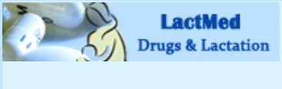 |  | Welcome to the LactMed database tutorial.  (Fill in instructions for closed captioning option)  LactMed is produced by the National Library of Medicine. It contains information on many of the drugs and chemicals to which breastfeeding mothers may be exposed.  It provides peer-reviewed information from the medical literature and the American Academy of Pediatrics about drug levels in breast milk and infant blood and possible adverse effects in the infant.
 | 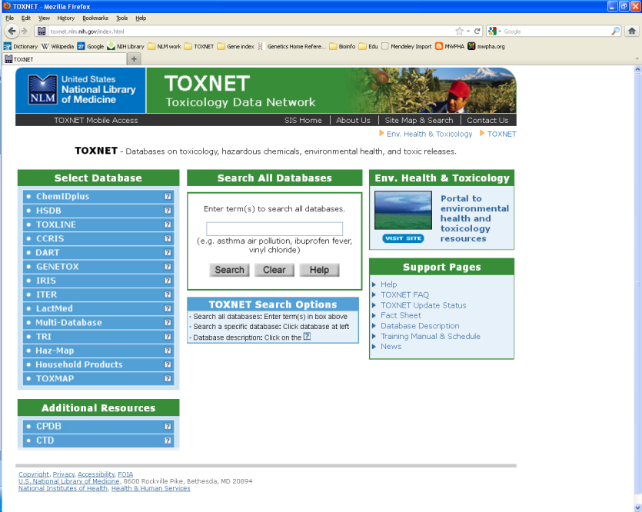 | Transition to website  Fade in callout for TOXNET URL  Highlight left-hand menu  Highlight only LactMed  Click LactMed to select | To search LactMed, go to the TOXNET homepage at  toxnet.nlm.nih.gov  LactMed is one of the many toxicology and environmental health databases that make up the TOXNET suite of resources.  Select LactMed by clicking it in the left-hand menu.
 | 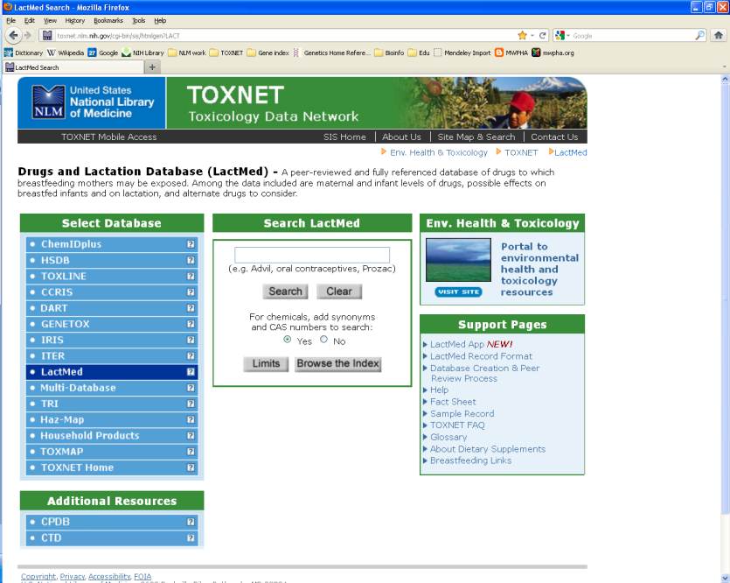 | Highlight “Search LactMed” above search box  Highlight Support Pages box  Type search term and hit Search button | Now the search box searches only LactMed, instead all the TOXNET databases.  Also notice the LactMed support pages available for more help.  Begin your search by entering a word or phrase that describes your topic of interest. You can enter generic or brand name drugs as well as non-drug terms.  For example, searching for the word ‘skin’ brings up a list of medications that are applied to the skin, or searching for ‘depression’ gets a list of results that includes several antidepressants.  Try entering the brand name ‘advil’ into the search box and click the search button.
 | 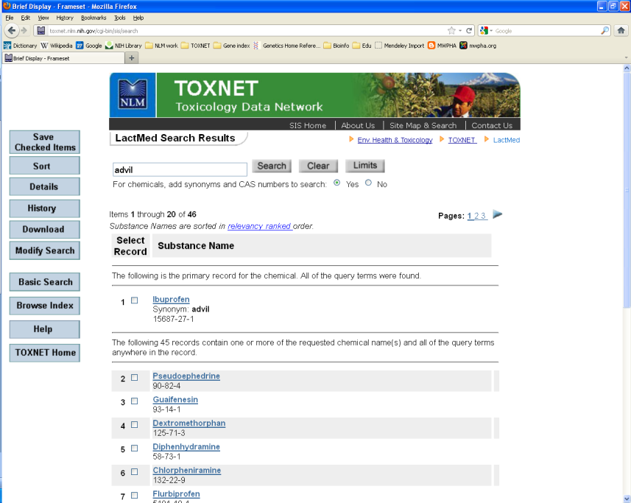 | Highlight top result  Highlight generic and brand names  Highlight remaining records  Click drug name link | The search results page brings up a list of drugs ranked according to how well a record matches your search word or phrase.  The top result is often the primary record for the drug you searched if you used a specific drug name as your search word.  Results are labeled with the generic drug name and might include synonyms such as the brand name. In this case, ‘ibuprofen’ is the generic drug name and ‘advil’ is the brand name.  The rest of the results are records that contain your search word somewhere within the contents of that record.  Your results may not always include the exact word you searched, especially when you search for a word that is not a specific drug name.  You can select the item you are interested in by clicking the drug name link. Click the ‘ibuprofen’ link at the top of the list.
 | 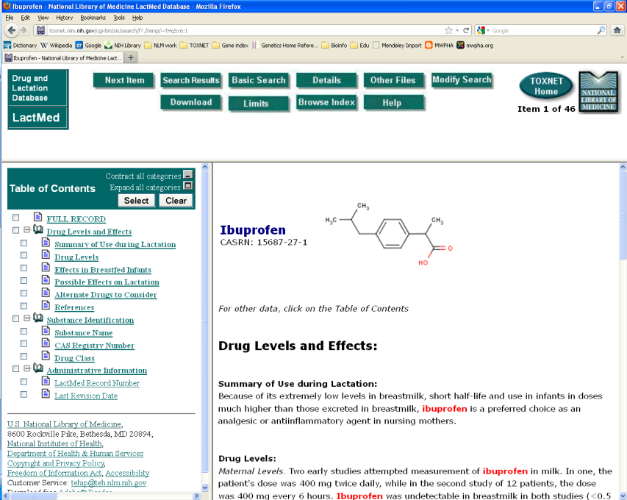 | Highlight content window  Highlight left-hand menu  Highlight button at top | This takes you to the full record for the drug.  Every LactMed record has 3 main parts to the page:  the content window with the information about the drug and its possible effects on lactation or breastfed infants,  a left-hand navigation menu containing the Table of Contents,  and buttons at the top of the page with various functions relating to your search and other LactMed features.
 |  | Scroll down slowly  Click Summary of Use during Lactation  Click Effects in Breastfed Infants  Click Possible Effects on Lactation  Click Alternate Drugs to Consider | The content window is set to open to the full record and you can scroll down to browse the entire entry.  Use the left-hand menu to jump to any part of the table of contents you wish.  Click on the ‘Summary of Use during Lactation’ section for the main points of the record and a description of using the drug while breastfeeding. The ibuprofen summary indicates that it is a preferred choice as a pain reliever in nursing mothers.  Click ‘Effects in Breastfed Infants’ to read about effects the drug may have on the infant, including whether there is any scientific evidence of adverse or harmful effects.  Click ‘Possible Effects on Lactation’ to see if the drug can have an effect on breast milk production or quality and composition.  Another useful section is ‘Alternate Drugs to Consider’. This section lists similar drugs to discuss with your healthcare provider.
 |  | Highlight relevant buttons as I explain them  Click Drugs and Lactation Database | Explore the buttons at the top of the record page to perform actions such as  return to your list of search results,  perform a new LactMed search,  or find more help and advanced training.  Click the ‘Drugs and Lactation Database’ link in the upper left-hand corner to return to the LactMed homepage.
 |  | Highlight LactMed App and Widget links  Highlight Glossary  Highlight About Dietary Supplements  Breastfeeding Links | This concludes the LactMed tutorial.  Check out the Support Pages for more information, including the LactMed app for mobile devices and the search widget,  the LactMed glossary,  information concerning dietary supplements,  and links to resources on breastfeeding that have been selected by professionals at the National Library of Medicine as credible health information resources.
 | Add final screen with the URL (as clickable hotspot?) and info about how to get help

