|  |  |  |  |
| --- | --- | --- | --- |
|  | 8/25/2014 |  | |
| |  |  | | --- | --- | |  |  | |  |  | |  |  | |  |  | | |  | |
| Competencies and the Network  *Defining Professional Competencies and Personal Characteristics for Health Information Outreach* | | | |
|  |  | | |  |  |  |  | | --- | --- | --- | --- | |  |  |  |  | |  |  |  |  | |  |  |  |  | |  |  |  |  | |  |  |  |  | |  |  |  |  | |

Don P. Jason III, Associate Fellow

**Project Sponsor:**

Renée Bougard, NN/LM NNO

Jacqueline Leskovec, NN/LM GMR

Table of Contents

**AbstractPage 2**

**Introduction Page 3**

**BackgroundPage 4**

**MethodsPage 5**

**OutcomesPage 10**

**Discussion Page 21**

**RecommendationsPage 23**

Abstract

**Objective:** This project assesses the comprehensiveness of professional competencies required for conducting effective health information outreach. In addition, desirable personal characteristics to complement these competencies were identified. Finally, suggestions on how the National Library of Medicine (NLM) and National Network of Libraries of Medicine, Greater Midwest Region (NN/LM GMR) Office can assist librarians in developing these competencies and characteristics were identified.

**Background:** In 2011, the NN/LM GMR conducted a Delphi study of their Outreach Libraries (Resource Libraries which received funding to conduct outreach) to identify competencies required for effective health information outreach practice. The study identified 39 professional competencies broken down into 5 categories.

**Methods:** In 2014, the results of the Delphi study were re-evaluated by an NLM Associate Fellow using a multi-method approach. Focus groups were conducted with GMR Outreach Librarians and Outreach Library Directors to evaluate the comprehensiveness of the competencies identified in 2011 as well as to identify personal characteristics for health information outreach practice. In addition, these focus groups were used to identify how the NLM and NN/LM GMR could assist Outreach Librarians with developing these competencies and characteristics. An analysis of final project reports submitted by GMR Outreach Libraries to the NLM was also conducted.

**Results:** While the competencies from 2011 were deemed essential, there were clear divisions between greater emphasized categories of skills and less emphasized categories of skills. Emerging competencies were also discovered. In addition, personal characteristics were identified. Current methods of GMR-sponsored support were proven effective and additional suggestions for support were identified.

**Recommendations:** The results may be used by the NN/LM GMR Office to assist librarians with:

1. Assessing their readiness for effective health information outreach practice and
2. Developing the identified knowledge, skills, and behaviors described in the professional competencies and personal characteristics

Introduction

In 2007, the need for a defined set of professional competencies for Outreach Librarians was identified at the National Network of Libraries of Medicine South Central Region (NN/LM SCR) Regional Advisory Council meeting. In addition, the topic of outreach competencies was raised at a meeting of the NN/LM Greater Midwest Region (NN/LM GMR) Outreach Librarians in March 2010. The SCR had a history of subcontracting outreach to its Resource Libraries (RL) since 1991, and the GMR had recently implemented a similar outreach subcontract with its RLs. Both Regions required a designated Outreach Librarian to coordinate the work performed under the subcontract and to serve as liaison to the NN/LM office. Interest in identifying professional competencies for Outreach Librarians was shared by the NN/LM Greater Midwest Region (GMR).

Resource Library Directors and NN/LM Staff proposed that core competencies (knowledge, skills, and behaviors) be identified to effectively conduct health information outreach. These competencies would be used to assist RL Directors in identifying personnel to serve as Outreach Librarians and NN/LM Staff in training Outreach Librarians to effectively conduct health information outreach.

The GMR formed a committee to identify the competencies needed for the librarians in this group. The committee recommended a Delphi study, which was in 2011. Part 1 of the Delphi survey was distributed to Outreach Librarians and Outreach Library Directors from GMR's 17 Outreach Libraries in summer 2011, resulting in a list of 39 competencies. Results from Part 2 of the Delphi survey (sent to the same audience in August 2011) found that 29 of the 39 competencies were rated as "essential" by more than 75% of the respondents."

# The Associate Project

The goals of the Associate project, conducted in 2014 were to: Evaluate the comprehensiveness of the 39 professional competencies for Outreach Librarians identified by the GMR; identify personal characteristics for Outreach Librarians to complement the professional competencies; and identify avenues for support and training that the GMR can implement, to help its Outreach Librarians develop and improve upon the competencies and characteristics.

Background

The National Network Office coordinates the National Network of Libraries of Medicine (The Network). The Network has 6,000 member libraries and is made up of 8 Regions. The Network was authorized in 1965 through congressional legislation known as the Medical Library Assistance Act (MLAA).

The Network’s goals are to:

* Provide health providers with access to biomedical information
* Provide the public with access to health information so they can make informed decisions about their health

The National Network Office at NLM coordinates the 8 Regional Medical Libraries and 3 Centers.

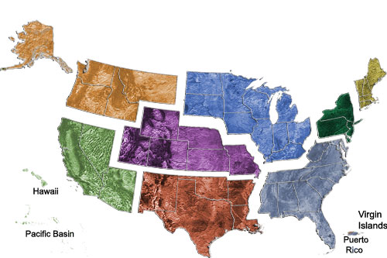

1. (Dark Green) Middle Atlantic Region - University of Pittsburgh
2. (Gray) Southeast/Atlantic Region - University of Maryland, Baltimore
3. (Blue) Greater Midwest Region - University of Illinois at Chicago
4. (Purple) MidContinental Region - University of Utah
5. (Red) South Central Region - Houston Academy of Medicine - Texas Medical Center Library
6. (Orange) Pacific Northwest Region - University of Washington
7. (Light Green) Pacific Southwest Region - University of California, Los Angeles
8. (Yellow) New England Region - University of Massachusetts Medical School

Three Centers:

* Outreach Evaluation Resource Center (OERC), University of Washington
* National Library of Medicine Training Center (NTC), University of Utah
* Web Services Technology Operations Center (Web-STOC), University of Washington

Methods

**Reviewing Previous Study:**

The GMR office conducted a survey in order to determine how to better support their Outreach Librarians, who are under subcontracts to conduct outreach throughout their region.

The GMR assembled a committee that conducted a literature review on competencies. This committee later recommended a Delphi survey. Outreach Librarians and Outreach Library Directors of the Greater Midwest Region participated in the two-part survey.

**Goals of the Previous Study:**

* To help librarians understand the knowledge, skills, and behaviors essential to the practice of health information outreach
* To assist library managers with selecting qualified job candidates for outreach positions
* To clarify the uniqueness of Outreach Librarianship through competencies
* To create an overall improvement in the quality of Outreach Librarianship

**Results of the Previous Study:** In the first round, the study generated a set of 39 competencies that fell into five categories. This is demonstrated on the next page in Figure 1-1.

In the second round over 75% of respondents identified 29 of 39 competencies as essential.

*(See appendices for a list of all 39 competencies as well as a breakdown of the competencies by category)*

Marketing Skills
Communication Skills
Teaching and Presentation Skills
Administrative Skills
Evaluation and Analysis Skills

**Figure 1-1**

**Focus Groups**

Three focus groups were conducted via Adobe Connect Pro. Two focus groups contained Outreach Librarians. One focus group contained library directors. 14 total participants out of a possible 30 participants attended the focus groups. There were 10 Outreach Librarians and 4 Outreach Library Directors who participated in the focus groups.

*(Explanation on 30 people - The GMR currently has 15 Outreach Libraries. Thus, those libraries have 15 Outreach Library Directors and 15 designated Outreach Librarians, which left us with a total of 30 possible focus group participants.)*

Three questions were asked during the focus groups:

1. **Which of the professional competencies identified in the 2011 study are still essential for health information outreach today?**

*Definition of professional competency: “Competencies encompass knowledge, skills, and abilities (KSAs)…Competencies are not only about what you know, but how you apply what you know.”*

*(Competency Management Initiative, National Institutes of Health, http://hr.od.nih.gov/workingatnih/competencies/default.htm)*

**Are there personal characteristics and traits that are necessary to conduct health information outreach effectively?**

*Definition of a personal characteristic: “Personal characteristics are the values, initiatives, and motivation that contribute to successful individual and organizational performance.”*

*(Competency Management Initiative, National Institutes of Health, http://hr.od.nih.gov/workingatnih/competencies/default.htm)*

**How can the GMR and/or the NLM help Outreach Librarians develop or improve upon professional competencies and personal characteristics?**

**Data Analysis**

The focus groups produced a wealth of qualitative data. However, it was necessary to find another data source to validate the feedback from the focus groups. The project team turned to an administrative data source, outreach reports submitted to the NN/LM GMR and NLM by Outreach Librarians. The team reviewed these reports to see if the original competencies were demonstrated in the reports.

In total, 39 reports were reviewed. They covered the years 2012, 2013 and 2014.

The team only looked at the reports from these years because these years coincide with the current Regional Medical Library contract, which covers the years 2011 to 2016.

Reports have 8 sections:

* *Executive Summary*- gives an overview of the outreach library, the type of outreach activities it engaged in for the year as well as the demographic groups it served.
* *Approaches and Interventions Used* - shares the methodology or process for doing outreach.
* *Evaluation Activities* - shows the way the Outreach Library assessed the outreach it conducted.
* *Problem or Barriers Encountered -* explains the struggles or hurdles that may have occurred during the outreach process.
* *Continuation Plans* - discusses how the Outreach Library will maintain the outreach projects it is currently conducting.
* *Impact –* shows the effect that an outreach activity had on a specific population, a community or an institution.
* *Lessons Learned -* speaks to best practices and what tips for success the Outreach Librarian learned while doing outreach.
* *Other* – is a general comments field where the Outreach Librarian can share additional information.

**Competency Mapping Process**

Competency mapping occurred in several phases. First, the project team read all 39 reports in their entirety. Second, references to competencies were identified in the reports. (These competencies were the 39 identified in the previous study.) Next, findings were documented and preliminary analysis was performed. Finally, conclusions and insights were identified.

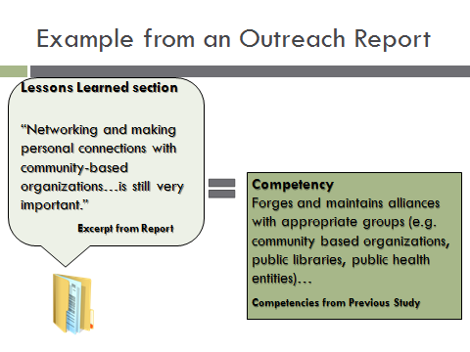

**Figure 1-2**

This is an example of competency mapping. This example comes from the “Lessons Learned section” of one report.

A member of the project team recognized references to a competency from the previous study.

The excerpt from the report reads:

“Networking and making personal connections with community-based organizations…is still very important.”

The similarity between this phrase and a competency from the previous study was recognized.

The competency from the previous study reads:

“Forges and maintains alliances with appropriate groups (for example, community based organizations, public libraries, public health entities)…”

This relationship was logged on a spreadsheet.

This process was done for each of the original competencies throughout all of the outreach reports. The conclusions and insights produced from this process are shown in the Outcomes section of this report.

*(For a more detailed methodology please see the appendices)*

Outcomes

# Professional Competencies

# **Focus Groups: Answer to Question 1**

**The Question: Which of the professional competencies identified in the 2011 study are still essential for health information outreach today?**

**What Outreach Librarians Stated in the Focus Groups:**

(#_) refers to the order the competencies were discussed in the Focus Groups. These numbers do not denote a ranking. The previous study did not rank the competencies and the current study did not rank them either.

## **Competencies, which were seen as 100 percent essential in previous study, are still essential in current study.**

* Understanding access methods to health information (#1)
* Seeking outreach opportunities (#2)
* Developing outreach appropriate to institutional mission (#3)
* Interacting effectively with others (#4)
* Using appropriate health information literacy concepts (#5)
* Strong oral communication skills (#6)

## **Competencies viewed as nonessential:**

* Writing skills (#27)
* Acquiring feedback for self-improvement (#32)
* Transmitting skills to peers (#34)
* Evaluating impact of outreach (#35)
* Assessment models (#37)
* Fundraising (#38)
* Grant writing (#39)

**The rationale for nonessential designation:**

*These are competencies of any competent employee, and not essential exclusively to Outreach Librarians:*

* Acquires feedback for self-improvement (#33 )
* Transmits skills to peers (#34)

*These competencies are not required, therefore not essential:*

* Acquires feedback for self-improvement (#33)
* Transmit skills to peers (#34)
* Evaluate effectiveness of outreach’s impact (#35)

## **Competencies in the previous study that were emphasized more in the current study:**

* Anticipating change (#28)
* Technology skills (#30)
* Knowing your demographic (#21 and #22)

**Competencies that should be combined into one:**

* Promoting library outreach (#20)
* Identifying role of outreach in institutional mission (#25)
* Garnering institutional support for outreach (#32)

## **What Outreach Library Directors Stated in the Focus Groups:**

**Competencies still essential to Outreach Librarians:**

* Understanding access methods to health information (#1)
* Seeking outreach opportunities (#2)
* Developing outreach appropriate to institutional mission (#3)
* Interacting effectively with others (#4)
* Using appropriate health information literacy concepts (#5)
* Strong oral communication skills (#6)
* Representing institution in a positive manner (#7)
* Appling appropriate technology for a given situation (#8)

**Competencies essential for all librarians:**

* Writing skills (#27)
* Creating a safe and welcoming environment (#26)
* Familiarity with resources (#1)
* Presentation skills (#12)

**Competencies that speak specifically to outreach:**

* Promoting library outreach service (#20)
* Using appropriate vocabulary level (#21)

**Competencies that should be combined together to make one new competency:**

* Choosing appropriate instructional strategies (#13)
* Understanding technology (#8)
* Using appropriate delivery methods (#14)

**A key theme – Collaboration**

*Outreach should be done as a team. No one person can have all 39 of the competencies. An outreach team might include:*

* Outreach Librarian
* Marketing Librarian
* Technology Librarian

## **Conclusions:**

**The Outreach Librarians and Outreach Library Directors agree on these topics:**

* The first 6-8 competencies from the previous study are essential to Outreach Librarianship today.
* Collaboration is necessary. One person cannot have all of the competencies.
* The competencies need to be consolidated. It is difficult to distinguish their slight differences.

**The Outreach Librarians and Outreach Library Directors disagree on these topics:**

* *Writing skills* ***-*** Outreach Librarians do not think this is essential. The Outreach Library Directors stated that this is essential.
* *Assessment -* Outreach Librarians do not think this is essential, while Outreach Library Directors think this is essential.

**All original competencies are emphasized to some degree**

*Greater emphasis on these categories of skills:*

* + Marketing
  + Evaluation and Analysis

*Less emphasis on these categories of skills:*

* Administrative
* Communication
* Teaching and Presentation

*(See appendices for a list of all 39 competencies and their specific category)*

# Personal Characteristics

# **Focus Groups: Answer to Question 2**

**The Question: Are there personal characteristics and traits that are necessary to conduct health information outreach effectively?**

To start the conversation on personal characteristics the project team presented these lists of characteristics. They come from the Medical Library Association as well as a textbook on community health workers. Here are the lists:

**Medical Library Association Competencies for Lifelong Learning and Professional Success**

* Ability to work independently or in groups
* Versatility
* Adaptability and flexibility
* Balance of personal and professional life
* Creativity, imagination, in problem solving
* Commitment to lifelong learning
* Leadership skills and qualities

**“Foundations for Community Health Workers” by Tim Berthold**

* Interpersonal warmth
* Trustworthiness
* Open-mindedness
* Objectivity
* Sensitivity
* Commitment to social justice
* Good psychological health
* Self-awareness and understanding

These lists were selected for different reasons. The list of MLA characteristics was selected because the Medical Library Association is well regarded by health sciences librarians. The project them felt MLA would have relevant personal characteristic for health information outreach. However, the project team also wanted to present a set of personal characteristics from a similar discipline to demonstrate a more holistic view of personal characteristics.

**What Outreach Librarians Stated in the Focus Groups:**

The Outreach Librarians agreed with all of the MLA characteristics as well as the characteristic for community health workers. However, some of the Outreach Librarians had a problem with some of the wording for the community health worker characteristics. For instance,

**Open-mindedness**- This was seen by some to be too academic a term and should be reworded to be “openness.”

**Commitment to social justice**- The Outreach Librarians wanted to reword this to say “Consumer/Patient Advocacy” of “Patient Empowerment”. Interestingly enough, several of the Outreach Librarians cited this as the reason why they became Outreach Librarians.

The Outreach Librarians did not view the two lists of characteristics, the project team presented, as all-inclusive.

**The Outreach Librarians added personal characteristics:**

* Leadership (with marketing and planning)
* Enthusiasm
* Cultural Competency
* Partnering with non-librarians to meet patron needs
  + The ability to work with volunteers, student groups and interns to successfully plan and execute outreach events.
* Poker Face/Composure
  + Ability to mask a shocked reaction. Often times members of the public come up to Outreach Librarians and divulge personal or family health histories that may be shocking. The Outreach Librarian has to remain calm.
* Knowing when to step back
  + Outreach is not about you. Often times Outreach Librarians have to adjust their approach to outreach depending on the situation. It may be appropriate to be more direct and extroverted at one health event, while at another event it may be more appropriate to be more introverted and let the public approach the librarian.
* Approachability
* Retail Mentality-
  + The ability to “sell/promote” NLM products to consumers. These products do not cost money, but consumers still need to be “sold” on the reliability and authoritative nature of NLM products.

## **What Outreach Library Directors Stated in the Focus Groups:**

The Outreach Library Directors thought all of the MLA Characteristics had a place in outreach, but were not happy with the characteristics for community health workers.

**Essential for outreach:**

* Ability to work independently or in groups
* Versatility
* Adaptability and flexibility
* Creativity, imagination, in problem solving
* Leadership skills and qualities
* Belief in what you are doing
* Courage

While the following characteristics were still seen as important, they were not considered essential for outreach.

**Nonessential for outreach:**

* Balance of personal and professional life
* Commitment to lifelong learning
* Commitment to social justice

The following characteristics were seen as difficult to measure. Hiring mangers cannot ask about these characteristics on job application and in job interviews, so Outreach Library Directors did not know how they would gain insight on these characteristics.

**Difficult to Measure these characteristics:**

* Interpersonal warmth
* Trustworthiness
* Open-mindedness
* Objectivity
* Sensitivity
* Commitment to social justice
* Good psychological health
* Self-awareness and understanding

While the Outreach Library Directors discussed the personal characteristics presented by the project team, they also wanted to add two characteristics.

**Added characteristics:**

* Belief in what you are doing
* Courage/Confidence

Opportunities for Support and Training

# **Focus Groups: Answer to Question 3**

**The Question: How can the GMR and/or the NLM help Outreach Librarians develop or improve upon professional competencies and personal characteristics?**

**Current GMR training and support that is working:**

*GMR Lake Effects:*

* Monthly Webinars
* Timely Outreach Topics:
* Outreach to Diverse Groups
* Disaster Preparedness

*GMR Tech Talks:*

* Bimonthly Webinars
* New Technology Topics
  + Microsoft Office Suite
  + Databases

**Participant Suggestions for Additional Support, using the competencies and characteristics as content for:**

* *Collaborative Outreach Program with Medical Library Association*
* *Outreach Boot Camp at NLM* 
  + There was interest in an Outreach Boot Camp for newly hired Outreach Librarians. These Outreach Librarians would come to NLM for intense training on the competencies and characteristics. This suggestion was also scalable to an online Boot Camp.
* *Continuing Education Opportunities*
* *Opportunities to Connect:*
  + The focus groups were a great way to facilitate support. Great way to share feedback and opinions
* *Peer Review/Performance Review:*
  + Some Outreach Librarians work alone so it is hard for them to be critiqued by other Outreach Librarians. They suggested having a way to do peer critiques at conferences or other meetings.

Competency Mapping

# **Data Analysis**

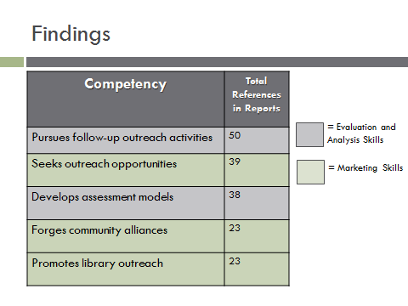

**Figure 1-4**

Here are the top 5 rows of a spreadsheet that has many more rows. These were the top 5 mentioned competencies in the reports. The competencies in gray are Evaluation and Analysis Skills and the competencies in Green are Marketing Skills. These two categories of competencies dominate the top of the spreadsheet, which indicates that they are the competencies which are most required or used in outreach.

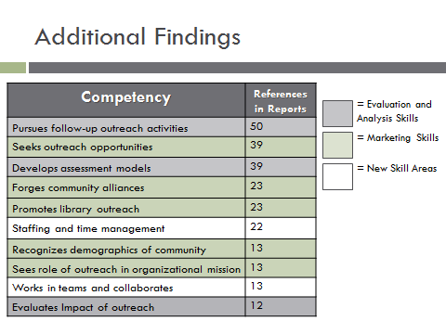

**Figure 1-5**

These are the top 10 most mentioned competencies. They further support the project team’s initial findings. The mapping process further validated what was said in the focus groups.

Of the top 10 most mentioned competencies in the reports, 3 competencies fall into the Evaluation and Analysis skills category, which is represented in gray. And 5 competencies fall into the Marketing Skills category, which is represented in green.

However, in the top 10 there are some competencies that do not fall into either category. They are not Evaluation and Analysis Skills or Marketing Skills. Interestingly enough, these competencies do not fall into the other three categories either.

The new skill areas, shown in the white rows are: not Administrative skills, not Communications skills and not Teaching and Presentation skills. Thus, the project team concluded that these are new skill areas, which are being branded as “emerging competencies.”

The Full Competency Mapping Spreadsheet

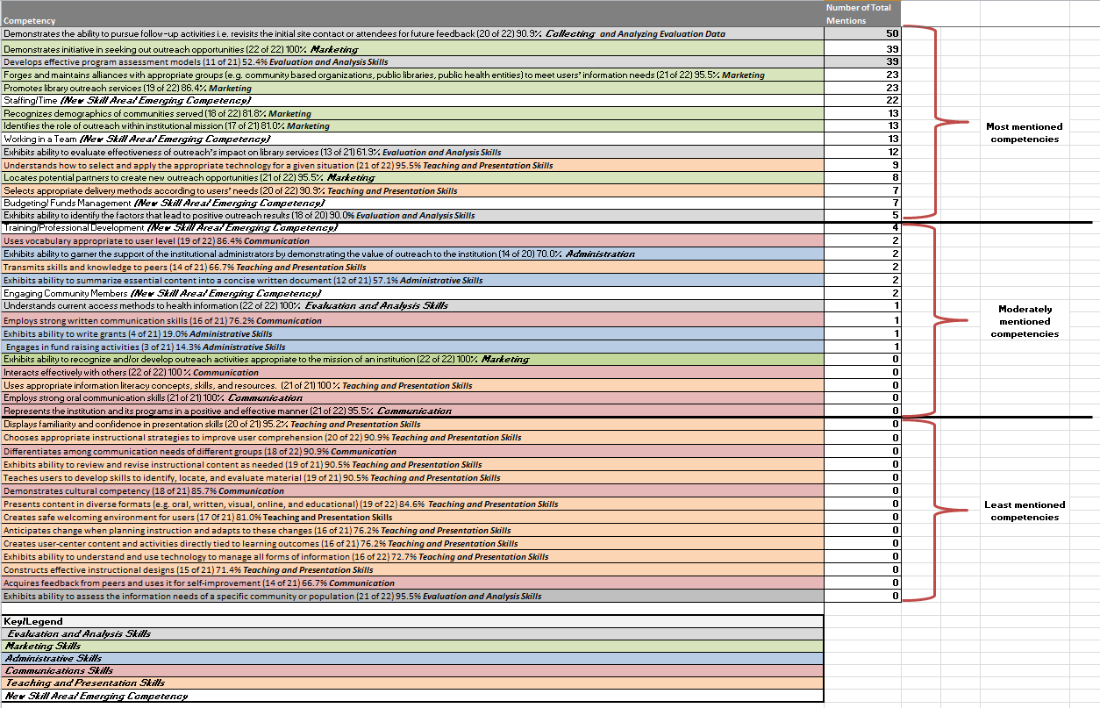

Moderately Mentioned

Competencies

Most Mentioned

Competencies

Least

Mentioned

Competencies

**Key/Legend**

Gray: Evaluation and Analysis Skills
Green: Marketing Skills
Blue: Administrative Skills
Red: Communication Skills
Orange: Teaching and Presentation Skills
White: New Skill Area / Emerging Competency

**Figure 1-6**

Figure 1-6 sows the entire spreadsheet. The top third of the spreadsheet features the most mentioned competencies, which happened to fall into the Evaluation and Analysis Skills as well as Marketing Skills categories. The middle third of the spreadsheet are the moderately mentioned competencies from the reports. It is made up of a mixture of all of the competencies and some new skill areas. Interestingly enough, all Administrative Skills reside in the middle third of the spreadsheet.

The competencies that are mentioned the least in the reports fall in the bottom third of the excel spreadsheet. The bottom third is made up, almost exclusively, of Teaching and Presentation Skills as well as Communication Skills.

In total, 19 of the original competencies did not map in the reports that were reviewed. However, 5 new skill areas were identified in the reports. These new skill areas are:

* Staffing and Time Management
* Teamwork and Collaboration
* Budgeting and Funds Management
* Seeking Additional Training
* Engaging the Public

The new skill areas were in the top and middle thirds of the spreadsheet. This means they are moderately to highly important to health information outreach practice.

*(See the appendices to view the entire competency mapping excel spreadsheet)*

Discussion

# **What was significant about the results?**

This project was significant because it validated a previous study on professional competencies. The previous study was validated by focus groups with Outreach Librarians and Outreach Library Directors from the GMR. This initial validation was further supported by data analysis done on outreach reports. The data analysis resulted in a color-coded competency mapping spreadsheet. This spreadsheet is broken down into thirds. The thirds include: most mentioned competencies, moderately mentioned competencies and least mentioned competencies. Overall, this spreadsheet allows for a visual validation. It also illustrates where the emerging competencies fall in terms of how frequently they were mentioned in outreach reports. These new skill areas/ emerging competencies have added to the comprehensiveness and timeliness of the competencies list.

This project was also significant because it proved that other skills, in addition to professional competencies, are needed to conduct health information outreach. Thus, the project team was able to identify personal characteristics that support the competencies.

This project also uncovered that the training and support the GMR is currently offering its Outreach Librarians, is working. Nevertheless, feedback was generated that provided suggestions for additional support and training.

# **Were there benefits to the Associate? What was learned?**

## **Benefit to the Associate**

The Associate enjoyed the National Network Offices’ unit during the curriculum phase of the Associate Fellowship Program. More specifically, the Associate was interested in the NNO’s approach to outreach. From the unit he learned that the NNO contracts outreach to its 8 Regional Medical Libraries who then subcontract the outreach to their regions in different ways. The Region the Associate was most interest in learning about was the Greater Midwest Region, because he worked in that Region before accepting his Associate Fellowship with NLM. He wanted to learn more about how the NNO awards outreach contracts to the NN/LM GMR and how the GMR then subcontracts outreach to its 15 Outreach Libraries. The Associate used a spring project with the NNO as a vehicle to gain this knowledge.

In addition, the Associate selected the project, in-part, because of the networking opportunities it would provide. This project gave the Associate the opportunity to meet a wide variety of Network members. He was able to arrive early at the Medical Library Association Conference in Chicago, IL in order to present at the Regional Medical Library (RML) Directors’ Meeting. The act of presenting and answering questions began preparing him for the capstone presentation he was required to give at the end of his Associate Fellowship.

In addition, the presentation at the RML Director’s Meeting opened the door for the Associate to meet the entire project team face-to-face. Before that meeting he had only corresponded with them via conference calls and emails.

## **What was learned**

The Associate learned that competencies and characteristics are very timely topics. Professional organizations such as: the Medical Library Association, the American Medical Informatics Association as well as the U.S. National Institutes of Health have taken an interest in these topics. These organizations have devoted their time and expertise to defining competencies and characteristics, in an effort to improve member or employee efficiency and performance.

Finally, this project allowed the Associate to expand his knowledge of the Network. The NN/LM unit during the Associate Fellowship Program curriculum was very informative and provided a baseline of knowledge on the Network. However, working with the NNO furthered his understanding. He went from knowing what the Network does, to learning first-hand how the Network accomplished its goals. He received a better understanding of the: resources sharing and the Network funding model that enables outreach to occur across America.

In conclusion, this project presented the Associate with countless opportunities to learn as well as many opportunities for professional growth and development.

Recommendations

# Future Steps

The research on competencies and characteristics will not end with this project. The Associate and an Outreach Librarian who participated in the study will present on professional competencies and personal characteristics in the fall of 2014. This will occur during the October 2014 meeting of the Midwest chapter of the Medical Library Association.

In addition, the results of the current study will be provided to the Regional Medical Libraries to assist them in further defining their support of outreach, in their Regions.

It is important to remember that the insights explored in this report were generated from the Greater Midwest Region alone. The NN/LM GMR is only one Region out of 8 total Regions that make up the Network.

As figure 1-7 illustrates, this study (focus groups and competency mapping from reports) should be replicated in other Regions to further define competencies and characteristics essential for health information outreach.

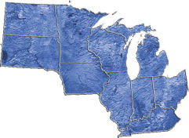

Scope of Current Study



Directions for Future Study

**Figure 1-7**