|  |  |  |  |
| --- | --- | --- | --- |
|  | 2/18/2014 |  | |
| |  |  | | --- | --- | |  |  | |  |  | |  |  | |  |  | | |  | |
| Turning Data Insights into Action: Developing a Google Analytics Customization Plan for the Division of Specialized Information Services  *Developing a Google Analytics Customization Plan for the Division of Specialized Information Services* | | | |
|  |  | | |  |  |  | | --- | --- | --- | |  |  |  | |  |  |  | |  |  |  | |  |  |  | |  |  |  | |  |  |  | |
|  |  | | Don P. Jason III, MLIS, MS |

**Project Sponsors:**

Colette Hochstein, D.M.D., MLS  
Stephanie Publicker, MLS

Table of Contents

**AbstractPage 2**

**Introduction Page 3**

**MethodsPage 5**

**OutcomesPage 10**

**Discussion Page 26**

**RecommendationsPage 28**

Abstract

BACKGROUND: The U.S. National Library of Medicine (NL M) Division of Specialized Information Services (SIS) has worked with staff in the Web Communications & New Media Division of HHS/ASPA to implement Google Analytics (GA) on a number of its pages. This initiative came about after President Obama pledged to make the government more transparent, accountable and participatory. Part of this includes understanding and optimizing usage and performance of government web pages. Google Analytics is a tool that can assist with this effort.

SIS has implemented several of GA’s features, but has not fully explored the tool. In this project an NLM Associate investigated additional features available in GA. He decided how the features would benefit SIS efforts, and implemented these features in customized dashboards.

The objectives of the project include:

* gaining an understanding of Google Analytics,
* becoming familiar with how SIS has implemented Google Analytics on its pages,
* becoming familiar with Google Analytics customized dashboards and reports
* becoming familiar with special implementation techniques,
* exploring how/which of the above might increase the value of Google Analytics to SIS.

METHODS: The Associate started by reading articles and blog posts on how to use and interpret Google Analytics. Next, he completed tutorials to learn how to customize GA. Then, he gained access to a test account and practiced with Google Analytics. After that, he built four customized dashboards. Finally, he shared them with the SIS project team members.

RESULTS/ CONCLUSIONS: Four customized dashboards were created for SIS, and shared in Google Analytics. They summarize statistics for DIMRC, Environmental Health, HIV/AIDS Information, and Outreach.

Introduction

Google Analytics (GA) is a free Web analytics tool available to anyone with a Google Account. The GA tool provides statistics and other tools that can help users engage in search engine optimization (SEO) and effective marketing. GA features include:

* Customizable dashboards and reports
* The ability to view data over time in order to extract trends
* The ability to share visualized data via email

GA only gives a snapshot of what is occurring on a web site because it does not collect all of the data associated with that web site. Instead of collecting data on every event that occurs on a site, GA uses a technique called sampling. This technique randomly chooses a subset of the total number of web events. Then this subset is analyzed to create the GA reports. The analysis of the subset of web events yields similar results to the analysis of the entire set of web events. For more information on sampling please see the Google Analytics Support Page: <https://support.google.com/analytics/answer/2637192?hl=en>

GA also does not have all of the data because Web users can prevent GA from collecting their data by turning off cookies or deleting their cache after viewing a web site that has GA installed. Also, GA will not collect data from people with JavaScript disabled. Additionally GA will not collect data from people that are logged into their Google Accounts (Gmail, etc.) while searching and browsing the web passively. However, if that person goes from browsing content on the web passively, to actively sharing content via Google-affiliated social networking sites (Google+, Google Groups, etc. *), then GA will report on the interaction. This may cause concerns for privacy.

More specifically, this heightened level of tracking allows the owner of the GA account to trace who posted the link on social media. For instance, if someone shares a link to an SIS resource on Google+ or in Google Groups the monitor of the SIS GA account will be notified (through GA) that a link to one of SIS’s resources was posted. The GA account monitor will then be able to see the post in context and essentially view the link sharer’s social media profile.

Overall, there are more advanced Web metric systems that can be purchased. However, GA is a great starting point for those needing a free, basic web metrics tool.

*The 17 Google-affiliated social networks are:

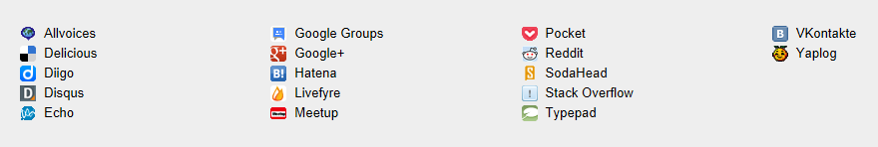

(Please note that Facebook and Twitter are not listed as being one of the 17 Google-affiliated social networks that are monitored in a heightened level of detail.)

Methods

# **Step 1: Read the Literature**

The Associate read articles and blog posts on Google Analytics in order to gain a better understanding of the technology. These articles included:

Google Analytics for Libraries  
<http://josephsandersmorgan.com/home/wp-content/uploads/downloads/2010/07/GoogleAnalyticsforLibraries3.pdf>

Improving Library web sites with Web Analytics

<http://www.slideshare.net/smemmott/mla-2010-improving-library-web-sites-with-web-analytics>

Using Google Analytics for Improving Library web site Content and Design: A Case Study

<http://unllib.unl.edu/LPP/fang.htm>

Discovering Digital Library User Behavior with Google Analytics

<http://journal.code4lib.org/articles/6942>

Web site Statistics 2.0: Using Google Analytics to Measure Library Web site Effectiveness

<http://www.tandfonline.com/doi/abs/10.1080/07317131003765910#.UmUx6XDRg6Y>

How Two Nonprofits Improve Their Site Performance with Google Analytics

<http://analytics.blogspot.com/2012/05/how-two-nonprofits-improve-their-site.html>

# **Step 2: Complete Online Tutorials**

The Associate completed online tutorials in order to familiarize himself with Google Analytics. The tutorials included:

Google Support Pages

<https://support.google.com/analytics/?hl=en>

Google Analytics Basic and Advanced

<http://www.google.com/nonprofits/learning/video-tutorials.html#tab5>

Google Analytics Tutorial Step-By-Step

<http://www.youtube.com/watch?v=mm78xlsADgc>

Google Analytics Essential Training

[http://www.lynda.com/Google-Analytics-tutorials/essential-training/61024-2.html](http://www.lynda.com/Google-Analytics-tutorials/essential-training/61024-2.html%20)

50 Resources for Getting the Most Out of Google Analytics

<http://blog.kissmetrics.com/50-resources-for-getting-the-most-out-of-google-analytics/>

Google Analytics Tutorial: 8 Valuable Tips to Hustle With Data

<http://www.kaushik.net/avinash/google-analytics-tutorial-8-valuable-tips-to-hustle-with-data/>

Google Analytics Custom Reports

<https://support.google.com/analytics/answer/1033013?hl=en>

# **Step 3: Hands-on Exploration with a Google Analytics Test Account**

The Associate conducted hands-on exploration with a Google Analytics test account and decided to look at specific features of Google Analytics one by one in order to better understand these features. This was preferable to taking more tutorials because many sections in Google Analytics were marked as “NEW,” so very little information was available in tutorials. Also, many of the tutorials were six months, one year or two years old. While this would not pose a hindrance to learning most other computer software it did cause problems when attempting to learning GA. Google Analytics changes its features on a monthly or even weekly basis. Thus, a tutorial that is even a month old can be obsolete.

The following summarizes what the Associate discovered when he went through the “Acquisitions” Tab and the “Audience” Tab in Google Analytics, feature by feature.

## **Acquisitions**

SIS has a great interest in where their visitors are coming from, so the Associate decided to explore the “Acquisitions” set of GA features first.

The Associate looked at the “Acquisitions” section/tab in order to determine what information he could access.

Under “Acquisitions” both the “Overview” and the “Channels” section are marked as “NEW” so not a whole lot of information is available about them as far as tutorials are concerned.

The “Overview” reports how many people arrive at your site from Referrals (being directed from other web sites), from direct traffic, from searching on Google and from social media.

“Channels” shows the same information as “Overview”; however, it gives a little more detail (the addition of the number of new visits, percentage of new visitors, bounce rate and average visit duration). This section also allows you to drill down deeper.

“Referrals” takes you to the actual sites that led users to the SIS sites. “Organic Search” shows the actual keywords typed into Google, “Social” shows the traffic from social media sites. “Direct” is the traffic that went right to the sites.

(For “Organic Search” Google sometimes reports “Not provided.” This occurs when someone is searching while logged into their Google account. If someone is logged into Google (Gmail, Google+, etc.) it does not provide the search terms used.)

“All Traffic” simply gives a ranking of the most popular traffic sites irrespective of the source (i.e. referral, direct traffic, social or an organic search)

The “Social” section was very interesting.  “Overview” shows all of the visits via SISs social media accounts as well as the percentage of the total number of social media visits that came from each individual type of social media. For instance, it might say that there were 100 total social media interactions for the month. 50 interactions (50 percent) of the social media interactions came from Twitter and 40 interactions (40 percent) came from Facebook, while 10 interactions (10 percent) came from WordPress.   Clicking on the “network referrals” reveals the same information as “overview,” plus the average amount of time the visits lasted.

“Landing Pages” shows which page was shared via each specific social media outlet and how many visits and page views were generated from that event.  It also reports the average duration of each visit.

“Visitors Flow” shows how many visitors came to a page from the specific social media outlet. It shows the jump from the social media site to the specific page that was on the SIS site. The flow shows how many visitors dropped off and did not view anymore pages on the SIS sites. It will also show how many pages a viewer continued on to view throughout the course of their visit. For example, some people came to the SIS sites via social media and continue on to view 12 plus pages within the SIS site before dropping off.

In the “Social” section “Data Hub Activity,” “Conversion,” “Trackbacks” and “Plugins” have no data at this time.

Overall, in the “Acquisitions” section there was no data collected for: “AdWords,” “Campaigns,” “Cost Analysis” or “Search Engine Optimization” as SIS is not using these features of GA.

GA has included redundancy. The “Keywords” (drill down to “Organic” keywords) and the “All Referrals” section are both covered under the new “Channels” section.

## **Audience**

Next, the Associate explored the Audience section of Google Analytics.

The “Geo” tab gives information concerning the language visitors have preset on their computer at the time they access SIS Web sites. The Location subset allows you to see a map indicating where in the world people are accessing SIS Web site. (You can drill down to the city-level).

The “Behavior” section has a “New vs. Returning” subset that shows new and returning visitors.  The “Frequency and Recency” shows the number of people who visited, how many pages they viewed while on the site and how often that person visited in the specified window of time. For instance, the page/dimrc.html had 19 people who came to the site 201 or more separate times, in the same month. While they were on the site they visited 24 pages. (This could be people who work in SIS.) “Engagement” shows how long visits lasted.

The “Technology” section has a subset called “Browser and OS,” which tells what Internet browsers people used to access the sites. It also tells what operating system visitors used as well as the screen color and resolution.  (This might be helpful in the future if SIS wants to update some of its Internet resources. SIS could use this data to optimize performance and display for the most frequently used operating systems, browsers and screen resolution and color.)  “Network” shows what Internet service provider is used by the visitor to SIS web sites. (Universities’ networks appear and networks from corporations also appear.) This may help indirectly answer some of the questions regarding the demographics of the web sites’ visitors.

Under “Mobile,” the “Overview” section tells you how many people access SIS sites via desktops, tablets and mobile phones. (It addresses new visits and bounce rates, etc. just like it does in the regular “overview” section for traditional traffic from desktop/laptops). “Devices” shows the actual device that people use to access the sites.

SIS is not using the “Custom” section as of yet.

The “Visitor Flow” section shows the same information that is presented in the “Geo” Tab. “Visitor Flow” just shows it in a different layout.

SIS will not pursue the “Interest” and “Demographics” reports, so the Associate did not explore these subsections.

# **Step 4: Build a Google Analytics Dashboard that Provides Insight**

The research project was guided by a set of questions. These questions were presented to the Associate during the initial meeting with the project proposal team. The questions are listed below:

* Which (TEHIP/DIMRC/OUTREACH/HIV) pages are visited the most often and how long do users typically spend on these pages?
* What appears to be the most common navigation pattern for the greatest number of users?
* What keywords (from Google or Bing or Yahoo) lead users to our site?  Does it appear that they are able to find what they were looking for after they get to the site from a search engine?
* Other than Google, NLM, TOXNET and Direct, which sites refer visitors to us most often?
* From the (TEHIP/DIMRC/OUTREACH/) home page, what are the most frequent exiting pages?
* Do users click from the TEHIP/DIMRC fly-out menu to get to our secondary pages?
* How do we set up and use “Visitor Flow” to maximize information?
* Are our users mostly new or repeat visitors?
* Are most repeat visitors coming from places that represent professionals (universities, for example)?
* Is the Social Network referral capture set up well?
* Are users finding what they came to look for?
* Is there a way to customize our Google Analytics account pages to show the data we are most interested in on the Dashboard, via Shortcuts, etc.?
* How do we create a Custom Report that automatically generates monthly with some of the above information?

Outcomes

# **First Attempt to Create a Google Analytics Dashboard**

The Associate started the process of building the customized dashboard for SIS by gaining access to the SIS Google Analytics account. First he went through Google Analytics and found widgets and indicators he thought would answer the questions posed to him by SIS, and created shortcuts for them to use later in the customized dashboard. However, he soon found it more direct and intuitive to bypass the shortcuts and install Google Analytics standard reports directly into the GA dashboard. He completed a 12-widget DIMRC dashboard.

The Associate provided the preliminary dashboard in question and answer format.

Several basic overview-type widgets were included: one widget provides the average number of visits per day for the month; the next widget provides the average number of pages/visits along with the average visit duration. A third widget provides the bounce rate for the month.

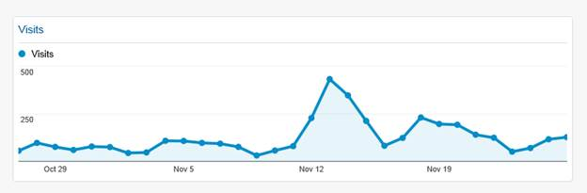

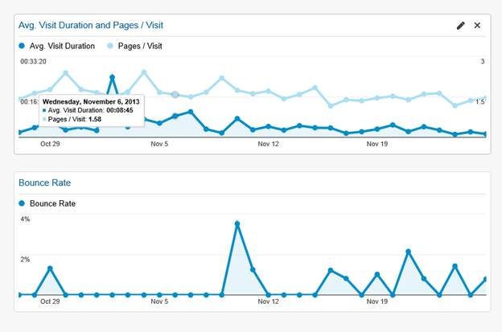

## **Direct Questions: Questions asked by SIS**

***Q: Which (TEHIP/DIMRC/OUTREACH/HIV) pages are visited the most often and how long do users typically spend on these pages?***

*Two Answers:*

A1: The Associate added to the dashboard a section called “Most Visited Pages.” A click on the hyperlinked title allows viewers to see the average time spent on all of the pages. Clicking on a specific page shows the average time visitors spent on that particular page.

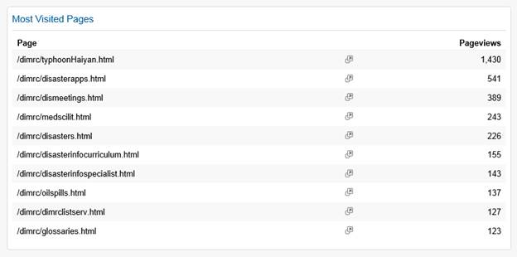

A2: The section on the new dashboards called “Most Common Landing/Entrance Pages.” This gives the first page visitors use to enter the site. By clicking on the list of web addresses, the length of their visit can be shown as well.

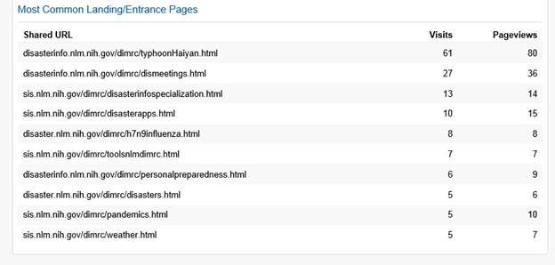

***Q: From the (TEHIP/DIMRC/OUTREACH/HIV) home page, what are the most frequent exiting pages?***

A: A widget showing the list of most commonly exited pages was added to the dashboard. Clicking on the hyperlinked title will give more detail concerning these exit pages.

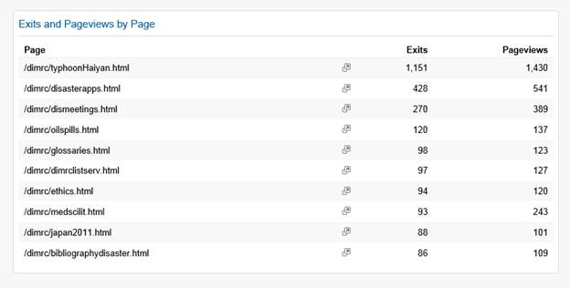

***Q: What keywords (from Google or Bing or Yahoo) lead users to our site?  Does it appear that they are able to find what they were looking for after they get to the site from a search engine?***

A: The Associate added a widget which reports on Keywords in relationship to visits and percentage of new visits to the dashboard. The Associate was unable to answer the second part of the question, concerning visitors having the ability to find what they are looking for.  This would most likely require tools such as focus groups, interviews or surveys.

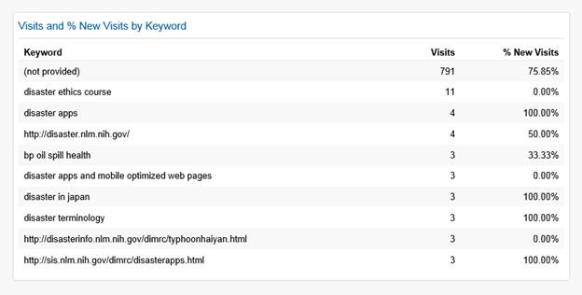

***Q: Other than Google, NLM, TOXNET and Direct, which sites refer visitors to us most often?***

A: The Associate included a widget that shows the most popular referral method to the DIMRC site.

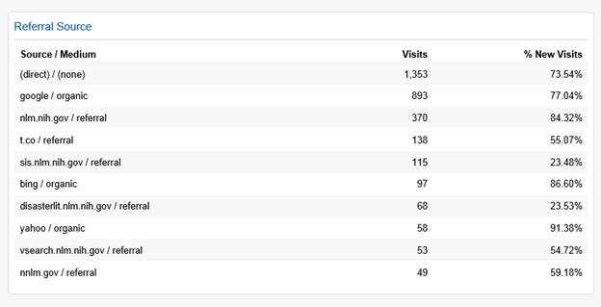

***Q:  Are our users mostly new or repeat visitors?***

A: This widget addresses the issue of new vs. repeat visitors. 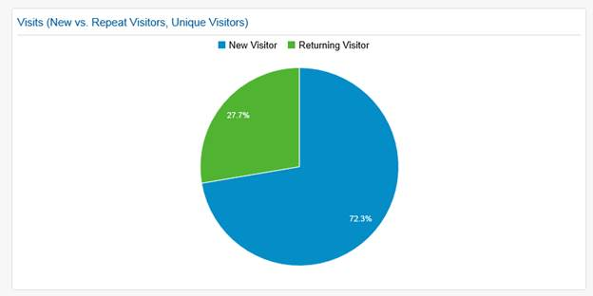

***Q: Are the most repeat visitors coming from places that represent professionals (universities, for example)?***

A: Some information about this was captured via a widget that shows the Internet networks that visitors use to access the SIS web sites. Some networks are affiliated with universities, government agencies, or corporate America, etc. This is shown by the URL extension, which may include an “.edu,” or “.gov.”

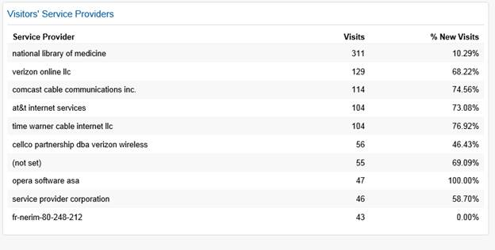

***Q: Is the Social Network referral capture set up well?***

A: While the Associate was unable to say if the Social Network is set up well; however, he did find data that showed the referrals from social media.

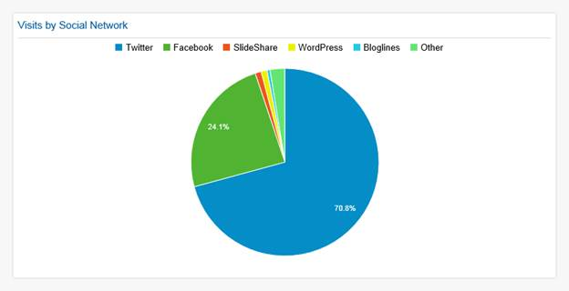

***Q:  Are users finding what they came to look for?*** [***https://support.google.com/analytics/answer/2558811***](https://support.google.com/analytics/answer/2558811)

A:  Indirectly the question can be answered by seeing what SIS-generated content people are sharing online. If people found the content useful enough to share on a blog or on some other online forum, then it may be because they found the content valuable. Google Analytics tracks every time users post links to SIS content, add an SIS web site to their favorites/bookmark list, or post SIS content in their blogs and social media accounts.

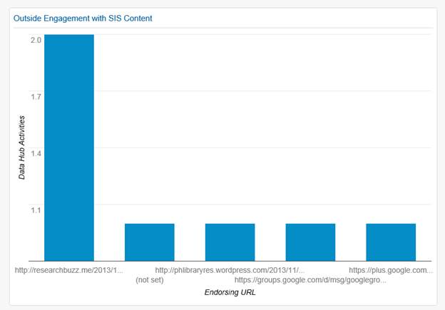

A: To answer this question the suggested way, you would need to use the in-page layout mode. When the Associate tried to enter this mode on Google Analytics an error message occurred, which stated that the code on the SIS pages were not installed in a way that would allow this feature to be used.

## **Process Questions: Questions SIS Generated as the Project Progressed**

***Q: Is there a way to customize our Google Analytics account pages to show the data we are most interested in on the Dashboard, via Shortcuts, etc.?***

A: Yes. This project is geared towards answering this question.

***Q: How do we create a Custom Report that automatically generates monthly with some of the above information?***

A:  There is an option in the dashboard for setting up regularly scheduled email notifications.

# **Critique from SIS Project Collaborators**

## **Questions that were answered correctly**

* ***Q: Which (TEHIP/DIMRC/OUTREACH/HIV) pages are visited the most often and how long do users typically spend on these pages?***
* ***Q: From the (TEHIP/DIMRC/OUTREACH/HIV) home page, what are the most frequent exiting pages?***
* ***Q: What keywords (from Google or Bing or Yahoo) lead users to our site?***
* ***Q: which sites refer visitors to us most often?***
* ***Q:  Are our users mostly new or repeat visitors?***
* ***Q: Is there a way to customize our Google Analytics account pages to show the data we are most interested in on the Dashboard, via Shortcuts, etc.?***
* ***Q: How do we create a Custom Report that automatically generates monthly with some of the above information?***

## **Questions requiring other action**

* ***Q: Are most repeat visitors coming from places that represent professionals (universities, for example)?* Suggestions: I think it may be more informative to use the Acquisition/All Referrals data for this question- what do you think?**
* ***For the referrals from social media can you provide a bar chart/other presentation options for this data in addition to the pie chart representation?***

# **Corrected Dashboard**

The Associate used the Disaster Information Management Resource Center (DIMRC) Dashboard as a model. After he created this as the prototype of the customized dashboard and it was reviewed by the project team, he proceeded to make the dashboards for the remaining SIS sites. These sites include the: Environmental Health and Toxicology web site, the Outreach Activities and Resources web site, and the HIV/AIDS Information Resources web site. He made all four of the customized dashboards the same and shared them with members of the SIS project team.

The Associate gave each widget a standardized title, and put all of the widgets in the same order on all four dashboards.

The next page shows a majority of a finalized dashboard:

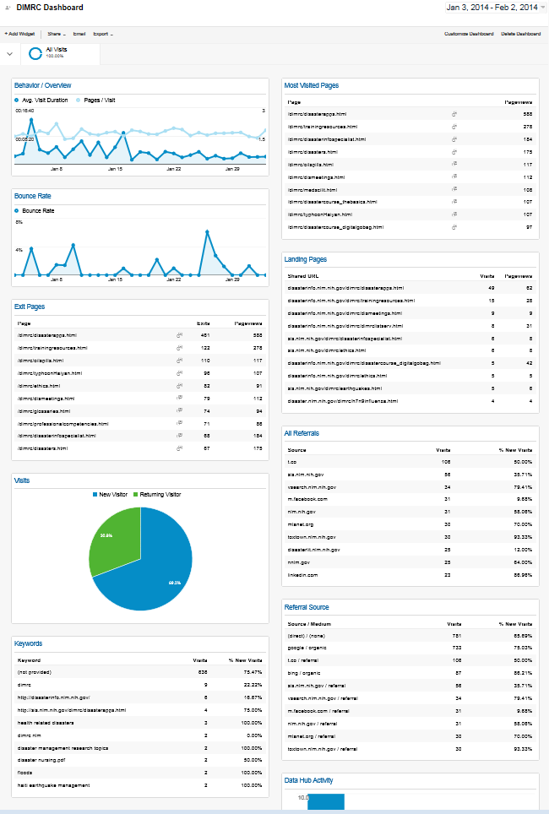

Here is the explanation of the entire dashboard, widget by widget.

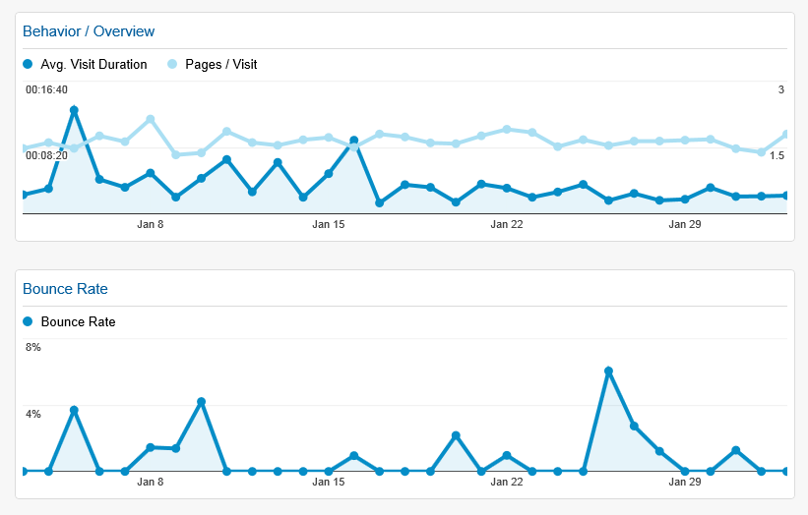

These first two widgets have not changed much, except for the fact that the one widget that simply mentions basic visit information has been removed to make way for other, more informative, widgets. These widgets show the Average Visit Duration and Average Pages viewed per Visit. The second widget shows the Bounce Rate, which is the number of people that arrived on the page and instantly backed out of it without clicking on anything.

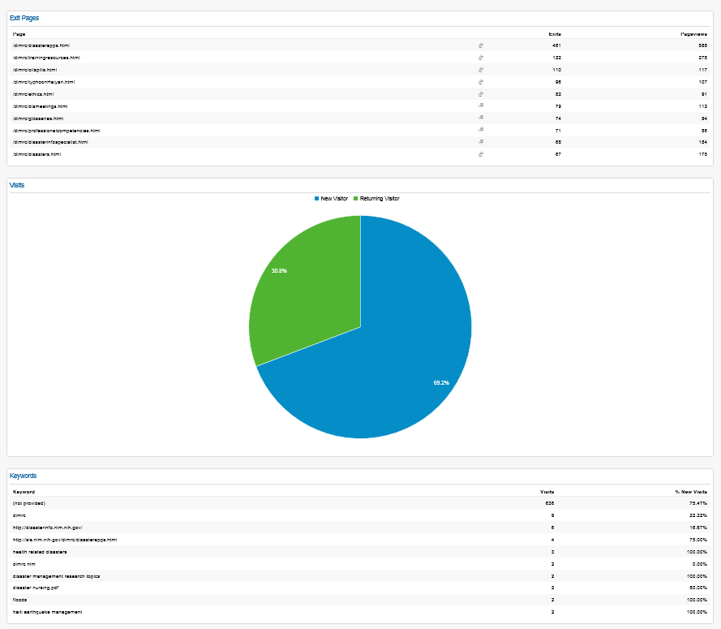

These three widgets show the pages that people exited from most frequently, the breakdown of new versus repeat visitors as well as the list of key words people typed into search engines to get to the specific SIS web site.

­ 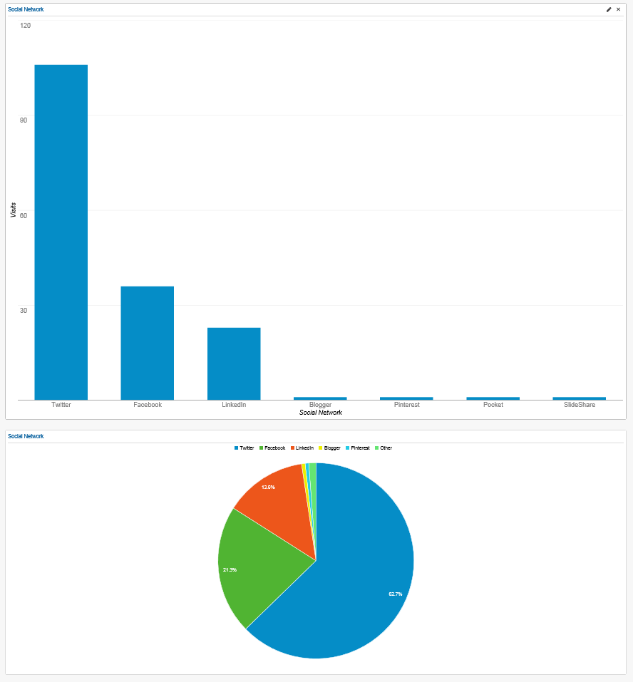

This next set of widgets show two views of the same information. They show the number and percentage of visitors that came to the specific SIS web site via social media sites such as: Twitter, Facebook, and WordPress, etc.

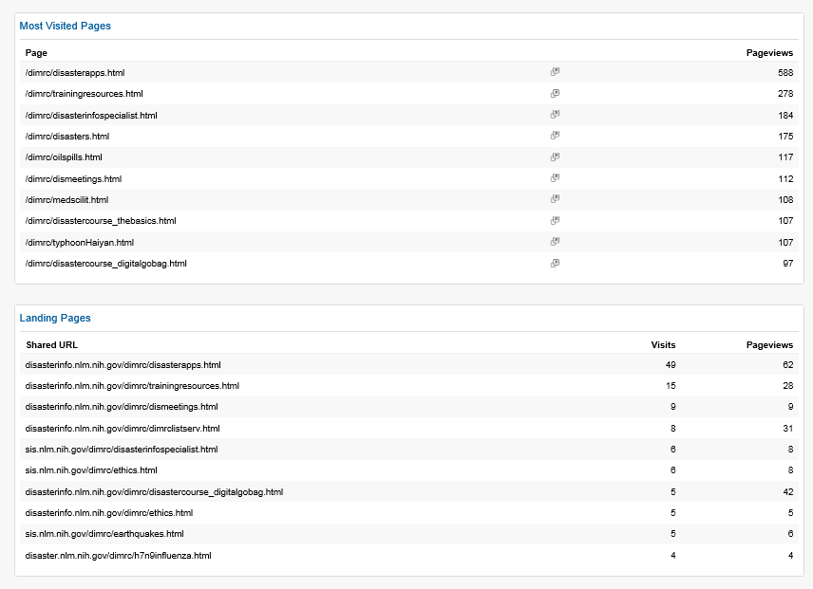

These widgets show the most visited pages out of the whole web site as well as the most common landing page or entrance page to the web sites.

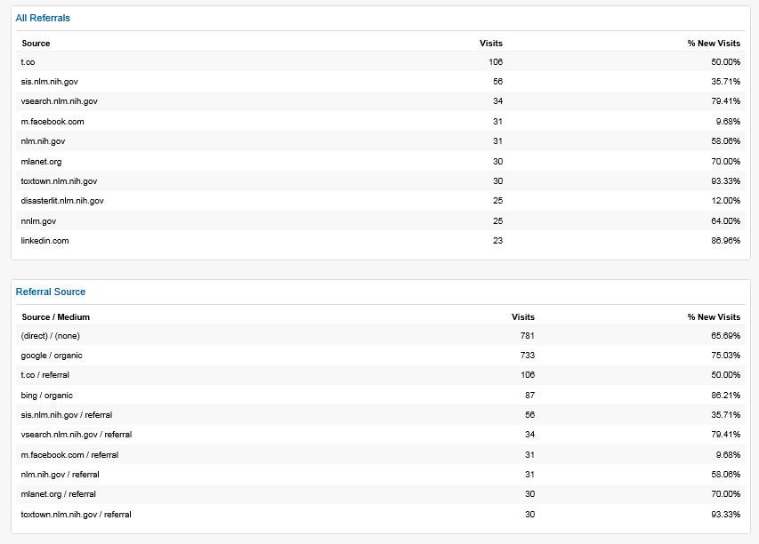

The upper widgets show the web site a user visited directly before entering one of SIS web sites. The lower widget shows the type of referrals the SIS web site is receiving.

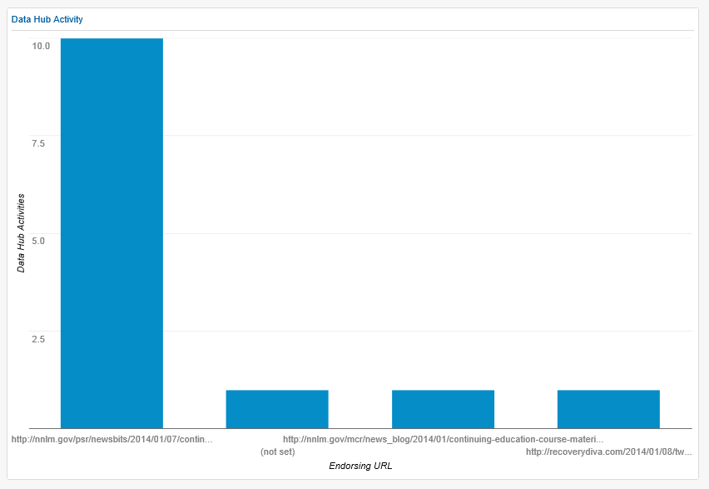

This widget shows how visitors are using SIS content. It shows: when they add one of the SIS pages to favorites, when they share a link to an SIS web site via a social media site or when they embed SIS content into their own web site.

Discussion

# **What was significant about the results?**

Originally, the results were to consist of the Associate providing a list of customizations that SIS could later implement. However, it became easier to simply implement the Google Analytics customizations himself. The results consisted of four customized dashboards that were shared with two member of the project proposal team. These team members will set the dashboards to email them monthly reports, so they can see how the four web sites are performing.

# **Were there Unexpected Results?**

The Associate was surprised to see that Google Analytics was such a powerful tool. It was shown to have many more features than were able to be explored in this project. For instance, Google Analytics allows its users to track demographics of visitors by age, gender and interest; however, that requires the activation of a special set of coding on the web pages being studied. It was initially surprising to the Associate that SIS did not want to activate this code and begin collecting this type of data. However, it was later explained that as a government entity, SIS has a duty to comply with the federal government’s policy on user privacy. The policy can be found here: <http://www.nlm.nih.gov/privacy.html> .

Even without this additional code placed on the web pages, Google Analytics is able to capture data the Associate thought would be impossible to find. For instance, Google Analytics shows when someone added one of SIS sites to favorites. It also shows when someone shares one of SIS on certain social media sites. If the social media site was Associated with a specific person, Google Analytics provides a link to the originating page.

# **Benefits to the Associate, What was Learned?**

## **Benefits to the Associate**

The Associate now has a better understanding of Google Analytics. This is a valuable job skill. In this digital age, where web presence is generally the first impression the public has, almost every company, organization or institution has a web site. These entities often place a high importance on their web presence, and want to know how well their web site meets the needs of its users. They want to know if people are able to use search engines to find their web site and what users are doing on their web site.

The Associate gained the ability to use Google Analytics to provide answers to these questions. He now knows how to set up customized reports and dashboards that can exclude extraneous information and only present the information that an organization or institution deems necessary.

## **What was Learned**

## A great deal was learned about the setup of Google Analytics. For instance, Google Analytics only allows one user account to have 10 customized dashboards with 12 widgets per dashboard, at any one time. While this may look like a lot, it really is not. Google Analytics gives account holders access to thousands of pieces of information about their web sites. Thus, the Associate learned that it is imperative to know what information is truly needed in the Google Analytics customized dashboard.

The Associate also received a better understanding of the type of data that Google Analytics collects.

It was also learned that it is quite easy for consumers to get around having their data collected by Google Analytics. Google Analytics uses “cookies” in order to collect data from users. When a user goes to a web site that has Google Analytics installed, cookies are deposited on the user’s computer, so when the user comes back to the site, the site will know that this is a repeat user of the site. If users delete cookies or set their browser to block cookies Google Analytics will not be able to track them online.

This may sound counterintuitive, but if users don’t want Google Analytics to track them, they should log into their Gmail or Google+ account and surf the web while logged in. Google Analytics will not track users that are logged into Gmail or some other Google subsidiary product. It will simply say “not provided” inside the Google Analytics software report.

# **What Should the Associate have done Differently?**

The Associate could have made a better effort to find more articles, tutorials and resources that showed him specifically how-to build the dashboards and reports. He was able to find many resources that were focused on the concepts behind Google Analytics, and how to interpret results and convert them into changes to a web site. However, there were very few resources that walked the Associate through the process of building a customized dashboard. Nevertheless, this could have been because Google Analytics is constantly changing. Updates are made to the web site several times per month, and any tutorials or articles focusing on the “how-to” would soon be obsolete.

Recommendations

# **Unanswered Questions**

There are several unanswered questions. They are:

* ***Q: How do we set up and use “Visitor Flow” to maximize information?***
* ***Q: What appears to be the most common navigation pattern for the greatest number of users?***
* ***Q: Do users click from the TEHIP/DIMRC fly-out menu to get to our secondary pages?***

The first two unanswered questions stem around visitor flow. There was a great deal of interest in including the visitor flow on the dashboard. Visitor flow shows GA users how many visitors came to a web site from the specific social media outlet. It shows the jump from the social media site to the specific page that was on the SIS site. Then the flow shows how many visitors dropped off and did not view anymore pages on the SIS sites. It will also show how many pages a viewer continued on to view throughout the course of their visit.

However, there are some technical issues preventing the visitor flow from being added to the dashboard. These issues are highlighted in the image below:

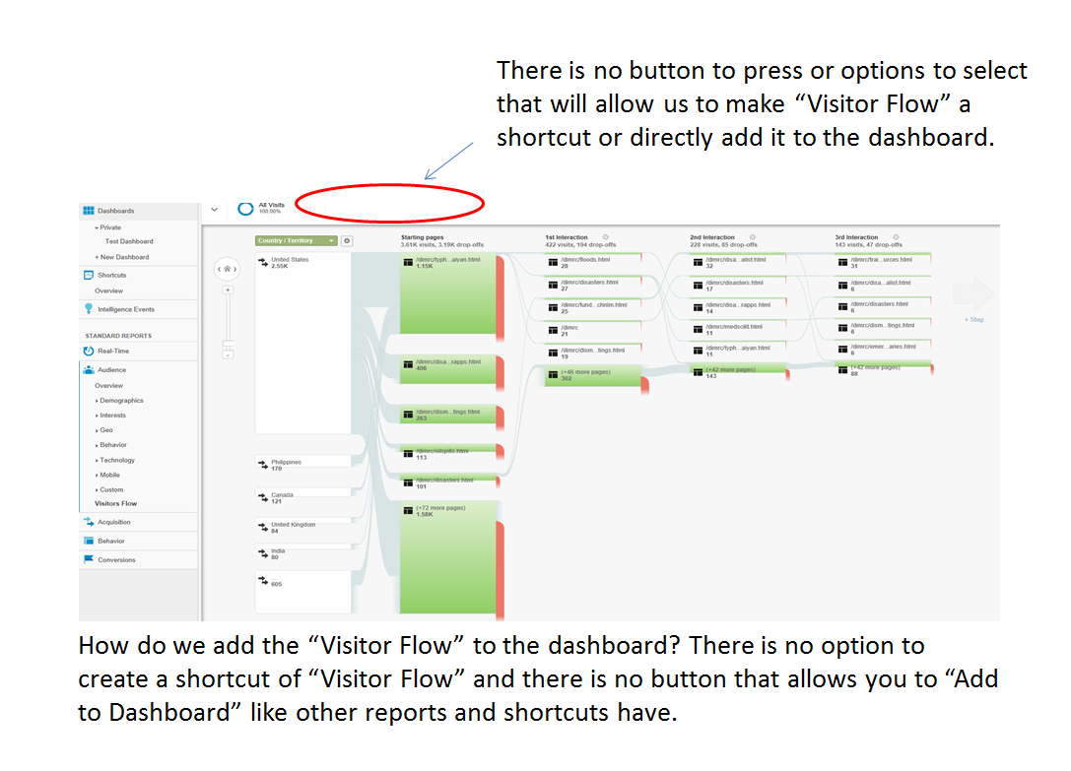

# **New Questions Developed During the Course of the Project**

**Q. Can the “Frequency and Recency” as well as “Engagement” indicators be added to the customized dashboard?**

A. “Frequency and Recency” allow you to see the number of people who visited, how many pages they viewed while on the site and how often that person visited in the specified window of time. For instance, /dimrc.html had 19 people who visited the site 201 or more separate times, in the same month. While they were on the site they visited 24 pages. (This could be people who work in SIS.) “Engagement” shows how long visits lasted.

Upon further investigation it was not possible to add these two indicators to the dashboard at this time. Google Analytics is still changing and being updated and the Google team has not yet created widgets suitable for the dashboard. However, it does say to “Stay Tuned,” which may mean that these widgets will be available shortly.

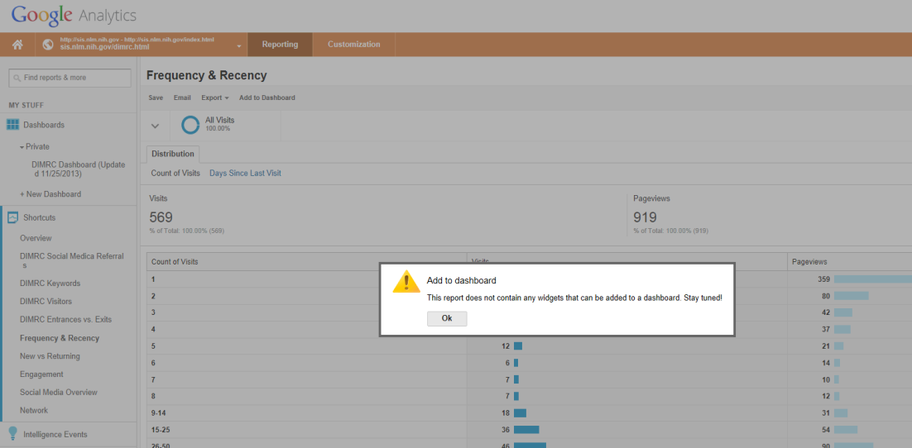

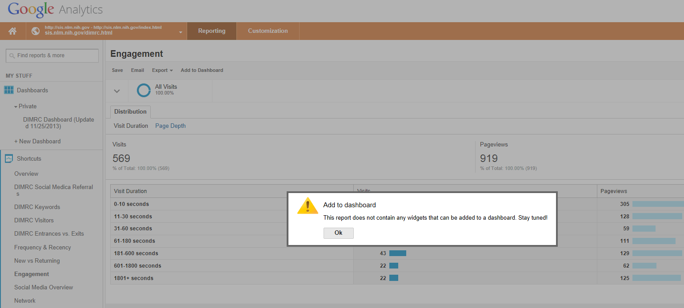

# **Editing and Adjusting the Dashboards**

The Google Analytics customized dashboards can be adjusted. To get to the widget follow these instructions.

Step 1 Locate the heading “My Stuff,” click on “Dashboards.”

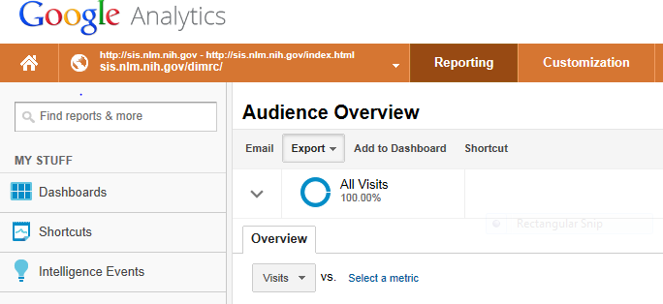

Step 2: Click on “Shared” and under shared click on the dashboard you are interested in viewing.

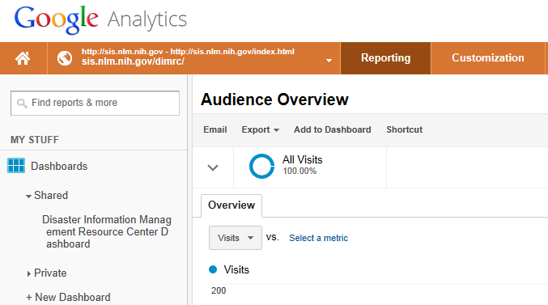

Step 3: The Dashboard appears full screen. There are several options for editing and adjusting the dashboard.

**Option: Changing the title of the dashboard.**

Step1: click on the title and it will turn yellow. Edit the text in the yellow region and click “save.”

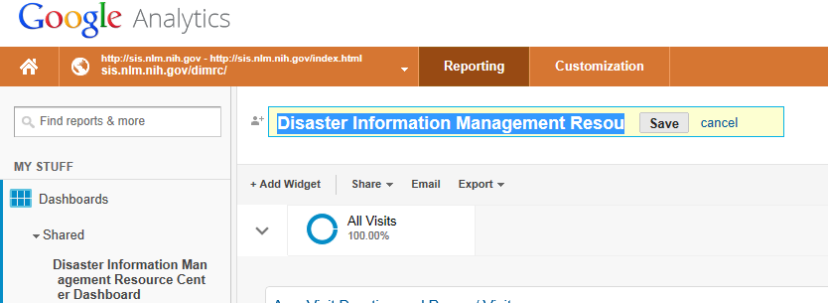

**Option: Editing a widget in the dashboard.**

Click the “x” to remove a widget from the dashboard and click the “pencil” icon to edit the widget. Editing the widget allows you to adjust its appearance on the dashboard (pie chart vs. bar graph vs. line graph, etc.) The pencil icon will also let you change the name of the widget.

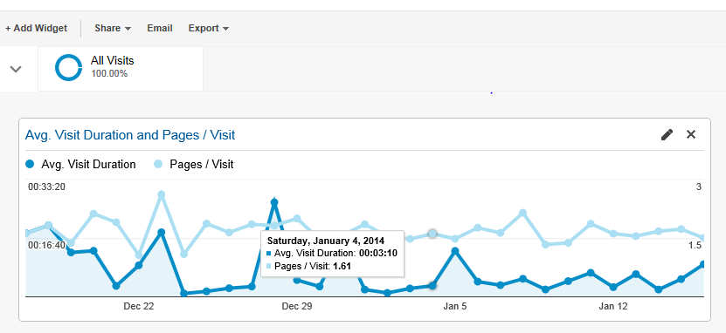

**Option: Adding a widget to the dashboard**

Step 1: go to the main page of the Google Analytics account you are working in and click on “Standard Reports.” Then pick a report that you want to view.

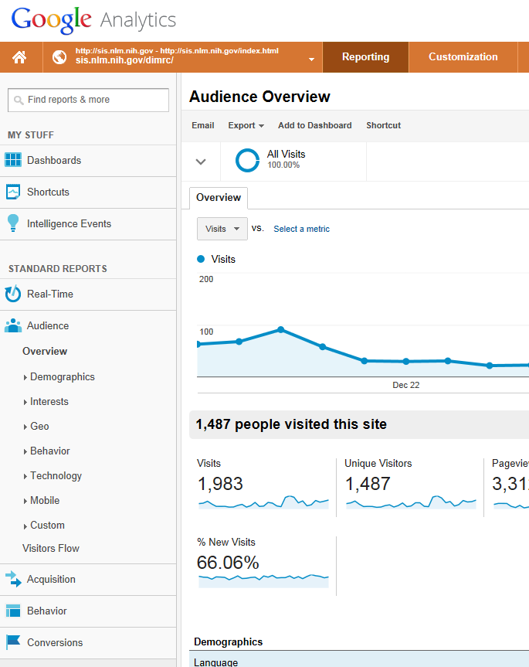

Step 2: For example clicking on “New vs Returning” brings up that report. Click “Add to Dashboard” and follow the prompts. This will put the widget on the dashboard. (There is a limit of 12 widgets per dashboard)

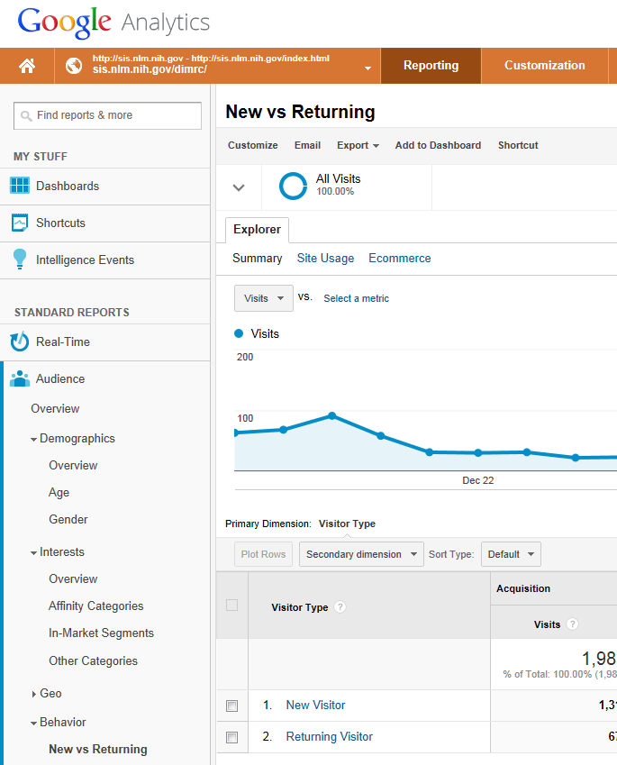

Step 3: Click on “Dashboard,” under “My Stuff” and select the Dashboard that you sent the widget to. Then the widget will appear.

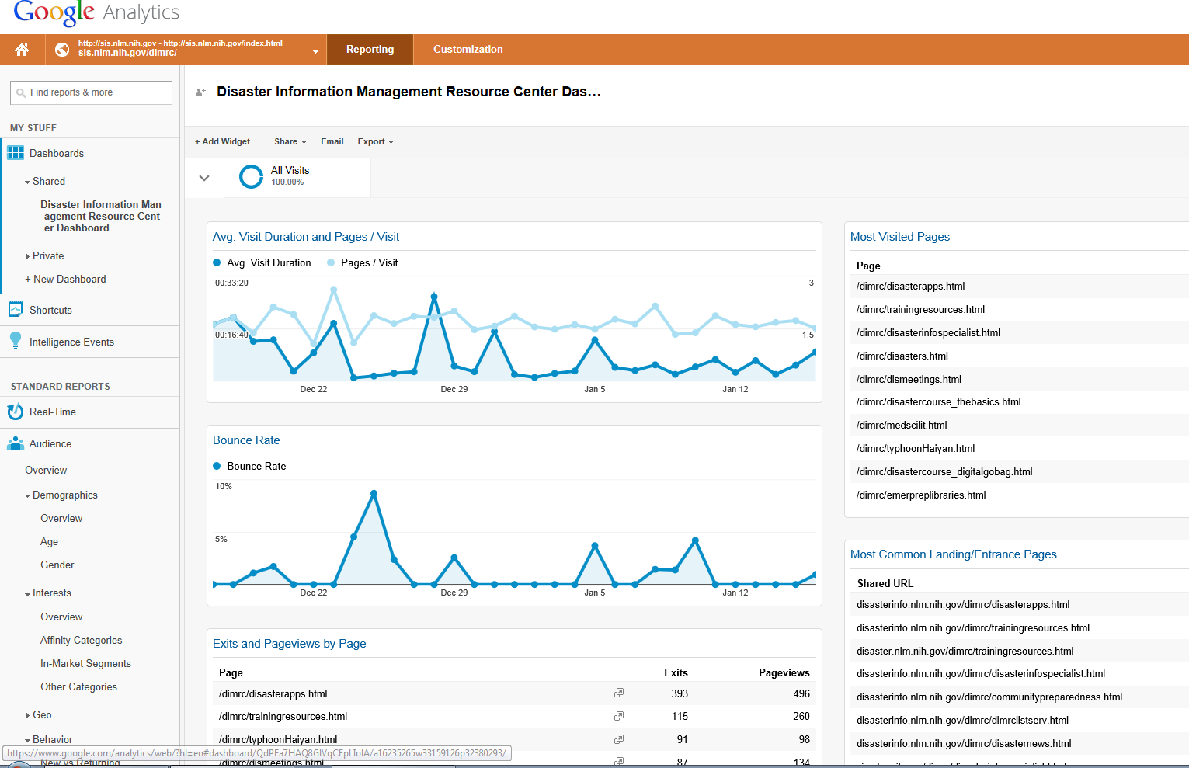

Step 4: Find your widget on the dashboard. Click the Pencil icon to change the name of the widget or transform the look of the widget.Returning Visitor: 33.9%
New Visitor: 66.1%

**Option: Customizing the look of the dashboard**

Step 1: Click on the Customize Dashboard option. The next option over allows you to delete the dashboard.

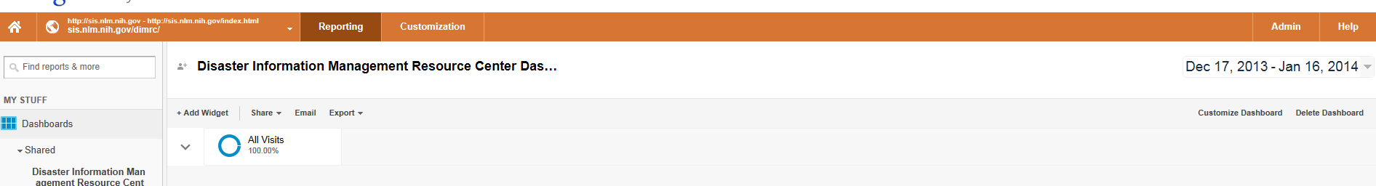

Step 2: choose a layout option for the dashboard and click “save.”

