DEVELOPING A USER-CENTERED VIEW
OF DAILYMED FOR MOBILE DEVICES
Stephen Kiyoi
Associate Fellow, 2010-2011
PROJECT LEADERS:
Stuart J Nelson, M.D., Head, Medical Subject Headings Section
Wei Ma, Chief, Applications Branch, Office of Computer and Communications Systems
PROJECT TEAM MEMBERS:
Chandra Kola, Senior software Engineer, Applications Branch, Office of Computer and Communications Systems
David Zhang, Web Developer, Applications Branch, Office of Computer and Communications Systems

ABSTRACT
OBJECTIVE
The aim of this project was to create a user-friendly interface for a mobile version of DailyMed, the National Library of Medicine’s website for structured product labels (SPLs) provided by the Food and Drug Administration. Project leaders sought to capitalize on the growing use of the mobile internet to access health related information.
METHODS
The Associate documented existing functionality of the DailyMed desktop website, including search, label emailing, browsing, dictionary, SPL previewer, adverse event reporting, etc. Through the course of several meetings, team members elected to highlight and simplify the search and retrieval of SPLs by removing secondary features such as the dictionary and preview functions. In a comparative analysis process, the Associate gathered screenshots of Wikipedia’s mobile website, and MedlinePlus mobile website for comparisons and ideas in the initial design process.
RESULTS
The Associate successfully communicated with team members to produce a set of 20 high level user interface design documents (wireframes) contributing to a polished user interface on the DailyMed Mobile website, fully operable on multiple mobile devices. All team members were pleased with the final results.
CONCLUSIONS
In the calendar year of 2010, the DailyMed desktop website received over 77 million page hits, and over 3 million unique visitors. With the creation of a DailyMed mobile website, the National Library of Medicine aims to extend this valuable resource to more users in more contexts to achieve an even greater impact.

Table of Contents
INTRODUCTION 5
METHODOLOGY: PROJECT COMPONENTS 6
OUTCOMES: WIREFRAMES 7
WIREFRAME FIGURES 8
HOMEPAGE 8
SEARCH RESULTS 9
BROWSE CHOICE OF DRUGS 10
RECORD PAGE 11
SHARE LABEL V.1 12
SHARE LABEL V.1 FLOW 13
SHARE LABEL FAILURE FLOW 14
SHARE LABEL V.2 15
SHARE LABEL EMAIL FORM 16
RXNORM NAMES 17
RXNORM NAMES FLOW 18
ABOUT DAILYMED 19
ABOUT RXNORM 20
VETERINARY RECORD PAGE 21
PRIVACY 22
ACCESSIBILITY 23
COPYRIGHT 24
CONTACT US 25
CONTACT US FLOW 26
CONTACT US FAILURE FLOW 27
DAILYMED MOBILE AND DESKTOP COMPARISON FIGURES 28
HOMEPAGE 28
SEARCH RESULTS 29
RECORD PAGE 30
SHARE LABEL PAGE 31
SHARE LABEL EMAIL FORM 32
RXNORM NAMES 33
VETERINARY RECORD PAGE 34
PRIVACY 35
ACCESSIBILITY 36
COPYRIGHT 37
CONTACT US 38
DISCUSSION 39
RECOMMENDATIONS 40
BIBLIOGRAPHY 41
APPENDIX A: TIMELINE 42
APPENDIX B: ORIGINAL PROJECT PROPOSAL 43

INTRODUCTION
Beginning October, 2005, drug manufacturers have been required to submit electronic, HL7 standardized drug labels to the Food and Drug Administration (FDA) for approval. NLM worked closely with the FDA to sign a memorandum of agreement, which called for NLM to receive these drug labels once they were approved by the FDA. And on November of 2005, the National Library of Medicine (NLM) introduced the DailyMed, its online repository of drug product labels, to the general public.
Since that time, DailyMed has grown steadily in both scope and functionality. Beginning originally with a single label for the first three months, DailyMed accessioned its 500th label on August 4th, 2006, just over a year from its inception. As of January, 2011, DailyMed has grown to include over 20,000 labels, including 623 veterinary drug labels. DailyMed currently receives over 77 million page hits a year. DailyMed has also increased in functionality. In May of 2009, DailyMed introduced its product identification system, designed to assist patients and health professionals in identifying solid dose form medications by color, size, shape, scoring, and imprint.
NLM has always been acutely aware of the need, not only to develop high quality, comprehensive resources, but also to provide them in the most convenient way to the widest possible audience. With the growing popularity of internet enabled phones and tablets in the United States, and mobile phone usage internationally, NLM sees a tremendous opportunity to extend the impact and reach of its products and services. According to Pew Internet & American Life Surveys, cell phone internet access has grown rapidly over the past several years. From April, 2009 to May, 2010, the percentage of Americans who access the internet from their cell phone grew sharply from 25% to 38%.¹ An even larger percentage of young adults (18-29; 65%) use their mobile phone to access the internet. ¹ As these young adults are likely to carry these habits into the future, they provide a valuable indicator of long term mobile internet trends.
Those on the mobile internet are also increasingly likely to use their devices to access health information. According to Pew Internet & American Life Survey’s 2010 Mobile Health Report, 17% of cell owners have used their phone to look up health or medical information and 29% of cell owners ages 18-29 have used their phone to look up health information. ²
NLM has sought to capitalize on this trend towards mobile health information by providing more of its resources through mobile devices. In every case, the relatively small size of mobile phone screens necessitates extensive redesign of the user interface to improve readability and navigation. This project provides a set of wireframes to NLM’s Office of Computer and Communications Systems (OCCS) for their reference in the development of a fully functional DailyMed mobile website.

METHODOLOGY: PROJECT COMPONENTS
Creating a user-friendly interface for DailyMed mobile website required that the Associate and the project team: acquire a detailed understanding of the DailyMed desktop website and its functionality, decide which functionality to include on the DailyMed mobile website, identify existing mobile websites to serve as fully functional examples of design ideas, and create a set of wireframes to communicate design ideas to members within the project team. Below is a brief explanation of these project methodologies, in the chronological order of the design process.
DECIDE FUNCTIONALITY
After identifying the DailyMed Desktop website’s existing functionality, the project team chose to highlight the search, retrieval and display of SPLs by removing most secondary features such as the dictionary and preview functions. This decision contributed to a streamlined interface which would be convenient for mobile users in their often rushed or distracted environments. The project team also focused its attention on improving the design of the label emailing functionality, so that mobile users could easily email a label for later review on a larger screen.
CONDUCT COMPETITIVE ANALYSIS
In the early stages of design, the Associate searched for existing mobile websites to communicate design ideas with members of the project team. The Associate chose to focus on Wikipedia’s mobile website, for its ability to expand and contract sections of its record pages without reloading, and the MedlinePlus mobile website, as an example of NLM’s de facto web design standards. These fully functional websites offered a robust illustration of functionality and design, and helped make a strong case for how design ideas could be implemented successfully.
CREATE WIREFRAMES
Multiple design and content layout issues were discussed within the project team. The possibility of DailyMed logo redesign, the differentiation of Veterinary SPLs from Human SPLs, rewritten “about” text, and content placement were all discussed and resolved in the early stages of the design process to avoid redundancy of work in the later stages. Once these issues had been discussed, the Associate created a set of 20 wireframes to communicate webpage design and content layout to OCCS as they developed the website. All wireframes were designed using Microsoft Visio.

OUTCOMES: WIREFRAMES
These wireframes represent high level design ideas for OCCS’ reference as they develop the DailyMed mobile website. These wireframes convey simplicity, ease of use, prominent search functionality, and convenient navigation. While these documents provided a foundation for OCCS reference in development, the Associate offered design input to OCCS developers throughout the development process. Discrepancies between the wireframes and fully developed screenshots represent close collaboration between team members. Several design elements, such as: search instructions inside search box, search box and go button on same line, and maximum 20 search results per page will be implemented in later iterations due to tight release schedule.
In some cases, where the “flow” or “actions” of a page are not intuitive, a separate “flow” document has been included after a static representation of the given page. Textual explanations were also included within wireframes wherever necessary.

WIREFRAME FIGURES

HOMEPAGE
- DailyMed logo link to homepage throughout.
- Create large link button area around “About DailyMed” and “Browse Labels” text.
- Maximize link button area on all links.
- Include auto complete in all search boxes. Begin after 3 characters.
- Do not restrict one or two character searches. (these may be valuable in retrieving large data sets for researchers)

SEARCH RESULTS
- “See more results link” adds 20 more results to (or as many as available) to bottom of screen.
- Above action also updates the “Results:” indication at top of screen to indicate number of records shown.
- “See more results” link shows until there are no more results to be displayed.

BROWSE CHOICE OF DRUGS
- Follows MedlinePlus design closely.
- David Zhang, OCCS to develop prototype options.

RECORD PAGE
Use order of sections from Dr. Nelson.
Only show sections if they are available.
“+” switches to “-“ when pressed, and includes:
- Black box warning
- Highlights
- Description
- How supplied
- Dosage and administration
- Adverse reactions
- Indications
- Contraindications
- Overdosage
- Patient Package Inset
- Medication Guide
- Patient Counseling Information
- Clinical Pharmacology
- References
Box and arrow icon indicates outside link.
Link to PubMed for Handhelds if possible.

SHARE LABEL V.1

SHARE LABEL V.1 FLOW
- “Share label” link expands a section of the screen.
- “Send” button and “E-mail Label –“ buttons both collapse E-mail label section.
- “Label sent” in rightmost frame indicates that label has been sent.

SHARE LABEL FAILURE FLOW

SHARE LABEL V.2

- Technically more difficult.
- Animate the fading of the background, and highlighting of the form to orient user. (if possible)
- Touching any other part of screen, or pressing cancel will collapse highlighted, expanded form.
- Animate, and follow same flow as above when pressing send, cancel, or any other part of screen.

SHARE LABEL EMAIL FORM
- This is what the recipient of a shared label will see in email form.
- Line color changes from Red to green for veterinary labels.
- Subject line changes to “DailyMed Veterinary Drug Label” for veterinary label.

RXNORM NAMES

RXNORM NAMES FLOW
- “RxNorm Names +” link expands section of screen.
- “What is RxNorm” links to “About RxNorm” page.
- “RxNorm Names –“ collapses section of screen.

ABOUT DAILYMED

- Borrowed text from about NLM page.
- Create live link to keep updated information.
- All static, informative pages follow this template (without search box at top)

ABOUT RXNORM
- Borrowed text from RxNorm webpage.
- Create live link to keep updated information.
- All static, informative pages follow this template (without search box at top)

VETERINARY RECORD PAGE
- Green Header and Green bar indicate veterinary drug label.
- “Veterinary Medicine Labels” in green text indicates veterinary drug label.
- Apply banner and color scheme to all veterinary related drug labels, and email form.
- Otherwise, identical to main DailyMed drug label record page.

PRIVACY

ACCESSIBILITY

- Include phone number links.

COPYRIGHT

CONTACT US

CONTACT US FLOW
- Valid message results in moving loading icon.
- Successful message sent redirect user to their last point of browsing (in this case, the homepage) with an expanded section as shown in left frame.
- “Close” button collapses expanded successful comment section.

CONTACT US FAILURE FLOW

DAILYMED MOBILE AND DESKTOP COMPARISON FIGURES
Below are screen shot comparisons of the desktop and mobile versions of the DailyMed website. Mobile design focused on highlighting search, retrieval and display of SPLs by removing secondary functionality.

HOMEPAGE
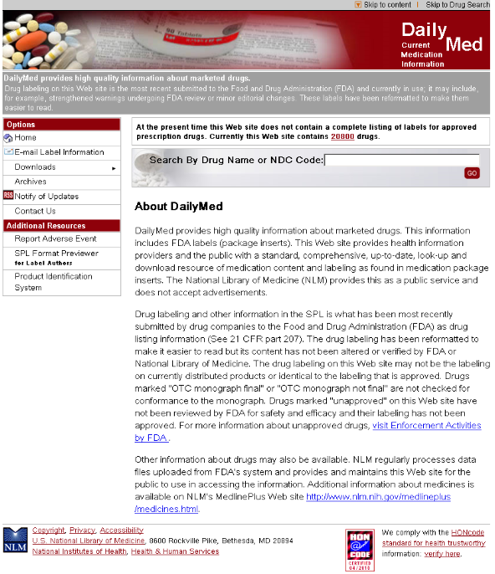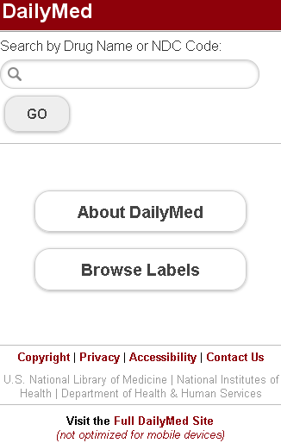

SEARCH RESULTS
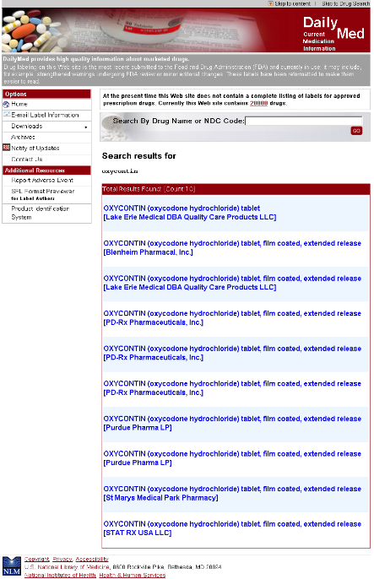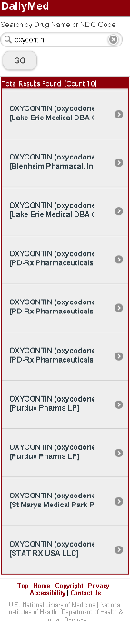

RECORD PAGE

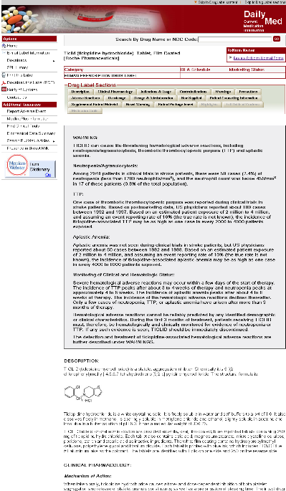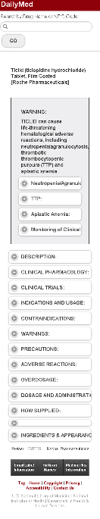

SHARE LABEL PAGE

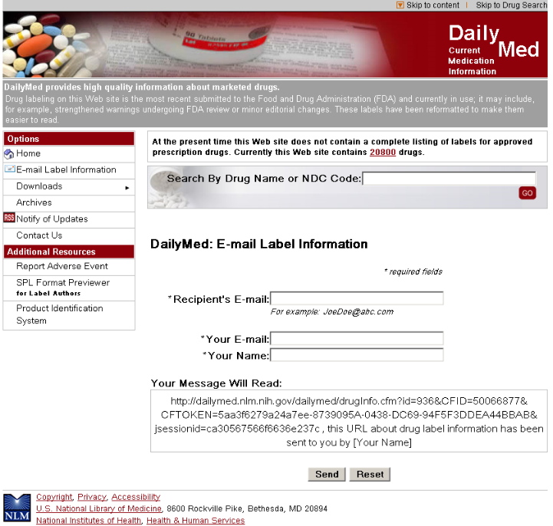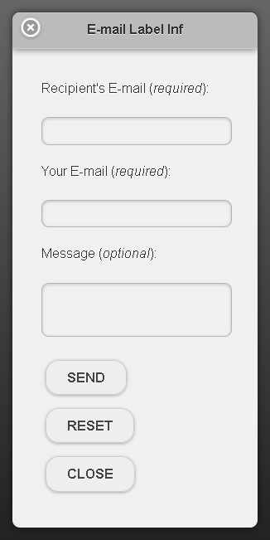

SHARE LABEL EMAIL FORM
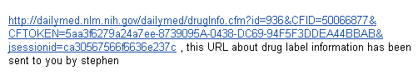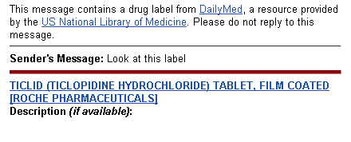

RXNORM NAMES

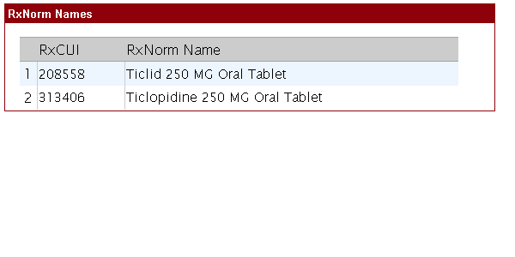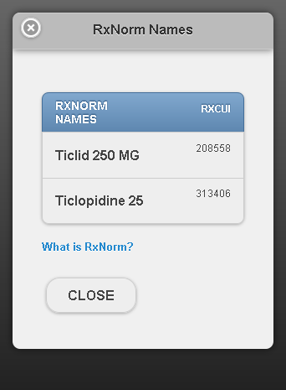

VETERINARY RECORD PAGE

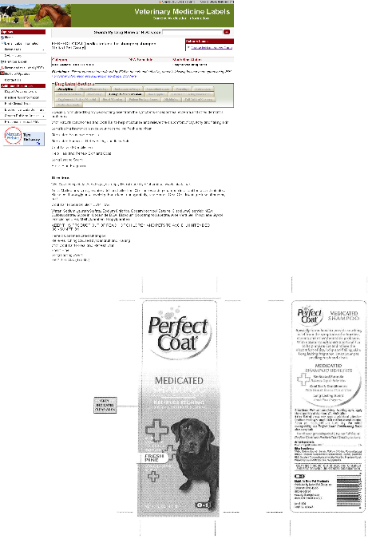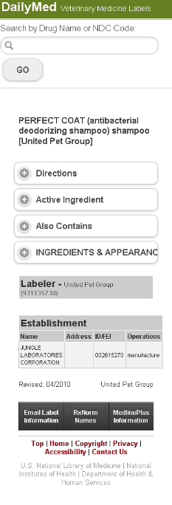

PRIVACY

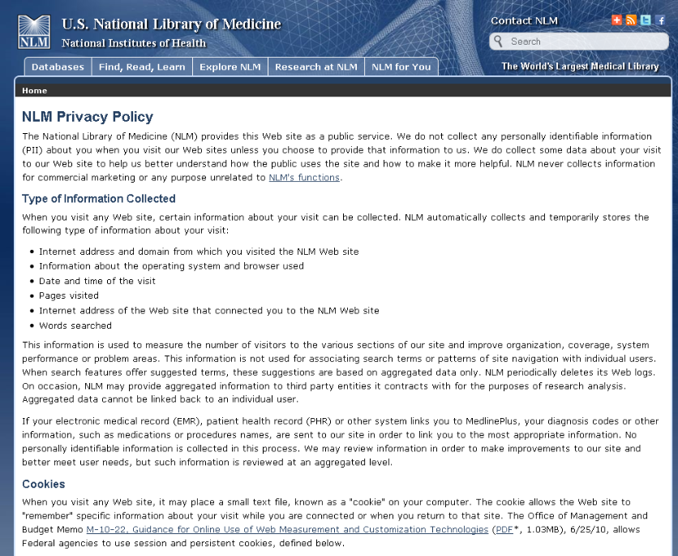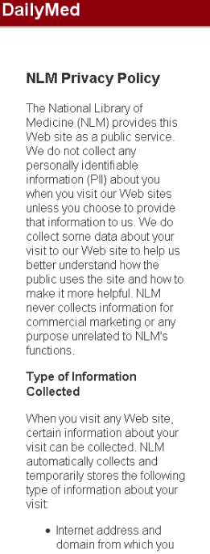

ACCESSIBILITY

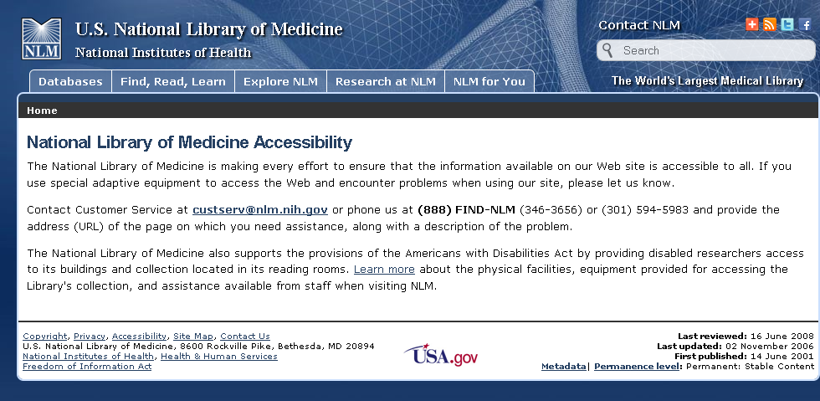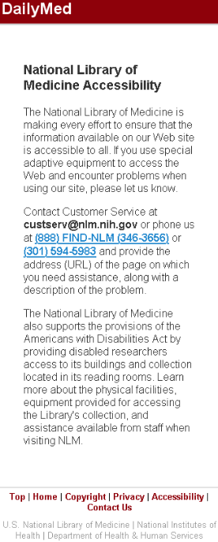

COPYRIGHT
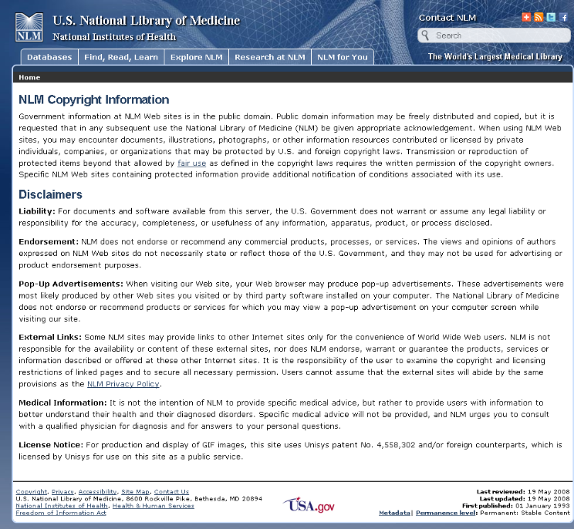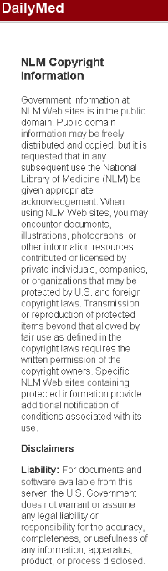

CONTACT US

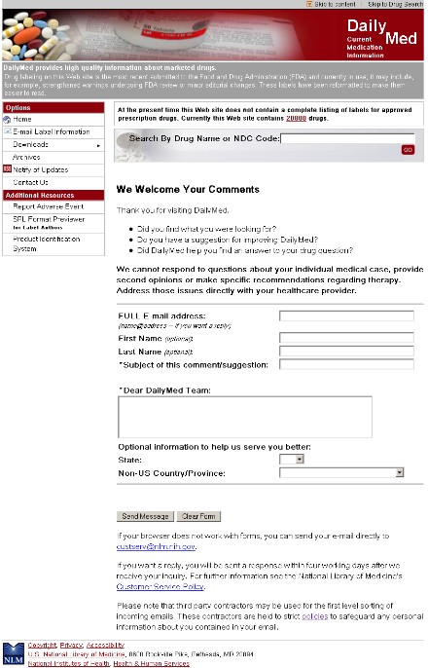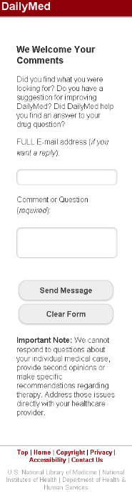

DISCUSSION
Libraries and other large organizations are increasingly looking to information architects (IA) and design firms to create the information layout, user interface, and overall design of their websites. IA designers are unique in that they focus design on the users’ experience with the site – thus the term “user interface” – and not specifically on the system itself. IA designers will often theorize on who their users are, and create personas in an attempt to better understand and serve them. Many will conduct focus groups, user testing, and card sort labeling exercises, all in an effort to make their websites more usable.
Although original research with real life users was beyond the scope of this project, the Associate sought to incorporate information design principles into the creation of a streamlined user interface for the DailyMed mobile website. In general, user interfaces should be clean and uncluttered, retain consistent footers and banners, color scheme, and easily accessible navigation, which all contribute to the greater usability of the website. In the case of a mobile version of an existing page, effort should be taken to make the two versions as consistent as possible to carry over brand recognition and familiarity.
In the course of the project, the Associate gained valuable experience communicating project goals between departments. Like many medium to large sized organizations, NLM has separate branches for Information Technology and program management. In the course of this project, Wei Ma, Chief of the Applications Branch within OCCS, NLM’s IT branch, oversaw a team of developers serving Dr. Stuart Nelson, Head of Medical Subject Headings, as their client. OCCS administers development and maintenance, but all administrative decisions are deferred to Dr. Nelson. This structure, typical of NLM’s web related projects, required close communication to establish specific expectations, and to avoid redundancy of work should expectations fail to be met. The Associate gained valuable experience in interdepartmental communication between Library Operations and the Office of Computer and Communications Systems. With the increasing integration of IT systems into traditional library settings, there is increasing demand for librarians with the ability to communicate between these two.
Perhaps the most challenging component of the project for the Associate was establishing times to meet during the busy curriculum portion of the associate year. The DailyMed team had a standing weekly appointment with Dr. Nelson, but this conflicted with the Associate’s scheduled curriculum on the majority of weeks. Also, the chain of communication within this rather complicated team organization was not immediately clear. The Associate didn’t know who to communicate with directly – the immediate OCCS team including Chandra Khola and David Zhang, the OCCS chief, Wei Ma, or the client, Dr. Stuart Nelson. Eventually, a dynamic worked out whereby the Associate would meet with Dr. Nelson individually to discuss preliminary design ideas. These ideas would then be more specifically developed with the immediate OCCS team including Chandra Khola, and David Zhang. Once this team was satisfied with their results, they presented to Wei Ma. And once Wei Ma was satisfied with the outputs, they were presented, in near complete form, to Dr. Nelson for review.
Although this process took some time to establish and complete, the end result was favorable to everyone involved. Dr. Nelson was very pleased with the design and prototypes at the last meeting, and approved the go ahead on final development.

RECOMMENDATIONS
Based on his experience with the project, the Associate recommends the DailyMed team: follow mobile internet and health trends closely to stay abreast of this accelerating field, continue adding additional functionality to later versions DailyMed, and consider using Adobe Photoshop for user interface creation. Establishing clear communication channels early will contribute to all of these goals.
STAY ABREAST OF MOBILE INTERNET HEALTH TRENDS
Use of the mobile internet to access health information has grown rapidly over the past several years, and this growth is likely to accelerate into the foreseeable future. Surely, the greater number of users will expect greater and improved functionality in their web products. The DailyMed team should keep detailed usage metrics of the DailyMed mobile website, and stay abreast of mobile internet health usage in order to better serve these users.
CONTINUE ITERATIVE IMPROVEMENT OF DAILYMED MOBILE
By following these trends, the DailyMed team will have an informed direction in its feature development. Introducing new features iteratively allows users to acclimate to changes in the product while also improving their overall experience. Some features to consider include: saved SPLs, multiple SPL emailing, and the porting of attributed MedlinePlus consumer drug information to the DailyMed mobile website.
CONSIDER ADOBE PHOTOSHOP FOR UI DESIGN CREATION
The Adobe Photoshop software allows IA designers very specific control over the visual design of a webpage. With Photoshop, IA designers are able to create an image of what the webpage should look like, slice that image into page components, such as navigation bar buttons, content areas, footer links, etc, and port those images into Adobe Dreamweaver for HTML coding. This design flexibility may help DailyMed avoid a generic design appearance.
ESTABLISH CLEAR COMMUNICATIONS EARLY
Establishing clear communication channels at the beginning of a project helps to ensure efficiency of work by reducing redundancy. It also ensures that work is appropriately reviewed before going to management or a client for approval.

BIBLIOGRAPHY
- Fox, S. Mobile Health 2010: Summary of findings [Internet]. Pew Internet & American Life project; 2010 Oct [cited 2011 Feb 2]. 1p. Available from: http://pewinternet.org/Reports/2010/Mobile-Health-2010/Overview.aspx
- Smith, A. Mobile Access 2010: Summary of Findings [Internet]. Pew Internet & American Life project; 2010 Oct [cited 2011 Feb 2]. 1p. Available from: http://www.pewinternet.org/Reports/2010/Mobile-Access-2010/Summary-of-Findings.aspx

APPENDIX A: TIMELINE
SEPTEMBER 2010
September 28: Kathel Dunn, Associate Fellowship Coordinator sends out call for proposals.
OCTOBER, 2010
October 1: Stuart Nelson mentions plans to develop a mobile version of the DailyMed resource during the Organization of Information Unit within the Associate Fellowship curriculum.
October 5: Initial meeting with Dr. Nelson re: project and expectations.
October 8: Dr. Nelson introduces Wei Ma, Chief, Applications Branch, OCCS via email.
October 20: Official project proposals list becomes available, including “Developing a User-Centered View of DailyMed for Mobile Devices” project submitted by Dr. Nelson.
October 22: Meet Wei Ma, Chandra Kola, Senior Software Engineer, and David Zhang, Web Developer re: project expectations, availability, and responsibilities.
NOVEMBER, 2010
November 22: Meet Chandra Kola and David Zhang re: project components and timeline.
November 24: Meet David Zhang re: division of design and development responsibilities.
DECEMBER, 2010
December 3: Meet Dr. Nelson re: DailyMed Mobile specifications.
December 6: Meet Chandra Kola, and David re: Dr. Nelson’s specifications, reassessment of responsibility timelines.
December 16: Meet Chandra Kola, David Zhang, to present Wireframe templates and webpage prototypes to Wei Ma.
December 17: The Associate, Wei Ma, Chandra Kola, David Zhang meet Dr. Nelson to present wireframe templates and webpage prototypes.
JANURARY, 2010
January 7: The Associate, Wei Ma, Chandra Kola, David Zhang meet Dr. Nelson to update progress on DailyMed Mobile website.
January 18: The Associate, Wei Ma, Chandra Kola, and David Zhang meet to discuss project report and project status.

APPENDIX B: ORIGINAL PROJECT PROPOSAL
Title:
Developing a User-Centered View of DailyMed for Mobile Devices
Submitted by:
Stuart Nelson
Description:
With the increasing use of mobile devices, and the existence of applications that can read a bar code and respond by sending it to a database, it is desirable to devise an interface for DailyMed that is appropriate for a mobile device.
Working closely with Dr. Nelson, Chris Hui, and the technical OCCS staff of DailyMed, the associate will develop a user-centered view of Dailymed for devices such as an iPad, iPhone, and Droid. The interface will be generic and capable of responding to many different mobile devices, and not an application for a single device.
Time requirements:
50-70 hours over the next months, as scheduling permits.
Note that the OCCS staff will be available to work with the associate after October 14.
Expected Outputs:
This project should start the DailyMed team on a path towards a user-oriented, mobile compatible, interface for DailyMed. The plan is to have a robust working mobile interface by the end of this calendar year or in early January.
Project Leader:
Stuart Nelson

