Creating a HomePage for Sciencv
Kate Masterton, associate fellow
Project Sponsors: Kathy Kwan & Bart Trawick (NCBI)
February 18, 2014
Contents
Abstract 3
Introduction 4
Procedures 5
Outcomes 6
Future Work 6
Conclusion 6
Appendix 7
Sciencv Walkthrough 7
First Draft Mockup 13
Final Mockup 14
Data Dictionary Table of Contents 20
Data Dictionary Attribute and Element Descriptions 21
Sample XSD Annotations 22
SAMPLE HTML Documentation 23

Abstract
Objective: SciENcv, a new product from NCBI, is a researcher profile system for all individuals who apply for, receive or are associated with research investments from federal agencies. SciENcv is currently available in beta for anyone to use. However, currently there is no centralized web location to house information about SciENcv (ie: a homepage). Due to the rising interest in developing researcher profile systems, a need exists to provide information that developers can use to build functionality into external new or current systems. In order for data to be interoperable between systems, detailed information about data schemas must be provided for developers.
Methods: Associate mocked up a landing page for SciENcv using Microsoft Visio, added content to developer site via Drupal CMS, and annotated data schema (xsd) using Oxygen XML Editor which generates HTML data documentation.
Results: A landing page for SciENcv is now live (http://www.ncbi.nlm.nih.gov/sciencv/). The landing page includes information and tutorials about SciENcv, and also links to the data documentation.
Conclusion: This project will be a successful attempt to provide information about SciENcv for users and developers once it goes live.

Introduction
Science Experts Network Curriculum Vitae (SciENcv) is a new electronic system that helps researchers assemble the professional information needed for participation in federally funded research. SciENcv gathers and compiles information on expertise, employment, education and professional accomplishments. Researchers can use SciENcv to create and maintain biosketches that are submitted with grant applications and annual reports. SciENcv allows researchers to describe and highlight their scientific contributions in their own words.

What SciENcv does:

- Eliminates the need to repeatedly enter biosketch information
- Reduces the administrative burden associated with federal grant submission and reporting requirements
- Provides access to a researcher-claimed data repository with information on expertise, employment, education, and professional accomplishments
- Allows researchers to describe their scientific contributions in their own language

Who Developed SciENcv

The SciENcv utility is a cooperative project requested by the Federal Demonstration Partnership (FDP), which is an association of academic research institutions and federal agencies. In collaboration with FDP, the product is being built by the National Center for Biotechnology Information (NCBI) at the National Institutes of Health under the aegis of an interagency workgroup composed of members from the Department of Defense, the Department of Energy, the Environmental Protection Agency, the National Institutes of Health, the National Science Foundation (NSF), The Smithsonian, and the United States Department of Agriculture. The interagency workgroup operates under the National Science and Technology Council’s (NSTC) Research Business Models and Science of Science Policy Committees.
Principles of SciENcv
- Any researcher may register
- Leverages data from existing systems
- Data is owned by the researcher
- Researcher controls what data is public
- Researcher edits and maintains information
- Researcher provides own data to describe research outcomes
- Researcher has ultimate control over data in biosketch
Project Overview
The aim of the project was to help NCBI to create a home page for SciENcv as a focal point of promotion and information dissemination for SciENcv to users and collaborators. Additionally, the Associate helped to investigate technical requirements and possible specifications for interfacing with outside systems.

Procedures

Microsoft Visio was used to create a draft mockup for the landing page, including links for the homepage, SciENcv description for the homepage, and formatting and imagery for the homepage. The initial draft underwent several iterative revisions, and the final mockup was delivered to NCBI developers for CSS generation. While the mockup was finalized, a Drupal page for SciENcv was created and content was added to the page.
As the page developed, a process for providing data documentation for developers was also debated. Initially, a data dictionary providing comprehensive documentation and hyperlinking was drafted. However, due to the transient nature of the evolving XSD, it was decided to instead merely annotate the SciENcv data schema in order to automatically generate documentation in HTML. This documentation is not as complete, but it is easier to maintain and update. Annotations were made using Oxygen XML Editor, which can automatically generate data documentation to HTML format.
Finally, the mockups and annotations were finalized and all content was added to the Drupal page. NCBI developers created CSS for the page according to specifications in the mockups. The site was developed, approved, and launched.

Outcomes
During an initial walkthrough of the biosketch generation process, an informal usability analysis was delivered to SciENcv developers. A landing page is now developed and launched (http://www.ncbi.nlm.nih.gov/sciencv/), and provides an overview of SciENcv (including background, partners, and news) as well as information for developers. The page links to an annotated XSD file that includes descriptions of data elements and attributes directly in the schema code. Using the annotated XSD file, an automatically generated data documentation file was generated in HTML. The data documentation goes beyond the in-code annotations because the complex elements are hyperlinked, making navigation easier. This documentation is incorporated into the landing page.
In addition to deliverables for NLM, the Associate gained skills using Drupal CMS and Oxygen XML Editor, and a familiarity with SciENcv and other researcher profile systems.

Future Work
The next steps will be the development of an Application Programming Interface (API) for SciENcv that can be embedded in the landing page for download and use in external systems.
In addition, the XML Schema Definition (XSD) continues to evolve. Small alterations to the data documentation will need to be incorporated as the XSD changes. The Associate has left the beginnings of a comprehensive data dictionary, which can be completed if deemed useful in addition to the documentation generated by Oxygen XML Editor. And finally, a plan for site maintenance must be generated and followed in order to ensure that the page created by the Associate does not become outdated.

Conclusion
Through this project, vital information for external developers of researcher profile systems who wish to exchange data with SciENcv is provided via a public web page. In addition, the data documentation will be useful to NCBI staff during future development of SciENcv. And finally, the landing page will provide a place for interested individuals to gain broad details, including background and tutorials, about SciENcv.

Appendix

Sciencv Walkthrough
SciENCV walk through
Kate Masterton
10/22/2013
Introduction
In order to provide feedback about the usability of SciENCV, I walked through the process of creating a biosketch using My NCBI and SciENCV. I then observed another Associate Fellow, Holly Thompson, walk through the process of creating a biosketch using My NCBI and SciENCV, and asked her to complete various tasks in order to test usability.
Overall, creating a biosketch using SciENCV was quite easy for both Associate Fellows who tried, even without using instructions. Neither Associate Fellow had an eRA Commons account. Both had previously existing My NCBI accounts and Ms. Thompson had a previously existing My Bibliography. In both cases, the perspective is from an individual with a library science background and without scientific research experience.
One initial note: There is inconsistency on the web about what the correct capitalization of this product is. Some releases (including information found on NIH sites) indicate that it is SciENcv, while others indicate that it is SciENCV. In My NCBI it is capitalized as SciENCV, so that is how I will reference it.
Observations
1. Although on the final PDF form the name for Program Director/Principal Investigator is listed as Last, First, Middle we can’t find out how to add a middle name, except by tagging it on to the end of the first name entry (there is no “middle name” entry field).
No entry field for middle name
2. Kate had some confusion about how to manage the list of citations from My Bibliography for presentation on the PDF (the “show/hide entries” option). She initially assumed “show/hide entries” would refer to showing or hiding the whole list while working on the rest of the biosketch, and was not the option to select which citations were wanted for the biosketch. Initially, she thought she would actually have to delete citations completely from My Bibliography so they wouldn’t appear on the biosketch.
3. From My NCBI homepage, the PDF icon in the SciENCV section does not generate a PDF – not a big obstacle b/c it takes you to the “manage SciENCV” where you can easily create a PDF, but may cause confusion.
My NCBI home page

4. The automatic ordering of educational entries was a bit confusing – and although they are likely ordered in reverse chronological order for standardization purposes, it would have been nice to be able to manually move them around. For example, I received two educational achievements (a master’s and a certificate) in 09/2013, but wanted the certificate listed after the master’s. I had to find a workaround to make it so (what I was able to do is make the date later for the certificate, save it, then edit it back to the correct date and the entries then stayed in the desired order).

5. No standard format for state and country in educational information (ie: could enter in Michigan or MI and it wouldn’t matter). While flexibility is nice, with something like this it may be easier to just have a standard list to choose from. This also means anything can be entered in to these fields and will save. For example, when walking through the process Holly accidently mistook country for zip code (most likely an assumption error) and the program did not catch it. Hopefully one would review his/her work and notice the error, but it would be nice if the machine helped out.

This entry will save – there will be no error message. Also it is unclear whether to use abbreviations or full spelling.

6. It seemed inconsistent that the dates for the research support section had a standard mandatory format but some of the other date entries did not (ie: in the education section date format is fairly clearly indicated by YYYY, but you can save the entry and proceed with the incorrect format – you don’t get an error message).

If the date is entered in an incorrect format when adding a funding award, the program gives an error message and won’t let the user proceed

If the date is entered in an incorrect format when adding an education/training item, the program does not give an error message and will let the user proceed
The result of saving an education/training item with an incorrectly formatted date
7. Holly encountered an issue while completing the personal statement. She entered text into the box and then explored the other options. She decided to preview her work (but was confused by the preview icon initially). Once she previewed, she assumed she should hit the “x” button to exit preview mode. This actually closed the whole thing and she lost her personal statement. Later she realized that she should have hit the preview button again to return to editor, but felt it was not intuitive.

What was thought to result in exit from preview mode
Preview mode
When one types in a personal statement and hits the “preview” icon…

Hit to exit preview mode
It may seem intuitive that hitting “x” will exit preview mode. But this closes the personal statement resulting in the possible loss of work. There is no feedback from the system indicating this will happen.

8. Holly encountered a little confusion between “send to” and “add to favorites” within PubMed, and didn’t know which she should use to add a citation to her SciENCV.

9. As discussed it would be helpful if one were able to save multiple biosketches within SciENCV, depending on the need. For now show/hide entries provides a workaround.

10. While it is clearly stated in the instructions to not exceed 4 pages, SciENCV will generate a PDF longer than that (ie: Kate made one that was 6 pages). SciENCV provided no feedback about how many pages would be generated, so it felt like trial and error, not knowing exactly how long the final product would be or how it would be formatted.

11. There is no way to manually control formatting, such as page breaks. This is likely intentional, but could potentially cause frustration if someone wanted to create extra space on the form (ie: if room allows move the start of the citation list to the next page).

12. While Kate was happy to discover that one could navigate away from SciENCV and come back to her work later, because there wasn’t a “save” button or any type of feedback indicating that the work would be saved, the first time I navigated away to PubMed in order to create citations, she wasn’t sure her work would still be there when she came back to finish the biosketch.

13. Holly felt confused by leaving the SciENCV edit page (ie: when going to PubMed or My Bibliography to add citations). She didn’t feel that navigation back to SciENCV after leaving the page was prominent. She felt it would have been more intuitive if she were to be automatically routed back to what she was working on.

14. Holly did not understand the connection between My Bibliography and SciENCV until Kate explained it to her. For example, when she entered in new citations while working on her biosketch, she didn’t realize that she was actually working in My Bibliography, and that the new citations would be added there as well.

15. When Holly added an ORCID ID to her SciENCV, she noticed that it did not appear on the PDF afterwards.

16. Both Kate and Holly experienced some problems (including loss of work) using browser navigation. While this is unsurprising and experienced in many other websites, the fact that we were even trying to use browser navigation may hint at a need for further development of in-page navigation opportunities.

First Draft Mockup

Final Mockup

Data Dictionary Table of Contents

Attribute Descriptions
@accounttype
@addresstype
@canpeerreview
@citationtype
@code
@currency
@current
@degreename
@degreestatus
@degreetype
@id
@idtype
@leavetype
@orgtype
@phonetype
@ref
@source
@spoken
@statementtype
@trainingtype
@type
@uid
@withhonors
@written
Element Descriptions
<academicrank>
<account>
<amount>
<assignee>
<author>
<authors>
<award>
<awardid>
<birthdate>
<chapternumber>
<chaptertitle>
<citation>
<citations>
<city>
<conferencecity>
<conferencecountry>
<conferencedate>
<conferencestate>
<conferencetitle>
<contributions>
<country>
<date>
<day>
<degree>
<description>
<displaydate>
<distinction>
<distinctiondate>
<distinctions>
<documentsummary>
<doi>
<edition>
<editors>
<education>
<effectivedate>
<emailaddress>
<employment>
<employmentstatus>
<enddate>
<expecteddate>
<extension>
<externalid>
<externalids>
<funding>
<fundingsource>
<gender>
<givennames>
<grantassociation>
<Id>
<identification>
<info>
<issue>
<journalname>
<language>
<leaveofabsence>
<mailingaddress>
<major>
<membership>
<memberships>
<minor>
<month>
<name>
<number>
<numberofpages>
<organization>
<orgname>
<orgsection>
<page>
<phone>
<phonenumber>
<position>
<positiontitle>
<postalcode>
<prefix>
<presentedname>
<principalinvestigator>
<printlocation>
<proceedingstitle>
<professionalaccreditation>
<professionaltraining>
<profile>
<projecttitle>
<publisher>
<refsystem>
<refuid>
<renewable>
<researchclassification>
<role>
<salutation>
<startdate>
<statement>
<statements>
<stateorprovince>
<status>
<streetaddressline>
<stringname>
<subtitle>
<suffix>
<supervisor>
<supervisors>
<surname>
<tenuredate>
<thesistitle>
<title>
<volume>
<webaddress>
<year>

Data Dictionary Attribute and Element Descriptions
Attribute Descriptions
Definition: | Contains a narrative description of the attribute
In Element(s): | Discusses in which elements an attribute can be used in
Value(s): | Provides any pre-determined values for the attribute
Usage: | Discusses expected uses for the attribute, such as when or why it might be used
Example(s): | Provides examples of the attribute use for clarification
Note(s): | Provides any additional notes about the attribute

Element Descriptions
Definition: | Provides a narrative description of the element and information about how it may be used
May Be Contained In: | Provides a list of elements in which the discussed element may be nested
Child Element(s): | Provides a list of elements that can be nested within the element
Attribute(s): | Provides any attributes that can be used with the element
Type: | Provides details about the data type (ie: date)
Usage: | Discusses expected uses for the element, such as when or why it might be used
Example(s): | Provides examples of the element for clarification
Note(s): | Provides any additional notes about the element

Sample XSD Annotations
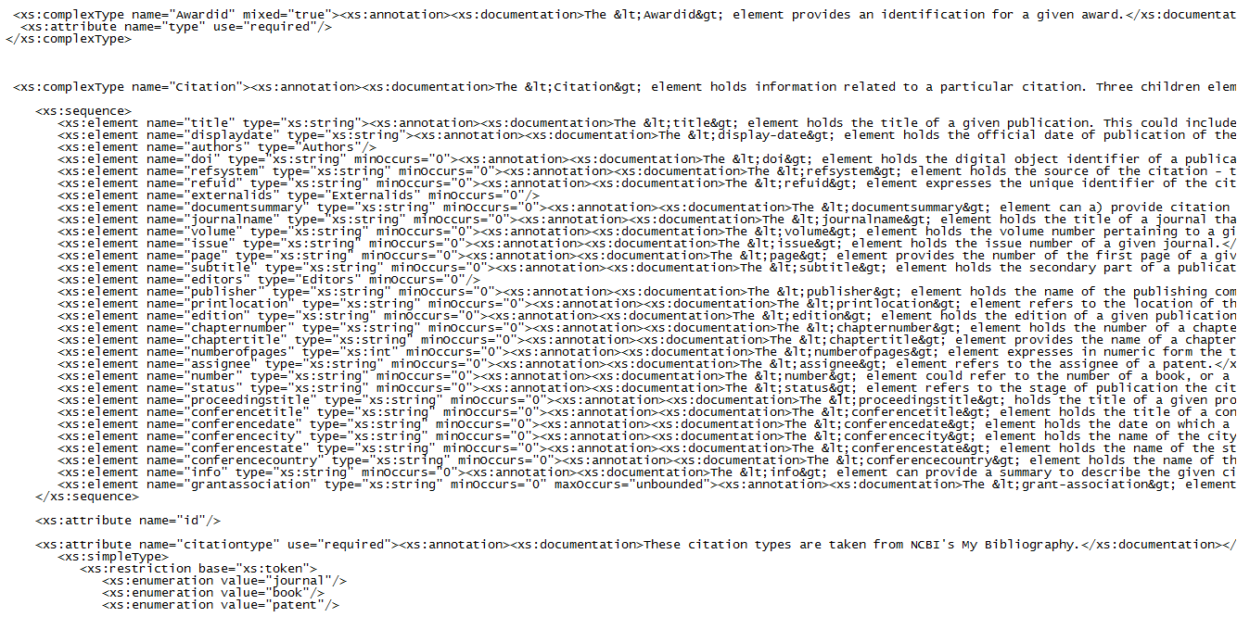

SAMPLE HTML Documentation
