Development of a Digital Library for the National Institute of Hygiene of Morocco
Project leader:
Salima M’seffar, Associate Fellow
August 2011
Project sponsors:
Kathel Dunn, Associate Fellowship Program Coordinator
Sally Sinn, the Medical Heritage Library Project Manager
Table of Contents
Abstract 3
- Introduction 4
- Methodology…………………………………………………………………………………..6
- Literature reviews ………………………………………………………………………...6
Selection criteria ………………………………………………………………………….6
Stakeholders……………………………………………………………………………….9
Project management……………………………………………………………………...10
Metadata………………………………………………………………………………….11
Equipment………………………………………………………………………………..15
Funding…………………………………………………………………………………..18
- NLM’s Interviews……………………………………………………………………......20
- Site Visits………………………………………………………………………..............24
The National Library of Medicine: Preservation and Collection Management Section (Walter Cybulski)………………………………………………………………………...24
The Johns Hopkins University Library (Robert Klingenbergen)………………………..29
The Mount Vernon Library (Joan Stahl)………………………………………………...31
Lessons learned from the site’s visit…………………………………………………….33
- Results: a targeted proposal for INH…………........................................................................33
The Bulletin of the Institute of Hygiene…………………………………………………33
Malaria epidemics in Morocco historical materials……………………………………...34
Maroc Medical…………………………………………………………………………...36
- Conclusions…………………………………………………………………………………..38
References…………………………………………………………………………………………………43
Appendices………………………………………………………………………………………………..45
Abstract:
Objective: to develop a proposal for creating a digital library for the National Institute of Hygiene of Morocco. The collection proposed, in addition to its historical value, is rich in medical and public health information about North-West African countries: Morocco, Algeria and Tunisia. Most of the materials proposed are published in French and talk about past epidemics or emerging infectious diseases that are still at risk for the world populations.
Methods: in order to create a comprehensive plan with the necessary steps for developing a digital library capability, I conducted an environmental scan of literature (best practices, handbooks), I interviewed the National Library of Medicine staff, and visited the Johns Hopkins University and Mt. Vernon library.
Results: Lessons learned from literature review and the interviews will be exposed. Then a targeted proposal for the digital library of the National Institute of Hygiene will be described and will include three rare medical collections to digitize for the National Institute of Hygiene of Morocco. These collections are: the Bulletin of the National Institute of Hygiene, Malaria collection and “Maroc Medical” Journal.
Conclusions: After reviewing the elements of the plan and my library’s characteristics, I developed a plan and identified needs to additional resources and external funding. I suggested that collection’s digitization starts small with one of the proposed materials and extends to include more up-to-date resources that show the way elimination and eradication of epidemics in Morocco are handled and pursued.
- Introduction
This is a proposal for the development of a digital library for the National Institute of Hygiene of Morocco (NIH).
In 2004, when I was hired as the librarian of the National Institute of Hygiene, one of my first steps was inventorying the collection and creating our bibliographical database which is not online. Until that time the library did not have an online catalog. I noticed the depth and breadth of the NIH (Hygiene) collection of old medical and biomedical books, textbooks, journals and health related maps (1880’s – 1950’s). These materials are not visible to the user and not well explored. As the older materials were not the main interest of the primary users of the NIH library, I decided to catalog only 1950-present materials.
However, many internal and external users were asking for “The Institute of Hygiene’s Bulletin” articles from the older time period. The internal users are the staff members. The external users are trainees, students, researchers not affiliated to the NIH or the general public. The bulletin of the Institute of Hygiene volumes were published from 1930 to 1975 and report on French Colonial health administration policy and efforts in eradication of Malaria, Trachoma, Poliomyelitis, Cholera and many other diseases in Morocco, were not indexed neither catalogued nor even described. So each interested user had to start looking them up one by one which was a time consuming.
Because of the interest in the Bulletins, I decided to create a table of contents for the entire Bulletins’ collection, digitized as a PDF file and accessible online. The impact was very appreciated by the users who were relieved and saved their time by using Word search boxes to retrieve the article references. The usage of the National Institute of Hygiene Bulletin increased. But the volumes are not well preserved and frequently used.
Digitizing them and opening them to the public access will:
- give a visibility of the role of the Institute in enhancing the Moroccan public health,
- give a visibility of how rich is the collection of the National Institute of Hygiene Library, at the National and International level,
- help to preserve these volumes by reducing their checking out/ copying them for each user,
- provide the history of medicine researchers additional free online resources to explore about Morocco,
- Be the first step for a larger digitization process in order to convert the library from being paper based to digital based.
- Be less time consuming for the users to search the Library ancient collection.

The Associate fellowship year is the best opportunity to begin this project because:
- It stands to help me accomplish one of my goals and work on my interests. Exploring the digitization of NIH library collection interests me as well as the National Institute of Hygiene decision makers.
- It takes place at the National Library of Medicine that has been exploring the digitization since 2006. The Preservation staff and the History of Medicine staff acquired a rich and valuable experience and they are more than happy to share with me. The staff is also very knowledgeable about other foreign libraries working on similar projects.
- It’s an easy way to be introduced to these libraries and search for partnerships.
- The History of Medicine Division (HMD) is currently working on the Medical Heritage Library repository. The staff currently involved has many lessons learned and advice to give concerning procedures, standards, file formats and equipment.
- As part of the Associate Fellowship program includes site visits and conferences attendance, it provides many opportunities to meet people who are also experiencing the digitization, ask questions and learn from their experience.

About the National Institute of Hygiene Library
The Library of the National Institute of Hygiene was created in 1930. The library is staffed by one librarian and has 2 computers, an INMAGIC catalog database, 1 printer and provided with the high speed Internet connection.
Before 2004, before being hired, the library was closed for 14 years. There was no acquisition policy and no collection management. I was hired to renovate the library and reorganize it by acquiring new materials and responding to the staff needs in biomedical information.
The collection is mostly comprised of old textbooks and journals: 1880’s to 1950’s, published in both French and English. There are only about 1800 new textbooks (1970’s - today), 120 print journal titles (most of them from the 90’s) in addition to limited access to ScienceDirect.
Characteristics of the Use and Users of the Older Materials
The Library users are the NIH staff and researchers in total more than 300 employees. Most of them are onsite but there are staff members in 16 other regional laboratories. Offsite laboratory technicians and physicians can’t, obviously, use library services although they have internet connections. Potential users are Fellows, students and the general public. All are welcome without registration. Most of them use the new collection of books and journal articles that are related to HIV/AIDS, Genetics, Biochemistry, Environmental Health and Toxicology.

The ones that use the older materials are the researchers investigating in malaria, tuberculosis, poliomyelitis and previous epidemics. Once a year an international scholar visits the library and uses these old materials when s(he) is looking for maps, photographs, historical, sociological or epidemiological data related to Morocco or the Maghreb region.
Most of the time, the users interested in older materials are writing about historical facts in Morocco. They could be related to health, politics, industry, society, biology, or other sciences. For example one of the International users, Valerie Viehoff, from University College London, UK, published for her PhD in Human geography about: Engineering modernity: the provision of water for Tangier, 1840-1956. As a main information source, she was using the Bulletin of the Institute. Another user from the International Organization of the Francophonie was interested in the evolution of medical ads and drugs marketing.
- Methodology

- LITERATURE REVIEWS

Overview of the literature review
Through the literature review, I was able to frame the plan for the digital project to be developed in Morocco. Reading about other libraries’ success stories and surveys enabled me to capture the key elements of planning this project. These elements are: the selection criteria, staffing and the required skills, metadata schema, types and selection criteria for the equipment, distribution and potential sources of funding.
These elements of the plan are developed in more detail below:
SELECTION CRITERIA
The first step in a digitization project is deciding which collection to digitize because digitization is costly and time consuming. Key questions a project manager needs to respond to are:
- Why propose this body of materials to digitize?
- What about copyright and how can we resolve it?
Therefore, content managers, content specialists and digitization program managers should take into consideration the following criteria before pronouncing the part of the collection they want to work on:
- Copyright status: the collection’s right status and its impact on accessibility to the larger audience. There are three copyright types impacting on the collection access:

- Significance of the collection: defining the importance of the collection to target is relevant to the project manager. Still there are three key factors that help in making this decision:
  - The experts’ attestation
  - Relevance to current research activities
  - Current use of collection and predicted increase of the collection’s usage after its digitization
- Current and potential users: As digitization increases the use of the selected collection, it is wise to know the current users of the proposed materials and their needs, the difficulty that presents the current non digitized access. It’s also good to know the physical conditions of these materials and their impact on the usage limits. For example deteriorating materials are more likely to be excluded from circulation and less used because they are hard to handle.
- Organization and descriptive metadata: Before digitization, the selected collection must be organized and described. MARC records or other catalogue records are highly recommended. Most libraries use MARC cataloguing standards which facilitates their records’ exchange and interoperability. MARC record helps also unexpected discovery of digital resources from within the catalog by users who don’t know about the digital collection’s existence. If not, additional costs have to be planned for a standardized reorganization of catalogue records and cover staff and equipments’ expenses. The costs would cover hiring additional staff or purchasing bibliographic software. Reorganizing catalogue records, in case the catalogue is not organized, is required to correct missed information, standardize records format, use format that are more likely to be delivered online and interoperable with other digital libraries. Ideally the description of these catalogue records should be factual at the item level and standardized in order to insure their interoperability.
- Relationship to other digital collections: if the selected materials can contribute to a pre-existent digital collection, it adds to their value and enables the digitization team to make connections with potential partners that would be interested in cooperative digitization efforts at or beyond the home institution.
- Formats, languages and nature of materials: the feasibility and ease of the digitization is related to the source format. Digitizing a text into image or a searchable XML is easier than digitizing audiovisual materials.
Materials’ language is also a factor to take into consideration since non-Western languages add complexity in text searching and materials description.
Materials’ nature is critical in selecting them to be digitized because digitization will require handling the items more frequently. The condition of these materials will impact in deciding between outsourcing, in-house processing and not digitizing if the materials are deteriorating.

- Sources of funding: if finding a source of funding is required to accomplish the project, it will be important to choose a collection that fits in funding priorities. Project planning development can be done in three steps:
- Write skeletal digitization project for different important collections;
- Research funding sources;
- Find best match of funder and proposed collection to digitize;
- Finalize the project plan with funding requirements.
STAKEHOLDERS:
Before writing the project plan and budget, all the actors interested in this issue should establish the priorities that everyone can accept. Involving stakeholders “affects the institution's reputation and may affect future donations and community cooperation.” [1]
Stakeholders involved in deciding which part of the collection should be digitized, are cited randomly below. They are complementing each other like pie parts.
Collection creators
Represented individuals
or groups in the collection
Institutional staff managing the collection
Middle people: digital publishers,
Search engines
Professional colleagues, Funders
Discipline specialists,

General public

User communities
Stakeholders decide the project priorities. However, the project processing requires an interactive team approach. Ideally, a project team should include:
• Project Manager
• Selector, Conservator, Preparations Technician
• Cataloger, Metadata Analyst
• Scanning Technician or Photographer, Quality Control Technician
• Programmer or other Database Developer to integrate metadata and images
• Systems Administrator, Network Administrator
• User Interface Developer or Designer
The team can be regrouped from the home institution bringing together staff from different areas, students or volunteers.
The skills required to complete a digitization project are, in the following figure, grouped into three categories: management, information management, and technical skills:

PROJECT MANAGEMENT:
Key questions: How the digitization will be processed? Will the pre and post-scanning processing of materials (stabilization, cataloging, treatment, and shelving) be considered?
In order to make a plan for any digitization project, it’s highly recommended that the project manager set goals. Starting at the end is the best way to plan for a project. This means it’s crucial to focus on the outcomes expected which can fit into 3 categories:
- Collections: Specify the exact physical outcomes desired for the source materials. Quality control, authentication of files and their sources have to be taken into consideration.
- Digital reproductions: scanning.
Approaches vary according to the materials selected, the audiences’ interests and digital formats’ choices. Scanning system choice relies on project managers’ priorities and librarians’ expectations. Developing specifications for digital formatting can be done through one of the following methods:
- Benchmarking the sources materials characteristics and choose digital reproductions that would best fit the most the original characteristics. Source materials characteristics refer to: organization, presentation, size, dimension, colors, details, age and condition.
- Choose digital reproductions’ attributes according to the equipment decided for processing the digital files.
- Benefits to the institution: developing digital projects that are seen beneficial for the institution could also be a starting point. Many institutions worked on building their electronic resources either for access, infrastructure, preservation, feasibility or experience gaining. So, digitize to preserve or digitize to offer access? Open access or controlled?
Starting with small projects helps the organization in building procedures and guidelines, integrating digital systems to existing or new catalogs, and establishing partnership with electronic content publishers. These benefits enrich the institutional capabilities in building bigger digital projects. Example: University of Minnesota: University Archives project of digitizing legacy university publications. Their selection criteria were the highly used content items. They began the digitization as a project and now it’s a routine function.
METADATA: What metadata standard should be used?
Metadata is a structured data or information that makes it easy to use other information. That’s a kind of structured information that describes, locates, defines or helps to retrieve an information resource. In libraries, metadata is a formal scheme of resource description, no matter what is the information support. For example: library catalog records. The storage of metadata can be embedded or separated from a digital object.
Metadata storage:
Most of the time it comes included in the HTML documents and image files headers. What are the advantages of each metadata storage scheme?
The following table shows the difference between embedded and separate metadata storage:
Embedded storage | Separate storage
Ensuring that metadata won’t be lost  Avoids linking issues between data and metadata  Ensures Simultaneous update of the data and metadata.  Impossible to embed metadata in some objects like artifacts. | Simplifies metadata management  Facilitates search and retrieval  Stored in database system linked to the described objects.

Metadata types: 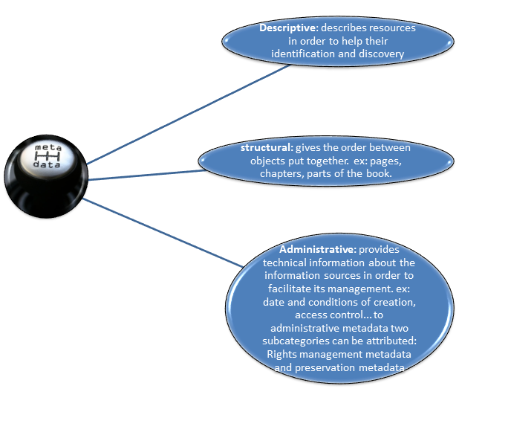
http://siliconangle.com/blog/2011/03/31/metadata-at-the-heart-of-microsoft%E2%80%99s-complaint-against-google-key-within-the-enterprise-too/
Metadata usage:
Metadata is significant in four areas: resource discovery, rights management and access control, presentation and navigation, administration and preservation. The two last uses are the most related to my work:
- Metadata for presentation and navigation: Structural metadata is required to make order and logical organization between digital images. Examples of functions included in structural metadata are: key access points, browsing, navigation, structural relationships and presentation formats. There are two approaches in creating a structural metadata: data-management techniques and document-encoding techniques.
- Metadata for administration and preservation: this includes the management and long term preservation of both digital files and the metadata of these files. The essential requirements fall into three main areas: images characteristics and features, images production and reformatting features, identification and integrity of images.
Metadata Standards:
A key concern is that metadata should be capable of being machine processed. This was the leading cause of the creation of MARC (Machine Readable Capacity), the Text Encoding Initiative (TEI) that is standard encoding for full text documents in XML, and EAD (Encoded Archival Description).The different mechanisms of delivering metadata on the internet are: HTML META tags, XML and RDF (Resource Description Framework). XML and HTML are simpler and more stable than XML and RDF which still under flux and experimentation.
The Dublin Core Metadata for resource discovery is structured into 15 elements qualifiers and value qualifiers. It is the most popular standard, used in more than 20 countries.
The most popular metadata standards used in different digitization projects are: Dublin Core 92%, MARC 84% and XML 75%. [2]
Metadata has its challenges:
Functionality the digital age (digital rights, access management, system administration, preservation) requires more flexible/extensible models of metadata.
Permanence:
While the URLs are becoming less stable, because they tend to change or to be broken, metadata should deal with this unstable frameworks of information resources. For online resources, metadata describes and locate these resources. But internet links sometimes break, online resources could be retracted which impacts metadata reliability and effectiveness.
Integrity: “it has become increasingly difficult to identify the integrity of information resources.” [3]
Because of large internet communities that interact without boundaries, outside of traditional publishers’ framework, judging of online resources integrity is very controversial and less reliable than with traditional printed materials. Metadata has also become something to manage very carefully.
Accommodating the variety of metadata: To match the context of networked digital resources, the metadata requirements are: multiple dimensions and forms, extensibility, community-specific management and creation, functionality and simplicity.
Interoperability: Internet broke the traditional community’s interactions in the favor of spontaneous interactions. In a traditional framework, a community cites the work of another community directly and systematically which wasn’t possible due to traditional boundaries of print materials. These kinds of connections require that all digital information have to be standardized and interoperable. As an example, any of the Washington Post’s online articles will refer to Facebook friends’ activities or to the most tweeted articles. This example shows three communities’ interoperations: the Post, Facebook and Twitter. This emphasizes the need for common metadata standards “that allow resource discovery, resource management and content rating”.
EQUIPMENT
In order to decide which software to use for the digitization, it’s important to consider the library's requirements for the digital collection, where there are some essential components to include, as shown in the following figure:
As it was mentioned earlier for the project planning requirements to be done with a team, it is also the case when it comes to choose particular software for digitization. This team should work together in deciding the software features.
There are seven specific features to look for when choosing software for building a digital repository:

The table below shows the subcomponents of each attribute:
Software’s features | Features’ Subcomponents | Examples
Basic technology building blocks: | Servers | Windows or Unix/Linux
 | Web server | Apache
 | Database | MySQL, DB2, Oracle
 | Digital repository software.
Product or software features | File formats supported | Text, images, datasets, video, audio, etc.
 | Metadata standards | Descriptive, technical, preservation, rights.
 | Interoperability | OAI Compliance, Z39.50, SRW,etc.
 | Permanent address | Persistent URL
 | Metadata search or browse
 | Full text search | OCR
 | Workflow | Submission for content approval
 | User authentication and authorisation | User’s account, content’s contributor, end-user access to content.
Software platform model: licensing and distribution models | Proprietary software | Purchase of software platform and subscription to additional consulting and maintenance.
 | Open source software | Software downloadable for free and can be customized by the IT staff. Ex: CDSware, DSpace, Fedora.
 | Software service model | Software platform and data management are controlled by the software’s vendor, who provides his services for a fee.
Technical issues and service delivery | Service availability | (24/7), 5 days a week, …
 | Scalability (growth)
 | Backup and recovery
 | System maintenance
 | Extensibility | Access to other university resources, systems
 | Customization
 | Internationalization/multilingual support | Non Romanized alphabet support, multilingual settings
 | Data loading
Implementation steps | - Examining service needs and requirements Digitization’s program goals and selection criteria.  - Choosing a software platform Assembling and setting up necessary hardware, servers  - Installing and configuring software  - Creating a test/demo version of your system  - Customizing the interface as needed  - Training staff  - Creating content approval workflows: accept, edit, reject, etc.  - Loading content  - Testing system
Cost considerations | Software costs (one-time and ongoing) | Open source / for fee software, ongoing costs for code source customization, overall planning, implementation, and  System’s running.
 | Hardware, servers, etc. | In house hosting, hosting fee services.
 | Operations staff | Staff training, staff for scanning, image processing, online repository content loading.
 | Programming staff (if necessary) | If software needs customization, source code modification.
 | Backup and recovery | If the data has additional offsite storage. In case the local digital files are lost, this backup repository keeps copies of these files that could be recovered. It could be a leasing service of free if it’s affiliated to the organization.
 | Preservation | Consider current needs and long term service’s needs ten  or fifteen years from now.
Major digital repositories software providers | - Archimede  - bepress  - CDSware  - CONTENTdm  - DSpace  - EPrints  - Fedora  - Greenstone: has an international usage  - Open Repository  - Omeka  - Digitool (Commercial software, Based on Exlibris)

FUNDING:
A study, “Funding and Priorities: the Library Resource Guide Benchmark Study On 2011 Library Spending Plans”, that was conducted to document current spending in different types of libraries for 2011 evaluate the economic recession impact on available funding. This same study shows that 12% of the libraries have increased their investments in digital content collection and services.
The survey SPEC Kit 294 shows: the mean start-up budget is $ 97,027 while the mean ongoing budget is $303,916. Start up budget was in most cases dedicated to software/ hardware fee.
The table below shows the top-ranked categories of start-up and on-going budgets for digitization:
Start-Up Budget median | On-going Budget median
Staffing and benefits 45 % | Staffing and benefits 76 %
Hardware acquisition 43 % | Hardware acquisition 20 %
Software acquisition 23 % | Software maintenance 20 %

In order to fund this project, it will be helpful first to list different potential funding sources:
- The Library
- Parent institution
- Information technology department.
- Grants, one time supplemental funds or gift from:
- International funding agencies
- Federal funding agencies
- State funding agencies
- National organizations
- Local organizations
- Foundations
- Commercial sources (industry)
- NLM’S INTERVIEWS
The National Library of Medicine (NLM) has gained a large experience in digitization beginning with “Digital Collections” online repository and currently with the “Medical Heritage Library”. The NLM’s digital collection goes further than that and includes also PubMed Central for journal articles and Images from the History of Medicine. Since I had the special opportunity to be onsite, it was very helpful to get started planning the project of digitizing the National Institute of Hygiene Library historical collection by interviewing staff members who contribute in NLM’s digital resources.
For this purpose I interviewed:
- Margaret Byrnes, Public Services Division
- Walter Cybulski, Public Services Division
- John Doyle, Technical Services Division
- Paul Theerman, History of Medicine Division
- Michael North, History of Medicine Division
The interviews are summarized below.
- How and why did you decide to start the digitization?
Digitization started at HMD when microfilming started dropping off. The first interest was in digitizing Cholera materials (Pamphlets/ Books) because, as it was the case for HIV/AIDS, Cholera epidemics is known for its quick epidemiological expansion to Asian, European and American countries between 1830 and 1880. 1500 copyright free items were hand scanned.
- What was your experience during the digitization?
Most of the interviewees highlighted the importance of metadata creation and organization and reviewing. In addition to their interacting team efforts to face project’s difficulties, they have been experienced individual problems’ solving according to their interest/ professional skills:
- Walter Cybulski and Margaret Byrnes: a lot of metadata work and post-scanning review.
- John Doyle: putting the data online using an open source pilot: FEDORA
- Paul Theerman: Digital image formatting, digital rights checking, standards and workflow managing.
- Michael North: collection preservation and conservation, team involvement materials’ selection. His advice to avoid detailed listing of materials to be scanned and to start by cataloguing first the materials selected before scanning them.

- Who are the staff required to complete the digitization?
The interviewees talked about a 6-10 people team. Mainly digitization team should include:
- A manager / coordinator
- A Cataloger/ librarian
- A Historian
- A Conservation/ preservation technician.
- Two IT persons (XML, HTML, Scanning)
- Two System librarians (programming and access solutions)

- Which training was/ is required?
- METS (Metadata Encoding and Transmission Standard)
- Hardware and software use,
- Scanning,
- Copyright law understanding,
- Conservation, curation and preservation’s conditions awareness.
- Project management
- Cataloguing

- What did you need to do to face skills mismatch (training? Class? Conferences?...)
- Attend Meetings, workshops, classes in scanning and conferences (MLA)
- Online reading: Blogs, e-journals, vendors’ websites, Libraries associations’ newsletters (IFLA, MLA), digital libraries’ websites using same software or scanners as the NLM.
- Participate in continuing education courses

- What equipment? Software? According to which criteria was the equipment selected
Paul Theerman, as the head of NLM’s Images and Archives Section, mentioned FUSEDSU-UMEX as being the scanner used to produce high quality images. The software’s name is Dobi. He said also that they contracted expert photographers in digital photography.
Walter Cybulski, Margaret Byrnes, John Doyle and Michael North talked about the scanners used by the HMD being large and expensive. They cited the following criteria that justify the purchase of Kirtas for NLM:
- It was specified in the grant to use Kirtas or outsource materials to be digitized. As that placed the NLM in a critical position, the HMD preferred buying Kirtas scanner and proceed with digitization onsite.
- Number of pages to be digitized
- Digital files’ size
- Preservation and survival terms of the digital materials
- Structuring, cleaning and OCR processing of the digital image.

- What were the selecting criteria for the collection materials that were chosen to be digitized?
Selecting the materials to digitize at the NLM was based on a number of priorities and criteria that decision makers as well as the project team all agreed. These priorities were:
- Microfilmed materials
- Subject area: Cholera materials, autobiographies, Cardio surgery, public health
- Materials’ origin (ex: China )
- Materials used for an exhibition: prints, photographs,
- Uniqueness and research value, materials that have never been scanned and online accessible
- Copyright free / permission to digitize
- Grants’ specifications: geographical- chronological coverage ( before 1865)

- Do you sustain the print?
The National Library of Medicine is the library of last resort for biomedical materials so the printed versions are all preserved after being digitized.

- What challenges did you face?
Challenges that interviewees cited could be grouped under 2 categories: technical challenges and managerial challenges.

- Any evaluation post digitization? (Usage, user’s satisfaction?)

The evaluation is not yet planned but the quality control is done along the way by checking and reviewing the digital files and their metadata. After digitizing 5700 materials by the end of the year, the usability evaluation would be helpful to know users’ behavior and preferences: book reader format or the casual paper format.

- SITE VISITS

  - The National Library of Medicine: Preservation and Collection Management Section (Walter Cybulski):
During my site visit to the NLM’s digitization laboratory, Walter Cybulski (PSD), Rosalyn Leiderman (PSD), Ruth Hill (PSD) and John Doyle (TSD) showed me the workflow for the digital project of the Medical heritage Library that is a large scale project.
The objective of this digital project is to preserve the old copyright free materials and to make them accessible online.
Project planning started in 2009. One year later, the digitization of materials was underway. To date, 3200 volumes have been digitized. The original print version of each material is preserved because the NLM is the library of last resort.
The steps for processing digital books are:
- Spreadsheet:
The HMD selects the documents list to be digitized from Voyager catalog. Then they migrate some selected fields from catalogue records to an Excel spreadsheet (see Appendix 1) that will be imported into scanning software. The fields selected are the ones that describe the uniqueness of an item: Universal Identifier, Barcode, Call number, Title, ... the scanning processor, upload the “Batch” spreadsheet to the Kirtas Machine server. See picture below:

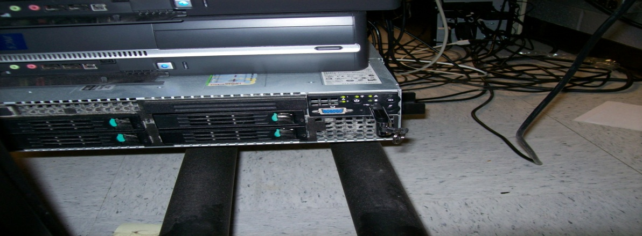

- Book Tracker:

Books list (Excel spreadsheet) is then imported to the scanner book Tracker where a new batch of books will be processed:
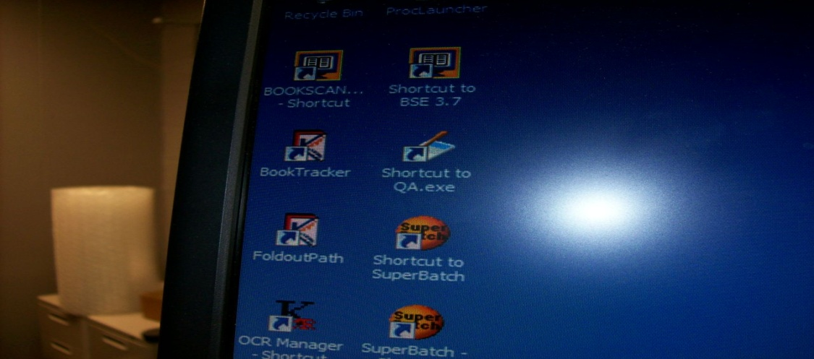

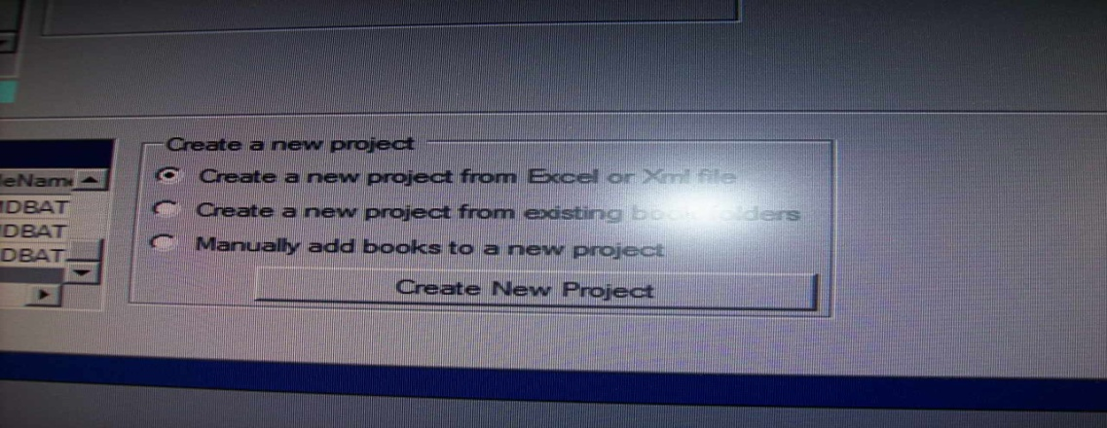
The scanning person is responsible of checking the spreadsheet data concordance with the book tracker’s assigned fields and validating the list:

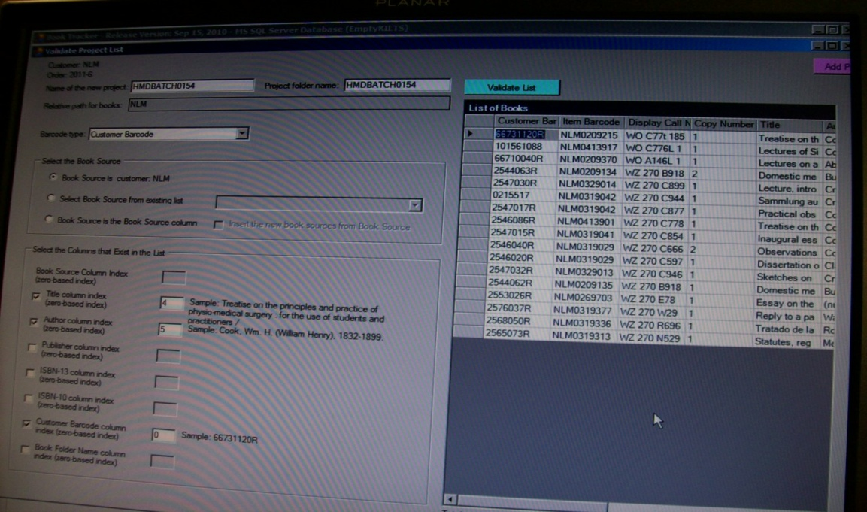

It is recommended to keep in mind one field to track, as for instance Unique Identifier that is attributed to only one item and cannot be duplicated.
The Book Tracker also can’t allow the list validation is it detects a book that was already scanned, until it’s removed from the books’ list. At that moment, the scanning person informs the HMD that a scanned book was included in the new batch of books supposed to digitize.

- Scanning and image capturing:
Once the Book Tracker’s validation list is done and the books shipped to the lab, the scanning person selects a book to start with. Before image capturing, a strip is attributed to the book and a Medical Heritage Library (MHL) Scanning Slip is filled with the Batch number and the NLM Unique Identifier (NLM UI), as shown in the picture:
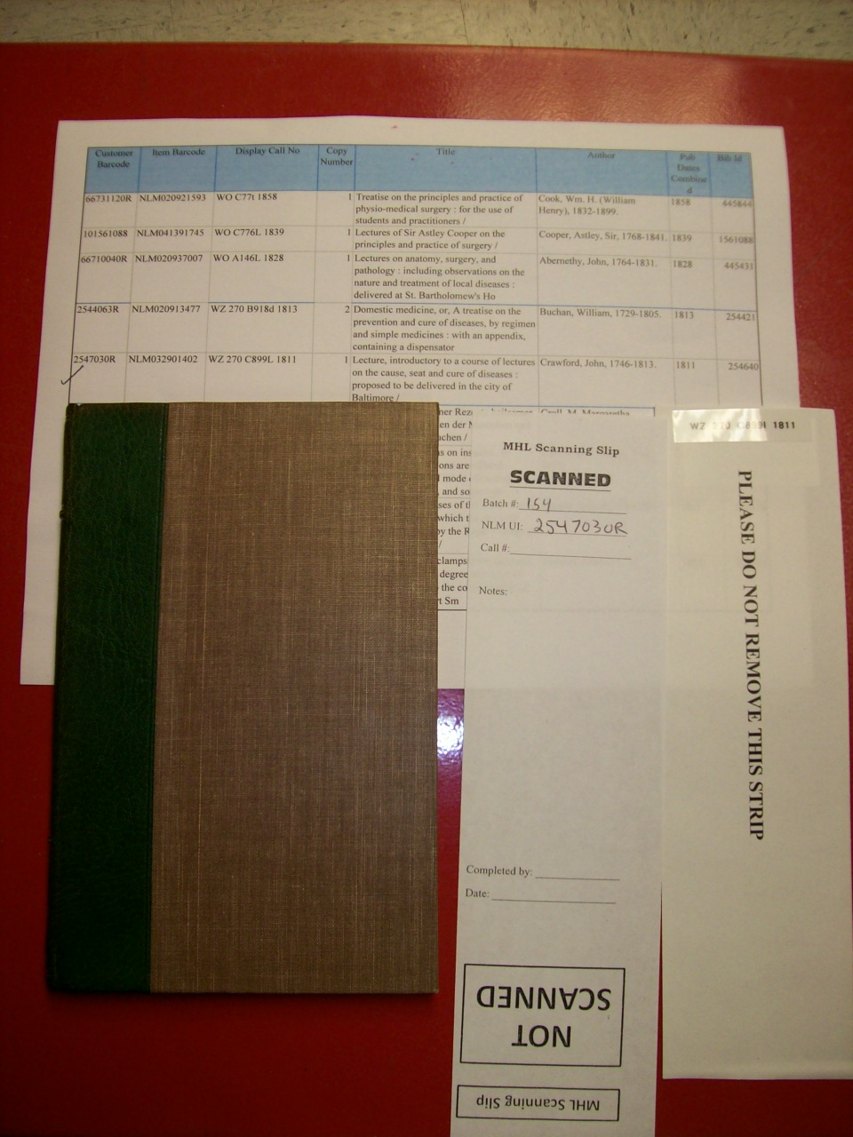
The procedure depends on vendor’s instructions. For Kirtas case, scanning is processed through Kabis Manager that controls software camera and data. The procedure with all its steps is described on the Kabis Manager handbook settled by the Scanning laboratory in order to help students and other scanning person to follow the required steps of image capturing. The handbook is in the Appendix 2.
While image capturing, the scanning person should keep in mind:
- One field to track: Unique Identifier for its reliability and uniqueness.
- The features to be done: OCR, colors…
Also, the project manager should work with the vendor to decide the batch’s size, descriptive features and an MD5 Checksum (fingerprint for digital files).
- Image processing:
Processing the images starts first by creating a template of a page of the scanned book in order to edit out clams, deskews and cracks. This stands for selecting two pages full of text in order to have a good zoom of PDFs. This template is submitted to every page of the book. The appendix 3 gives the best practices for image processing.
- Quality control:
Quality control phase consists on opening each file and look at each singular image to check if the images fit in the template’s frame and make sure that clams are off. The images are kept in colors for preservation and historical purposes.
- Quality Assurance (QA):
If the book is more than 100 pages, the reviewer look at 50 % of the book. The quality assurance is operated through the NLM Digital Project QA System that was developed in house in order to support and facilitate image curation workflow. 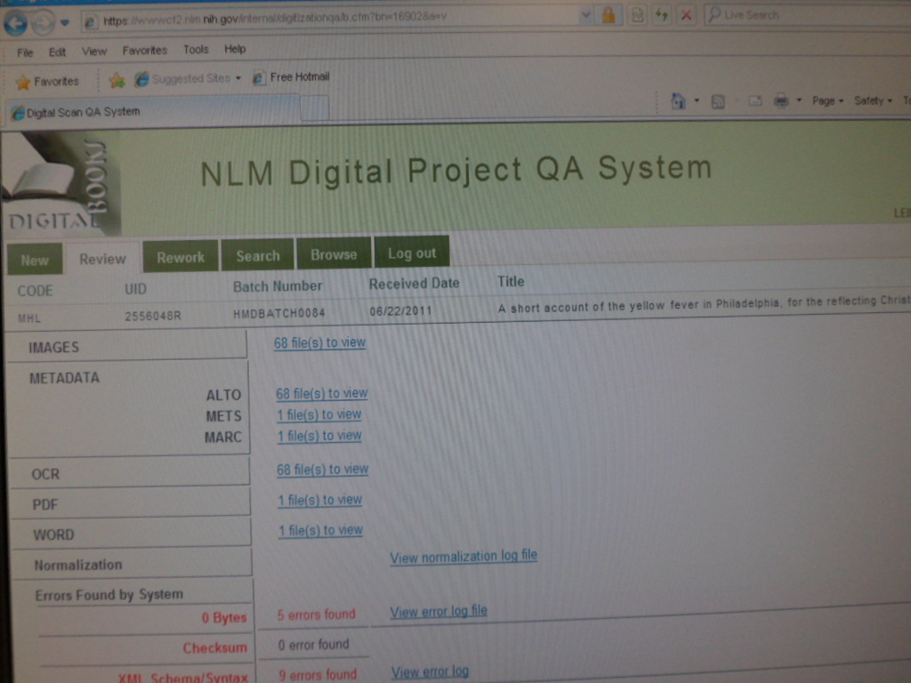
After going through the quality assurance, if a problem is found, the book should be uploaded again.
- Ingesting into the repository:
This step is operated through: adding core files from scanning, work with MARC records, image derivatives production, text file production using Fedora Indexing options, getting the files into repository, then batch ingest scripts.
  - The Johns Hopkins University Library: a medium scale project.
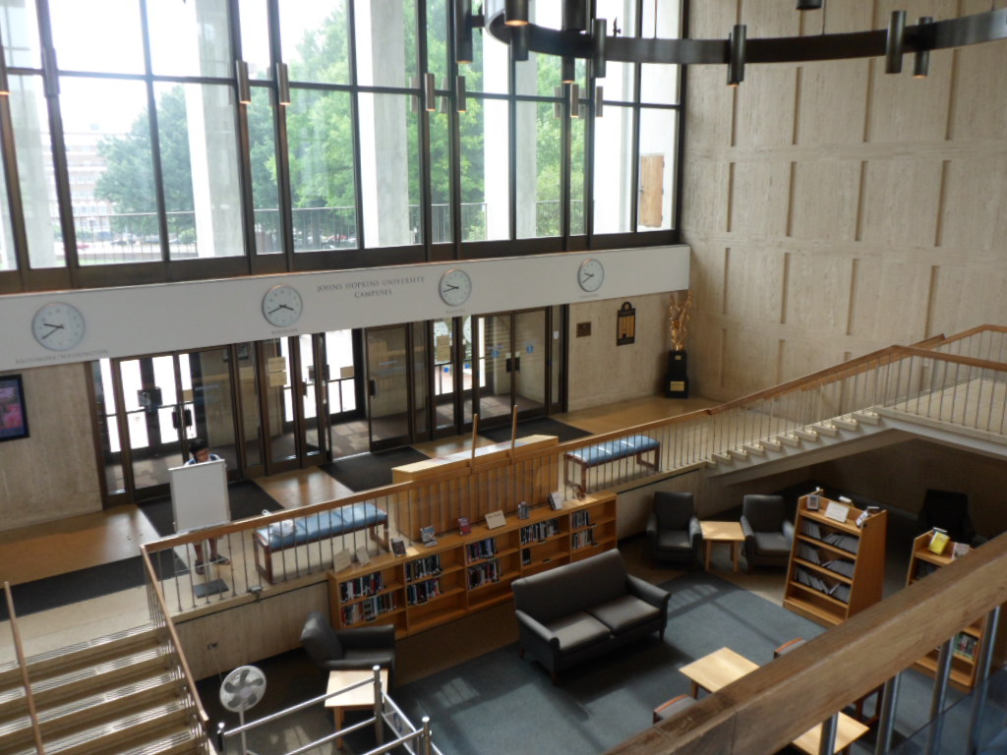
According to our host at The Johns Hopkins University Library, Robert Klingenbergen, the digital project began in 2008 with the purchase of the Kirtas Scanner Machine and later the Kirtas Sky View Machine (for fold out and oversized materials). In 2009, digitization processing started effectively with the help of the IT department and the university students’ involvement. Since then approximately 850 volumes have been digitized.
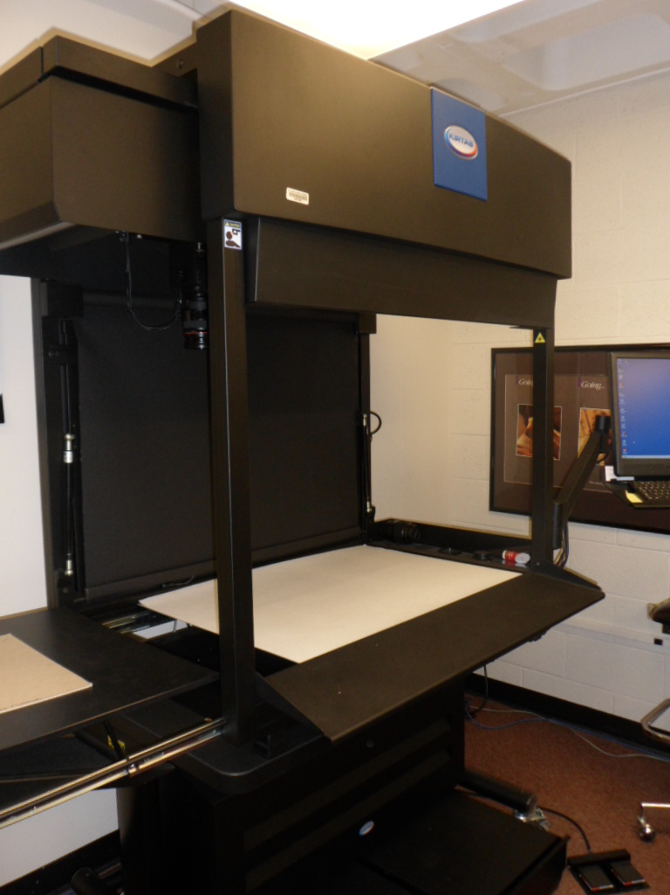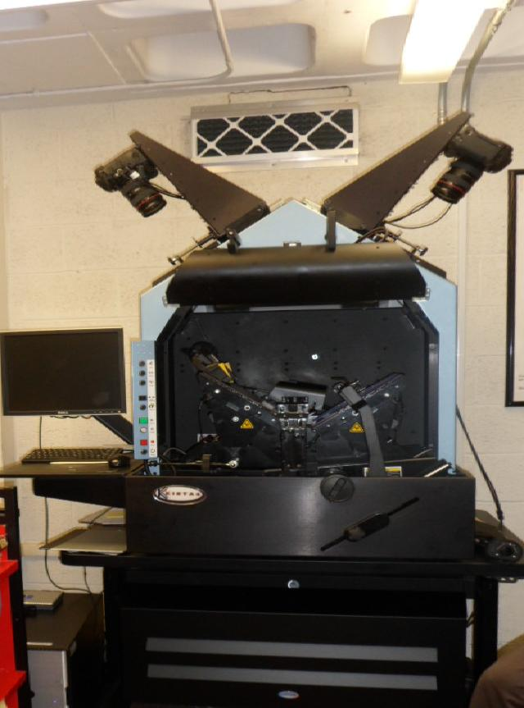
The purpose of this project is to preserve the “Wounded” books and materials from deterioration. That way their life extends and they are can still be circulated. After digitization, the print copy is given to the circulation desk, and the digital copy is stored hided in the library’s server.
The workflow description is available in the Appendix 4.
  - The Mount Vernon Library: a small scale project.
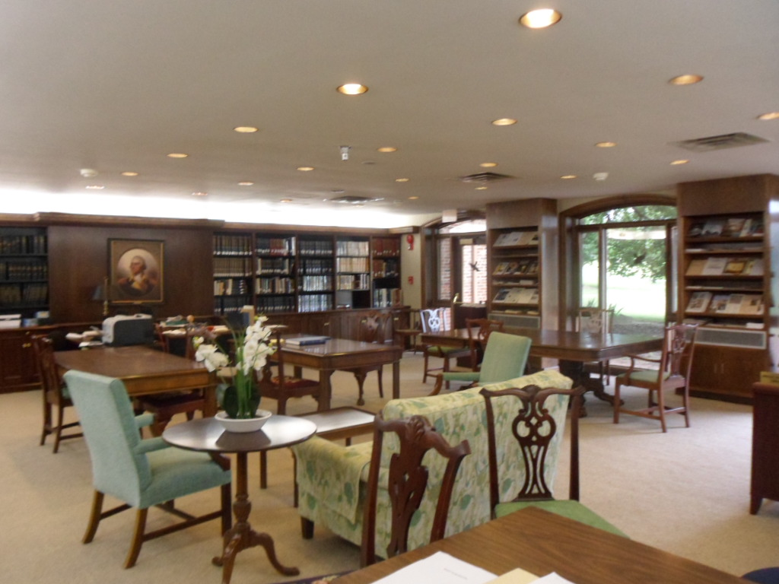
Mt Vernon Library is a small library with limited resources and a collection of 15,000 volumes: Manuscripts, Manuscripts, George Washington books, Special collection of Mt Vernon Ladies’ Association and the 1st Encyclopedia in the US.
The head of the library, Joan Stahl, started cataloguing the materials using the open source catalog system Koha since 2008. 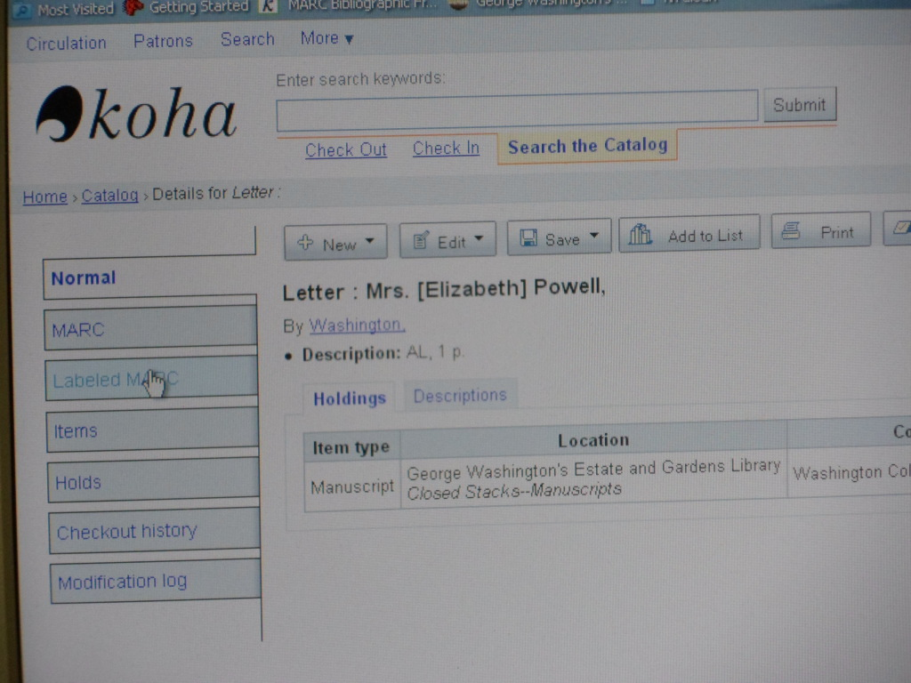
The digitization project started in 2009. The library didn’t have enough resources. A financing campaign was launched in order to fund this project. The donation campaign “Adopt a book” advertized the importance of digitization the special collection and the Mt Vernon Ladies Association records because they were reporting donors’ names that supported the preservation of Mt Vernon in the 19th century. Through this campaign, $20,000 was collected.
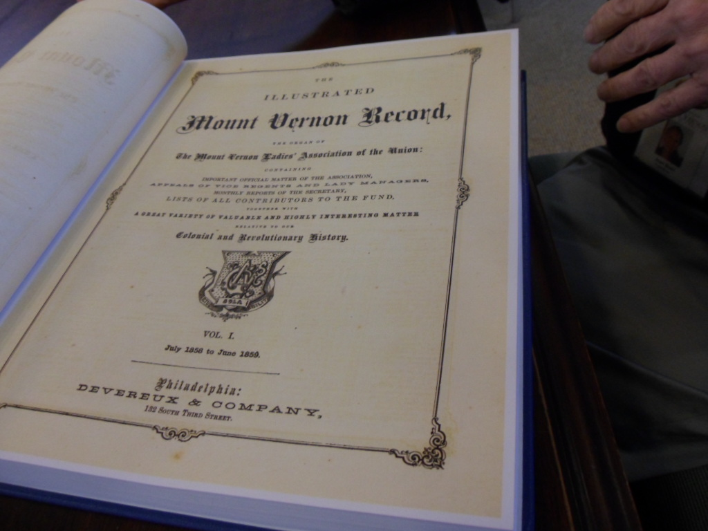
About 100 materials were outsourced, and put into the digital repository using the open source software: RescartaWeb.
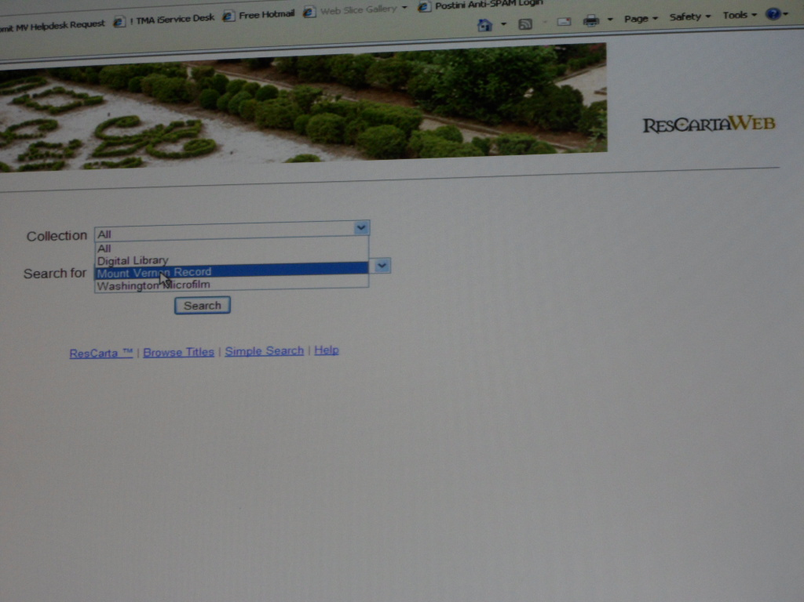
LESSONS LEARNED FROM THE SITE VISITS:
Visiting these libraries with three different digitization projects was helpful to learn from their experience and be aware that:
- Planning the project takes about one year
- The projects have a learning curve that can’t be skipped and that slows down the workflow.
- Different approaches were adopted according to resource availability and project’s goals
- Small projects tend to become bigger
- It’s possible to use digitization to extend the life of deteriorating materials under copyright law
- Partnership empowers digital libraries

- Results: a targeted proposal for Library of the National Institute of Hygiene

- Bulletin of the Institute of Hygiene
The Bulletin of the National Institute of Hygiene (1931-1994) was published in French by the Institute of Hygiene staff members about studies and researches they supervised, conducted or participated in. the authors were French practitioners during the colonial Morocco. Since 1956, the authors were the Moroccan physicians and practitioners. Each volume of the bulletin includes a study about a particular disease in a particular location, statistical data and the annual report about the activity of the NIH.
The bulletin of the National Institute of Hygiene is significant because:
- It’s the history of the Institute, as the active organ of the Health and Public Hygiene Direction at the colonial time.
- It’s a Moroccan history of medicine resource.
- It has a good quality of paper.
- It’s more used than “Maroc Medical” or the Bulletin of Pasteur Institute according to users’ loan records.
- Only 2 libraries in Morocco have this Bulletin: the Library of the National Institute of Hygiene and the National Library of the Kingdom of Morocco.
- It’s not included in the digital collection of “La Bibliotheque InterUniversitaire de Santé”- Paris.
- It’s out of copyright.
The other challenges of using the printed, original versions of the bulletin, in addition to not being online accessible and not indexed, is that the users can’t make copies of the articles they need onsite: because there is no copier. So they need to check out the Bulletins to copy them outside the Institute. Even if I take their ID as a security, it’s not logical that rare and historical materials be taken outside the institution to be copied like any other modern materials, without respecting the paper and the binding. Also there’s a risk to have them damaged or never see them back to the library. Users are not permitted to take more than one volume at a time out of the library, so they have to make multiple trips for additional volumes. These operations are challenging the security and safety of the materials.
- Malaria epidemics in Morocco historical materials
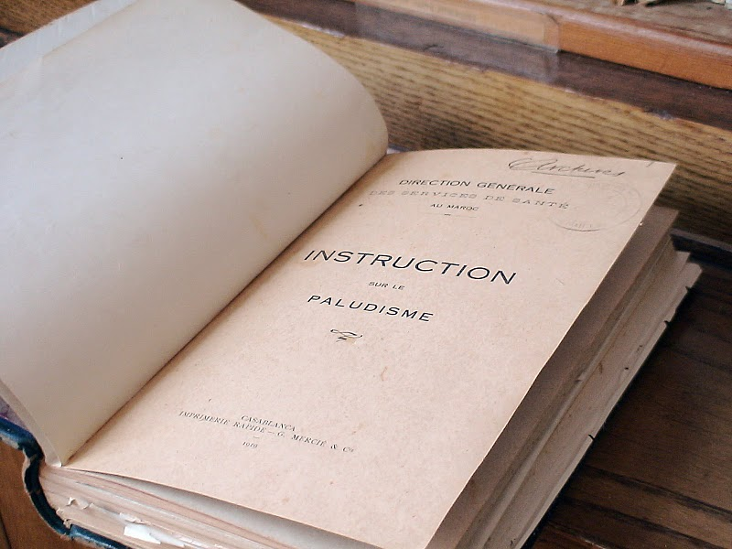
Many centuries before the French occupancy (1912) until the early 1990’s, malaria was a major issue in Morocco and costly in human lives.
In 1928, a malaria epidemic killed affected Moroccan agriculture workers and exhausted the labor force. People then couldn’t produce and get food, which caused hunger and under nutrition diseases.
After that, in 1929, an intensive initiative for malaria control was launched by the Health department. Part of this initiative was the creation of the Institute of Hygiene, Rabat in 1930 by Dr Leon Bernard, in order to sustain capacity building and epidemic surveillance and control.
At that time, many materials about malaria eradication programs in Morocco were published by the Institute of Hygiene’s teams, scientists or by other Health department facilities. These materials (journal articles, handbooks, textbooks, dissertations, maps, photographs….) are still preserved in the Institute of Hygiene Library. In 2005, Morocco was declared malaria free.
The interests of digitizing these materials are justified by the potential comeback of malaria epidemic in the Maghreb region. For the case of Morocco, here are the risk factors:
- Reported malaria cases brought from people outside the country (Kenya, Nigeria, Gabon, and Ghana) or from the country going to endemic areas in Africa for task force exchange, trainings, job opportunities and other forms of exchange across the African continent. Reported cases also are increased by illegal Sub-Saharan immigrants crossing Morocco to Europe. The parasite detected in these cases is the Plasmodium falciparum.
- The decrease of the Health Department’s surveillance after malaria eradication. Other programs are in focus: HIV/AIDS, TB, Influenza, Cancer, Tobacco control, family planning, etc.
- Climate change can increase the animal reservoirs and arthropod vectors for malaria
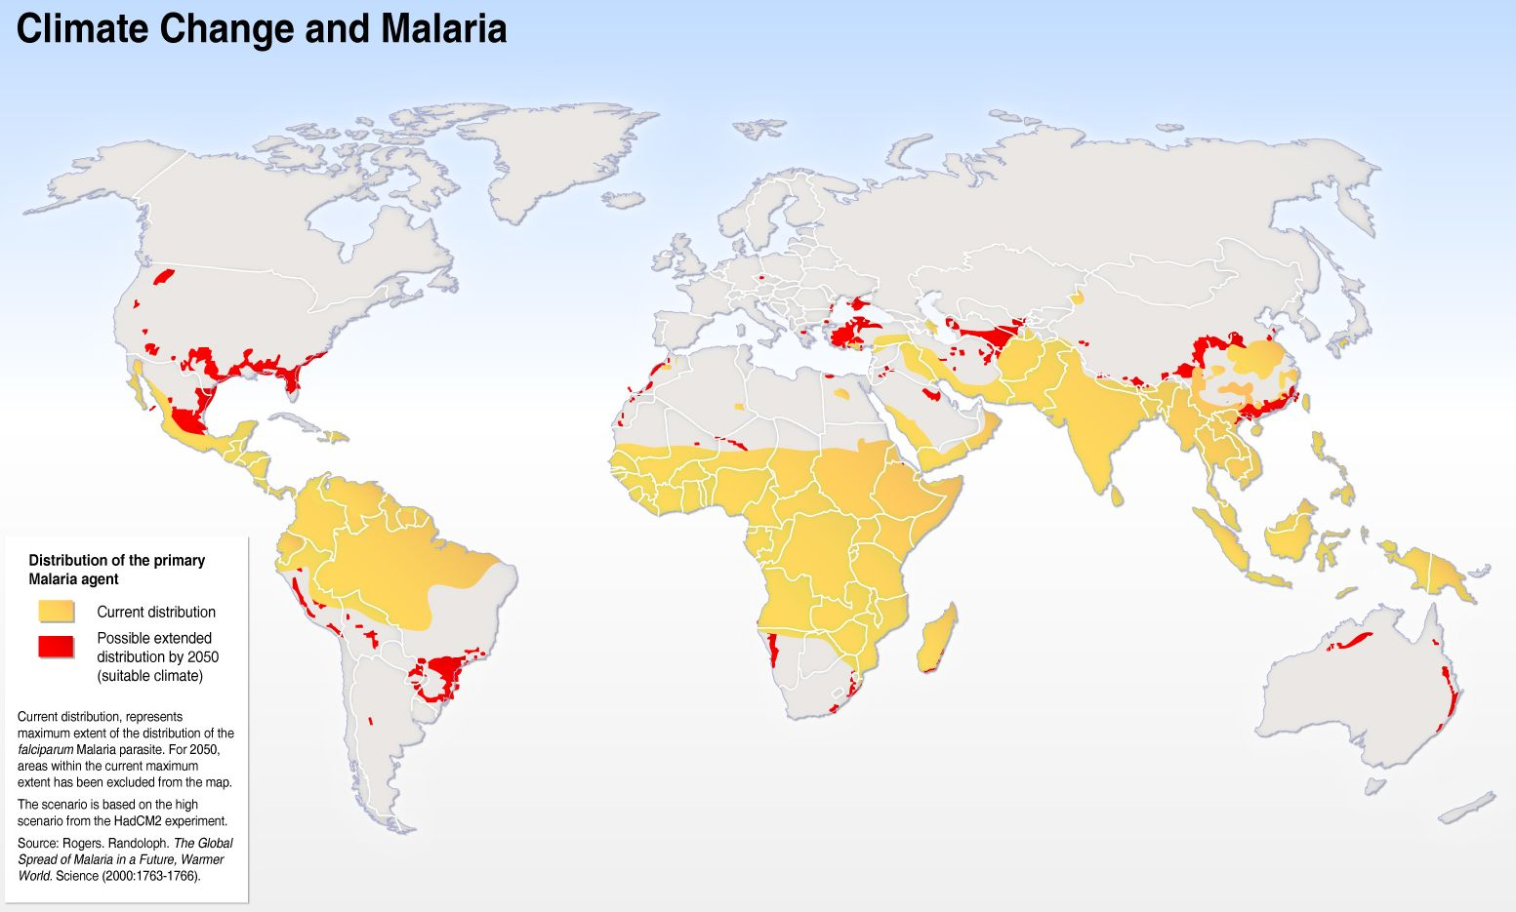

- Development projects: Urban constructions and road extension bring at the same time good news and bad news. Good news: facilitate human mobility, provide more housing and social facilities (schools, hospitals, universities…). Bad news: reduce green spaces, provide more breeding grounds for mosquitoes because of the lack of trees that absorb rain water.
- The permanent presence of Anopheles Labranchiae Falleroni and the expenditure of Anopheles Gambia to North Africa. Anopheles Labranchiae Falleroni was the main vector of Plasmodium vivax, Plasmodium falciparum and Plasmodium malariae.
Having a digital malaria collection will offer to historian researchers and malaria specialists additional resources to be explored in order to prevent a potential future epidemic.

- Maroc Médical
This journal is one of the oldest medical serials published by French medical practitioners in the early 1910s. This journal was regularly published and widely distributed across the Kingdom of Morocco since the early 1920s. The purpose of this journal was to publish the new research outcomes and diseases treatment in Morocco by French medical doctors. As there is Maroc Médical, there was a similar journal for all the North African countries occupied by the Republic of France in the early 20th century:

Algérie Médicale : NLM catalog for Algérie Médicale link
Tunisie Médicale : NLM catalog for history search query link
These journals have been indexed by Medline just for a number of years, except Tunisie Médicale that is still being indexed.
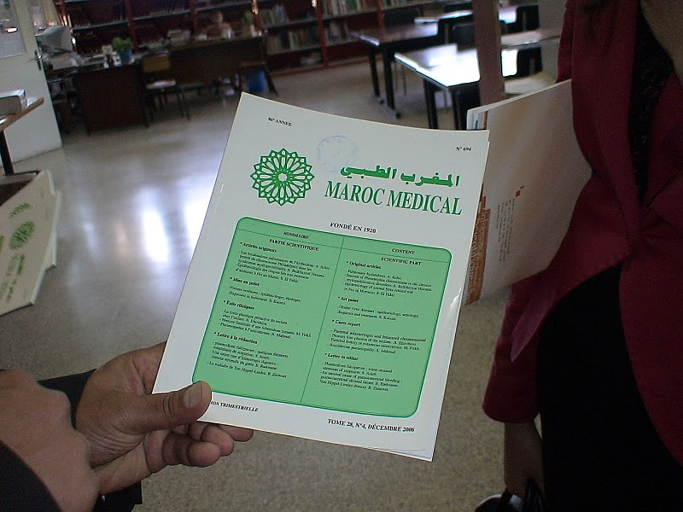

Maroc Médical was indexed by Medline from 1921 to 1975. When its name changed to “al-Maghrib al-ṭibbī. Maroc médical”, it was indexed by Medline from 1978 to 2001.
- Conclusions: implementation of the Targeted Proposal for the National Institute of Hygiene Library Morocco
The purpose from developing a digital library for the National Institute of Hygiene is to open the access to the old medical materials for the current users (Staff, trainees, international scholars) and to potential users at the international level.
The materials proposed fall under the public domain of the copyright law. This way the digital files will be on open access.
Plan development:
The following table shows the project plan phases:
Activities | Tasks
Materials’ Selection  Assessment | Selection of new cataloguing system: the current Information Library System cannot handle digital objects description and structure. It doesn’t include MARC. The new cataloguing system has to be open source, ingestible online. This new cataloguing system will be open source, for example Koha.  Export records to new catalog: the existing records should be migrated from the old catalog to the new catalog database.  Rejection of some items (brittle, foldout, and oversize): the collection proposed should be assessed to make sure that brittle, foldout and oversize materials are excluded from being digitized because of technical issues.
Space | Digitization has to be done in the library or in Institution because the materials are rare. Also with digitizing onsite the collection, bigger digital project could be developed easily and quickly since equipment will be available at hand.  Prepare the space: a space should be reserved to digitize the materials either at the library or at the institution level. Also the infrastructure should be installed: cabling computers to the scanner and server.
Software | The online repository software that will be used to ingest the digital files will be an open source. Several softwares are available online. Each one has to be studied, assessed and tested before selecting the most appropriate one to the requirements of this project. The next step should be adjusting the selected open source software to the requirements of the project.
Hardware | The hardware selection and acquisition depends first on the budget allocated, then on the selection criteria checklist developed earlier in the literature review section.  The emphasize is on: assessing the storage needs, experimenting a whole digitization process for different scanners vendors using a checklist, selecting and acquiring a scanner, training the staff members who will be digitizing, install a network for equipment: scanners and servers.
Metadata | Metadata organization starts at the beginning of the project with the descriptive metadata for the collection selected to be digitized (MARC catalogue). Then while processing the digitization, the files have to be attributed structural metadata which helps in organizing the digital files at the batch level and at the file’s level.
Digitization | Determine files’ formats: Prior to digitization, files’ formats should be defined. The librarian in collaboration with the IT technician must determine which formats digital files will take or stored under (Tiff, Jpeg, Jpeg2000,…)  Describe the workflow and process: the project manager with the project team should coordinate and describe the workflow of digitization operations in a simple language. This will help later when students or other staff will join the project to get easily familiar with the process.  Process reviewing: the quality control of processed images is an important step that allows identification of defected digital files that come with clams, deskews and cracks.  Quality Assurance: is a key task to make sure the files and their metadata are well matched and completed. It gives a general overview of the formats displayed, the digital file metadata.
Submission to digital repository: ingesting the digital object into the digital repository will allow these files to be accessible online to the public. The approver, who takes in charge this step, can modify metadata, validate or reject s submitted item. He also makes sure that the files are text searchable.
Evaluation: the approver, after ingesting the items into the repository, evaluates the online version of the displayed digital files: descriptive and structural metadata, text recognition, file formats, image quality.

Budget estimate
To estimate the necessary budget for a digital project, it is necessary to list first the staff members involved in that project and their hour salary charge. This cost per hour estimate is used to estimate the costs of the remaining activities for the accomplishment of the project.
The total costs are of $24,582.12 for the start-up expenses. Some costs are impossible to estimate before starting the project. This means that the number given is the minimum budget required. Additional costs will apply. More details about the budget distribution are given in this table:
Activity | Task | Staff | Number of hours | Cost an hour | Total cost
Select materials | Identifying materials | Librarian | 40 | $12.50 | $500
 | Determining legal restrictions (copyright, privacy rights, donor rights, etc.) | Librarian | 16 | $12.50 | $225
 | Investigating the availability of digital and other versions, such as microforms (online search) | Student | 10 | $3.20 | $32
 | Eliminating items due to condition or completeness | Student | 10 | $3.20 | $32
Determine the size of the collection | Determine the number of titles, volumes, pages to be scanned, pages | Librarian  Student | 16 | $15.7 | $251.2
Prepare documents | Checking out the documents from circulation | Student | 15 | $3.20 | $48
 | Creating documentation/instructions for bibliographic control, indexing, tagging, and encoding information | Librarian | 320 | $12.50 | $4,000
Determine imaging requirements (benchmarking) |  | Librarian  IT | 40 | $23.12 | $924.8
Determine requirements for and create metadata: Ongoing costs |  | Librarian  IT | 4 /week  (14 weeks for first collection) | $23.12 | $1294.72
Determine imaging costs | Estimating costs depends on estimating the number of pages for:  - Regular size and single-leaf and unbound (<=(8.5" x 14")  - Regular size and bound (<=(8.5" x 14")  - Oversize and bound (>8.5" x 14")  - Oversize and single-leaf or unbound (>8.5" x 14")  Additional conversion related costs (printing, derivatives and backups)  The Institute of Hygiene Bulletins fall under the regular size and bound (<=(8.5" x 14"). There are 56 volumes. Each volume holds around 300 pages. This leaves us with an estimate of 16,800 pages in total to digitize.  To digitize 30 pages an hour: will leave us with 560 hours (14 weeks FT) for image processing.
Determine text conversion costs | Vendor estimates should include fixed price per 1,000 characters for the following:  Re-keying or OCR processing, Inspection, Corrections, Supplies, Special handling, Media, Shipping and insurance
Post-process digital files: quality assurance serves to check if nothing is missing from the digital files. This step takes longer time at the beginning of the project. |  | Student  Lib | 4 hours/ week  (14 weeks) | $15.7 | $879.2
Estimate additional local costs | Project management and tracking | Lib | 96 | $12.50 | $1,200
 | Programming/systems support | IT | 960 | $10.62 | $10,195.2
 | Purchasing storage devices, media and software |  |  |  | $3,000
Others (Installation of new ILS, Online repository) |  |  |  |  | $2000
Total |  |  |  |  | $24,582.12

References:
- Sitts MK, Handbook for Digital Projects: A Management Tool for Preservation and Access [Internet]. Andover: Northeast Document Conservation Center; 2000. 182 p. Available from: http://www.nedcc.org/resources/digitalhandbook/dman.pdf

- Mugridge RL. SPEC Kit 294: Managing Digitization Activities. Washington, DC: ARL; 2006. 162 p.

- Kenney AR, Rieger OY. Moving theory into practice: digital imaging for libraries and archives. Mountain View, California: Research Libraries Group; 2000. 189 p.

- Indiana University. Indiana University digital library program: Strategic plan page [Internet]. Indiana University; 2005 Aug [Updated 2007 June 28]. Available from: http://www.dlib.indiana.edu/about/planning/stratPlan.shtml

- Washington State Library. Digital Best Practices: Planning Checklist Page [Internet]. Olympia: Washington State Library. Available from: http://digitalwa.statelib.wa.gov/newsite/projectmgmt/planning.htm

- Understanding Metadata [Internet]. Bethesda: National Information Standards Organization; 2004. 20 p. Available from: http://www.niso.org/publications/press/UnderstandingMetadata.pdf

- Erway R. Rapid capture: Faster throughput in Digitization of Special Collections [Internet]. Dublin, Ohio: Online Computer Library Center, 2011 Apr. 23 p. Available from: http://www.oclc.org/research/news/2011-05-03.htm?utm_source=WhatCountsEmail&utm_medium=OCLC%20Abstracts&utm_campaign=OCLC%20Abstracts

- BCR’s CDP Digital Imaging Best Practices Working Group. BCR’s CDP Digital Imaging Best Practices Version 2.0 [Internet]. 2008 June. 71 p. Available from: http://www.lyrasis.org/Products-and-Services/Digital-and-Preservation-Services/Digital-Toolbox/Digital-Imaging.aspx

- McKendrick J. Funding and priorities: the library resource guide benchmark study on 2011 library spending plans [Internet]. Chatham, NJ : Unisphere Media, 2011. 34 p. Available from: http://www.alamo.edu/nvc/lrc/File_Funding_and_Priorities_Academic_Libraries,_The_Library_Resource_Guide_Benchmark_Study_on_2011_Library_Spending_Plans.pdf

- Baylor University Institute for Oral History. Funding for Digital Oral History Projects [Internet]. Waco, TX: Baylor University Institute for Oral History; 2011. 4 p. Available from: http://www.baylor.edu/content/services/document.php/79844.pdf

- Ministry of Health of Kingdom of Morocco. Malaria Elimination Strategy in Morocco: Plan and elements of evaluation [Internet]. Rabat, Kingdom of Morocco: World Health Organization, Ministry of Health. 42 p. Available from: http://www.emro.who.int/rbm/MoroccoStrategicPlanEn.pdf

- Trari B, Carnevale P. [Malaria in Morocco: from pre-elimimation to elimination, what risks for the future?] Bull Soc Pathol Exot. 2011 Jun 3. [Epub ahead of print]

- Barton M. R., Waters M. M. Creating an institutional repository: LEADIRS Workbook [Internet]. Cambridge: The Cambridge-MIT Institute; 2004-2005. 134 p. Available from: http://www.dspace.org/images/stories/leadirs.pdf

- OCLC. RLG Worksheet for Estimating Digital Reformatting Costs [Internet]. Dublin, Ohio: OCLC; 1997. 21 p. Available from : http://www.oclc.org/research/activities/past/rlg/digimgtools/rlgworksheet.pdf

Appendices
Appendix 1: NLM’s batch preparation spread sheet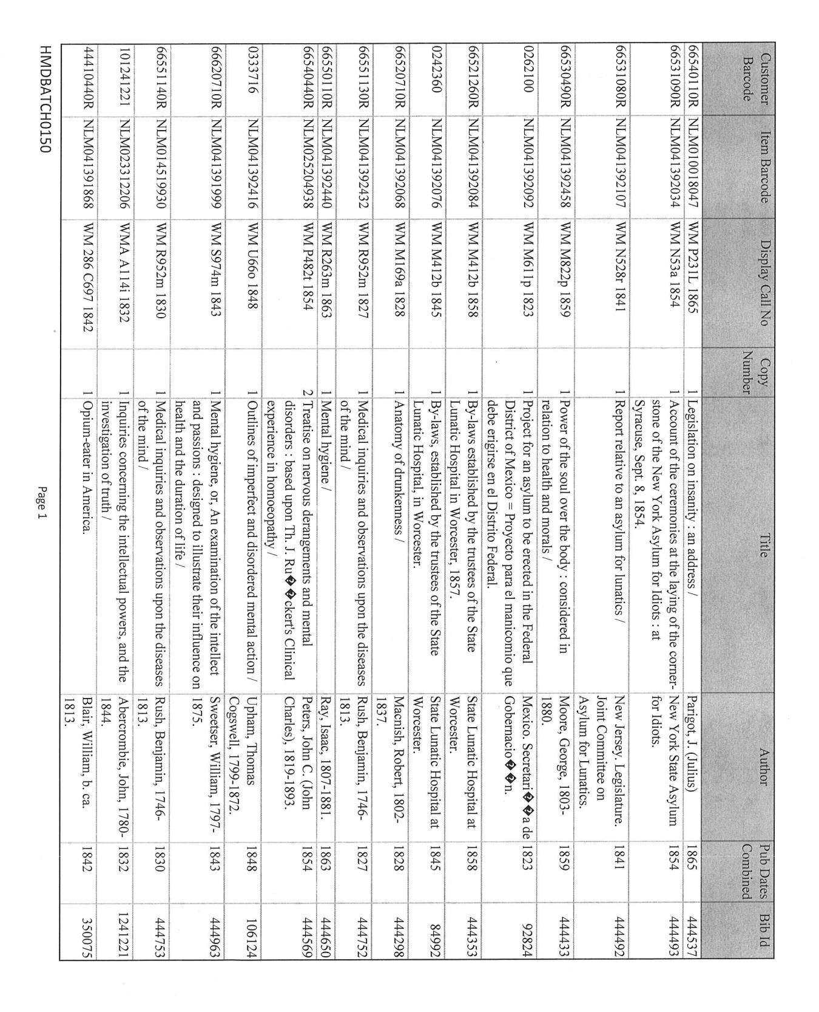
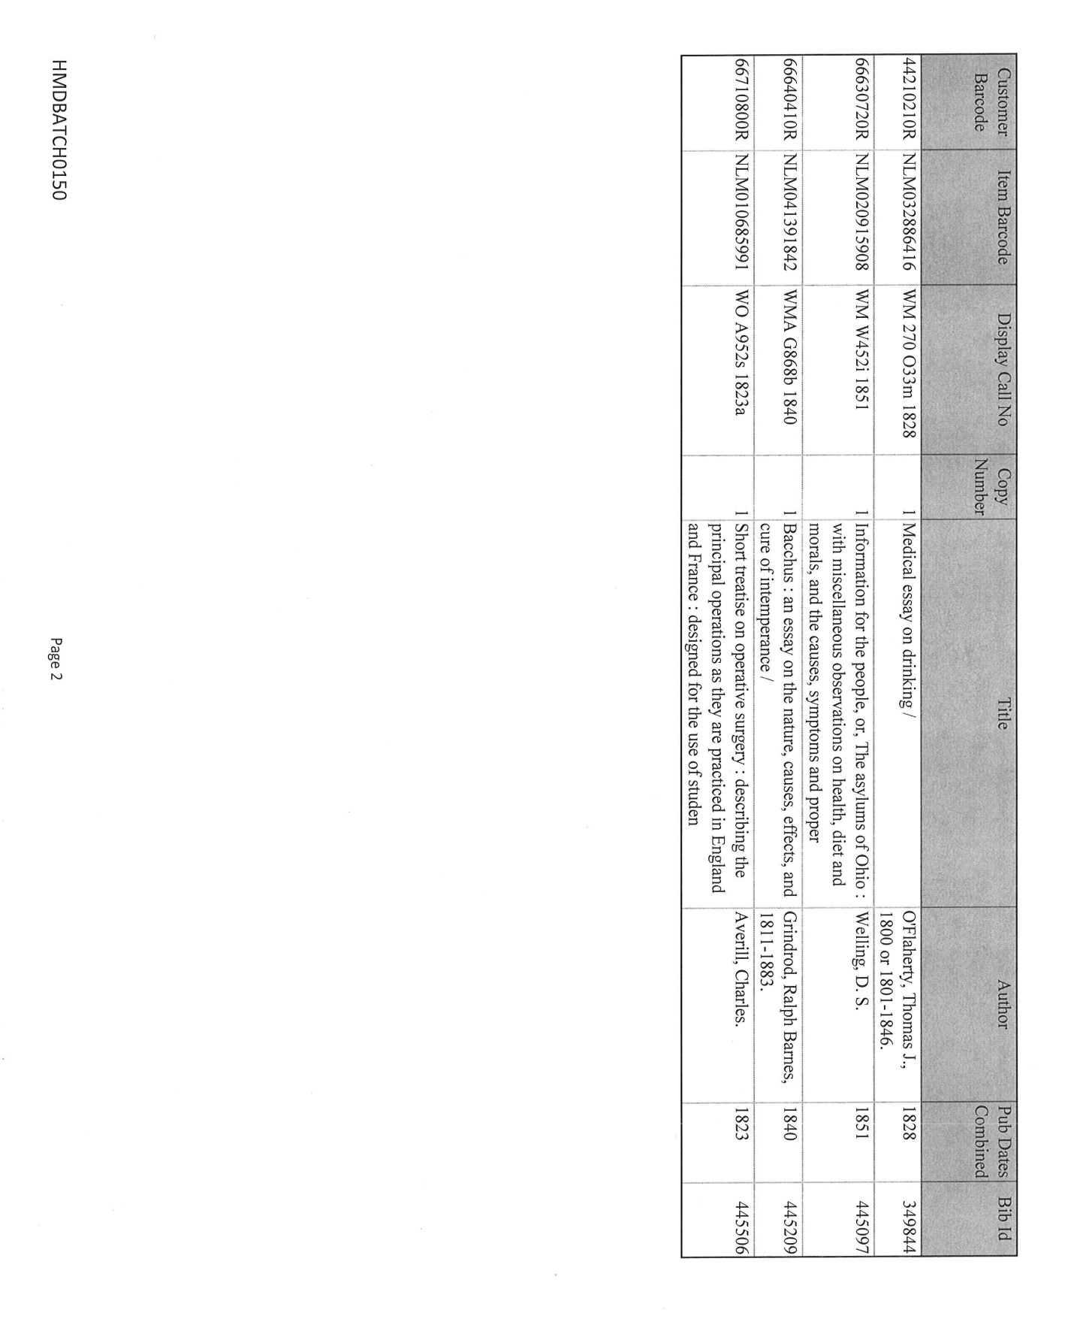
Appendix 2: Kabis handbook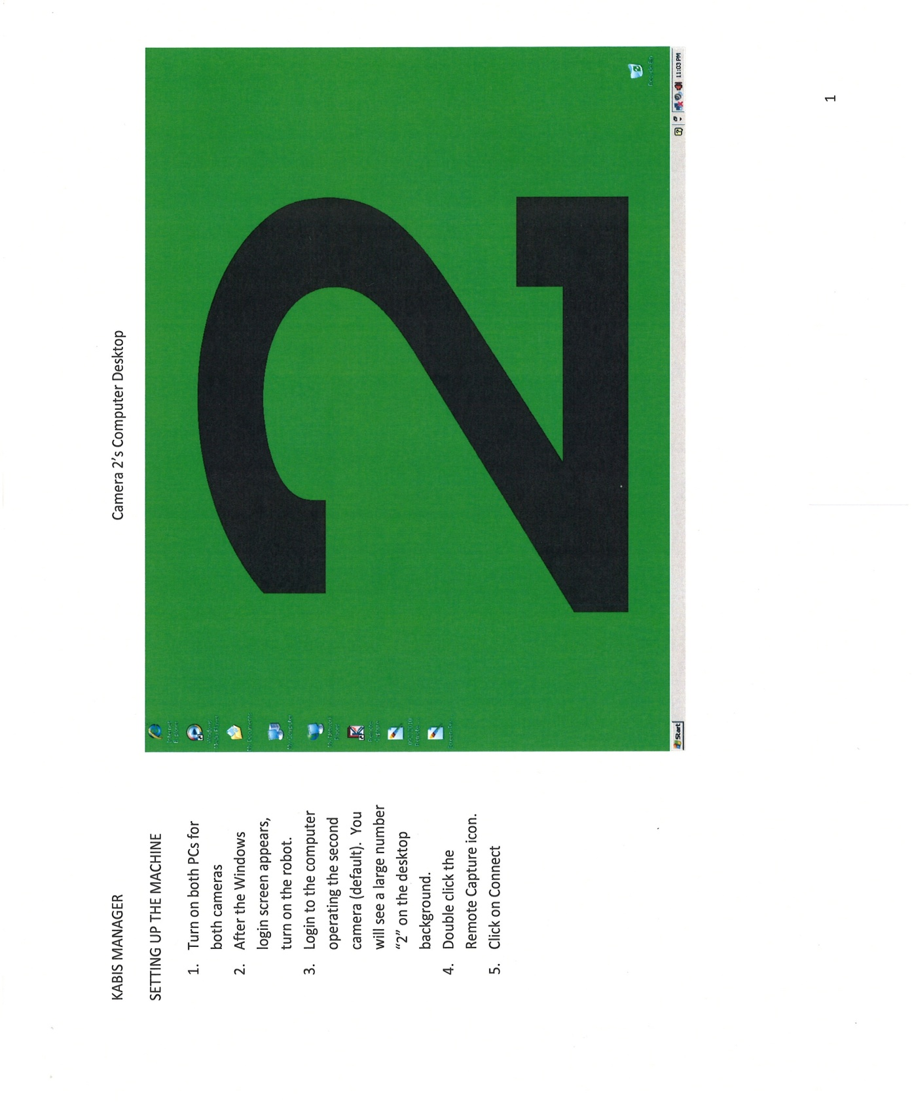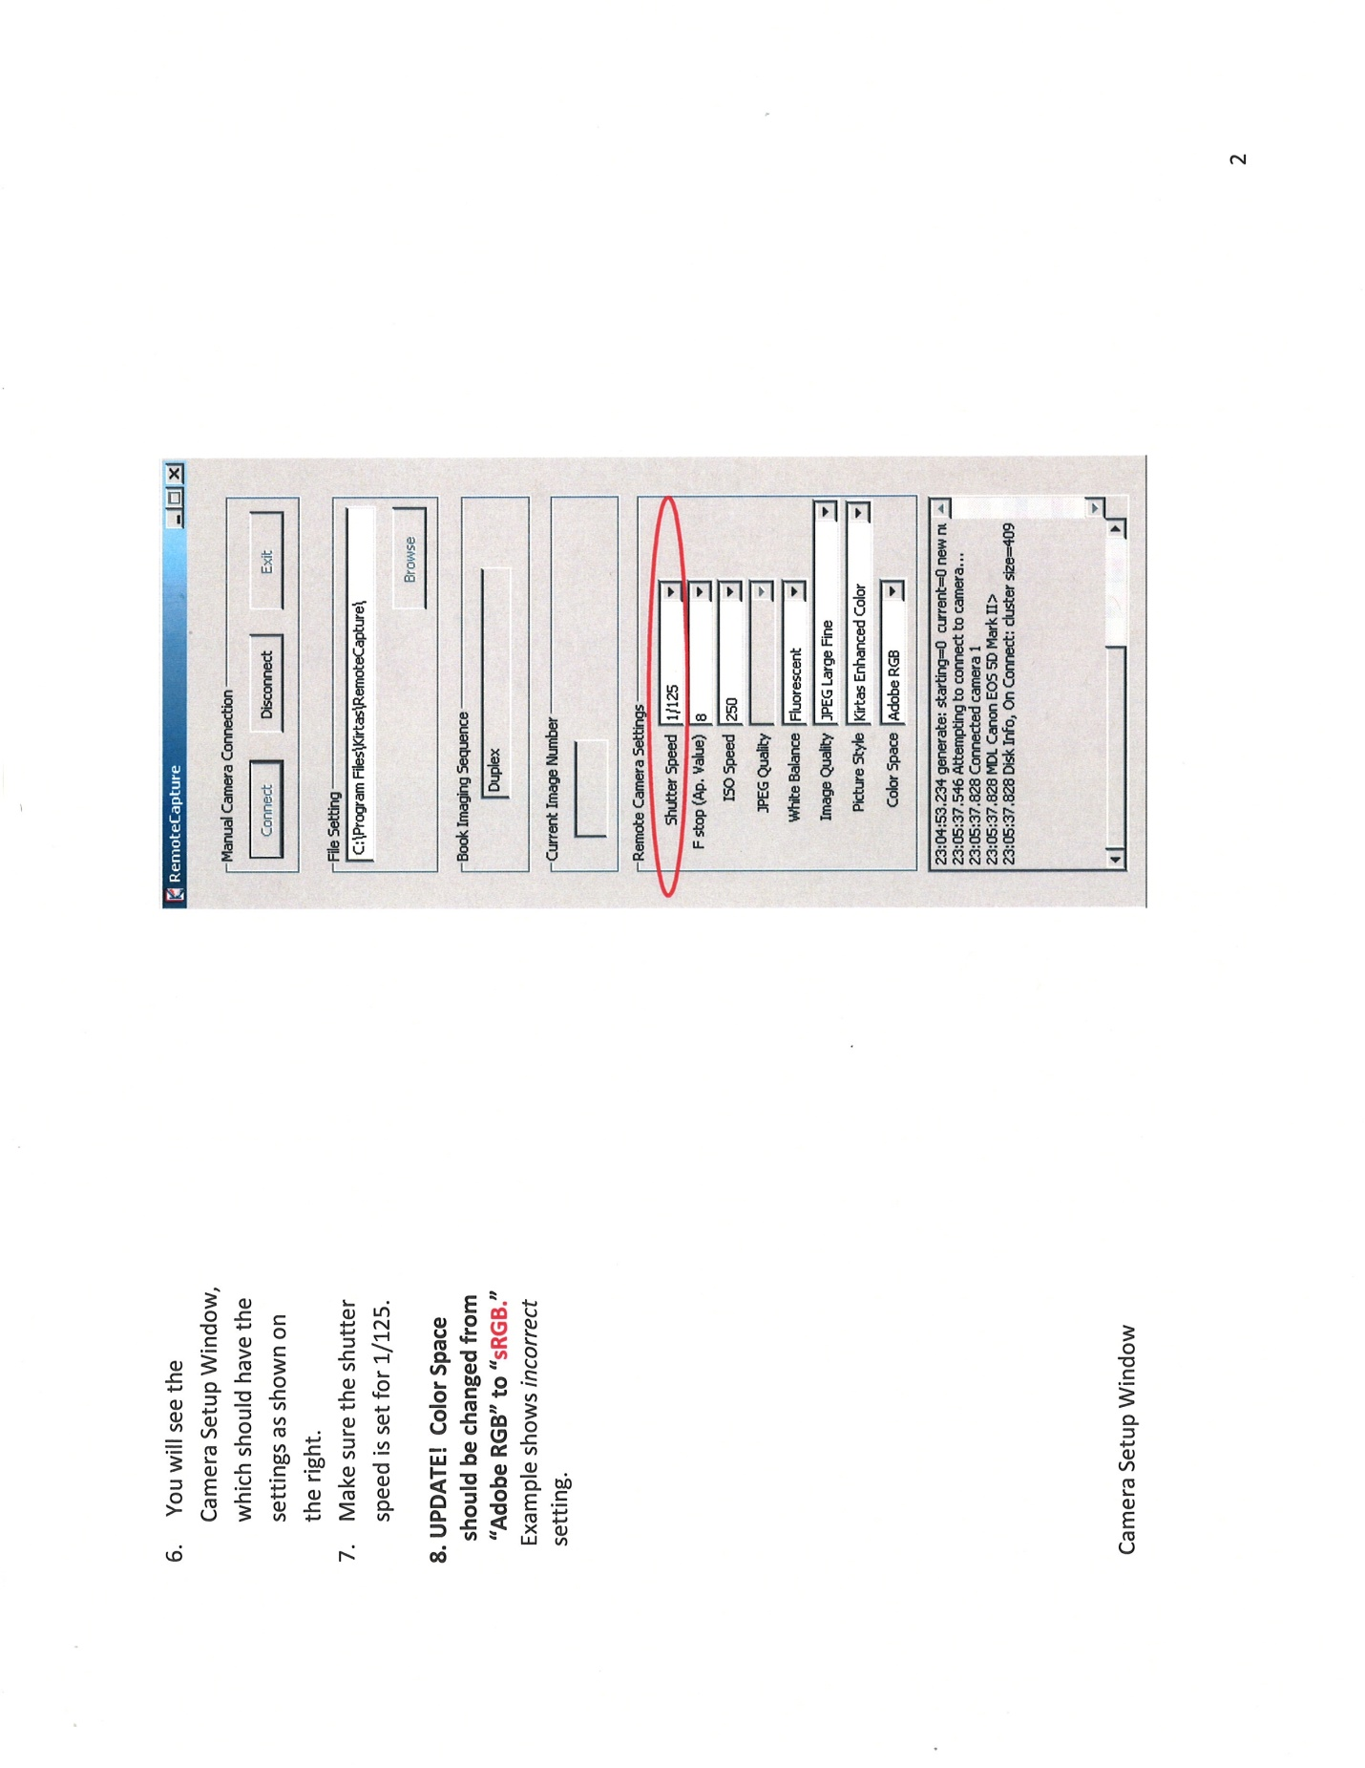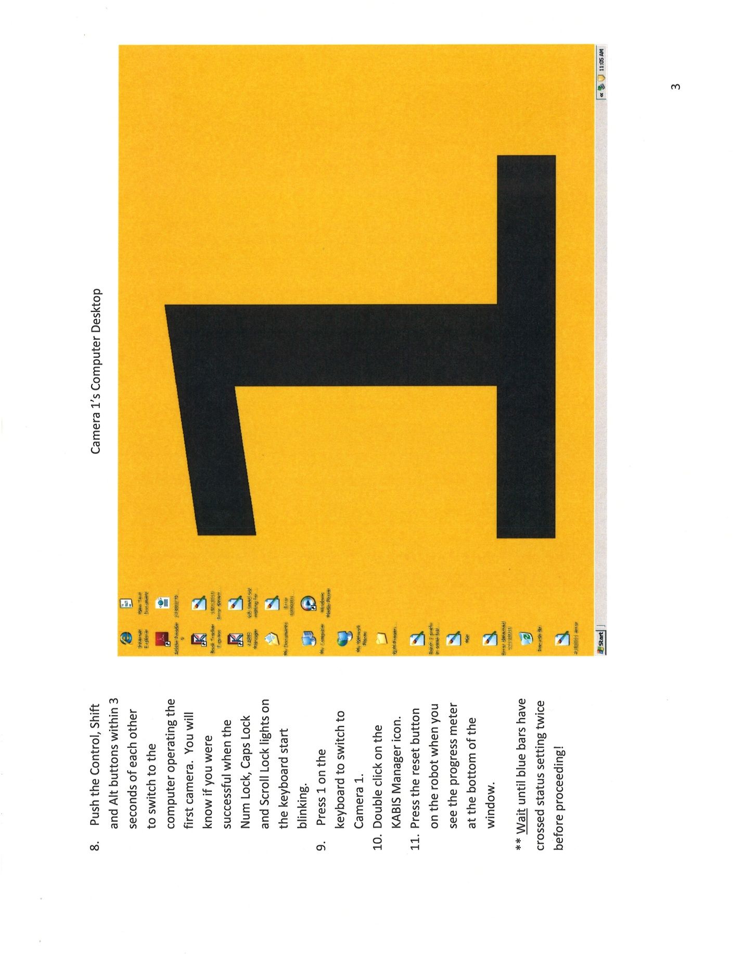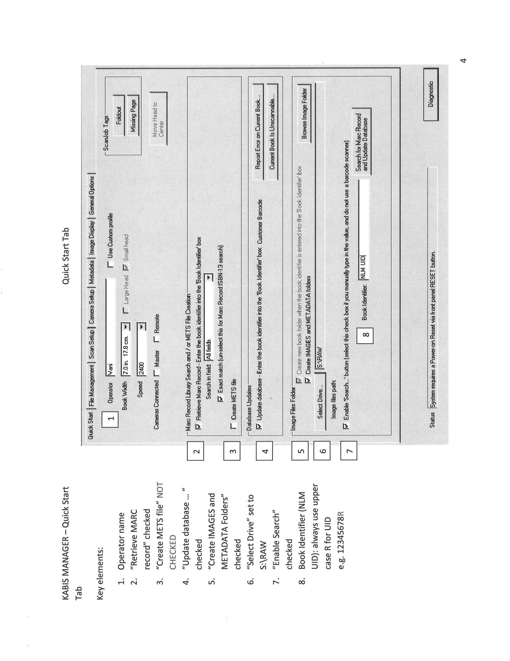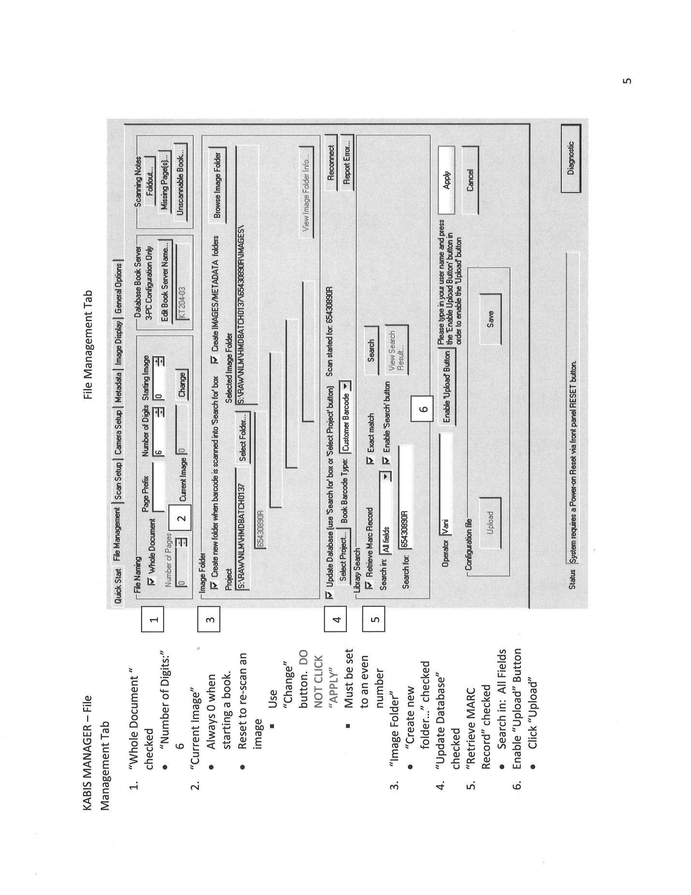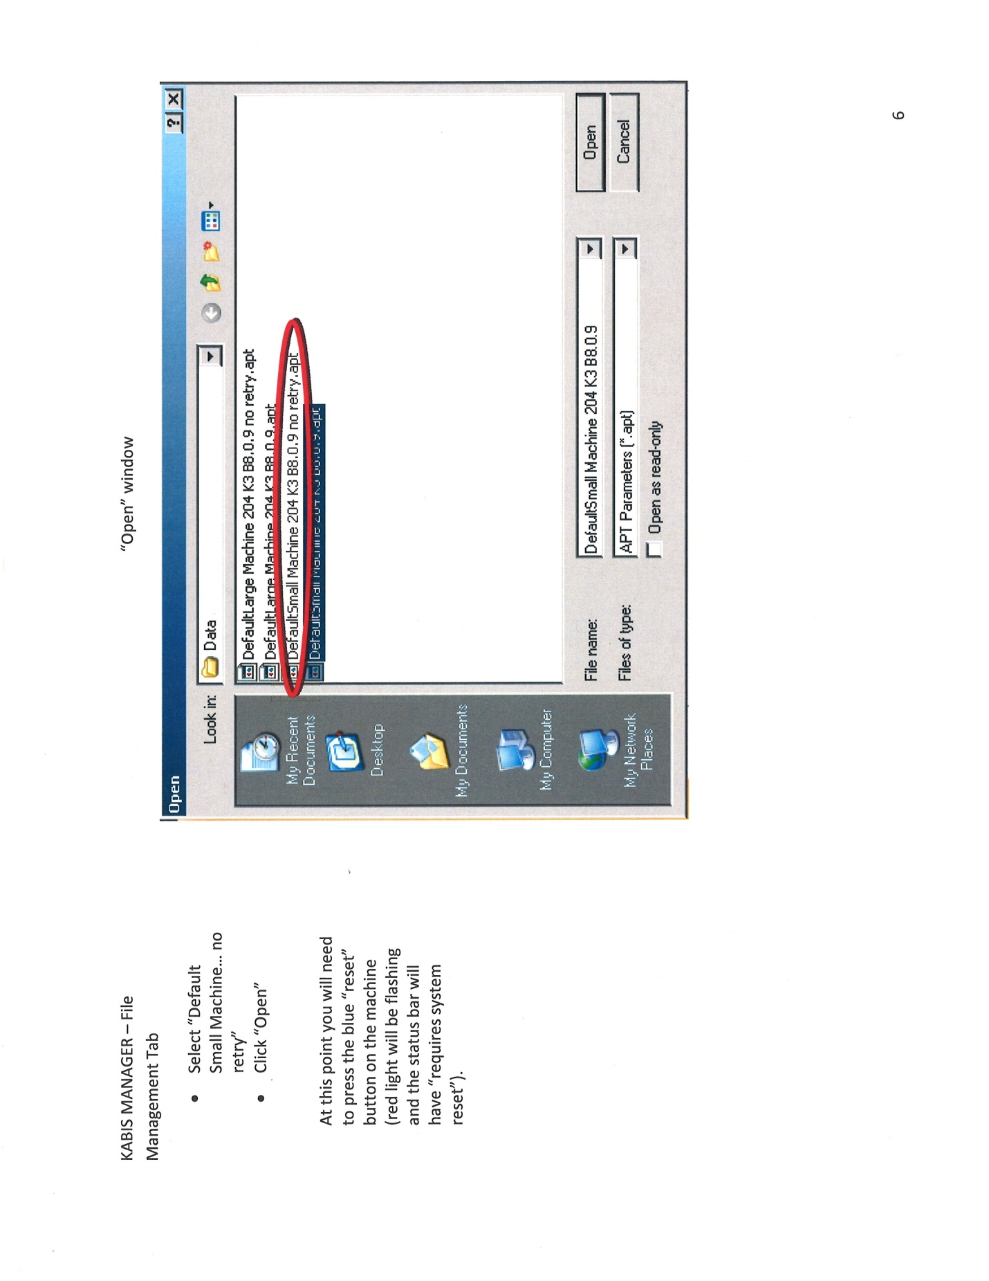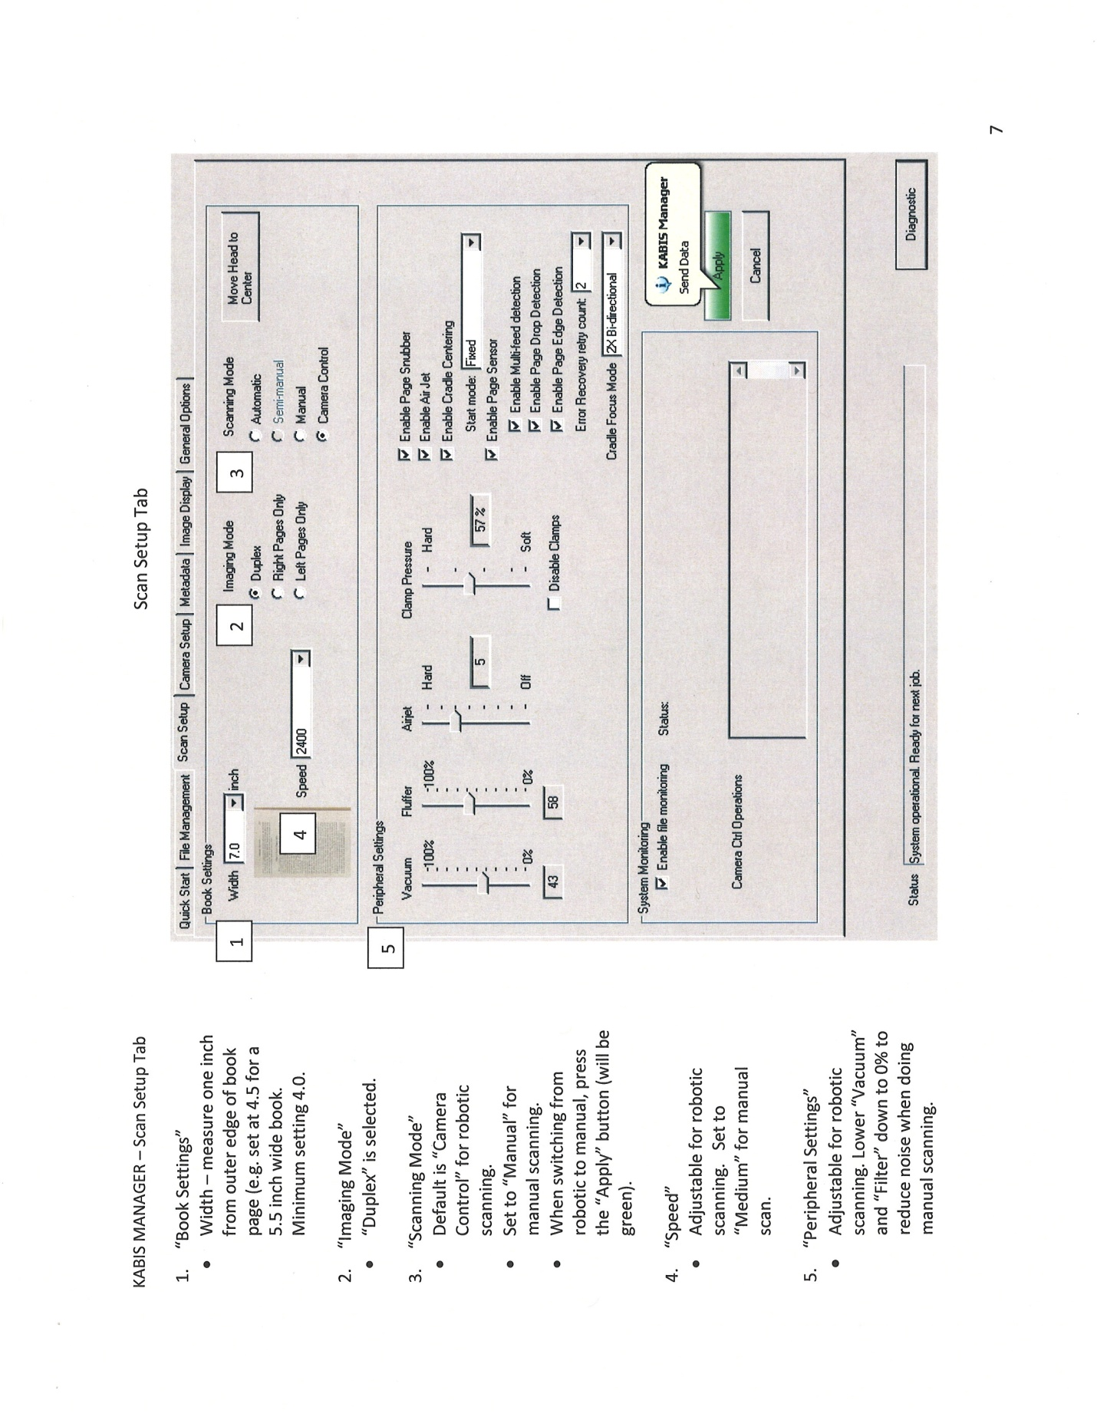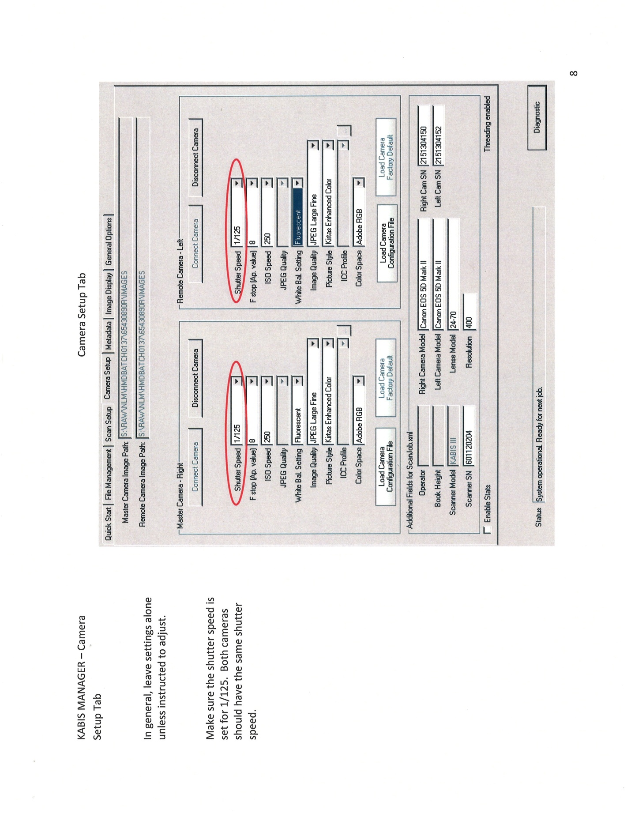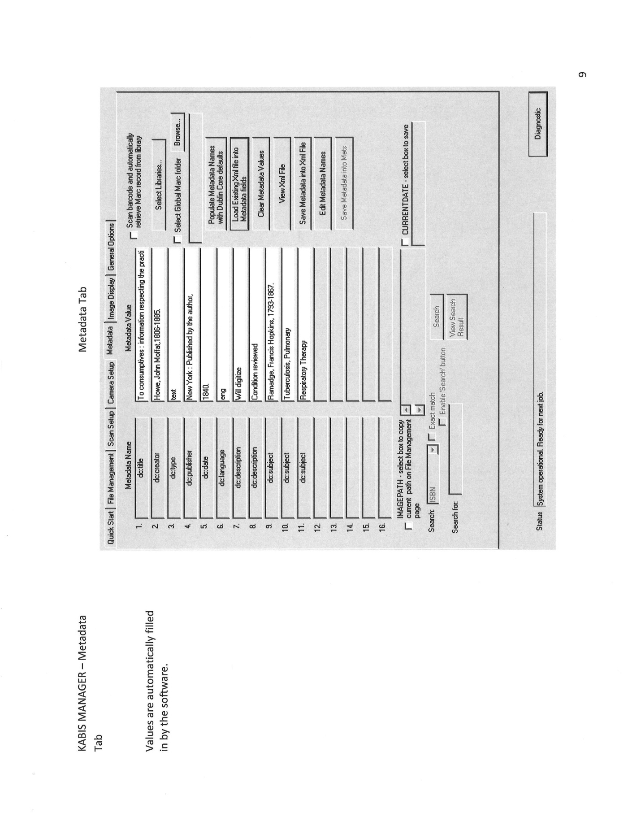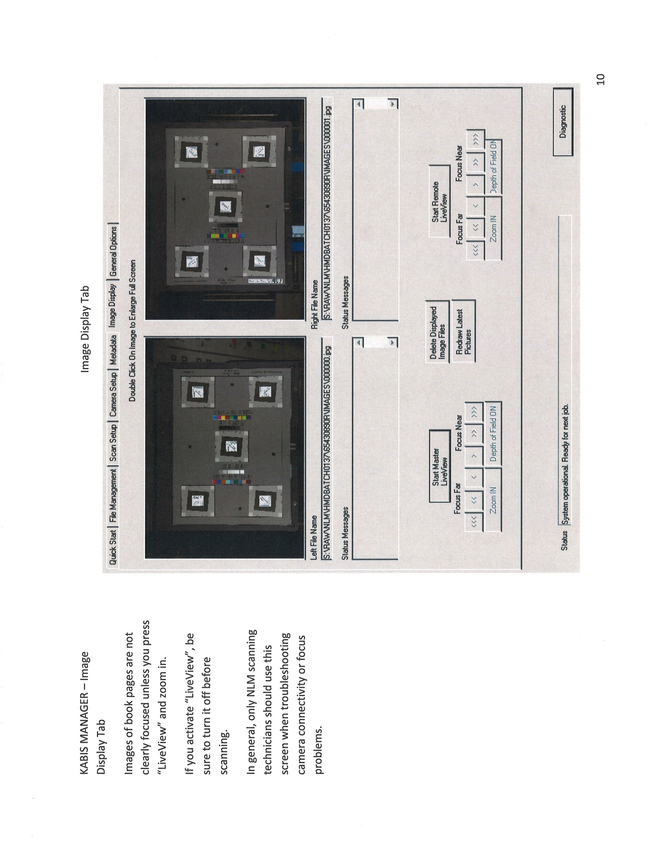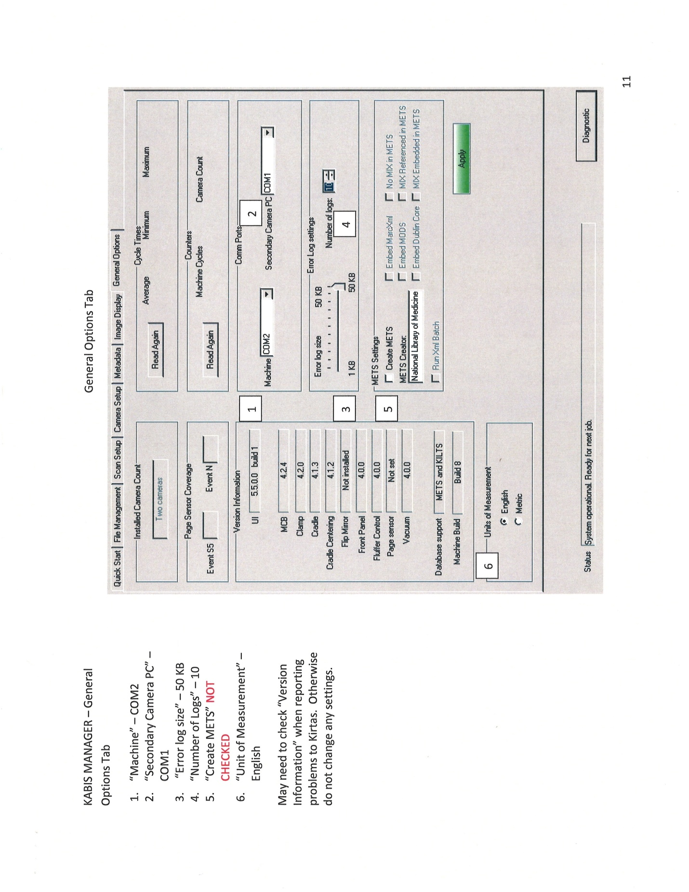
Appendix 3: BookScan Editor BSE Best Practices and Tips for Image processing.

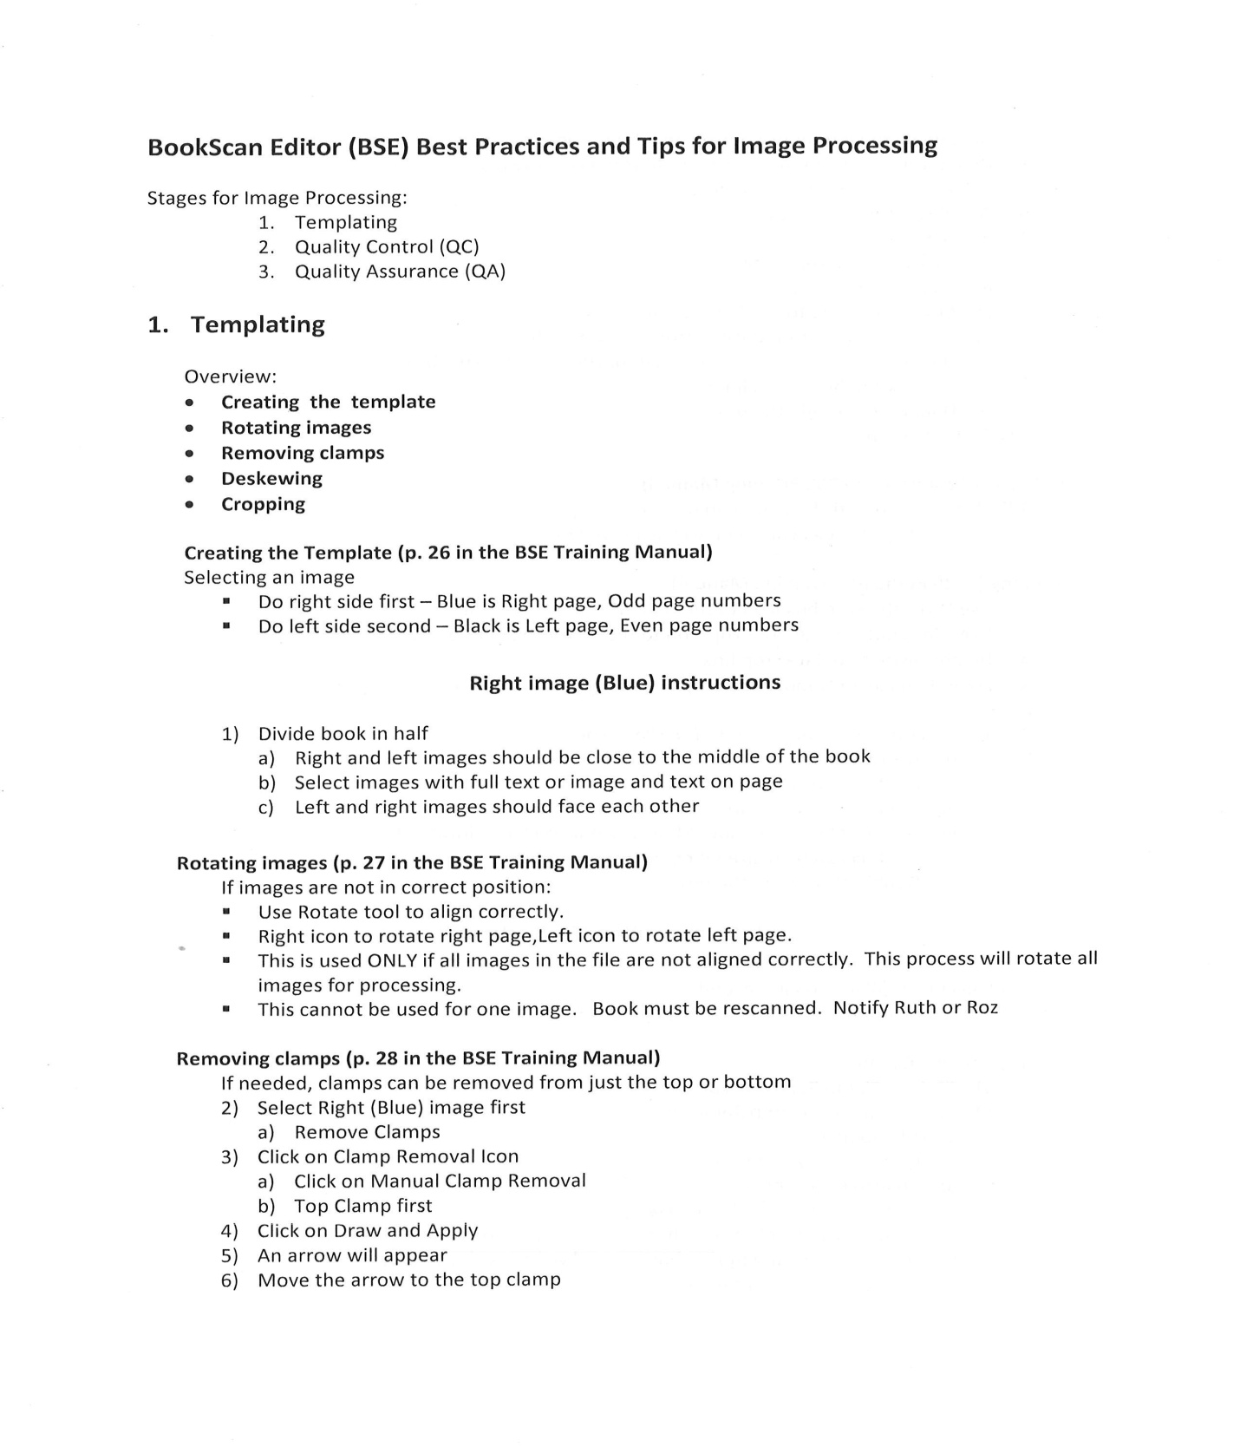

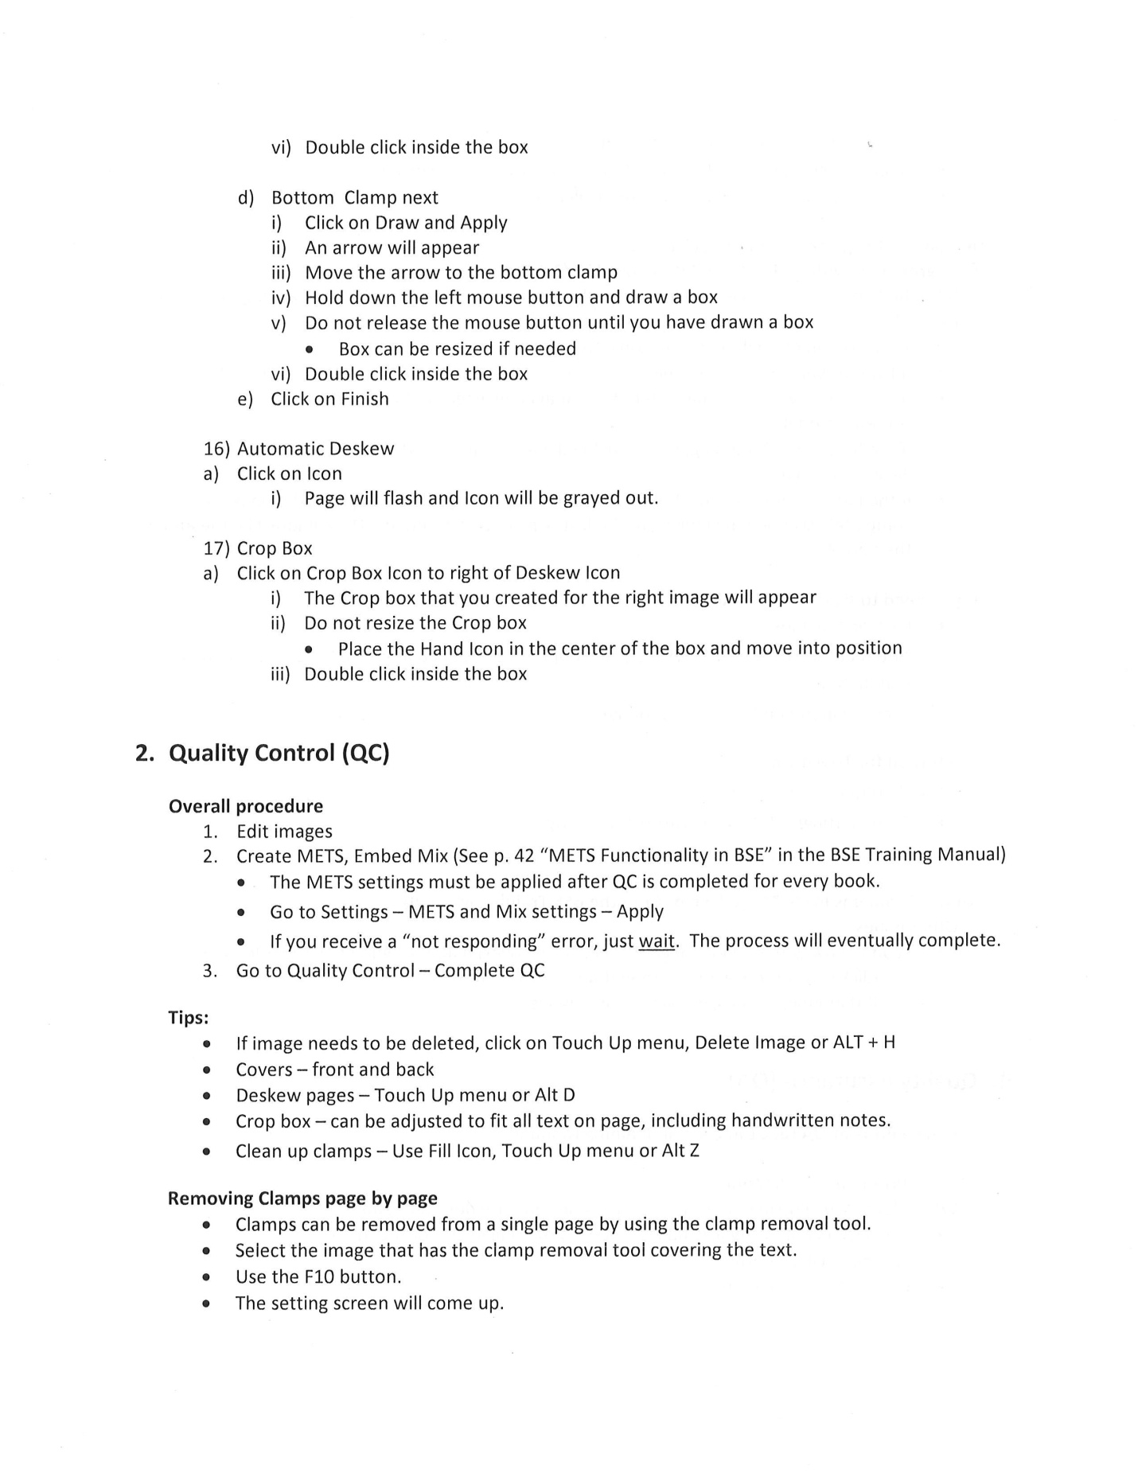

Appendix 4: Standard Practices & Procedures for Digital Reformatting at The Johns Hopkins University’s Sheridan Libraries

PreMIS parameters

- Intellectual Entity

  - Public domain (pre-1923) single volume monographs
  - Copyright protected (post-1922) single volume monographs
    - Damaged or brittle beyond use
    - Out of print
    - No suitable non-fragile replacement

- Objects

  - Specific copy of a title
  - Identified by unique barcode number
  - Typically single volume monographs
    - Special arrangements can be made with Tech Services Cataloging to digitize a series with 2 – 3 volumes

- Agent

  - Johns Hopkins University Sheridan Libraries
    - Department of Conservation & Preservation
      - Digital Reformatting Unit
        - scan operator’s or image processor’s JHED ID (unique university ID for each JHU faculty, student or staff)
  - Hardware
    - Kirtas Automatic Page Turner (APT) 2400 RA machine
    - Kirtas SkyView machine
    - 2 Canon EOS-1Ds Mark II cameras
    - 1 Canon EOS 5D Mark II camera
  - Software
    - Kirtas APT Manager version 2.9.0.19 software
    - Kirtas SkyView Manager version 2.17.3 software
    - Kirtas BookScan Editor (BSE) version 3.6.0.28 software
    - Kirtas SuperBatch software (part of BSE)
    - Kirtas OCR Manager version 3.0 software
    - Adobe Acrobat 8 Professional version 8.1.4 software
    - RawShooter essentials 2006 1.0 software (freeware)
    - XnView v. 1.97 software (freeware)
    - Raw Therapee v. 2.4.1 software (freeware)
    - Microsoft Windows Server 2003 R2

- Event

  - Event: Image Capture/Digitization/Scanning (Kirtas Automatic Page Turner)
    - Source
      - Unique object or portion thereof from library’s collection
        - bound volumes between 4.5” x 7” and 11” x 14 ¾”
    - Agents
      - Scan operator (JHED ID)
      - Kirtas Automatic Page Turner (APT) 2400 RA machine
      - Kirtas APT Manager software
      - 2 Canon EOS-1Ds Mark II cameras
    - File Folder structure
      - Drive letter
        - Scan Date (YYYYMMDD)
          - object’s unique 14 digit barcode
            - IMAGES: E.g. 000000.cr2
            - METADATA: E.g. 31151123451234_scanjob.xml
      - Depending on the number of pages, three to five objects will be scanned into each scan date folder. This allows processing workflow to be broken up into manageable subsets.
        - A second scan date folder for the same day will be named <YYYYMMDD_2>, etc
    - Output: Camera RAW 300 dpi 5010 x 3336 px 8-bit YCbCr color image file (CR2)
    - Metadata
      - All metadata files prefixed with object’s unique 14 digit barcode
      - Image files use 6 digit one-up number scheme
        - NOTE: No images are ever deleted or renumbered using operating system software as this would result in inaccurate matching to automatically created Kirtas metadata files
      - Descriptive metadata captured via library’s Z-39.50 server
        - <barcode>_Bookmetadata.xml
        - <barcode>_MRC.xml (MARC)
        - <barcode>_DC.xml (Dublin Core)
        - <barcode>_MODS.xml (Metadata Object Description Standard)
        - <barcode>_RefNum.xml
      - Technical metadata automatically recorded as <barcode>_Scanjob.xml produced by Kirtas APT Manager software
    - Retention
      - Camera RAW files are retained until Archive Copy event is completed
        - (see Event D. below)

  - Event: Image Capture/Digitization/Scanning (Kirtas SkyView)
    - Source
      - Unique object or portion thereof from library’s collection
        - bound volumes smaller than 4.5” x 7” or larger than 11” x 14 ¾”
        - unbound objects
        - oversized foldouts or attachments
    - Agents
      - Scan operator (JHED ID)
      - Kirtas SkyView machine
      - Kirtas SkyView Manager software
      - Canon EOS 5D Mark II camera
      - Autopano Giga 64 bits v 2.0.3 stitching software
    - File Folder structure
      - Drive letter
        - Scan Date (YYYYMMDD)
          - (for sources i.a & i.b above) object’s unique 14 digit barcode
            - IMAGES
            - METADATA
          - (for source i.c: foldouts above) object’s unique 14 digit barcode
            - IMAGES
            - METADATA
            - FOLDOUTS
              - Image files
              - Single metadata file: scanjob.xml
    - Output: Camera RAW 300 dpi 5634 x 3753 px 8-bit YCbCr color image file (CR2)
    - Metadata
      - All metadata files prefixed with object’s unique 14 digit barcode
      - Descriptive metadata captured via APT 2400’s internet connection to library’s Z-39.50 server
        - <barcode>_Bookmetadata.xml
        - <barcode>_MRC.xml (MARC)
        - <barcode>_DC.xml (Dublin Core)
        - <barcode>_MODS.xml (Metadata Object Description Standard)
        - <barcode>_RefNum.xml
      - Technical metadata automatically recorded as Scanjob.xml produced by Kirtas SkyView Manager software.
        - NOTE: Unlike APT Manager software, SkyView Manager software does not generate a scanjob.xml file with the object’s barcode automatically prefixed.
      - File automatically saved to folder where images are saved
        - Sources a & b: IMAGES folder
        - Source c: FOLDOUTS folder
          - File will be manually renamed <barcode> _SkyViewScanjob.xml when merged into <barcode> folder’s ArchiveCopy metadata folder. (see Event J below)

    - Retention
      - Camera RAW files are retained until Archive Copy event is completed (see Event C. 1. below)

  - Event: Image File Conversion (RAW to TIFF)
    - Source
      - Camera RAW 300 dpi color image file (CR2)
    - Agent
      - Scan operator or image processor (JHED ID)
      - RawShooter essentials 2006 1.0 software (freeware)
      - Raw Therapee v. 2.4.1 software (freeware)
    - File Folder structure
      - Batch process returns converted images to “Converted” folder located inside source file folder
      - Drive letter
        - Scan Date (YYYYMMDD)
          - object’s unique 14 digit barcode
            - IMAGES
              - 000001.cr2, etc
              - Converted
                - 000001.tif, etc
            - METADATA
    - Output
      - 8 bit TIFF (text images)/16 bit (photo images)
      - sRGB IEC61966-2.1
      - aka Unprocessed TIFF
    - Metadata
      - This document serves as the record of procedural actions taken which fall outside the scope of the system generated metadata files.
      - Image EXIF header information retained
      - Original name, date/time stamp retained
    - Retention
      - Unprocessed TIFFs deleted after all processing steps are complete

  - Event: Image Processing (Archive Copy)
    - Source
      - Unprocessed TIFF
    - Agent
      - Image processor (JHED ID)
      - Kirtas Book Scan Editor software (BSE)
      - Kirtas SuperBatch software
    - File structure
      - Drive letter
        - Scan Date (YYYYMMDD)
          - object’s unique 14 digit barcode
            - IMAGES
            - METADATA
            - ArchiveCopy
              - IMAGES
                - <barcode>_0000.tif
              - METADATA
                - Copies of all descriptive metadata files
                - Unique version of <barcode>_batchprocess.xml
    - Output
      - Archive Copy TIFF
        - full color retained
        - rotated 90 degrees to viewable orientation
        - cropped to exclude area beyond edge of boards/covers
    - Metadata
      - Image and metadata file names prefixed with object’s unique 14 digit barcode
      - Template process (Procjob.xml)
        - created by image processor (JHED ID)
        - recorded by Kirtas BSE software
        - performed by Kirtas SuperBatch software
      - Quality control process (BatchProcess.xml)
        - performed by image processor (JHED ID)
        - recorded by Kirtas BSE software
      - Retains EXIF
    - Retention
      - Archive Copy TIFFs converted to JPEG 2000 (see Event E below)
      - Archive Copy TIFFs deleted after Archive Copy JPEG 2000s are QC’d (see Event E below)

  - Event: Image File Conversion (TIFF to JPEG-2000)
    - Source
      - Archive Copy TIFF
    - Agent
      - Image processor (JHED ID)
      - XnView v. 1.97 software (freeware)
    - File Folder structure
      - Batch process returns converted image to source file folder
    - Output
      - Full color lossless JPEG-2000 (Archive Copy JP2)
    - Metadata
      - This document serves as the record of procedural actions taken which fall outside the scope of the system generated metadata files.
      - Original name, date/time stamp retained
    - Retention
      - Public domain objects
        - Archive Copy JP2s and Archive Copy Metadata folders transferred via ftp to JHU’s institutional repository (JScholarship) as part of unique collection, “Out of Copyright Books”
        - Metadata
          - Auto-ingest function produces file checksum and other technical metadata required for long term retention
      - Copyright protected objects
        - Archive Copy JP2s and Archive Copy Metadata folders transferred via ftp to JHU’s institutional repository (JScholarship) as part of unique collection, “digital_copyrighted” which has no public access or display
          - Derivative Print Copy PDF file (see Event H below) is used to print physical replacement copy for damaged copyright protected book
          - [ref Section 108 of Title 17 (The Copyright Law) of the US Code]
        - Metadata
          - Auto-ingest function produces file checksum and other technical metadata required for long term retention

  - Event: Image Processing (User Copy)
    - Source
      - Unprocessed TIFF
    - Agent
      - Image processor (JHED ID)
      - Kirtas Book Scan Editor software (BSE)
      - Kirtas SuperBatch software
    - File structure
      - Drive letter
        - Scan Date (YYYYMMDD)
          - object’s unique 14 digit barcode
            - IMAGES
            - METADATA
            - ArchiveCopy
              - IMAGES
              - METADATA
            - UserCopy
              - IMAGES
                - <barcode>_0000.tif
              - METADATA
                - Copies of all descriptive metadata files
                - Unique version of <barcode>_batchprocess.xml
    - Output
      - User Copy TIFF
        - rotated 90 degrees to viewable orientation
          - additional minor adjustments made as appropriate
        - cropped to exclude area beyond edge of page
        - clamps used to hold pages flat “blended out” of image
        - de-skewed to straighten skewed images
        - brightening and contrast
        - sharpening
        - page background color removed
          - image segmentation prevents adjustment to plates
          - speckling effect caused by background removal erased (despeckling & erase functions)
          - color plates retained in full color
        - text, sketches, and black and white plates reduced to grayscale
        - subject matter related marginalia retained
    - Metadata
      - Template process (Procjob.xml)
        - created by image processor (JHED ID)
        - recorded by Kirtas BSE software
        - performed by Kirtas SuperBatch software
      - Quality control process (BatchProcess.xml)
        - produced by Kirtas BSE software
    - Retention
      - Files deleted once derivative PDF is created and QC’d

  - Event: Image Processing (User Copy PDF)
    - Source
      - User Copy TIFF
    - Agent
      - Image processor (JHED ID)
      - Kirtas OCR Manager software
    - File Structure
      - Kirtas OCR Manager software creates a folder named “OCR” and places it in the main level of the folder structure.
      - Drive letter
        - Scan Date (YYYYMMDD)
          - object’s unique 14 digit barcode
            - IMAGES
            - METADATA
            - ArchiveCopy
              - IMAGES
              - METADATA
            - UserCopy
              - IMAGES
              - METADATA
            - PDF
    - Output
      - Image on text
      - Native resolution (300 dpi)
      - Single, searchable OCR’d PDF file
    - Metadata
      - Output file retains unique 14 digit barcode as its name
      - Output file includes header information
        - Producer: Johns Hopkins University Sheridan Libraries
        - Creator: Reformatting Unit
    - Retention
      - Public domain objects
        - UserCopy PDF is named <barcode>.pdf and placed in a folder named “ORIGINAL” which is transferred via ftp to JHU’s institutional repository (JScholarship) as part of unique collection, “Out of Copyright Books”
        - Metadata
          - Auto-ingest function produces file checksum and other technical metadata required for long term retention
      - Copyright protected objects
        - Archive Copy JP2s and Archive Copy Metadata folders transferred via ftp to JHU’s institutional repository (JScholarship) as part of unique collection, “digital_copyrighted” which has no public access or display
          - Derivative Print Copy PDF file (see Event H below) is used to print physical replacement copy for damaged copyright protected book
          - [ref Section 108 of Title 17 (The Copyright Law) of the US Code]
        - Metadata
          - Auto-ingest function produces file checksum and other technical metadata required for long term retention

  - Event: Image Processing (Print Copy)
    - Source
      - User Copy TIFF
    - Agent
      - Image processor (JHED ID)
      - Kirtas Book Scan Editor software (BSE)
    - File structure
      - Drive letter
        - Scan Date (YYYYMMDD)
          - object’s unique 14 digit barcode
            - IMAGES
            - METADATA
            - ArchiveCopy
              - IMAGES
              - METADATA
            - UserCopy
              - IMAGES
              - METADATA
            - PrintCopy
              - Image files
              - (Main level Metadata files (folder a.1.ii) are updated during processing. These are not retained.)
            - PDF
    - Output
      - Print Copy TIFF
        - Per instructions from print vendor, images reduced to bitonal
          - For plates that become illegible when reduced to bitonal, grayscale is restored
    - Metadata
      - Template process (Procjob.xml)
        - created by image processor (JHED ID)
        - recorded by Kirtas BSE software
        - performed by Kirtas BSE software
      - Quality control process (BatchProcess.xml)
        - produced by Kirtas BSE software
    - Retention
      - Print Copy TIFF files are deleted once derivative PDF is QC’d

  - Event: Image Processing (Print Copy PDF)
    - Source
      - Print Copy TIFF
    - Agent
      - Image processor (JHED ID)
      - Adobe Professional
    - File Folder Structure
      - Resulting <barcode>.PDF file is saved to PrintCopy folder
    - Output
      - Single, optimized, printable PDF file
        - <barcode>.pdf
    - Metadata
      - Retains object’s unique 14 digit barcode as file name
    - Retention
      - Retained on Reformatting Unit’s servers for potential future printing by vendor for sale to third parties (for public domain materials) and/or for use in creating a replacement copy (only option for copyrighted materials)

  - Event: Folder Renaming and File Clean-up
    - Source
      - Completed image and metadata files (from Events A – I above)
    - Agent
      - Senior image processor (JHED ID)
      - Windows
    - File Folder Structure
      - Before
        - Scan Date (YYYYMMDD)
          - object’s unique 14 digit barcode
            - IMAGES
            - METADATA
              - Copy of all descriptive metadata
            - ArchiveCopy
              - IMAGES
                - <barcode>_0001.tiff, etc
                - <barcode>_0001.jp2, etc
              - METADATA
                - Copy of all descriptive metadata
                - ArchiveCopy’s technical metadata files
            - UserCopy
              - IMAGES
                - <barcode>_0001.tiff, etc
              - METADATA
                - Copy of all descriptive metadata
                - UserCopy’s technical metadata files
            - PrintCopy
              - Image files: <barcode>_0001.tiff, etc
              - PrintCopy’s technical metadata files
              - <barcode>.pdf
            - PDF
              - Single, searchable OCR’d PDF file
                - <barcode>.pdf
      - Process
        - Scan Date (YYYYMMDD) – retained
          - object’s unique 14 digit barcode – retained
            - IMAGES –deleted
            - METADATA – moved to PrintCopy folder
              - Copy of all descriptive metadata – retained
              - PrintCopy’s technical metadata files – deleted
            - ArchiveCopy
              - IMAGES – retained, renamed Archive, moved to main level of barcode folder
                - <barcode>_0001.tiff, etc – deleted
                - <barcode>_0001.jp2, etc – retained
              - METADATA – retained, moved to main level of barcode folder
                - Copy of all descriptive metadata – retained
                - ArchiveCopy’s technical metadata files – retained
            - UserCopy – deleted
              - IMAGES – deleted
                - <barcode>_0001.tiff, etc – deleted
              - METADATA - deleted
                - Copy of all descriptive metadata – deleted
                - UserCopy’s technical metadata files – deleted
            - PrintCopy – retained
              - Image files: <barcode>_0001.tiff, etc – deleted
              - <barcode>.pdf - retained
            - PDF – renamed “Original”
              - Single, searchable OCR’d PDF file
                - <barcode>.pdf - retained
      - After
        - Scan Date (YYYYMMDD)
          - object’s unique 14 digit barcode
            - ARCHIVE
              - JPEG2000s (<barcode>_0001.jp2, etc)
            - METADATA
              - ArchiveCopy descriptive and technical metadata files
              - These correspond to the level of processing done to the JPEG2000s
            - ORIGINAL
              - Single, searchable OCR’d PDF file
                - <barcode>.pdf
            - PrintCopy
              - Single, optimized, printable PDF file
                - <barcode>.pdf
              - METADATA: descriptive metadata files
    - Output: Date folders whose contents have been completed and renamed are moved to a separate drive to await final transfer
      - Files intended for permanent retention in the institutional repository
        - JPEG2000s, metadata files, searchable PDF
      - Files intended to allow reproduction
        - Optimized, printable PDF
    - Metadata
      - Automatically produced metadata files for ArchiveCopy processing.
      - This document serves as the record of procedural actions taken which fall outside the scope of the system generated metadata files.
    - Retention
      - All remaining files are retained permanently
        - ARCHIVE, METADATA and ORIGINAL folders transferred to and retained in the institutional repository (see Events L, M, and N below)
        - PrintCopy files transferred to and retained on library servers and storage drives (see Event K below)

  - Event: Transfer of PrintCopy PDFs
    - Source
      - Print Copy folder and its contents from Event J (above)
    - Agent
      - Senior image processor (JHED ID)
    - File Folder Structure
      - F:\MasterPrintCopies
        - <barcode>folder
          - <barcode>.pdf
          - METADATA: descriptive metadata files
    - Output
      - Barcode folder is copied to MasterPrintCopies folder.
      - This copy of ARCHIVE, METADA and ORIGINAL are deleted.
      - <barcode>.pdf file and METADATA folder moved out of PrintCopy folder.
      - Empty PrintCopy folder deleted.
    - Metadata
      - This document serves as the record of procedural actions taken which fall outside the scope of the system generated metadata files.
      - Descriptive metadata captured via library’s Z-39.50 server
        - <barcode>_Bookmetadata.xml
        - <barcode>_MRC.xml (MARC)
        - <barcode>_DC.xml (Dublin Core)
        - <barcode>_MODS.xml (Metadata Object Description Standard)
        - <barcode>_RefNum.xml
    - Retention
      - Indefinite

  - Event: Transfer of Files to JHU Server, Thumper (Public Domain)
    - Source
      - Intellectual Entity A: Public Domain objects
      - ArchiveCopy JPEG2000s
      - ArchiveCopy METADATA folder
      - UserCopy PDF
    - Agent
      - Reformatting Unit staff (JHED ID)
      - ftp to library server, “Thumper”
    - File Folder Structure
      - Thumper (drive)\brittlebooks\public\
        - Transfer Date (YYYYMMDD)
          - object’s unique 14 digit barcode
            - ARCHIVE: JPEG2000s (<barcode>_0001.jp2, etc)
            - METADATA
              - ArchiveCopy descriptive and technical metadata files
              - These correspond to the level of processing done to the JPEG2000s
            - ORIGINAL
              - Single, searchable OCR’d PDF file
                - <barcode>.pdf
    - Output
      - A transfer date folder (<YYYYMMDD-transfer>) is created on the Thumper drive into which are moved 20 – 25 barcode folders with all subordinate folders and files except PrintCopy folder contents.
        - contents of entire scan date folders are moved together
        - one transfer date folder may contain the barcode folders of 5 – 7 scan date folders
      - Once the transfer process is complete and checked for completeness, the “-transfer” is removed from the Thumper folder name.
        - An automated program routinely searches the Thumper drive for date folders to begin a batch ingestion process. The presence of “-transfer” ensures the program ignores folders which are in the process of being updated.
    - Metadata
      - This document serves as the record of procedural actions taken which fall outside the scope of the system generated metadata files.
      - Microsoft Windows server records metadata related to the transference of files
      - Files are inspected and compared by Reformatting Unit staff to ensure complete and successful transfer of all files
    - Retention
      - Files are retained on Thumper drive until confirmation is received from DRCC staff that batch ingestion from Thumper to JScholarship was successful and complete

  - Event: Transfer of Files to JHU Server, Thumper (Copyright Protected)
    - Source
      - Intellectual Entity B: Copyright Protected objects
      - ArchiveCopy JPEG2000s
      - ArchiveCopy METADATA folder
      - UserCopy PDF
    - Agent
      - Reformatting Unit staff (JHED ID)
      - ftp to library server, “Thumper”
    - File Folder Structure
      - Thumper (drive)\digital_copyrighted\copyrighted\
        - Transfer Date (YYYYMMDD)
          - object’s unique 14 digit barcode
            - ARCHIVE: JPEG2000s (<barcode>_0001.jp2, etc)
            - METADATA
              - ArchiveCopy descriptive and technical metadata files
              - These correspond to the level of processing done to the JPEG2000s
            - ORIGINAL
              - Single, searchable OCR’d PDF file
                - <barcode>.pdf
    - Output
      - A transfer date folder (<YYYYMMDD-transfer>) is created on the Thumper drive into which are moved 20 – 25 barcode folders with all subordinate folders and files except PrintCopy folder contents.
        - contents of entire scan date folders are moved together
        - one transfer date folder may contain the barcode folders of 5 – 7 scan date folders
      - Once the transfer process is complete and checked for completeness, the “-transfer” is removed from the Thumper folder name.
        - An automated program routinely searches the Thumper drive for date folders to begin a batch ingestion process. The presence of “-transfer” ensures the program ignores folders which are in the process of being updated.
    - Metadata
      - This document serves as the record of procedural actions taken which fall outside the scope of the system generated metadata files.
      - Microsoft Windows server records metadata related to the transference of files
      - Files are inspected and compared by Reformatting Unit staff to ensure complete and successful transfer of all files
    - Retention
      - Files are retained on Thumper drive until confirmation is received from DRCC staff that batch ingestion from Thumper to JScholarship was successful and complete

  - Event: Batch Ingestion from Thumper to JScholarship (for David Reynolds/Elliot Metzger)
    - Source

    - Agent

    - File Folder Structure
      - Public Domain
      - Copyright Protected
    - Output

    - Metadata

    - Retention

- Rights
  - About JScholarship
    - http://www.library.jhu.edu/collections/institutionalrepository/irabout.html
  - JScholarship Digital Preservation Policy
    - http://www.library.jhu.edu/collections/institutionalrepository/irpreservationpolicy.html

Public Services Division
Technical Services Division

