Photographs for Analysis
Instructions
- Look carefully at each photograph from the Visiting Nurse Service photograph album, then read the caption.
- Make a note of what you see in the image that is mentioned in the caption.
- Make a note of what is mentioned in the caption that you cannot see in the photograph.
- Make a note of what you see in the image that is not mentioned in the caption.
- After you have analyzed each photograph, answer each of these questions:
- What inferences can you make about what nurses did as their work based on the photos and captions?
- What determinants of health do you see in the photographs and/or read in the captions? List them and consider whether they are personal, social, environmental, or economic.
- What do you know now about the Visiting Nurses or their clients that you did not know before looking at these photographs?

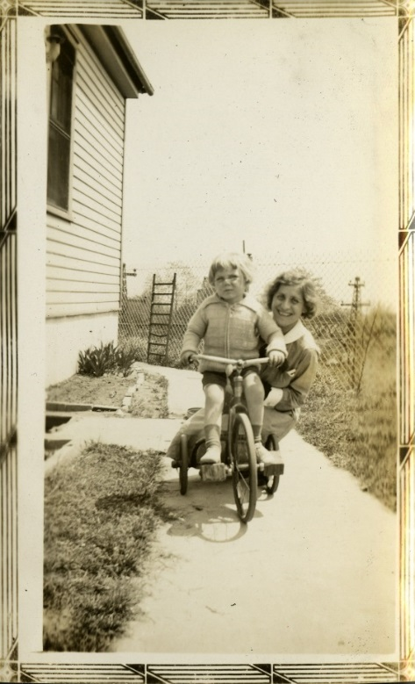
Caption: “Miss Kramer and Bobby. Henry Street was able to help tide the family over with emergency financial aid and free milk as well as nursing care. The coming of beer brought work for Mr. B.”
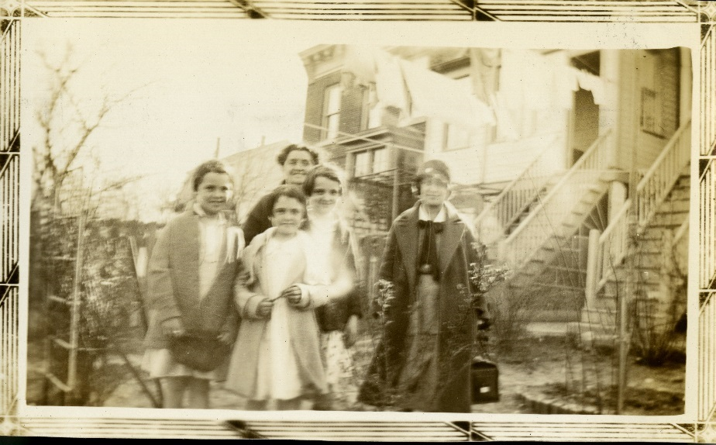
Caption: “Some of the Thomas children and mother. Miss Kramer pays a welfare visit to some of the little Thomases. Seven children in this family had scarlet fever, and one small boy died. Henry Street Settlement gave care to all seven children and since the children have arranged for tonsillectomies and dental care for some of them and given other health supervision.”

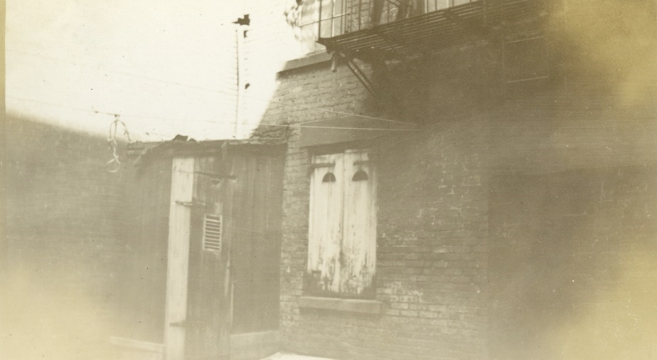
Greenwich Center. “Backyard toilet—Chelsea.”

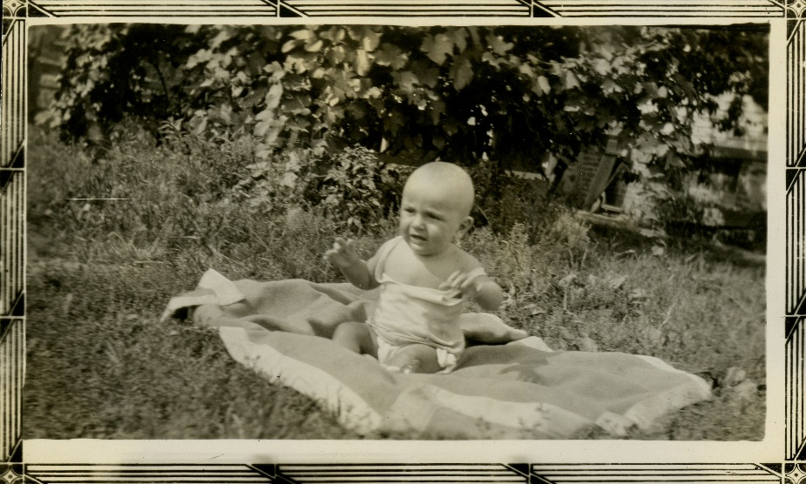
“Some Gun Hill babies. Elmer Newman, 7 months. He has a brother who was a cardiac patient of ours for a long time, but now is very well. Another brother is a counselor at one of the Henry Street camps.”

