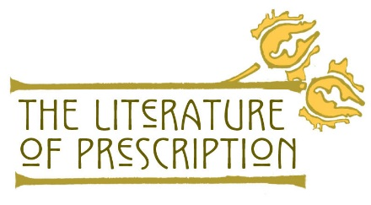
Team Members: ________________________________
______________________________
Date/Class period: _______________/______________

Critical Reading Notes
Instructions: Complete sections 1-5 and complete the “Apply WHAT” section after the class discussion.
1) Title
2) Author
3) Key Word or Image | 4) Important Details/Quotes from Reading Selection

5) Summarize WHAT: Write a short summary that captures the essence of all of the information above.

6) Apply WHAT: How is the summarized main idea(s) of the reading similar or different from today’s understanding about mental health disorders and gender assumptions? What are the factors that promoted changes or supported the status quo of the idea(s)?

https://www.nlm.nih.gov/theliteratureofprescription Page | 1

