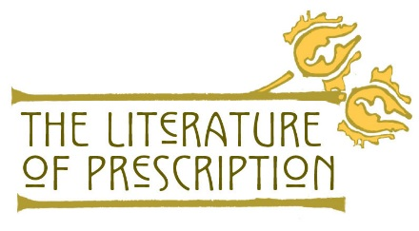

Team Members: ___________________________________
___________________________________
Date/Class period: _______________/___________________

Discussion Circle
Instructions:
- Appoint a time keeper/facilitator for the team, who will keep the discussion focused and moving.
- Assign each of the three remaining team members one of the three categories of text selections—symptoms, treatments, and causes—related to a mental illness described in “The Yellow Wall-Paper.”
- Conduct three discussion rounds in the order of Symptoms first, Treatments second, and Causes third.
- Follow the steps below for each discussion round:
  - a student presents the list of text selections on her or his assigned category (two minutes or less);
  - the other two students expand on the list or clarify any assumptions made by the presenting student (one minute for each student);
  - at the end of each discussion round, all three students work together to list at least five text examples under each category of the table below (one minute).
Literary Depictions of Mental Illness:
Symptoms | Treatments | Causes
- Review the three lists above and make inferences to finish the following sentences:
  - The symptoms express feelings of ___________________________
  - The treatments described in “The Yellow Wall-Paper” seem _______________________________________________________
  - The causes of the narrator’s mental illness originate from _______________________________________________________

https://www.nlm.nih.gov/theliteratureofprescription 1 | Page

