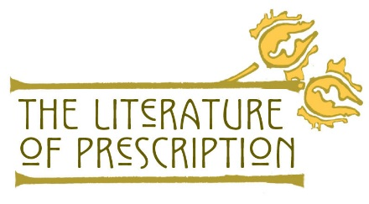

Primary Source Reading Questions

In Wear and Tear, or Hints of Overworked:
- What does Mitchell define “future womanly usefulness” (p.33) to be? How is this perspective/assumption reflected and depicted in Gilman’s short story, “The Yellow Wall-Paper”

- Mitchell notes “…the experience and opinions of those of us who are called upon to see how many school girls are suffering in health from confinement, want of exercise at the time of the day when they most incline to it, bad ventilation,* and too steady occupation of mind.” (p. 39-40) How might gender assumptions affect medical experts’ diagnoses of the cause and effect of an illness?

In Fat and Blood: And How to Make Them, Chapter IV Rest:
- Mitchell makes the point that, generally, exercise benefits most patients. Why might it lead to “increase of trouble, to extreme sense of fatigue, to nausea” (p. 38) in women? What gender assumption does this perpetuate?

- What reason does Mitchell propose for women doctors’ failure to treat other women with nervous illnesses? What fundamental gender assumptions support his reasoning?

In American Nervousness:
- What specific improvement/attribute does Beard comment on repeatedly in regards to women? How does this emphasize a common assumption about women in the late nineteenth century? How does Gilman use “The Yellow Wall-Paper” in criticizing the effects of such an assumption?

- Why was Beard so “surprised” after reading the essays produced by the member of the Women’s Congress in “Recent Improvement in the American Physique” in American Nervousness? How are these women similar or different from Gilman’s narrator?

In “Why I Wrote ‘The Yellow Wallpaper’”:
- How does Gilman describe Dr. Mitchell and her experience of his rest cure? Which characters in the short story embody her perspectives/experiences with a medical professional in real life?

- What does Gilman identify as the factors that help her recover from her “utter mental ruin”? What elements would you add to the short story for a different ending that is similar to Gilman’s life and experience? Would the story be as powerful? Why or why not?

Questions for All Teams:
- What were the words that Mitchell and Beard used to describe women? What gender assumptions are implied in those words?

- How might the gender assumptions held by these men of medical knowledge and social standing perpetuate social norms, and affect their viewing an epidemic of nervous disease among women?

- How did the ideas about women’s role in society affect their experiences of illness, and how they were treated by the medical profession?

https://www.nlm.nih.gov/theliteratureofprescription Page | 1

