Associate Fellow Report
Pinning the History of Medicine: Strategic Planning, Management, and Analysis of NLM History on Pinterest
Project Sponsor: Beth Mullen
Nicole Pettenati
8/22/2014

Contents
ACKNOWLEDGEMENTS 2
ABSTRACT 3
BACKGROUND 4
OBJECTIVE 4
METHODOLOGY 4
RESULTS 6
DISCUSSION: 7
CONCLUSION 8
APPENDIX A 10
APPENDIX B 16

ACKNOWLEDGEMENTS
I would like to thank Dr. Donald A.B. Lindberg and Ms. Betsy Humphreys for their continued support of the Associate Fellowship Program.
I would like to thank my project sponsor, Beth Mullen, for her time, feedback, and insights throughout this entire project. I would also like to thank Dr. Jeffrey Reznick, Chief of HMD, for his enthusiasm and support for this project.
Finally, I would like to thank Dr. Kathel Dunn for her encouragement throughout the entire Associate Fellowship Program.

ABSTRACT
BACKGROUND: Pinterest is a social media platform that allows users to gather visual bookmarks, or pins, onto virtual boards. These pins are comprised of an image, a description, and a link back to the original webpage content. Pins may represent things users want or like, items to purchase, steps of a process, and so on and board themes are open to users’ imaginations. Pins can be shared, or repinned, by users, which increases the content’s reach. Recently, the Federal Government entered into a terms of service with Pinterest, giving the History of Medicine Division an opportunity to explore how to leverage this platform to increase the audience and reach of the HMD collection.
OBJECTIVE: To develop a strategic plan for the History of Medicine Division’s presence on Pinterest, including documentation of best practices and content deployment strategy, and to execute that plan by creating pins and boards to share HMD resources on Pinterest.
METHODS: The methods consisted of a robust environmental scan of twenty like-institutions’ use of Pinterest and a limited literature review of four research articles and six blogs/best practice guides (as well as weekly Pinterest updates) to develop an understanding of user trends and recommended practices for creating quality pins. Finally initial pins and boards were developed based on the findings from the environmental scan and literature review. The literature about Pinterest provided helpful background information, but the number of research-based resources available was limited, and the environmental scan of other institutions’ practices afforded more useful guidelines for pin development.
RESULTS: The Associate, together with the Project Sponsor, established workflows, style guidelines, and content deployment strategies for NLMHistory on Pinterest based on the results of the environmental scan and literature review. Over a two month period, seven boards totaling 175 pins (and growing) were created and launched that fell within three categories: open-ended thematic boards for pins from across the collection (ex. “Medicine & the Arts”), product redelivery boards to promote discrete resources (ex. “Circulating Now”), and shared boards with other areas (ex. “Profiles in Science”). Pins continue to be added to these existing boards, and plans are in place for future content releases, including more narrowly scoped boards such as “Anatomy,” the development of which is based on use of existing boards and pins as well as content being pinned by other users directly from HMD sites.
CONCLUSION: HMD has established a presence on Pinterest that liberates and expands the reach of the collection into the public sphere where it can continue to be shared and circulated. This presence will grow as more content is pinned to Pinterest to meet users’ interests.

BACKGROUND
The History of Medicine Division (HMD) of the National Library of Medicine collects, preserves, makes available, and interprets for diverse audiences one of the world's richest collections of historical material related to human health and disease. In 2014, the Federal Government entered into a terms of service agreement with the Pinterest platform.
Pinterest is a social network that allows users to visually share and discover new interests by posting (known as ‘pinning’ on Pinterest) images or videos to their own or others’ boards (i.e. a collection of ‘pins,’ usually with a common theme) and browsing what other users have pinned. Pins act as virtual bookmarks back to web content with three basic components: an image, a description to give the image context, and the embedded URL.
HMD wanted to explore ways to leverage the opportunity to expand its outreach efforts and raise public awareness and use of the Library’s vast historical collections through Pinterest, believing that the greatest success in social media comes with identifying the best match between the audience and the content. With this in mind, HMD submitted a project proposal to have an Associate Fellow investigate other institutions’ uses of Pinterest and develop a strategic plan for HMD’s presence on the platform.

OBJECTIVE
The goal of this project was to investigate Pinterest as a tool to promote and share HMD resources and to develop and implement a strategic plan to leverage the platform with HMD content.

METHODOLOGY
In order to gain an understanding of how best to leverage Pinterest for HMD, the Associate Fellow conducted an environmental scan and literature review, described in more detail below. Additionally, the Associate began to create draft pins for boards dedicated to specific resources in order to become familiar with the mechanics of using Pinterest.
  - Environmental Scan
In the first phase of the project, the Associate conducted an environmental scan of approximately twenty federal institutions and libraries using Pinterest to promote their resources and collections (Appendix A). The environmental scan revealed that institutions like the National Institutes of Health, The Folger Shakespeare Library, and Smithsonian had active Pinterest profiles with varying numbers of boards and followers (Table 1).
Table 1: Institutions using Pinterest – a sampling (numbers as of 3/21/14)
Institution | Boards (#) | Pins (#) | Followers (#)
National Institutes of Health | 8 | 507 | 3631
The Folger Shakespeare Library | 7 | 105 | 473
The Smithsonian | 42 | 776 | 25,837

The Associate also looked at types of boards that institutions were creating and found that board themes also varied based on the institutions’ resources. For example, NIH’s boards centered around medical news and research and themes like “March is National Kidney Month.” The Smithsonian featured boards with themes like “Black History Month,” “Flags at the Smithsonian,” etc. Additionally, the Associate discovered that many institutions use collaborative boards. Collaborative boards allow multiple Pinterest users to pin to the same board. The Smithsonian museums used collaborative boards to demonstrate how items in various collections related to larger themes of interest to the general public.
The Associate also discovered that many institutions follow each other. Pinterest, like some other social media sites, allows users to follow other users. When the user being followed posts new material, those pins appear in a feed for the follower. In order to be “social,” HMD would want to consider following other institutions that pinned items of interest. A sampling of users that HMD was following at the conclusion of the project appears in Figure 1.
Figure 1: Pinterest Users HMD Follows – a sampling
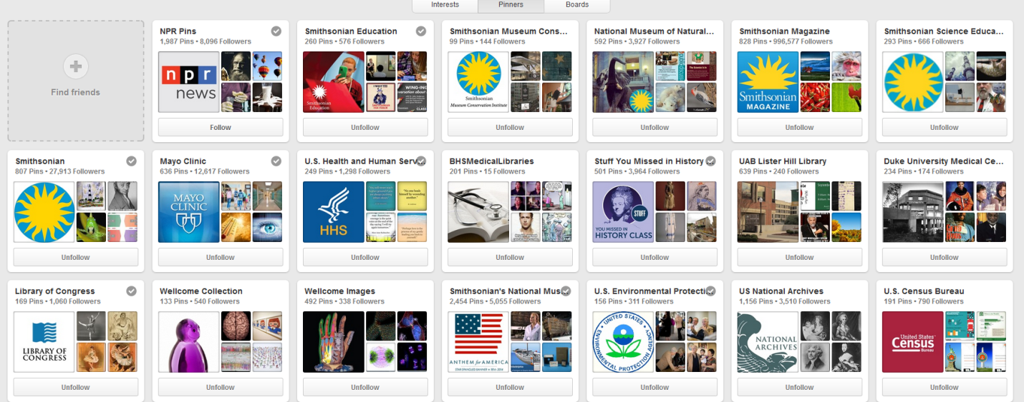
Literature Review
In addition to surveying other institutions’ uses of Pinterest, the Associate conducted a brief literature review of Pinterest how-to guides, blogs, and research studies done on Pinterest usage and compiled a resource list (Appendix B) to assist with decision-making about what to post on Pinterest and how. Some of the most valuable resources came directly from Pinterest. Pinterest sends out regular updates to business account holders (including non-profits like NLM) that provide quick tips as well as stories about how other institutions and businesses have successfully used Pinterest. Beyond these, the Associate also conducted online searches, using a snowball strategy, for studies and how-to guides. In total, the Associate discovered and reviewed four research articles and six blogs/blog posts. While research articles on Pinterest were sparse, they did provide some useful insight into how users use the platform. The literature review revealed that Pinterest acts as a database of intentions, a collection of things that people like and are inspired by or want to do; that the four most popular words on Pinterest are look, use, need, and want; that institutions with an active Pinterest presence see an increase in both traffic to their sites and time spent on their sites in relation to traffic from other resources; and that pins and boards show up in Google search results, which can boost the number of people who see an institution’s resources.
The literature also highlighted the importance of creating pins with eye-catching images and robust descriptions that provided context for the image and encouraged the user to click through to the original content. High quality pins lead to a higher likelihood of being repinned (or shared) by users, increasing the visibility of pins to more people, which in turn increases the number of people who click through on the pin to the original websites.
  - Development and testing
During the environmental scan and literature review, the Associate began creating resource-specific pins and board to promote the book Hidden Treasures and the HMD blog Circulating Now. These resources were already curated and gave the Associate an opportunity to focus on the mechanics of the Pinterest platform. In the case of the Hidden Treasures board, the Associate maintained a Microsoft Word document that included information about the image file location, the source URL, the description, etc. This level of documentation was required to accommodate the format of the book online and also to limit the amount of time required to assemble the components of a pin. However, with other resources, like Circulating Now, pinning directly from the webpage was much more efficient.
In addition to these initial resource-specific boards, the Associate and Project Sponsor began brainstorming ideas for thematic boards that would allow for the combination of resources from across various HMD collections in one place for users to see the variety and diversity of resources available from Images from the History of Medicine, Exhibitions, Digital Collections, etc. This brainstorming process was enhanced by Pinterest’s release of unlimited “secret boards” to all users. Secret boards allowed users to create entire boards without making them publicly visible. The Associate and Project Sponsor leveraged these boards to try out thematic ideas in a sandbox-like environment and test whether pins worked and appeared appropriately. Secret boards also allowed for the repinning of pins from one idea to the other to actually see what worked best. The final advantage of secret boards was the ability to quickly make pins and boards visible to the public by simply changing a setting on the board or repinning the pin, rather than having to shift information from a document onto the platform.

RESULTS
As of August 22, 2014, HMD’s Pinterest profile featured 10 boards, 280 pins, and 58 followers (see Figure 2). The boards fit into three general categories
- Broad Themes: Science & Society, Patients & Practitioners, Medicine & the Arts, Technology & Medicine
- Narrow Themes: About NLM History, Historical Anatomy
- Resources: Circulating Now, Hidden Treasure, Biographies*, Sir William Osler* (*maintained by Profiles and Science but shared on NLM’s History of Medicine Division profile)
Figure 2: Snapshot of HMD’s Pinterest Presence (August 22, 2014)
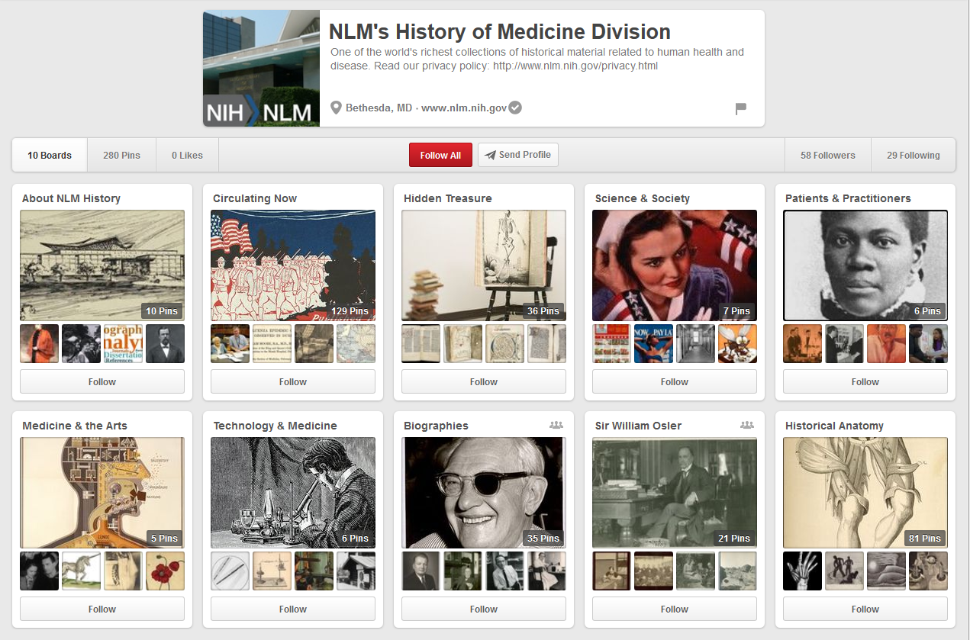
Though not released, other boards were in development, including the following:
- Historic Medical Sites in DC – a board featuring content from the HMD Site “Historic Medical Sites in the Washington, D.C. Area”, utilizing the maps feature of Pinterest, which allows users to place pins on an interactive map
- Changing the Face of Medicine – a resource specific board
- American Presidents – featuring presidential appearances in HMD collections
- K-12 – a board for gathering resources for classroom use

Additionally, the Associate worked with the Project Sponsor to contribute to an internal wiki that documents how to create pins, general guidelines, and lessons learned.

DISCUSSION:
The project underwent a slight shift during the environmental scan and literature review phases. Initially, the thought was that Pinterest would provide a place for newly digitized visual items to live and be promoted. However, investigation of the platform revealed that its purpose was to act as a place to collect bookmarks with visual components to lead users back to already-existing digital and online content. With that in mind, the project was able to move forward with less focus on how to coordinate a digitization process and more focus on promoting HMD’s online resources that users may not have realized existed together (for example, pinning something from Exhibitions next to something from Images from the History of Medicine). This early shift in mindset was critical to the success of the project.
As an external platform, Pinterest can make modifications without advanced notice that require users to adapt. In two cases throughout the project, this worked to HMD’s advantage, once in terms of release of the unlimited secret boards as mentioned, and again with the release of the maps feature which allowed the Associate to develop the “Historic Medical Sites” board. Moving forward, HMD should monitor changes and updates to Pinterest, constantly weighing whether or not new features can help bring another resource or idea to light that may not have been imagined before.
Pinterest is cyclical. Pins pinned today may see a resurgence in popularity months down the road based on new users to the site, interest in various topics, etc. Because of this, it is important to get material onto Pinterest so that users can discover and share (repin) it. In this regard, the project was successful in establishing a presence that HMD can continue to grow. Users have begun to follow HMD and repin HMD pins, and resources, and those numbers should continue to increase. In choosing which content to share on Pinterest, HMD can look at usage statistics that Pinterest provides to gage which pins get more traction with users. HMD can consider creating boards to promote new projects and efforts within the division and tailor content to areas in which users demonstrate an interest.
Moving forward, HMD will want to consider how it promotes its presence on Pinterest. One way to do this is within the platform itself by following other users. As illustrated, there are several federal institutions and libraries on Pinterest that it would be appropriate for HMD to follow. When a user follows another user, the second user gets an alert about the new follower and everyone on Pinterest can see who is following whom (ex. if HMD follows the Smithsonian, someone who comes to the Smithsonian page will see that HMD is following and may visit HMD’s profile). In determining who to follow, it is advisable for HMD to be cautious and only follow other federal or educational institutions, libraries, etc. HMD may also want to consider using collaborative boards, especially with other federal agencies on Pinterest. The collaborative space can help increase visibility among followers of the individual institutions involved and potentially increase new followers of HMD. Another option for promoting HMD’s Pinterest presence is to connect with NLM’s other social media outlets like Facebook and Twitter. A sample message could read, “Pinterest users can now follow NLM History of Medicine on Pinterest” with a URL to HMD’s profile, or messages could promote new boards and pins as they are developed.

CONCLUSION
Through the course of this project, the Associate was able to analyze a new tool for resource promotion (Pinterest) and develop a plan for using that tool moving forward. By taking the time to understand how Pinterest works and is used by institutions and general users, the Associate was able to help in making decisions about which content to share on Pinterest that would leverage the strengths of both platform and content. HMD now has an established presence on Pinterest with a growing number of boards and followers. Moving forward, HMD can continue to build upon the themes that already exist on the profile today and can expand to address new areas of interest to the public or new initiatives within the division. By leveraging the strengths of the collections with the features of Pinterest, HMD can [p]inspire the world!

APPENDIX A

Institutions Using Pinterest: Best Practices and Lessons Learned
Categories on Pinterest:
- Featured  - Design  - DIY & Crafts  - Food & Drink  - Hair & Beauty  - Health & Fitness  - Humor  - Women’s Fashion  - Animals  - Architecture  - Art  - Cars & Motorcycles  - Celebrities  - Education  - Film, Music, & Books  - Gardening | - Geek  - History  - Holidays & Events  - Illustrations & Posters  - Kids  - Men’s Fashion  - Outdoors  - Photography  - Products  - Quotes  - Science & Nature  - Sports  - Tattoos  - Technology  - Travel  - Weddings

On 3/21/14, the “Popular” feed featured pins about:
- Autism
- Healthy foods
- Pets
- Weddings
- Fashion, hair, nails
- Humorous quotes
- Recipes
- Pregnancy tips
- Home Décor tips (and organization)
- Famous people (movie stars, musicians)

Collaborations on Pinterest:
The Smithsonians share a few boards, too like “Smiths-Ho-Ho-Ho-nian” http://www.pinterest.com/smithsonian/smiths-ho-ho-ho-nian/
“Christmas-related artifacts from our museums, research centers and archives”
- 32 pins
- 15,126 followers
- Contains a mix of pictures including snowy outdoor pictures, images from archives and exhibits, pictures of decorations in the museum, etc. All include a brief caption or citation
So while each museum has its own profile and set of boards, they do collaborate and share boards for various occasions, or tie together thematic content that the museums may share. It seems like a really interesting idea, and those boards seem to have a lot of popularity.
Further Investigation of Highly Followed Pinners:
Smithsonian Magazine http://pinterest.com/smithsonianmag/
Official Pinterest account for Smithsonian magazine and Smithsonian.com. Pinning the best in history, science, arts and culture. Legal: http://www.si.edu/Termsofuse
- 29 boards
- 826 pins
- 1,011,083 Followers (!)
- Photo of the Day (2012, 2011), “Notable Beasts”, “Life Lists: Places to See Before You Die”, “Surprising Science”
- Most Popular Boards
  - From the Collections (http://www.pinterest.com/smithsonianmag/from-the-collections/) – 971,989 Followers (but only 7 pins….)
    - Most Popular Pin: Judy Garland’s ruby slippers (http://www.pinterest.com/pin/256423772503640931/) – 105 Repins
      - Links to article about the collections – “Famous Footwear”
  - Life Lists: Places to See Before You Die (http://www.pinterest.com/smithsonianmag/life-lists-places-to-see-before-you-die/) – 39,450 Followers
    - Most Popular Pin: Greek Isle, Santorini (http://www.pinterest.com/pin/256423772503594811/) – 603 Repins
      - Links to an article about Santorini, Photo credit: Bill Heinsohn/Alamy
      - The Pin itself garnered a few comments about it being beautiful
      - Annoyingly behind an ad-wall (no payment, but still a click after you’ve left Pinterest)
    - Another Popular Pin: Gaze at the Aurora Borealis (http://www.pinterest.com/pin/256423772503578578/) – 437 Repins
      - Links back to article, Photo credit: Constance McGuire, iStockphoto
      - No comments on pin
  - Most other boards average about 15,000 followers. Most of these boards are “Photo of the Day” type boards – it might be an interesting way to push new content into the feeds of people already following us
New York Public Library Picture Collection: http://pinterest.com/ArtPictureNYPL/
The Mid-Manhattan Branch of The New York Public Library. 455 Fifth Ave | NY, NY | 10016
- 36 Boards
- 3,434 Pins
- 275,089 Followers
- NYPL Blogs Board: http://www.pinterest.com/ArtPictureNYPL/nypl-blogs/
- Illuminating collections and services at The New York Public Library. Click on the images to be directed to the blog posts. About NYPL's blogs: http://www.nypl.org/voices/blogs/about-nypl-blogs
  - Pins tie to specific blog posts – compelling images, timely (referring to new movies, anniversaries of major events, etc.)
- Most Popular Boards
  - Books in Film and Television (http://www.pinterest.com/ArtPictureNYPL/books-in-film-and-television/) – 259,356 followers

  - What Are you Reading – 24,878 followers
  - The Librarian’s List – 30,230 followers

The British Library http://pinterest.com/britishlibrary/
Follow us to discover some of the British Library's visual treasures.
- 28 boards
- 1685 Pins
- 10,776 Followers
- BLogs Board: Illuminating collections and services at the British Library. Click on the images to be directed to the blog posts. About the British Library blogs: http://www.bl.uk/blogs/index.html
- Images link back to blog posts
- Boards based on current/past exhibitions (could be a cool way to promote Exhibition pages)
Pinners Reviewed:
American Art Museum (Smithsonian) http://pinterest.com/americanartpin/
The Smithsonian American Art Museum's collection is an unparalleled record of the American experience. Legal: http://s.si.edu/emVrm
- 37 boards
- 1351 pins
- 2,178 Followers
- One of their boards is a hilarious “Art Fun” board which includes interactions between staff and art, as well as captions – has 1841 followers.
- Boards by theme: wedding, holiday, the color red, “cats in art”, etc.
- Pins of artwork have captions that include the title, artist, medium, size, and how they became part of the Smithsonian collection
- Other pins may have captions describing what’s happening in the picture, or if it’s from an event.
National Air and Space Museum (Smithsonian) http://pinterest.com/airandspace/
One museum, two locations. The largest collection of historic air & space objects in the world at the Smithsonian National Air and Space Museum. airandspace.si.edu (ToU: http://s.si.edu/eTR5a)
- 42 boards
- 1025 pins
- 10,797 followers
- “today in history” boards by decade (date appears on individual pins)
- Most of the pins contain a caption describing the image – providing a little background, which is helpful for a quick look and probably more enticing to click on so you know what you are getting into.
National Museum of Natural History (Smithsonian) http://pinterest.com/nmnh/
Join us as we explore the natural world and our place in it. Comment policy: http://si.edu/Termsofuse#user-gen
- 50 boards
- 592 Pins
- 3,561 Followers
- Example Boards:, “Best of Encyclopedia of Life” (40 pins) and “Baby Animals” (59 pins) – most populated boards seem to be collaborations (in this case with Encyclopedia of life: http://www.pinterest.com/eoflife/)
- “Rediscover” Board: http://www.pinterest.com/nmnh/rediscover-nmnh/ - asks questions and looks like it’s supposed to link to the NMNH website for the answer. May be a good strategy
- Some of the pins about exhibits have captions that are a little long
Smithsonian http://pinterest.com/smithsonian/
We're not a museum. We're 19 of them! Plus 9 research centers & the National Zoo. Follow your favorites
- 42 Boards
- 776 Pins
- 25,837 Followers
- Boards themed around holidays, seasons, Black history month, etc.
Smithsonian Gardens http://pinterest.com/sigardens/
Enriching the Smithsonian experience through exceptional gardens, horticultural exhibits, collections and education. Legal: http://s.si.edu/emVrm
- 45 Boards
- 776 Pins
- 1704 followers
- Boards themed around certain gardens, exhibits, events
Smithsonian Mom http://pinterest.com/smithsonianmom/
Bringing the best of the Smithsonian to today's busy moms. Helping you find the events, activities, and ideas you're looking for!
- 1 board
- 4 pins
- 46 followers
- Probably not a good example. It’s not well maintained, and the audience might be too specific in some ways.
The Maryland Zoo in Baltimore http://pinterest.com/marylandzoo/
Welcome to the official pinterest boards of The Maryland Zoo in Baltimore. Here you'll find animals and inspiration that are truly wild.
- 26 Boards
- 1,628 Pins
- 661 Followers
- Boards themed around specific animals “Elephanatic”,”Cat Me If You Can”, events “Brew at the Zoo” or fun themes “Caption Worthy” (not a ton of comments on those pins, so it might not be the place for that type of engagement)
National Postal Museum http://pinterest.com/postalmuseum/
The National Postal Museum is located in Washington, DC. Pin from our collection at http://arago.si.edu. Follow us on Twitter and like NPM on Facebook!
- 44 boards
- 847 pins
- 1843 followers
- Many of the Postal Museum boards are shared with the other Smithsonians, so there are several thematic boards that include the stamp pins from NPM
- Others are themed like “Red, White and Blue”, “Famous Stamp Collectors” and “Dinosaur Stamps”
The British Postal Museum & Archive http://pinterest.com/postalheritage/
British postal services helped to shape the modern world. We work to ensure that this human story of communication, industry and innovation is available and enjoyable for all.
- 30 Boards
- 777 Piins
- 969 Followers
New York Public Library: http://pinterest.com/nypl/
Inspire lifelong learning, advance knowledge, strengthen communities.
- 31 boards
- 2045 pins
- 28,887 Followers
JFK Library: http://pinterest.com/jfklibrary/
Dedicated to the memory of our nation's 35th president and to all those who through the art of politics seek a new and better world.
- 11 boards
- 125 pins
- 920 followers
- Tips: make sure all of your pictures are oriented properly
- Not much recent activity
Birmingham Public Library: http://pinterest.com/bplonline/
Birmingham Public Library's place on Pinterest for books, crafts, resources, local history, & information. http://www.facebook.com/BirminghamPublicLibrary!
- 87 boards
- 4730 pins
- 2874 followers
- Boards on “New and Upcoming DVDs” – good for promoting new materials to followers
- Boards based on the local area, crafts, popular shows/cultural happenings
Concordia Hospital Library http://www.pinterest.com/chlibrary/
A unit of the University of Manitoba Health Sciences Libraries. We support the initiatives and patient-care activities of the Concordia Hospital.
- 7 boards
- 922 pins
- 164 followers
- Most of the boards are care-related, but there is one on Medical Libraries of the Past – unfortunately all of the pictures seem to blend together if you just look at the board, so nothing “pops”
Wellcome Images: http://www.pinterest.com/wellcomeimages/
A unique, rich and intriguing image collection, with themes ranging from medical and social history to contemporary healthcare and biomedical science.
- 12 boards
- 492 Pins
- 284 Followers
Wellcome Collection: http://www.pinterest.com/explorewellcome/
A free visitor destination for the incurably curious, exploring the connections between medicine, life and art in the past, present and future
- 6 boards
- 133 pins
- 481 followers
NASA Goddard Space Flight Center: http://www.pinterest.com/nasagoddard/
NASA Goddard Space Flight Center enables NASA’s mission through four scientific endeavors: Earth Science, Heliophysics, Solar System Exploration & Astrophysics.
- 18 boards
- 233 pins
- 29,466 followers
National Institutes of Health: http://www.pinterest.com/nihforhealth/
NIH...Turning Discovery Into Health ®. Please read our Privacy Policy: http://www.nih.gov/about/privacy.htm
- 8 boards
- 507 pins
- 3631 followers
- There are a couple of news/current events boards, boards about research. They use hastags for some, which is really helpful for pulling up in search results
Added on 3/31/14:
Claude Moore Health Sciences Library – Historical Collections Board (http://www.pinterest.com/ClaudeMooreHSL/historical-collections/)
- 19 pins
- 130 followers
Folger Shakespeare Library : http://www.pinterest.com/folgerlibrary/
The world's largest Shakespeare collection - plus home to Folger Theatre, Consort, Poetry, Exhibitions, Education, and PEN/Faulkner!
- 473 Followers
- 7 Boards
- 105 Pins
- 2 boards are collaborative

APPENDIX B

Pinterest Resource List

Blogs
Oh So Pinteresting: Don’t Just Pin It, Do It! http://www.ohsopinteresting.com/

Specific Posts
Share and Share Alike: Building Social Collections with Pinterest: http://publiclibrariesonline.org/2013/04/share/
Tell a Story in Images: Using Pinterest to Promote History: http://www.ohiolha.org/2013/10/tell-a-story-in-images-using-pinterest-to-promote-history/
New Pinterest Research Shows Which Images Get the Most Engagement http://searchenginewatch.com/article/2272742/New-Pinterest-Research-Shows-Which-Images-Get-the-Most-Engagement
Pinterest ROI Study by Piqora http://blog.piqora.com/pinterest-roi-study/
- More business oriented about profits
- 50% of visits happen after 3.5 months of first pinning – pins get discovered long after they’re originally posted
- On average, a Pinterest Pin generates more than 10 Repins
10 Nonprofits That Are Totally Nailing Pinterest Marketing http://blog.hubspot.com/marketing/10-nonprofits-nailing-pinterest-marketing-list
- Gates Foundation pins videos
- Thanking sponsors – pinning other people’s content
- American Red Cross – History of Organization
Examples of how museums are using Pinterest: http://jennifuchs.tumblr.com/post/17227794320/examples-of-how-museums-are-using-pinterest

Research Papers
“I Need to Try This!”: A Statistical Overview of Pinterest http://www.cc.gatech.edu/~sbakhshi/gilbert.chi13.pinterest.pdf
Case Study: Europeana & Partners on Pinterest http://pro.europeana.eu/pro-blog/-/blogs/1587205

http://www.nlm.nih.gov/hmd/index.html

