HIV Case Study: Ryan White and Activism
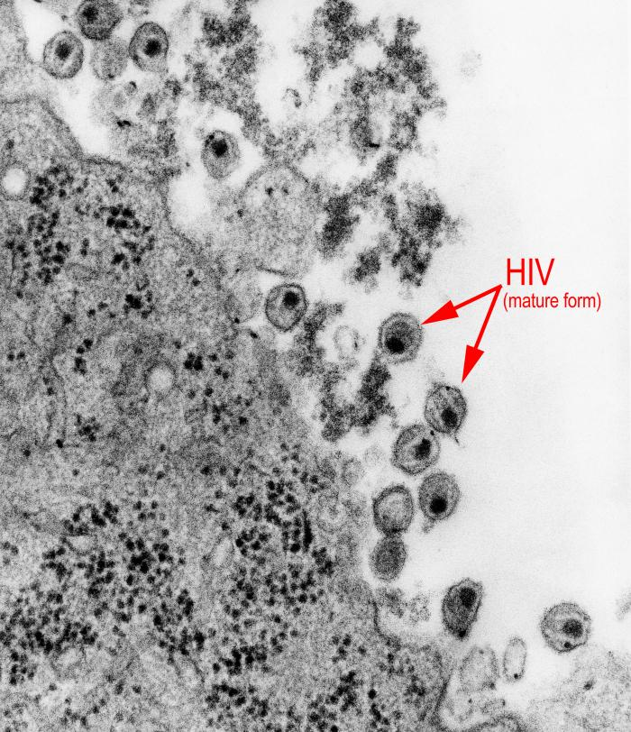
HIV (Human Immunodeficiency Virus) infects human immune cells and reproduces within them. HIV causes AIDS (Acquired Immunodeficiency Syndrome), which describes a weakened and “deficient” immune system. The body of someone with AIDS can no longer fight against many diseases that a person with a healthy immune system can. HIV is transmitted through infected blood and sexual fluids that have a high concentration of the virus. People carrying the virus can live without symptoms for years and unknowingly spread the disease. There are no known cures or vaccines to prevent HIV infection as of 2007.

(Left: Human immunodeficiency virus, Courtesy CDC Public Health Image Library)


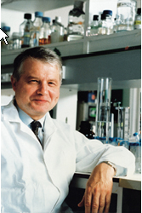
The first case of HIV/AIDS was reported by the U.S. Centers for Disease Control and Prevention (CDC) in June 1981. In 1985, the U.S. Food and Drug Administration (FDA) licensed the first blood test for AIDS. The discovery of the HIV virus in the mid-1980s by teams of scientists in France and the United States led by Doctors Montagnier and Gallo respectively, made the development of a test possible. Between the first reported case in 1981 and the end of 2005, more than half a million adults, adolescents, and children in the United States died of AIDS. Over one million people in the United States are living with HIV/AIDS, while an estimated 40,000 people are newly infected with HIV each year.
(Above left: Dr. Luc Montagnier, Pasteur Institute, France, Courtesy Reprinted by permission from Macmillan Publishers Ltd: Nature Magazine, Vol. 6, Number 3, March 2000; above right: Dr. Robert Gallo, National Cancer Institute, United States, 1980s, Courtesy Dewitt Stetten, Jr., Museum of Medical Research, National Institutes of Health)

In 1985, Ryan White, a 13-year-old hemophiliac with AIDS, was barred from attending school on the grounds that he might transmit HIV to other students. Although he eventually won a court battle to return to his school, the family experienced ongoing intimidation and harassment. They moved from Howard County to Cicero, Indiana in 1987, where Ryan became an honor roll student.

Media coverage of Ryan White’s experiences exposed the discrimination experienced by people living with HIV and AIDS. Ryan White educated people about the facts of the disease and its transmission, and spoke out for the rights of people living with AIDS. He was interviewed on numerous television programs and appeared on the cover of People magazine twice before his death in 1990. His story helped change the attitudes of many who had previously been unsympathetic to people living with the disease.
(Above: Ryan White speaks to the media, Hamilton Heights High School, Cicero, 1987, Courtesy Mary Ann Carter)


In New York in 1987, about 300 people formed the AIDS Coalition to Unleash Power (ACT UP), to challenge discrimination against people living with AIDS. They launched a series of demonstrations to campaign for AIDS research and HIV prevention education. The ACT UP protests in late 1988 against the slow process of drug approval by the U.S. Food and Drug Administration, resulted in expediting the review process for key AIDS medications including AZT. This important policy change also led to new rules for fast-tracking approval of drugs that could save lives. Activist groups like ACT UP mobilized people to focus the public’s attention on specific issues—for example, drug development and approval, and protecting the rights of people living with HIV/AIDS.
(Above: ACT UP demonstration at the U.S. food and Drug Administration, October 11, 1988, Courtesy Food and Drug Administration History Office)

