George Washington and Medicine

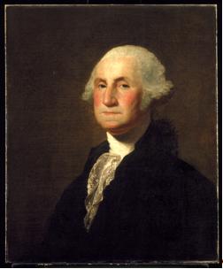
Quote 1: “During Washington’s life (1732–1799), medicine in America followed the practices of England. These practices were defined by speculative hypotheses, domestic remedies, and the beginnings of scientific investigation and formal education.”
Quote 2: “Washington’s status and wealth gave him—and his community—special privileges. During his life time, with the practice of medicine slowly becoming a licensed profession, he could call on a growing class of experts and new knowledge about the spread and prevention of disease. Even so, Washington, like everyone else of his era, encountered the limits of medicine when faced with serious illnesses.”

George Washington by Gilbert Stuart, ca. 1798
Courtesy Mount Vernon Ladies’ Association

- Read the quote above, circling words whose meanings are not clear from your reading.
- What is the key topic in the first quote? You may choose a phrase from the quote.
- What kind of circumstance does the second quote describe about George Washington and the state of medical care in his time?
- List the words you have circled below, look them up in a dictionary, and note their meanings next to their words below.
- What kinds of injuries and illness do you know of that George Washington suffered from during his lifetime?

