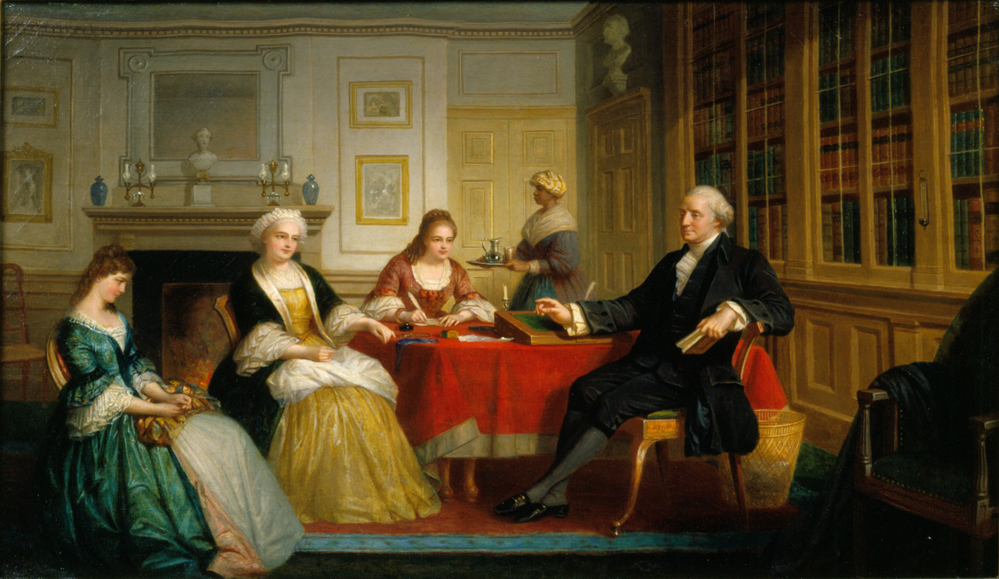

George Washington and Family, oil on canvas, Thomas Pritchard Rossiter, 1858–1860

Courtesy Mount Vernon Ladies’ Association

