**Class 1 Activity: Keeping a Daily Diary**

**Note:** This “Keeping a Daily Dairy Activity” is modeled after Lynda Barry’s “Six Minute Diary,” found at <https://www.youtube.com/watch?v=qxep3E6aljM>.

**Instructions:**

1. Limit the activity to around ten minutes, and do this every day for the duration of the course.
2. Using your composition notebook, draw a frame around a page, leaving half-inch (½”) margins all around so you have one large box on the page.
3. Draw a vertical line down the center of the box, and a horizontal line about two-thirds the of the way toward the bottom, so that you separate the one large box into four smaller boxes.
4. Label the boxes as shown below.

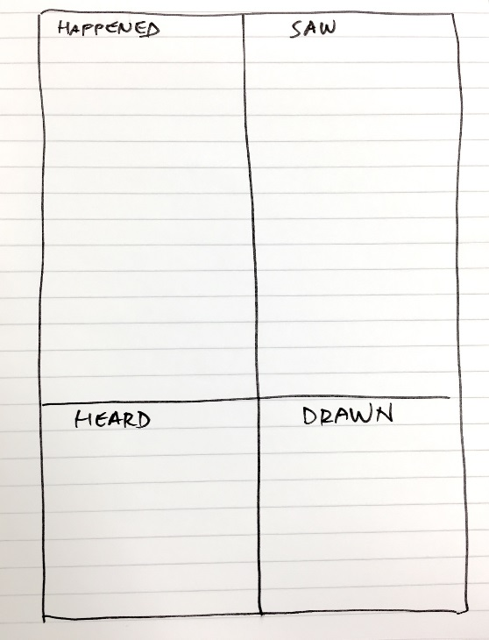

1. In the box labeled “HAPPENED,” take about two minutes to list about seven things that happened in the last 24 hours.
2. In the box labeled “SAW,” take about two minutes to write down about seven things that caught your eye in the last 24 hours.
3. In the box labeled “HEARD,” take about a minute to write down one or two things you overheard someone say in the last 24 hours. (Eavesdropping is a big part of this class!)
4. In the box labeled “DRAWN,” take one to two minutes to draw something that caught your eye during the last 24 hours.