Absalom Jones and Richard Allen
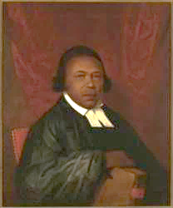 Absalom Jones, painting by Raphaelle Peale, 1810. Courtesy Delaware Art Museum

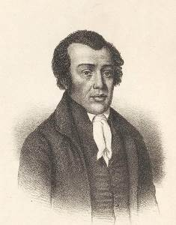 Richard Allen, Bishop of the first African Methodist Episcopal Church, undated. Courtesy Schomburg Center for Research in Black Culture, Photographs and Prints Division, The New York Public Library

Authors of A Narrative of the Proceedings of the Black People, during the Late Awful Calamity in Philadelphia, in the Year 1793

