Hair Colors
Instructions: Solve the two questions below and use a Punnett square to demonstrate how you arrived at your answers.

Question 1: Harry has dark hair like his father, but his mom had red hair. Using the genotypes of rr (red hair), Rr (dark/brown hair), RR (dark/brown hair), what possible genotypes does each of the Potters have?

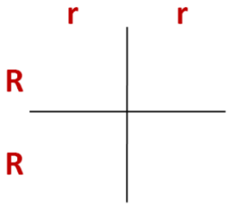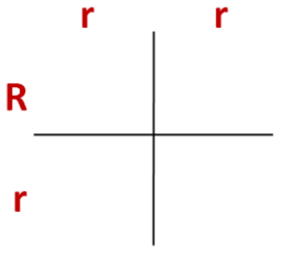

Question 2: Harry marries Ginny who has red hair. What are possible genotypes of their children’s hair colors?

