Word Match Activity
Instructions: Match the following genetic terms to their corresponding parts of the illustration: base pair, cell, chromosome, DNA (Deoxyribonucleic Acid), double helix*, genes, nucleus
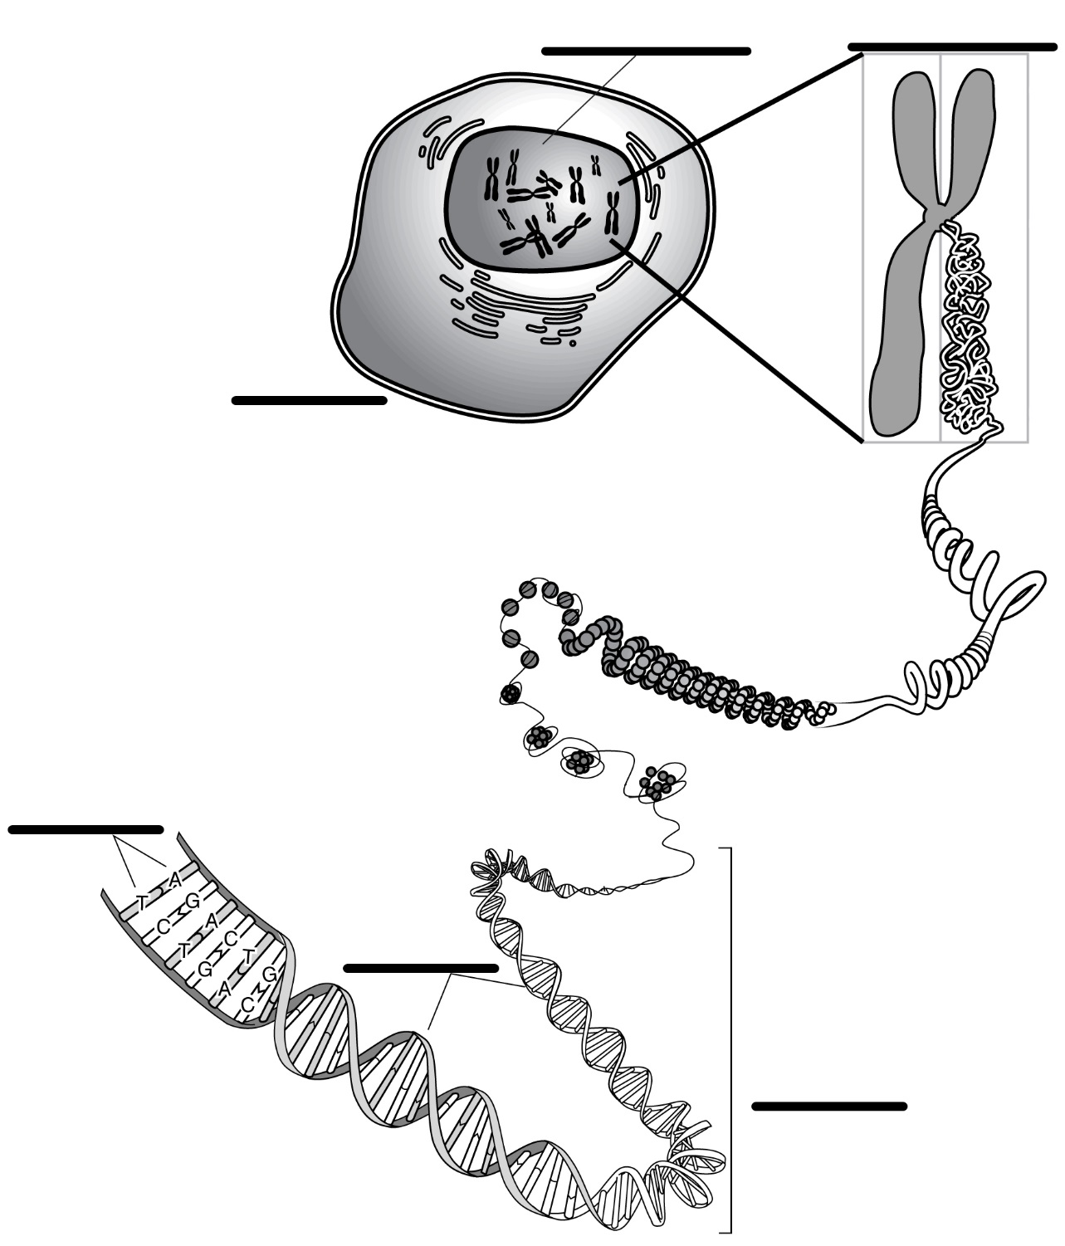
Illustration Source: Talking Glossary of Genetic Terms http://www.genome.gov/
glossary.cfm?key=chromosome

