The Four Humors
An Introduction with Primary Sources

During Shakespeare’s time, people believed that the “Four Humors” affected not only our physical health, but also our personalities and mental well-being. The four humors theory was developed in ancient Greece and Rome and influenced European medicine until at least the 18th century. The four humors were blood, phlegm, black bile, and yellow bile. These were in balance in a healthy person. Slight imbalances, favoring a specific humor, were thought to result in specific personality types. Greater imbalances were thought to lead to illness. In order to heal the sick, balance of the four humors had to be restored. Each humor was associated with a specific element, season, age, quality, personality type, and Zodiac symbols.

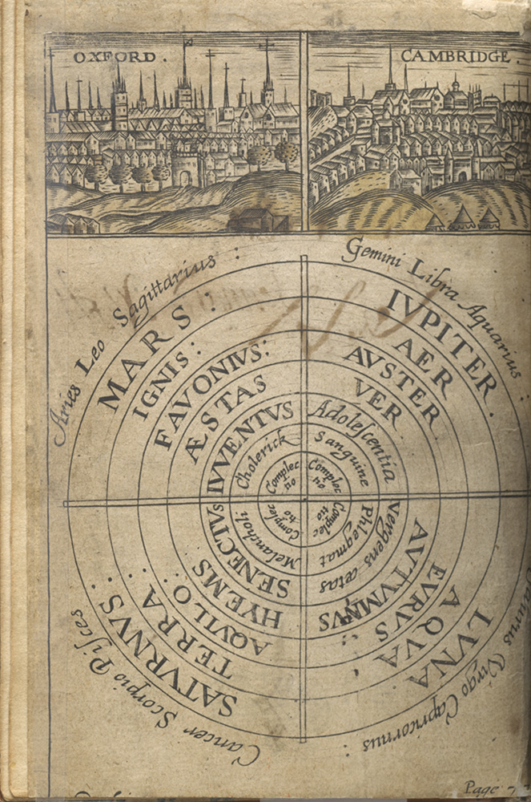

Thomas Walkington, Optick Glasse of Humor, 1631
Courtesy National Library of Medicine

The Four Humors: Blood
Associated Adjectives—Sanguine, sanguineous

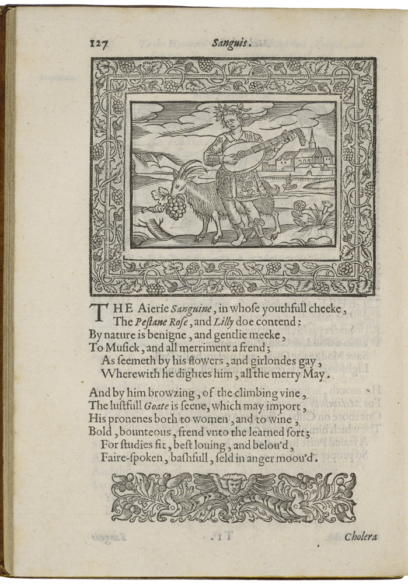
[Modern English translation of the text]

Airy Sanguine, whose youthful cheek is both pink and white, is naturally kind and gentle and humble. He loves music and all merriment, as indicated by the flowers and garlands that he decorates himself with throughout the merry month of May.

Near him are a climbing vine and a lustful goat, indicating his fondness for both wine and women. He is bold, generous, a friend to learning, fit for studies, most loving and beloved, fair-spoken, not boastful, and seldom angry.
Henry Peacham, Minerva Britanna, 1612. Courtesy Folger Shakespeare Library

The Four Humors: Yellow Bile
Associated Adjectives—Choleric

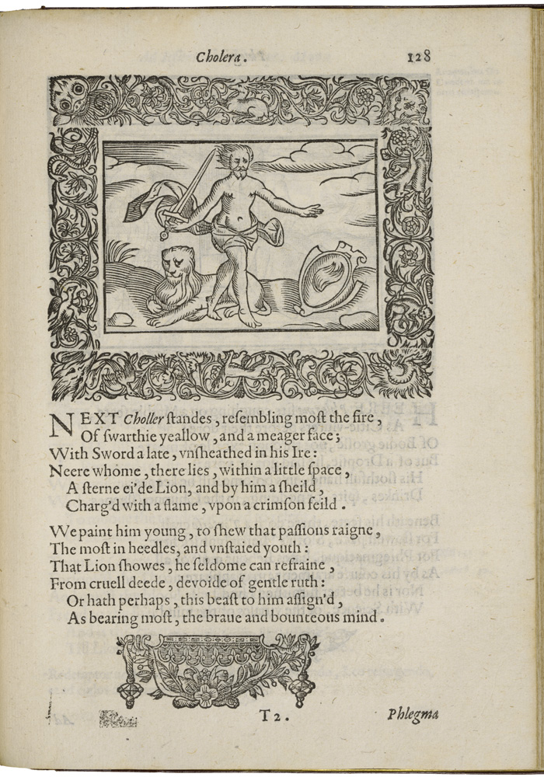
[Modern English translation of the text]

Next Choler stands, resembling fire the most, and having a face that is dark yellow and thin. He has a sword that he has taken out of its sheath in his anger, and close to him is a stern-eyed lion. He also has a shield with a flame on a crimson background.

He is painted young to show that his passions control him and that he is a thoughtless and
undisciplined young man. The lion indicates that he can seldom keep from performing cruel deeds and is without pity. However, the lion also indicates that he has a brave and wide-ranging mind.

Henry Peacham, Minerva Britanna, 1612. Courtesy Folger Shakespeare Library

The Four Humors: Phlegm
Associated Adjectives—Phlegmatic

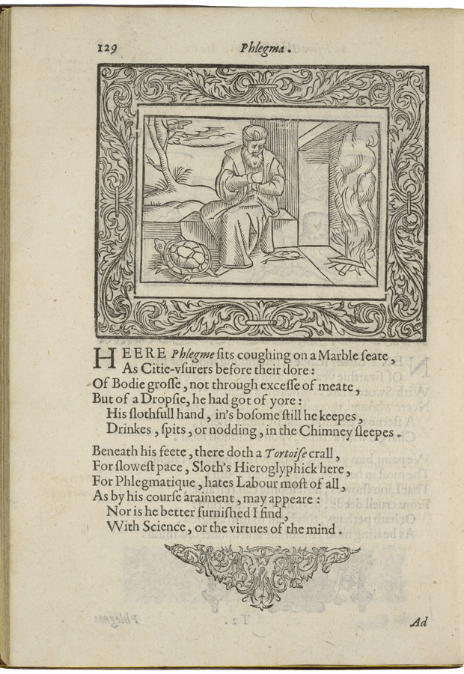
[Modern English translation of the text]

Here Phlegm sits coughing on a marble seat, just like the money lenders in the city sit in front of their gold. His body is fat, not because he eats too much meat but because he has dropsy, so fluid has collected in his body. He keeps his lazy hand in his shirt as he drinks and spits and nods off to sleep by the chimney.

A tortoise crawls beneath his feet, symbolizing his sloth, or laziness, because Phlegm hates working most of all, as his coarse clothing indicates. Nor does he like to study or put his mind to good use.

Henry Peacham, Minerva Britanna, 1612. Courtesy Folger Shakespeare Library

The Four Humors: Black Bile
Associated Adjectives—Melancholy

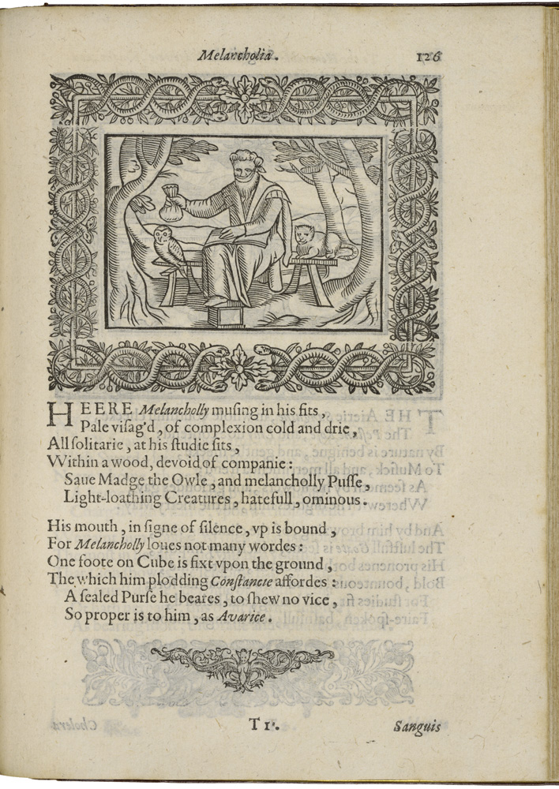
[Modern English translation of the text]

Here Melancholy, absorbed in his struggles, with a pale face and cold, dry complexion, sits by himself in his studies. He is in the woods, without any company except for Madge the owl and a melancholy cat, two hateful and ominous animals that loathe the light.

As an indication of his silence, his mouth is bound because Melancholy doesn’t like to talk. One of his feet is on a cube, fixing him firmly to the ground and providing him with a dull steadiness. He also has a sealed purse to indicate that there is no vice better suited
to him than greediness.

Henry Peacham, Minerva Britanna, 1612. Courtesy Folger Shakespeare Library

