"The Growth of Roman Power in Asia Minor: Asia Minor I”

Use the map of Asia Minor I below to answer the following questions:
- Which period of the Roman Empire does this map represent?
- Which three large bodies of water are named in this map?
- Locate the cities where Galen studied and worked: Smyrna, Alexandria, and Pergamum.
- What country now occupies the city of Pergamum?
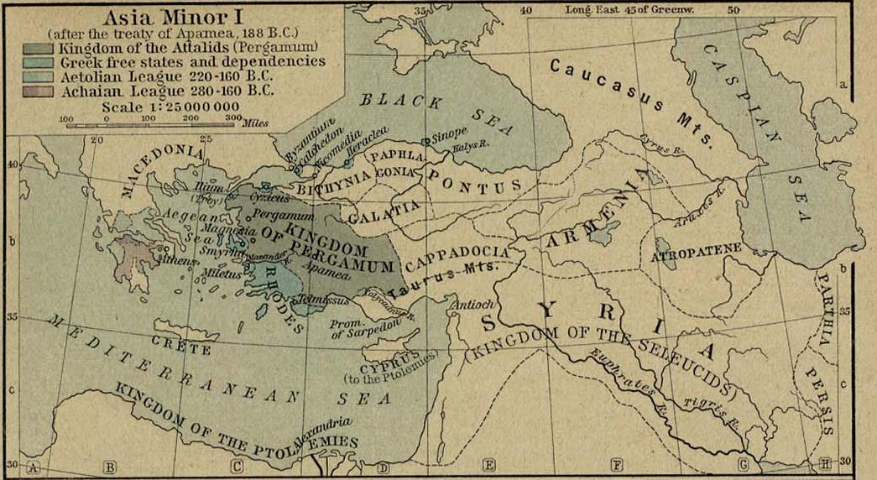
"The Growth of Roman Power in Asia Minor" from The Historical Atlas by William R. Shepherd, 1923. Accessed from the Perry-Castañeda Library available online at http://www.lib.utexas.edu/maps/historical/shepherd/asia_minor_roman_power.jpg

