Teacher’s "The Growth of Roman Power in Asia Minor: Asia Minor I”

Use the map of Asia Minor I below to answer the following questions:
- Which period of the Roman Empire does this map represent? After the treaty of Apamea in 188 B.C.E., which halted the Seleucid Dynasty
(one of the three parts of Alexander the Great’s former empire) from moving farther west
- Which three large bodies of water are named in this map? Mediterranean, Black, and Caspian Seas
- Locate the cities where Galen studied and worked: Smyrna, Alexandria, and Pergamum. See the red circles on left side of the map
- What country now occupies the city of Pergamum? Turkey

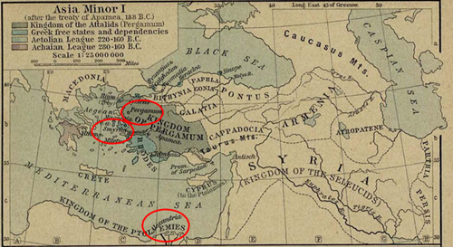
"The Growth of Roman Power in Asia Minor" from The Historical Atlas by William R. Shepherd, 1923. Accessed from the Perry-Castañeda Library available online at http://www.lib.utexas.edu/maps/historical/shepherd/asia_minor_roman_power.jpg

