Teacher’s Sanguine
Using both the illustration and its accompanying text:
- Mark the physical characteristics of the sanguine person by highlighting them
- Mark the emotional and moral characteristics of the sanguine person by underlining them.

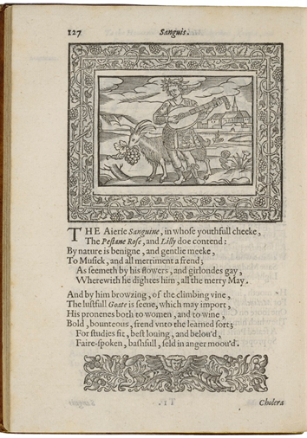
Henry Peacham, Minerva Britanna, 1612
Courtesy Folger Shakespeare Library

The airy Sanguine, in whose youthful cheek,
The pestane rose and lily do contend:
By nature is benign and gently meek,
To music and all merriment a friend;
As seems by his flowers and garlands gay,
Wherewith he adorns himself, all the merry May.

And by him browsing, of the climbing vine,
The lustful goat is seen, which may import,
His proneness both to women and to wine,
Bold, bounteous, friend unto the learned fort;
For studies fit, best loving and beloved,
Fair-spoken, bashful, seldom in angry mood.

