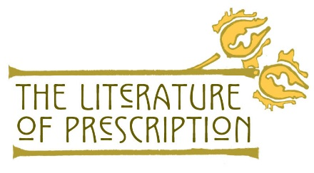

Class Discussion Rubric

Standards | Exceeds Standard  (5 points) | Meets Standard  (4 points) | Needs Improvement  (0 - 3 points)
Develop and demonstrate critical reading, listening, and viewing strategies. | Student gives passage, page number, and thorough explanation of the text’s significance.  Student fully identifies and evaluates the primary focus, logic, style, and structure of a text. | Student gives general textual idea but cannot locate/identify passage for support.  Student adequately identifies and evaluates the primary focus, logic, style, and structure of a text. | Student cannot give textual support for discussion point.  Student cannot identify and/or evaluate the primary focus, logic, style, and structure of a text.
Construct meaning beyond the literal level—e.g., drawing inferences, confirming and correcting, making comparisons and connections, and drawing conclusions. | Student responds to questions with full and specific knowledge, and often uses literary language in their response—e.g., themes, imagery, symbolism, motifs, etc. | Student demonstrates general idea in her or his responses, but without key details or deeper analyses. | Student cannot answer questions about the topic.
Participate as an active member of a reading, listening, and viewing community. | Student listens attentively and refers to relevant class materials to aid in full participation in the discussion.  Student records key ideas and revises her or his previous responses based on new findings from the discussion.  Student consistently volunteers to share knowledge with class. | Student is attentive but may not refer to class materials during the discussion.  Student may not record key ideas and information from the discussion.  Student occasionally volunteers to share knowledge with class. | Student is inattentive and does not have or refer to class materials related to the discussion at hand.  Student doesn’t take notes or revise his or her responses based on the discussion.  Student never volunteers to share knowledge with class.

https://www.nlm.nih.gov/theliteratureofprescription Page | 1

