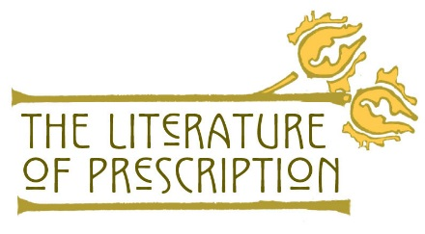

Essay Rubric

Points  Criteria | 4 (9-10) pts. | 3 (8) pts. | 2 (7) pts. | 1 (6) pts.
Structure & Organization  (4 pts.) | Introduction, body, and conclusion are well defined and effective. Thesis and topic sentence are clear and relevant. There are smooth transitions between paragraphs. The paper reads smoothly. | Introduction, body and/or conclusion may have minor errors, but reader can still follow the flow of the paper. | Introduction, body, and/or conclusion have significant flaws which affect flow of paper, such as missing thesis, transition, topic sentence. | Paper may be missing a paragraph, thesis, or have some other structural error which makes the paper ineffective.
Content Knowledge  (10 pts.) | Student addresses the essay topic explicitly by applying her or his full and specific content knowledge. | Student demonstrates knowledge of content, but doesn’t elaborate clearly—e.g., key details are missing. | Student gives plot summary or little analysis, demonstrating minimal content knowledge or understanding. | Student fails to provide any evidence of her or his comprehension of the content.
Grammar & Spelling  (4 pts.) | There are no spelling, grammatical, or punctuation errors. | There are one or two spelling, grammatical or punctuation errors. | There are three spelling, grammatical or punctuation errors. | There are four or more spelling, grammatical or punctuation errors.
Citation Format  (4 pts.) | All citations are used appropriately, formatted properly, and explained thoroughly. | One or two citations are missing or formatted incorrectly. | Three or four citations are missing or formatted incorrectly. | Five or more citations are missing or formatted incorrectly.
Quote Effectiveness  (4 pts.) | Quotes are used to make specific and effective references to main idea. | Quotes generally support the main idea with few exceptions—e.g., weak explanation or analysis. | Quotes are used ineffectively—e.g., not tied to main idea. | Paper contains no quotes or references.

Grading Scale Chart: Total Point (%)
26 (100%) | 25 (96%) | 24 (92%) | 23 (88%) | 22 (85%) | 21 (81%) | 20 (77%) | 19 (73%) | 18 (69%) | 17 (65%)

https://www.nlm.nih.gov/theliteratureofprescription Page | 1

