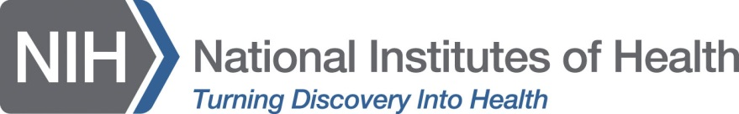
_____________________________________________________________________________________________

National Institutes of Health
Office of Communications
1 Center Drive, MSC 0188 Bethesda, MD 20892-0188
(301) 496-4461
FAX (301) 496-0017

Please direct questions regarding
Science Day for Students at NIH
to scienceday@mail.nih.gov

AUTHORIZATION
I, , authorize The National Institutes of Health (NIH) to record and/or broadcast or livestream interviews, films, recordings, or photographs of me taken with my knowledge and agreement. The recordings may be used by NIH for the development, promotion and broadcast or distribution in any medium of science, health or educational programming. NIH is entitled to edit, copy, adapt or translate the contribution and authorize others to do so in connection with NIH projects.

Date Printed Name

________________________________________ Signature

________________________________________
Email address:

