UMLS Step-by-Step

Downloading the UMLS Release Files

In this tutorial you will:
- Use the UMLSKS
- Download the most current UMLS release files
- Create your UMLS file folder
 Note: You must have 13 GB of free hard disc space and 1 GB of RAM to download the UMLS Release Files.
- Create a new folder to store the UMLS files.
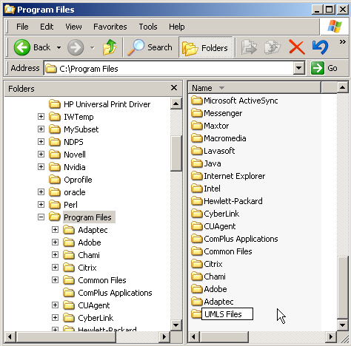

- Navigate to the UMLSKS home page in your preferred Internet browser.
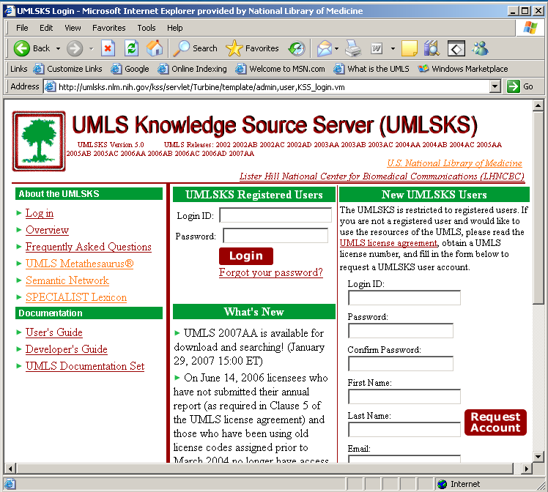

- Enter your log in ID and password
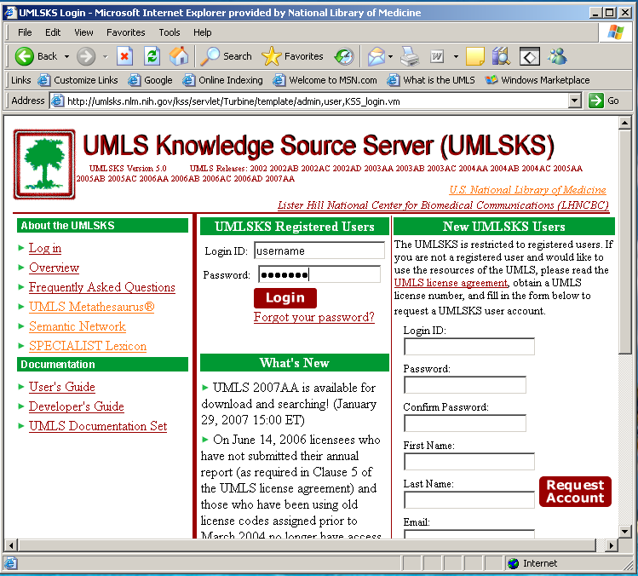

- Click Login
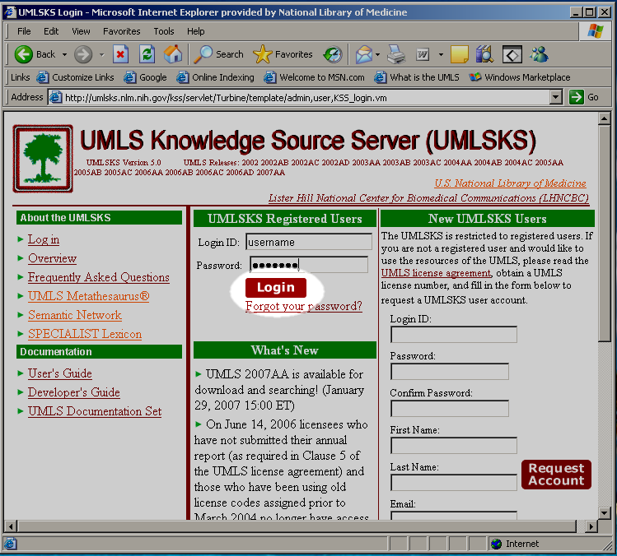

- Select “UMLS Knowledge Sources” from the Downloads menu on the left hand side.
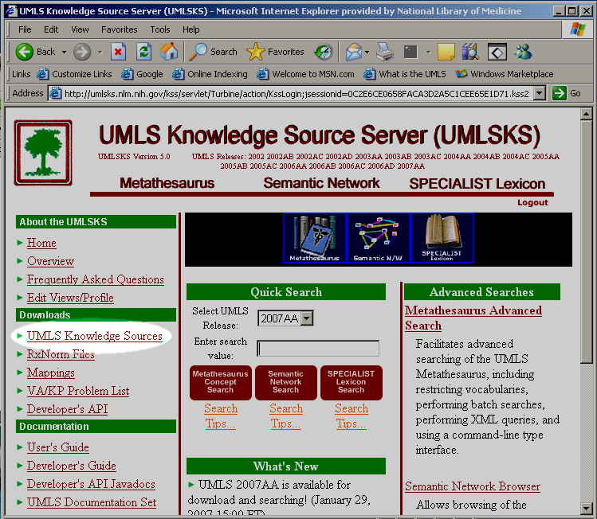

- Click on the first file in the table
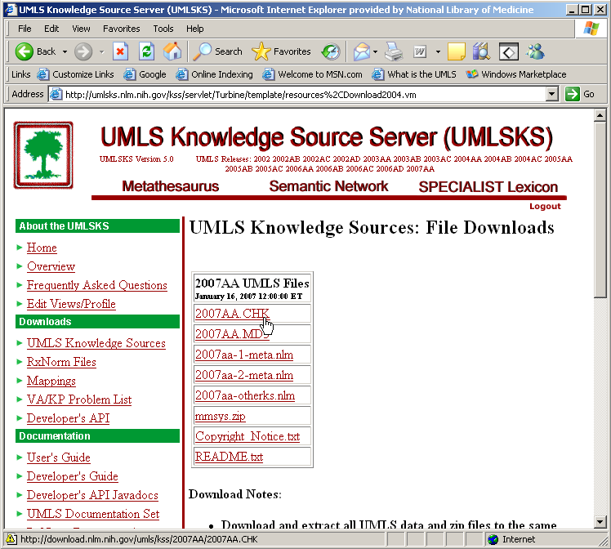
- Click Save
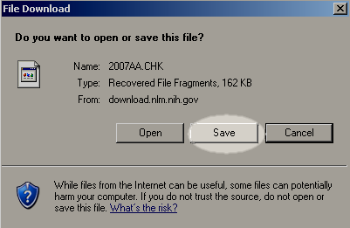

- Navigate to the folder you created in Step 1.
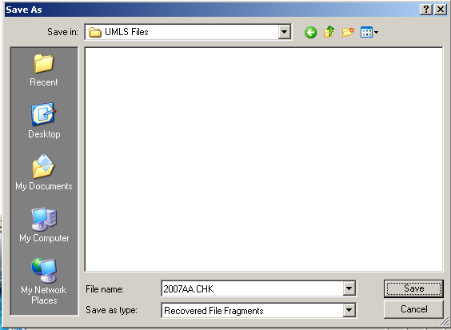

- Click Save
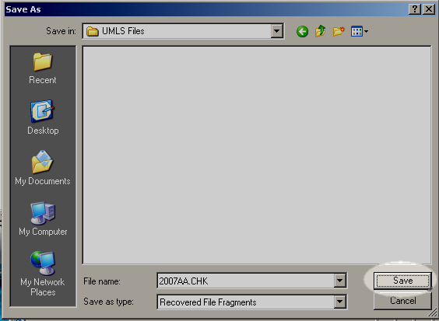
- Repeat steps 7 to 10 for each of the files in the table
- Confirm that your folder structure matches the image on the right.
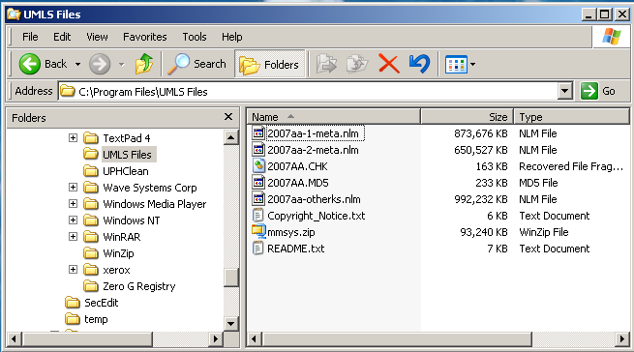

- Extract the files from mmsys.zip, this will create a folder labeled “mmsys” Note: the image below shows one method, right mouse clicking and choosing Extract to here, to extract the files. You are not required to use this method.
 Note: You may be prompted to overwrite the Copyright_Notice.txt and README.txt files. This is expected, overwriting this files will not cause a problem.
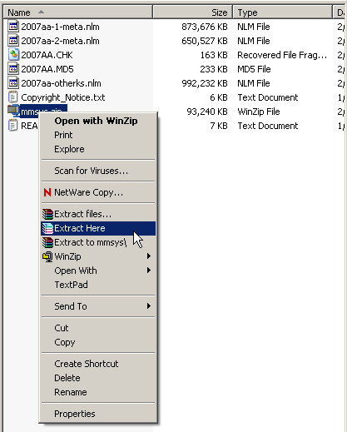

- Confirm that your folder structure and files match the image on the right
