UMLS Step-by-Step

Extract SNOMED CT from the UMLS

In this tutorial you will:
- Use MetamorphoSys
- Create a custom Metathesaurus subset containing only SNOMED Clinical Terms
- Create custom database load scripts
 Note: You must have the UMLS Knowledge Source available either via download or DVD to complete this process.
 Note: You must have 13 GB of free hard disc space and 1 GB of RAM to use the UMLS Knowledge Sources.
- Create a folder in a location with at least 13 GB of free space that will hold your SNOMEDCT data.
- Start MetamorphoSys, the UMLS customization program.
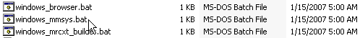

- From the Welcome Screen, select "Install UMLS".
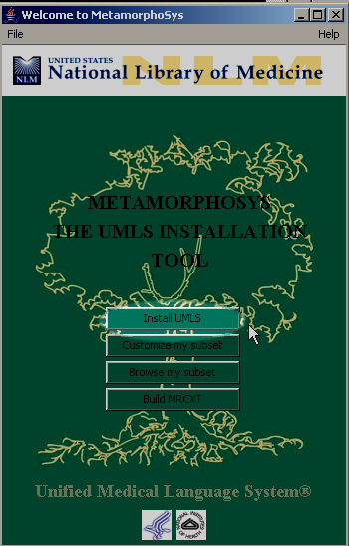

- Click Browse.
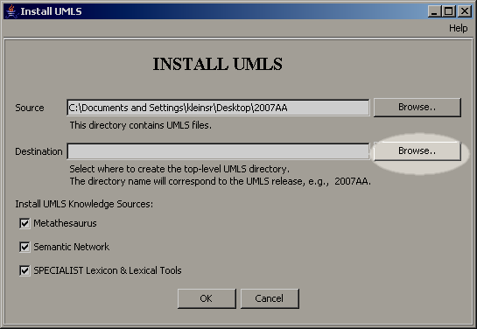
- Select the folder you created in step 1.
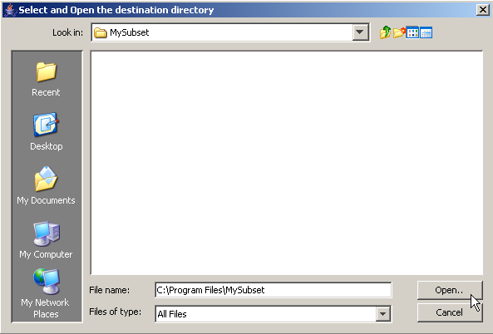

- Uncheck the box next to Semantic Network and SPECIALIST Lexicon & Lexical Tools.
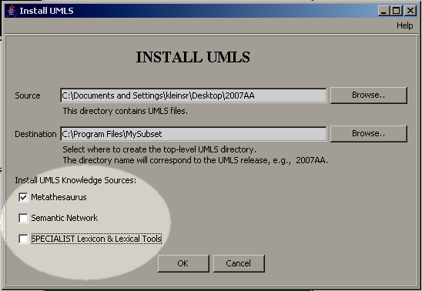
- Click OK.
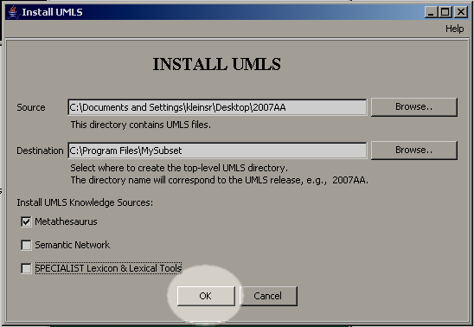

- Select New Configuration on the MetamorphoSys Configuration screen.
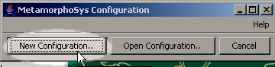
- Click Accept after reviewing the license agreement notice.
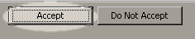
- Select the second option - Level 0 + SNOMED CT — contains all Level 0 sources (no additional licenses needed for sources) and SNOMED CT. - on the Default Subset screen.
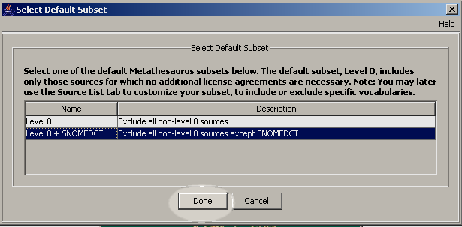
- Select the Output Options Tab.

- On the Output Options screen Select Write Database Load Scripts and either Oracle or MySQL
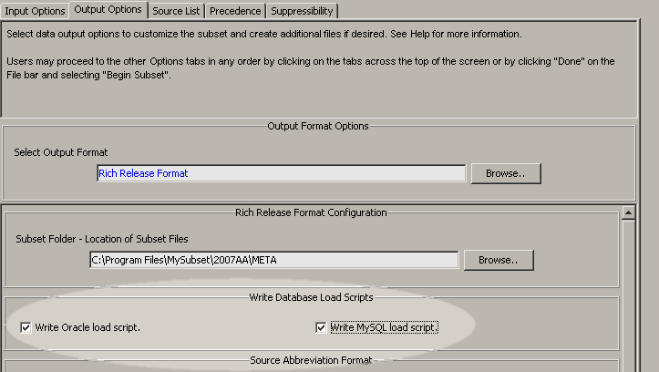
- Select the Source List tab.
- Select the radio button labeled 'Select sources to INCLUDE in subset'
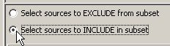

- Select SNOMED Clinical Terms.
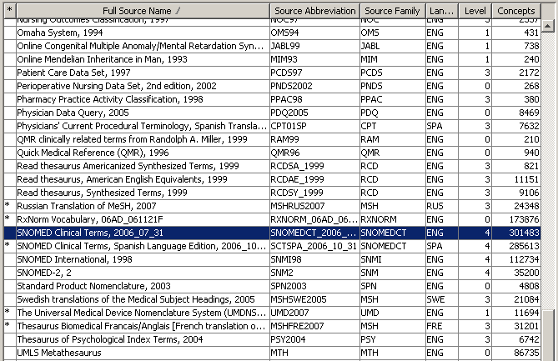
- Click Cancel when prompted to include SNOMED Clinical Terms, Spanish Language Edition.
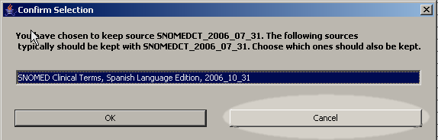
- Select Done from the main menu bar and click Begin Subset.
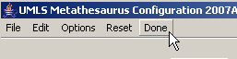
- When this process is complete (this may take over 4 hours) use the custom database load scripts to load the data into a database.
 For more information: SNOMED/UMLS issues are detailed on the UMLS website at: http://www.nlm.nih.gov/research/umls/Snomed/snomed_main.html .
The location of SNOMED CT fields within the UMLS files is detailed in a table inside the report Insertion of SNOMED CT® into the UMLS® Metathesaurus®: Explanatory Notes, available at http://www.nlm.nih.gov/research/umls/Snomed/snomed_represented.html.

