UMLS Step-by-Step

Install only the Semantic Network

In this tutorial you will:
- Use MetamorphoSys
- Install the Semantic Network files
 Note: You must have the UMLS Knowledge Source available either via download or DVD to complete this process.
 Note: You must have 1 GB of RAM to use MetamorphoSys. You will need at least 1 GB of free hard disc space to store the Semantic Network files.
Create a folder in a location with at least 1 GB of free hard disc space that will hold the Semantic Network data.
Start MetamorphoSys, the UMLS customization program
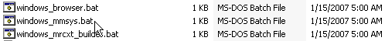

From the Welcome Screen, select Install UMLS
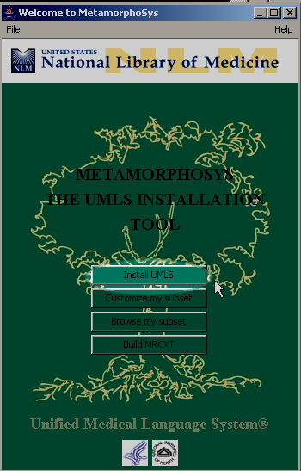

Select the folder you created in step 1.
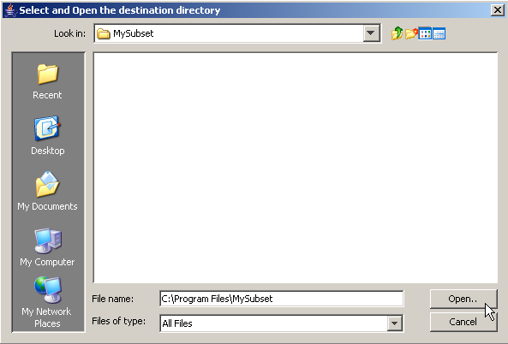
Uncheck the box next to Metathesaurus and SPECIALIST Lexicon and Lexical tools.
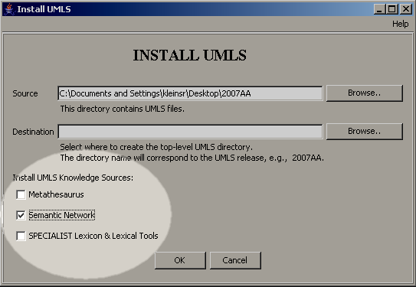

Click OK.
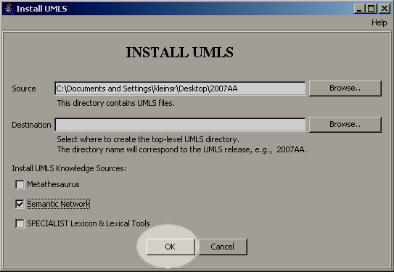
The Semantic Network should install in under 15 minutes. You will see a progress monitor in the upper left hand corner of your screen. When installation is complete the installation log file will appear in the center of your screen.
Click OK after reading the installation log file.
